# Endowment

## Introduction

The Endowment (KEM) module of the Kuali Financial System (KFS) provides functionality to manage and report endowment funds and charitable trusts. It captures information to track endowment funds (including security information, investment activity records, actual asset allocations, and investment pool data). It also tracks and records investment performance (investment income, realized gains and losses, unrealized gains and losses, fees to the various funds, historical book value, accumulated earnings, and net gains, etc.). KEM also supports standard and ad hoc inquiries including balance inquiries for current and historical balances, balances by individual funds, and balances by security or other asset. Finally, it assists in managing investment pools via functionality that automates investment of donor funds in the institution's pooled or common funds, provides historical unit values and spending policy rates by pool, and projects the budgeted payout or the anticipated actual income for the current and subsequent fiscal year.

This guide provides information about using the functions of the Endowment module. It is organized as follows.

* The first section provides high-level information about KEM batch processes.
* The next section summarizes the options available to users and indicates how they are grouped on the KFS menus.
* Each of the remaining sections presents background information and instructions specific to a group of functions on the menu. These sections are divided into subsections covering individual functions in the menu grouping. For each function, the applicable subsection presents a breadcrumb trail showing how to access the function and information on the layout and fields on the related screen(s). As appropriate, some subsections include business rules and routing information for e-docs and/or special instructions for performing activities.

 In order to work efficiently in the KFS screens, you need to understand the basics of the user interface. For information and instructions on logging on and off, navigating, understanding the components of screens, and performing basic operations in the screens, see Overview|document=WordDocuments\KFS 5\_2 Overview.docx;topic=Overviewthe KFS Overview and Introduction to the User Interface. This and other KFS user guides are available for download from the [Kuali Financial System Learning Center](https://wiki.kuali.org/display/KULDOC/Home).

 As you work in the KEM screens, keep in mind that information presented in this guide is also available via KFS online help.

## Endowment Batch Processing

 This section provides a high-level overview of the KFS batch processing that takes place each night to keep your institution's endowment records current. You do not need to understand this processing in order to successfully create and work with endowment transactions via the user interface. If, however, you are interested in what happens in the system after e-docs are approved, this overview is worth reading.

The KFS contains many important processes that ensure that the endowment system runs correctly and interfaces appropriately with the General Ledger (GL). If you create and/or work with endowment e-docs, the most apparent of these processes are those that generate new endowment transactions and those that update KEMID balances and security holdings. Other important processes are less apparent to you and other users. These processes ensure that all reference and balance inquiry data are updated from the transactions processed that day so users can view accurate and up-to-date information for each KEMID record.

You and other users do not directly interact with any of the batch processes. Instead, you create e-docs that, when fully approved and collected into a batch, are used as input to the batch processing sequence. Additionally, you may view and work with transactions automatically created by these processes.

 **Endowment batch processing must occur every day**—including weekends and holidays—in order to correctly calculate accruals and properly process batch processes that depend on a frequency code.

Batch processing occurs daily and is usually run at a time when it does not compete with online transaction activity or table maintenance (typically in the early morning hours). At the discretion of your institution, this processing may be time triggered, event triggered, or manually started.

Each batch process produces a log file along with two reports—one summarizing the activity of the process and the other noting exceptions.

### Batch Processing Sequence

Endowment processing is a general term for a sequence of 'batch' processes that are run on a daily basis (with exceptions–see the list below for two processes that are run only at month end). Each day's batch includes all endowment transactions that have been approved during the day. The processes in the sequence include:

* Import Gift Transactions
* Post E-Docs
* Generate Ticklers
* Update Market Value in Holding History Records
* Create Pooled Fund Distribution Transactions
* Create Accrual Transactions
* Calculate Daily Accruals
* Create Recurring Cash Transfer Transactions
* Create Fee Transactions
* Create Automated Cash Investment Transactions
* Roll Frequency Codes
* Create Cash Sweep Transactions
* Create Pooled Fund Control Transactions
* Update Available Cash Records
* Update Market Value in Holding History Records
* Update Current Tax Lot Balance Records
* Update Corpus Records
* Update History Cash (run at month-end only)
* Update Holding History (run at month-end only)
* KEM to KFS General Ledger Interface
* Roll Process Date

 On any given date, it is possible that no activity will be generated by one or more of the batch processes listed above. Nevertheless, because so many of these processes are date- or frequency-driven, your institution must run all of the processes (except as noted) with each processing cycle.

 Additionally, your institution must run all processes every day of the week—including weekends and holidays—in order to accurately accrue, calculate, and update the income earned by the securities held by your institution's KEMIDs.

 Transactions are processed based on the parameters that your institution has set up. For more information about the parameters, see Parameter|document=WordDocuments\KFS 5\_2 System\_Admin.docx;topic=Parameter“Parameter” in the KFS Guide to System Administration.

As shown below, some processes must be run sequentially while others may be run in parallel with each other.



As indicated in the diagram above, a few batch processes must be developed and provided by your institution. Such batch processes are not covered in this section. Instead, the following subsections provide an overview of each process delivered with the standard KFS.

### Post E-Docs Process

* This process does not collect or process Endowment Holding History Value Adjustment (EHVA) transactions.

For each transaction line in an e-doc, the KEM maintains a transaction archive record that is available for reporting and researching activity within a KEMID. The KEM also maintains a set of tables that represent cash balances and security holdings for each KEMID, and the records in these tables are separate from the actual KEM e-doc records.

The Post E-Docs process updates all of these records. To do so, it is always run first in the KEM batch processing sequence. Throughout the rest of the processing sequence, it is run again after batch processes that generate transactional e-docs. These additional runs are necessary for processing newly generated e-docs that your institution has chosen to post without approval.

The Post E-Docs process uses as input all unprocessed endowment e-docs with a route status of Final. For each transaction line in each e-doc, the process instructs the system to:

* Create transaction archive record(s) and transaction security archive record(s) for use in reporting.
* For each cash transaction, update cash balance record(s).
* For each transaction line that has an associated tax lot line:
* Update holding lot tax record(s).
* If the transaction involves a change in units and/or cost of a holding, update unit and cost values for the security.
* Mark the transaction line as posted.

After all transaction lines in an e-doc are marked as posted, the system marks the e-doc as posted.

### Generate Ticklers Process

The Generate Ticklers process creates and delivers ticklers (electronic reminders) in the form of simple routable e-docs. It creates these e-docs based on information in Tickler records whose content is due to be delivered on the current date. It also routes the generated e-docs as FYI to the person(s) and/or group(s) identified in the associated tables for the ticklers. Finally, the process places an action item in each recipient's action list.

All Tickler e-docs generated by this process are assigned a routing status of Final. Because these e-docs are FYI, no action is required on the part of the recipients, and each recipient is responsible for deleting tickler(s) from his or her action list.

This process must be run daily but may be run at any point in the overall batch processing sequence.

### Create Accrual Transactions Process

The Create Accrual Transactions process instructs the system to generate deposit entry transactions for all KEMIDs for which accrued income is now payable. This process may be run early in the batch processing sequence, but it must be run to completion before the accrual calculations job is run. It may be run in parallel with the Post E-Docs process and with the Create Pooled Fund Distribution Transactions process.

Through the Create Accrual Transactions process, the system locates all active securities that have been accruing income and are now scheduled to distribute the income on the processing date. It then generates a transactional document that credits the accrued income to the KEMID spendable income. For each security record for which payment is now due, this process generates one or more Cash Increase (ECI) e-docs. Each Cash Increase e-doc:

* Has a document header that includes the description 'Accrued Income Distribution' or another standard description defined by your institution.
* Has a transaction sub-type of Cash (C).
* Has a transaction source type of Automated Entry (A).
* References a single security record.

Additionally, if a KEMID holds multiple tax lots of a security with accrued income due, each Cash Increase e-doc contains only one transaction line for each combination of KEMID, security, registration code, and income/principal indicator.

Using the MAXIMUM\_TRANSACTION\_LINES parameter, your institution specifies the maximum number of transaction lines that may be added to an e-doc through this batch process. Using the NO\_ROUTE institutional parameter, your institution specifies whether the generated e-doc(s) should be submitted for approval or be blanket approved.

### Create Pooled Fund Distribution Transactions Process

The Create Pooled Fund Distribution Transactions process serves two purposes: It generates e-docs for distributing income by generating Cash Increase (ECI) e-docs for KEMIDs holding pooled funds, and if those funds are to be split between other KEMID's (as per the KEMID's payout instructions), the process immediately generates cash transfers to those KEMIDs. This process also generates Holding Adjustment (EHA) e-docs to distribute gains or losses to the KEMIDs holding the pooled funds.

 The prompt for activating the generation of holding adjustment transactions is in the Pooled Fund Value maintenance screen. On this screen, the user inputs a per-share value to be distributed and instructs the system when to effect the distribution.

This process may be run early in the batch processing sequence. It may be run in parallel with the Create Accrual Transactions process.

Each Cash Increase e-doc generated by this process:

* Has a document header that includes the description stated by your institution in the Endowment parameter for the process.
* Has a transaction sub-type of Cash (C).
* Has a transaction source type of Automated Entry (A).
* References a single security record.

Additionally, if a KEMID holds multiple tax lots of a security, each Cash Increase e-doc contains only one transaction line for each combination of KEMID, security, registration code, and income/principal indicator.

Each Holding Adjustment e-doc generated by this process:

* Has a document header that includes the description stated by your institution in the Endowment parameter for the process.
* Has a transaction sub-type of Non-Cash (N).
* Has a transaction source type of Automated Entry (A).
* Contains the security ID and registration code of the tax lot records affected.
* Contains an entry in the Decrease or Increase transaction lines as follows:
* If the value of the transaction is negative, the distribution represents a loss to the holding value, so the transaction lines are added to the e-doc's Decrease transaction lines.
* If the value of the transaction is positive, the distribution represents a gain to the holding value, so the transaction lines are added to the e-doc's Increase transaction lines.

Using the MAXIMUM\_TRANSACTION\_LINES parameter, your institution specifies the maximum number of transaction lines that may be added to an e-doc through this batch process.

### Calculate Daily Accruals Process

The Calculate Daily Accruals process instructs the system to calculate four types of KEM accruals:

* Automated cash management: The accrual mechanism for “money market” type accounts; calculated daily based on the holdings on each date; adds the amount of interest earned today to the total interest due to the account holder.
* Dividend : The total dividend amount to be paid to the holder of a security; based on the ex-dividend record date (that is, the required date of ownership), units held, and dividend amount and payment date; accrued dividends are calculated periodically, based on the ex-dividend date.
* Treasury notes and bonds: Calculated based on the number of days in the six months prior to the semi-annual payment date.
* Time deposits: Simple interest calculation (not compounded); payment frequencies vary depending on the instrument. For example, income may be paid monthly, quarterly, semi-annually, annually or at maturity.

This process must be run after both the initial Post E-Docs process and the Create Accrual Transaction process have been run to completion. It must be run in the early stages of the nightly process to ensure that all accruals are calculated on the securities held on that date and on those securities only. The sub-processes for the four different accrual methods may be run separately (in parallel) or as a group (single job).

#### Accrual Calculations

 Unless otherwise indicated, all calculations adhere to the standard rounding rules. For information on those rules, see Standard Rounding Rules|document=WordDocuments\KFS 5\_2 KEM.docx;topic=Standard Rounding Rules.

The information required for calculating and recording accruals is stored in three tables.

* The Security table contains information for each security regarding the frequency of payments, next payment date, the ex-dividend date, and dividend amount or annual payment rate.
* Each security has a class code defined by a Class Code record that contains information about the type of accrual, if any, to calculate for the security.
* Actual accrual amounts are calculated for individual holdings and stored in the Holding Tax Lot table.

Calculations vary according to the accrual type. However, for all accrual types, when the divisor is the number of days in the year, the system uses 365 except for a leap year, in which case the system uses 366. Additionally, all calculations are done by security and reporting of totals processed is by security.

Automated cash management calculations are performed on securities having class codes with an accrual method of 'A' (Automated Cash Management). The calculations are as follows:

* For each Holding Tax Lot record for a security for which the number of holding units is greater than zero:

Accrual Amount = (Holding Units x Rate) ÷ Number of Days in Calendar Year

* In the Holding Tax Lot record, add the calculated accrual amount to the accrued income due in the Holding Lot record.

Dividend calculations are performed as follows on securities having class codes with an accrual method of 'D' (Dividend) on the ex-dividend date:

* For each Holding Tax Lot record for a security for which the number of holding units is greater than zero:

Accrual Amount = Holding Units x Security Dividend Amount

* In the Holding Tax Lot record, add the calculated accrual amount to the accrued income due in the Holding Lot record.

 Reminder: Dividends accrue periodically as described above. They do not accrue daily.

Treasury notes and bonds calculations are performed on securities having class codes with an accrual method of 'T' (Treasury Notes and Bonds). The calculations are as follows:

* Number of Days in Calculation Interval = Number of days between last date income was paid and the next pay date, based on the frequency code for the security. For example, if the payments are March 15th and September 15th, one six month interval will be March 16th to September 15th (184 days) and the other interval will be September 16th to March 15th (181 days or 182 in a leap year).
* For each Holding Tax Lot record for a security where the number of holding units are greater than zero:

Accrual Amount = (Holding Units x [Security Rate ÷ 2]) ÷ Number of Days in Calculation Interval

* In the Holding Tax Lot record, add the calculated accrual amount to the accrued income due in the Holding Lot record.

Time deposit calculations are performed on securities having class codes with an accrual method of 'M' (Market). The calculations are as follows:

* For each Holding Tax Lot record for a security where the number of holding units are greater than zero:

Accrual Amount = (Holding Units x Rate) ÷ Number of Days in Calendar Year

* In the Holding Tax Lot record, add the calculated accrual amount to the accrued income due in the Holding Lot record.

### Create Recurring Cash Transfer Transactions Process

The Create Recurring Cash Transfer Transactions process directs the system to examine your institution's instructions for recurring transfers of cash that have been established via Recurring Cash Transfer Transactions e-docs. Based on these instructions, the system generates Cash Transfer (ECT) e-docs and/or Endowment to General Ledger Cash Transfer (EGLT) e-docs as needed.

Because recurring transactions are set to occur at varying frequencies, this process is always set to run nightly. This schedule ensures that all necessary transactions are generated on time. In the overall batch processing sequence, this process:

* Must occur after the Create Accrual Transactions and Create Pooled Fund Distributions processes have run to completion.
* Must occur after the initial run of the Post E-Docs process that handles all manually entered transactions.
* Must occur before any automated investment batch processes are run.

After this process runs to completion, the batch processing sequence must include another run of the Post E-Docs process because this process may generate e-docs that have been designated as “no route” by your institution and are, therefore, ready to post.

Each Cash Transfer and Endowment to General Ledger Transfer e-doc created by the Create Recurring Cash Transfer Transactions process has:

* A document header that includes the standard description defined by your institution for this type of document.
* A transaction sub-type of Cash (C).
* A transaction source type of Recurring Entry (R).

#### Transfer Calculations

 Unless otherwise indicated, all calculations adhere to the standard rounding rules. For information on those rules, see Standard Rounding Rules|document=WordDocuments\KFS 5\_2 KEM.docx;topic=Standard Rounding Rules.

The instructions in a Recurring Cash Transfer Transactions e-doc must reference only one KEMID as the source of funds but may reference multiple targets for the transfer. For each target specified, an instruction in the e-doc indicates how the transfer amount is to be calculated. Any of three calculation methods may be specified in the instruction, and a single e-doc may specify a different instruction/calculation method for each target.

The three types of instruction and the corresponding processing performed by this batch process are as follows.

* If the instruction is to move a percentage using an Etran code, the process moves the specified percent of the funds deposited to the endowment since the last transaction processed for the specified Etran code.
* If the instruction is to move a percent of the funds, the process bases its calculation on the current cash equivalents balance for the KEMID.
* If the instruction is to move a specific amount, the system generates the target (To) transaction line for that amount.

When multiple calculation methods are associated with a single recurring transfer record, the system determines the order in which to process instructions for a target based on the order in which the record for this particular target was entered in the transfer instruction e-doc.

When performing calculations, the system always calculates target transfer amounts first and then totals the target amounts to obtain the source amount.

 If your institution does not allow the KEMID to have a negative cash balance as a result of this transaction, and if the calculated source amount will overdraw the KEMID, the process cancels the e-doc and reports the information on the exception report.

### Create Fee Transactions Process

The process of creating fee transactions allows your institution to base fees on either balances or activity, and your institution may opt to charge, accrue, or waive the fees at the KEMID level. Because these aspects of processing vary between institutions, this section cannot explain the actual calculations performed by the system during the Create Fee Transactions process. Instead this section covers the parts of the process that are standard—initial processing and determination of how to charge the fee.

Standard processing includes the following:

* If the fee for the KEMID is to be waived, the process adds the calculated fee to both total waived fees this fiscal year and total waived fees for the KEMID.
* If the fee for the KEMID is to be accrued, the process adds the calculated fee to total accrued fees.
* Accrued and waived fees are reported by KEMID.
* Cash Decrease (ECDD) documents are generated for fees as needed.
* If the process is unable to calculate a fee and generate a transaction line, it reports the issue on an exception report.

In the overall sequence of batch processes, this process must be run before the Create Automated Cash Investment Transactions process and the Create Cash Sweep Transactions process. Because this process generates Cash Decrease e-docs, the batch sequence must include a run of the Post E-Docs process after this process has run to completion.

#### Fee Calculations

 Unless otherwise indicated, all calculations adhere to the standard rounding rules. For information on those rules, see Standard Rounding Rules|document=WordDocuments\KFS 5\_2 KEM.docx;topic=Standard Rounding Rules.

As part of this process, the system determines how the fee calculation is to be made based upon the fee type specified in the KEMID Fee record.

* If the fee type is T (Transactions), the system uses transaction records from the Transaction Archive table to calculate the fee.
* If the fee rate definition code is C (Count), the system totals the number of the records that fit the selection criteria and have been posted since the last processing date for the fee.
* If the rate definition code is V (Value), the system totals the income cash amount and/or principal cash amount of the records that fit the selection criteria and have been posted since the last processing date for the fee.
* If the fee type is B (Balance), the system uses Current Tax Lot Balance or Holding History records to calculate the fee.
* For records in which the fee rate definition code is C (Count), the system:

1. Totals the number of units held by the records that fit the selection criteria.
2. If the fee balance type is AU (Average Units), calculates the fee as the total of all holding units for records in which the month-end date is greater than the last processing date for the fee, divided by the number of records selected.
3. If the fee balance type is MU (Month End Units), calculates the fee as the total of the holding units for all records in which the month-end date is the most recent month-end date.
4. If the fee balance type is CU (Current Units), calculates the fee as the total of the current units held for all selected records.

* For records in which the fee rate definition code is V (Value), the system:

1. Examines the market value of the records that fit the selection criteria.
2. If the fee balance type is AMV (Average Market Value), calculates the fee as the total of the holding market values for all Holding History records in which the month-end date is greater than the last processing date for the fee, divided by the number of records selected.
3. If the fee balance type is MMV (Month End Market Value), calculates the fee as the total of the holding market values for all Holding History records in which the month-end date is the most recent month-end date.
4. If the fee balance type is CMV (Current Market Value), calculates the fee as the total of all selected Current Tax Lot records.

The system then analyzes the appropriate KEMID records to determine whether a fee is to be charged and processes it appropriately. If a fee is to be charged, the system calculates fees against the total amount calculated for each KEMID according to the rules outlined above. The actual fee amount is calculated by adding together the results of these calculations:

* Multiply the value of the total amount calculated that is less than or equal to the KEMID's fee break 1 by the KEMID's fee rate 1.
* Multiply the value of the total amount calculated that is greater than the KEMID's fee break 1 and less than or equal to the KEMID's fee break 2 by the KEMID's fee rate 2.
* Multiply the value of the total amount calculated that is greater than the KEMID's fee break 2 by the KEMID's fee rate 3.

The calculated fee is compared to the minimum fee amount charge. If it is less than the minimum fee amount charged, the system charges the minimum fee amount.

### Create Automated Cash Investment Transactions Process

The Create Automated Cash Investment Transactions process directs the system to examine the cash balance for the KEMID and determine how many shares of pooled funds are to be purchased if the balance is greater than zero or sold if the balance is less than zero. Each investment is based upon the investment model that has been designed by your institution and stored in the Automated Cash Investment (ACI) Model e-doc for the KEMID. In this e-doc, each KEMID may have one unique model for investment of principal cash and one unique model for investment of income (spending) cash. Each model may split the investments into up to four separate pooled funds designated by your institution.

Based on information in the KEMID's Automated Cash Investment (ACI) Model e-doc, this process instructs the system to generate transactions as needed.

* If the KEMID has excess cash equivalents (including cash) available, the system generates Asset Increase (EAI) e-docs to reduce the cash balance for the KEMID and increase the units held of the pooled funds in the model definition.
* If the KEMID current cash equivalent balance is less than zero, the system generates Asset Decrease e-docs (EAD) to increase the cash balance of the KEMID and reduce the units of pooled funds held.

This process must be run daily to review your institution's ACI models and determine whether further asset increase or decrease processing is required. In the overall batch processing sequence, this process must be run after all processes that generate transactions affecting cash balances are complete and the balances are updated. It must be run before the Create Cash Sweep Transactions process and the Create Pooled Fund Control Transactions process. Because this process generates transactional e-docs, the batch sequence must include a run of the Post E-Docs process after this process has run to completion.

Each Asset Decrease and Asset Increase e-doc created by the Create ACI Transactions process includes:

* A document header that includes the standard description defined by your institution for this type of document.
* A transaction sub-type of Cash (C).
* A transaction source type of Automated Entry (A).
* References a single security (pooled fund) record.

#### Cash Equivalents Calculations

Each KEMID's income cash equivalent is equal to the KEMID's current income cash plus the total market value of all of the KEMID's income records in which the class code type for the security is C (Cash Equivalent).

Each KEMID's principal cash equivalent is equal to the KEMID's current principal cash plus the total market value of all of the KEMID's principal records in which the class code type for the security is C (Cash Equivalent).

#### Cash Available and Cash Needed Calculations

 Unless otherwise indicated, all calculations adhere to the standard rounding rules. For information on those rules, see Standard Rounding Rules|document=WordDocuments\KFS 5\_2 KEM.docx;topic=Standard Rounding Rules.

If excess income or principal cash is available, the process directs the system to calculate how many units of a security to purchase. Purchases are made at the current unit value for each pool. The system obtains the current unit value from the security record for each pooled fund in the model and calculates the number of units to purchase as follows.

1. Using the percentages specified in the model, calculates the amount of cash available for purchase of each security (pooled fund).
2. Using the calculated amount available for purchase for each pooled fund, divides the amount by the pooled fund unit value to obtain the number of units of each pool to purchase.
3. If the purchase of fractional shares is not allowed in the model, rounds the result down to the nearest whole number to ensure that the cash equivalents are not overdrawn .

**** The rule noted above is a non-standard rounding rule.

1. Calculates the actual purchase amount for each pooled fund by taking the number of purchase units times the unit value.
2. Rounds the result to two decimals as the actual purchase amount.

If available income or principal cash funds are less than zero, the system calculates the number of units to sell. Sales are made at the current unit value for each pool. It obtains the current unit value from the security record for each pooled fund in the model and calculates the number of units to sell as follows.

1. Using the percentages specified in the model, calculates the amount of cash needed from the sale of each security (pooled fund).
2. Using the calculated amount needed for sale of each pooled fund, divides the amount by the pooled fund unit value to obtain the number of units of each pool to sell.
3. If the sale of fractional shares is not allowed in the model, rounds the result up to the nearest whole number to ensure that adequate cash is withdrawn.

 The rule noted above is a non-standard rounding rule.

1. Calculates the actual amount to be sold from each pooled fund by taking the number of units sold times the unit value.
2. Rounds the result to two decimals as the actual sold amount.

### Roll Frequency Codes Process

This process instructs the system to update all fields that are used to instruct some of the other batch processes to run. The relevant fields are found in the Security, Fee Method, Tickler and Recurring Cash Transfer records. Through this process, the system examines all records to determine whether the next processing date has arrived. If this date has arrived, the system updates the next processing date based on the frequency specified for the activity.

This process must be run as part of every batch processing sequence. It must run after all transactions are generated and/or posted by other batch processes.

### Create Cash Sweep Transactions Process

 This process relies on your institution's cash sweep models for input. These models are created via the Cash Sweep Models e-doc. If your institution does not use cash sweep models, this process need not be included in the batch processing sequence.

The Create Cash Sweep Transactions process directs the system to examine the frequency codes of your institution's cash sweep models. When the appropriate dates arrive, the system generates e-docs for investing excess cash or selling investments as needed to return a KEMID's negative cash balance to positive.

For the overnight investment of cash (cash sweep), the process causes the system to generate asset increase (EAI) e-docs for the KEMIDs based upon the cash sweep model assigned to the KEMID record. If a KEMID cash balance is negative, it creates Asset Decrease (EAD) e-docs in attempts to sell sufficient investments to address the shortfall. If the KEMID does not own sufficient cash equivalents to cover the entire negative balance, all will be redeemed to reduce the overdraft.

Each Asset Increase and Asset Decrease e-doc generated:

* Has a document header that includes the description 'Increase Cash Sweep Investments' or 'Decrease Cash Sweep Investments,' depending on the type of e-doc.
* Has a transaction sub-type of Cash (C).
* Has a transaction source type of Automated Entry (A).
* References a single security record.

This process must be run daily, and must be run after all transactions—including all batch processes that generate transactions—have been created and balances have been updated. Additionally, it must occur before the Pooled Fund Control Transactions process is run. Because this process generates transactional e-docs, the batch sequence must include a run of the Post E-Docs process after this process has run to completion.

### Create Pooled Fund Control Transactions Process

The purpose of this process is to provide an end-of-the-processing-day total of all purchase and sale activity for pooled funds in KEM and a total for the pooled fund income distributed as cash to the KEMIDs during the processing day. This process causes the system to calculate and provide transaction totals for three types of e-docs affecting KEMID holdings of pooled funds:

* Asset Increase e-docs: Total of all transactions (carry value)
* Asset Decrease e-docs: Two totals—carry values and gains/losses
* Cash Increase e-docs (for income distributed): Total of all transactions

These calculations result in the system generation of Cash Increase (ECI) and Cash Decrease (ECDD) transactions, depending on whether the resulting totals are positive or negative. (This functionality allows for reversed transactions.)

* After totaling asset increases, if the total is positive, the system generates a Cash Increase e-doc; if the total is negative, the system generates a Cash Decrease e-doc. In both cases, the transaction affects the principal side of the pooled fund control KEMID.
* After totaling asset decreases, if the total is positive, the system generates a Cash Increase e-doc; if the total is negative, the system generates a Cash Decrease e-doc. In both cases, the transaction affects the principal side of the pooled fund control KEMID.
* After totaling gains and losses, if the total is positive (indicating a net gain), the system generates a Cash Decrease e-doc; if the total is negative (indicating a net loss), the system generates a Cash Increase e-doc. In both cases, the transaction also affects the principal side of the pooled fund control KEMID.
* After totaling cash increases, if the total is positive, the system generates a Cash Decrease e-doc; if the total is negative, the system generates a Cash Increase e-doc. In both cases, the transaction affects the income side of the pooled fund control KEMID.

This process does not post totals that affect the carry value of the underlying assets owned by a pooled fund. Instead, it automatically generates all transactions and posts them to the control accounts individually, provided these individual assets are maintained on the KEM system.

 Distributions of unrealized gains and losses to KEMIDs are not included in the totals because these values are already a part of the asset value adjustments made through individual asset transactions in the control account.

Each Cash Increase and Cash Decrease e-doc generated through this process:

* Has a document header that includes the standard description specified by your institution for pooled fund control purchases, pooled fund control sales, pooled fund control sale gains losses, and pooled fund control income distributions, as applicable.
* Contains only one transaction line.
* Has a transaction sub-type of Cash (C).
* Has a transaction source type of Automated Entry (A).
* References a single security record.

The Create Pooled Fund Control Transactions process is always run daily. In the batch transaction sequence, it must be run after the Automated Cash Investment and Cash Sweeps processes have been run because those processes affect pooled funds. Because this process generates transactional e-docs, the batch sequence must include a run of the Post E-Docs process after this process has run to completion.

### Update Available Cash Records Process

The Update Available Cash Records process causes the system to generate records at the end of each processing sequence to summarize the available spendable funds for every open KEMID. Values in each record are used to monitor movement of funds out of the KEMID and provide a notice to the initiator of an e-doc when a transaction requires more funds than are available.

 Your institution may define a parameter that indicates to the system the percentage of market value of the pooled funds that is considered available for spending.

Through this process, the system calculates available income cash, available principal cash, and available total cash.

This process must be run daily. In the overall sequence of batch jobs, it must not be run until after all transactions (including those created manually and those created via other batch processes) have been generated and/or posted. Furthermore, it must not be run until after the Update Current Tax Lot Balance Records process has run to completion because it depends upon market values established via this process.

#### Available Cash Calculations

Available income cash is the sum of:

* Current income cash, plus
* The market value of the current tax lot balance records for income cash equivalents, plus
* The market value of the current tax lot balance records for pooled investments income times the available funds percent established by your institution (the purpose of which is to account for only a percentage of the market value in order to allow for pricing changes).

Available principal cash is calculated as follows.

* If the KEMID is permanently restricted, available principal cash is always zero.
* Otherwise, available principal cash is the sum of:
* Current principal cash, plus
* The market value of the current tax lot balance records for principal cash equivalents, plus
* The market value of the current tax lot balance records for pooled investments principal times the available funds percent established by your institution (the purpose of which is to account for only a percentage of the market value in order to allow for pricing changes).

Total available cash is the sum of available income cash plus available principal cash as calculated according to the rules above.

### Update Holding History Market Values Process

The Holding History table is the means by which the system stores historic month-end values for all securities held by KEMIDs as of the end of the month. If any Endowment History Value Adjustment (EHVA) documents have attained a route status of Final during the day, the Update Holding History Market Values process instructs the system to update records in this table for all securities affected by these EHVA e-docs. The system locates the record for a given security and month-end date and modifies the unit value and market value in the record. If the valuation method for the security is M (Market Value), the system determines the unit value before updating the record.

This process must be run daily but may be run at any point in the overall batch processing sequence.

#### Market Value Calculations

 Unless otherwise indicated, all calculations adhere to the standard rounding rules. For information on those rules, see Standard Rounding Rules|document=WordDocuments\KFS 5\_2 KEM.docx;topic=Standard Rounding Rules.

For bonds, Market Value = [Units x Unit Value] ÷ 100.

For all other investments, Market Value = Units x Unit Value.

 We strongly advise your institution not to use this process for determining market value for alternative investments because the calculation method for this type of investment already accounts for the known market value at the time. If the process is used for this purpose despite this warning, market value for alternative investments is calculated as for all other investments.

### Update Current Tax Lot Balance Records Process

At the end of each batch processing sequence and in preparation for the next day's business, this process instructs the system to compile information in the Holding Tax Lot table along with calculations of market value and estimated income into a new table called Current Tax Lot Balances. Data is this table is used for balance inquiries and is used as the source of data—including estimated income—for Holding Archive records.

The process is run daily. It must be run only after all transactions are generated and/or posted (manually and via other batch processes), and after market (unit) values are updated if these updates come from an outside source.

#### Market Value Calculations

In looking at current or historical values of a security or group of securities, the market value is typically of greater interest than the carry value. Depending on the class code of each security, market value is calculated as follows:

* For bonds, Market Value = [Units x Unit Value] ÷ 100.
* For alternative investments, Market Value = Market Valuation – total cash activity (income + principal) since the last value date.
* For all other investments, Market Value = Units x Unit Value.

#### Next Twelve Months Estimated Calculations

 The estimated annual income for a security represents the amount of income the security will generate over the next twelve months if the rate or income amount and the units held remain constant. This estimate is provided for informational purposes only. It is not stored in the database in the Holding Tax Lot table, but at the end of the month the estimated value for the next twelve month period is calculated and stored in the Holding History table.

Estimated income for the next twelve months is simply the amount of income that can be expected for the security if the KEMID continues to own exactly the same number of shares or units of the security over the next twelve-month period. Each time a distribution amount changes and the change affects the security rate, estimated income for the next twelve months also changes.

The estimated income for the next twelve months for each security = Holding Units x Security Rate.

#### Remainder of Fiscal Year Estimated Calculations

This estimate indicates what the KEMID is expected to receive through the end of the organization's fiscal year. The estimate depends, in part, on the frequency of the payments for the security and the next payment date (both of which are tied to the type of security). Some securities have no estimated income because the expected payout is unknown (e.g., alternative investments, real estate, receivables, liabilities, etc.). If the calculation cannot be performed because the rate is zero, the estimated income is also zero.

This calculation is made only for current holdings at the tax lot level and is based on the class code type (alternative investments, bonds, cash equivalents, etc.) of the security as follows:

* For alternative investments, liabilities, and other investments not accounted for below, the estimated amount is zero.
* For bonds, the system assumes a semi-annual payment.
* If the next payment is due after the fiscal year end date, the value is zero.
* If the number of months remaining in the fiscal year after the next income due date is less than six, Remainder of Fiscal Year Estimate = (Holding Units x Security Rate) ÷ 2.
* If the number of months remaining in the fiscal year after the next income due date is six or more, the Remainder of Fiscal Year Estimate = Holding Units x Security Rate
* For cash equivalents, the system obtains the next income due date and the frequency of payments from the Security record. It then calculates an amount for the remainder of the fiscal year to be added to the tax lot accrued income due:
* If the next income due date is after the fiscal year end date, the value is zero.
* If the next income due date is prior to the last day of the fiscal year, the system determines the date of the last payment to be made in the fiscal year and then calculates the number of days until the date of the last payment to be made in the fiscal year. It then calculates income to be accrued for the remainder of the fiscal year: Number of days until last payment date times security rate times holding units, the result of which is divided by 365. This value is then added to the Accrued Income Due to obtain the total income the KEMID might receive for this holding through the end of the fiscal year.
* For pooled funds, the system obtains the next income due date and the frequency of payments from the Security record.
* If the next income due date is after the fiscal year end date, the value is zero.
* If the date is prior to the last day of the fiscal year, the system determines the date of the last payment to be made in the fiscal year. Based upon that date and the frequency of payments, the system calculates the number of payments remaining in the fiscal year. It then calculates as follows: Remainder of Fiscal Year Estimate = (Number of Payments Remaining x Security Rate x Holding Units) ÷ Total Number of Payments Expected for the Entire Fiscal Year.
* For stocks, the system assumes quarterly payments. After determining the next income due date:
* If the date is after the fiscal year end date, the value is zero.
* If the date is more than four months in the past, the system assumes that the value is invalid since it has not been updated recently. As a result, the expected income value is zero.
* If the date is prior to the last day of the fiscal year, the system calculates that Total Anticipated Income for Twelve Month Period = Holding Units x Security Rate. The system then determines the quarter of the fiscal year that the next income due date falls into. If the date is in the first quarter, Anticipated Income = Total Anticipated Income for Twelve Month Period. If the date is in the second quarter, Anticipated Income = Total Anticipated Income for Twelve Month Period x 3/4. If the date is in the third quarter, Anticipated Income = Total Anticipated Income for Twelve Month Period x ½. If the date is in the fourth quarter, Anticipated Income = Total Anticipated Income for Twelve Month Period x ¼.

#### Next Fiscal Year Estimated Calculations

At some point during the fiscal year, your organization may determine the payout per unit for **Pooled Funds** for the next fiscal year. As a result, you may wish to show that estimated amount as well as current estimates. This value should be made available from the point that it is known until the end of that fiscal year.

For each security, the calculation is Next Fiscal Year Investment Income = Next Fiscal Year Distributed Amount x Holding Units.

 In order for the system to calculate this value for a security, the Security record must contain a non-zero value in the Next Fiscal Year Distributed Amount field. The default value for the field is zero, so the result of this calculation will always be zero unless another value has been specified in the field. At the end of the fiscal year, the field is once again set to zero by the fiscal year end batch process.

### Update Corpus Records Process

The Update Corpus Records process allows your institution to maintain a record of the portion of true endowments that are considered permanently restricted ('corpus'), including the actual gifts and any earnings that donors require your institution to reinvest. Through this process, the system updates corpus value records in two tables—Current Endowment Corpus and KEMID Corpus Value.

Basic processing includes the following.

* On the last day of your institution's fiscal year, the endowment corpus value is stored as the prior fiscal year end corpus value.
* On the first day of the fiscal year, the system resets the values in both tables by copying the current corpus values to the prior fiscal year values and copying the current principal values to the prior fiscal year end principal market values. These values are used as a quick reference to the year-end corpus value.
* On subsequent days throughout the current fiscal year, the system accesses the transaction archive records for each KEMID and totals the corpus amount. Then it adds this total to the current corpus value in the Current Endowment Corpus and KEMID Corpus Value records.
* The process also updates the current principal market value in the records by copying it from system's current balance values. This value is used as a quick reference to the current corpus value.

The process is run daily. It must be scheduled to run after all other post, update, and create batch processes and before the Roll Process Date process to ensure that all values are accurate.

### Update History Cash Process

The Update History Cash process appends current cash balance records to the History Cash table at the end of each month. Records in this table are used for reporting purposes and statement generation.

This process is run monthly on the last processing day of the month. It must not be scheduled to run until after all transactions have been generated and/or posted (manually or by other batch processes).

### Update Holding History Process

The Update Holding History process appends current tax lot balance records to the Holding History table at the end of each month. Records in this table are used for reporting purposes and statement generation.

This process is run monthly on the last processing day of the month. It must not be scheduled to run until after all transactions have been generated and/or posted (manually or by other batch processes). Additionally, it must not be scheduled to run until after the Update History Cash process has run to completion because it relies on the Month End Date ID record generated by that process.

### KEM to KFS General Ledger Interface Batch Process

The KEM to KFS General Ledger Interface batch process consolidates all KEM activity for the day into valid GL debits and credits. This process:

* Collects data from posted KEM transactions (that is, data that have updated the KEM cash and holding files).
* Translates the collected data into a valid GL entry data file in the flat file format expected by the GL Enterprise Batch Feed.
* Places this file along with the requisite reconciliation file into the appropriate KFS directory, where it is picked up by the GL Scrubber.

After the process finishes, the KEM debits and credits are picked up by the Enterprise Batch Feed process and are then used to update GL records during the daily run of your institution's standard GL batch processes.

 For information on the Enterprise Batch Feed and GL processes, see GL Process|topic=GL Processthe KFS Guide to Core Components and Functions. This and other KFS user guides are available for download from the [Kuali Financial System Learning Center](https://wiki.kuali.org/display/KULDOC/Home).

KEM document types that can result in entries to the Gl include the following.

* Cash Increase (ECI)
* Cash Decrease (ECDD)
* Cash Transfer (ECT)
* Endowment to General Ledger Transfer of funds (EGLT)
* General Ledger to Endowment Transfer of Funds (GLET)
* Asset Increase (EAI)
* Asset Decrease (EAD)
* Liability Increase (ELI)
* Liability Decrease (ELD)
* Security Transfer (EST)
* Corporate Reorganization ECCR)
* Holding Adjustment (EHA)

 Four KEMID transaction documents do not affect the KEMID balances (cash or holdings) and therefore do not result in activity carried to the GL. These e-docs include Corpus Adjustment (ECA), Unit/Share Adjustment (EUSA), Tax Lot Rebalancing , and Holding History Market Value Adjustment (EHVA).

Each KEM transaction that is carried to the GL provides links to the appropriate GL account and object code.

* The link from the KEM transaction to the GL account is through the KEMID. If the transaction affects income assets (including cash), the link is the KEMID Income General Ledger account. If the transaction affects principal assets (including cash), the link is the KEMID Principal General Ledger account.
* The link from the KEM transaction to the GL object code is through the Etran Code and the Chart Code for the appropriate GL account.

System parameters control two important aspects of processing.

* Since more than one KEMID can link to the same Income GL and/or Principal GL account, and since more than one ETRAN code can link to the same GL object code, the COMBINE\_ENDOWMENT\_GL\_ENTRIES parameter allows your institution to specify whether GL entries will be made for each transaction line or collapsed into summary transactions based on the chart/GL account/object code combination.
* For cash-based Asset Decrease transactions where there is a gain or loss on the sale, an additional entry will be made to a gain/loss object to ensure that the GL activity is balanced. The object for this accounting line is established by your institution through the CASH\_SALE\_GAIN\_LOSS\_OBJECT\_CODE parameter. The object must be valid for all charts to which the KEMIDs may be linked.

This process must be run daily. It must not be scheduled to run until after all transaction-generating batch processes are complete. It must be run before the Roll Process Date process.

### Roll Process Date Process

 The Roll Process Date process is valid only if your institution runs the KEM batch processes based upon the Process Date parameter. **If your institution's nightly KEM batch processing is likely to occur past midnight, use of the system date for processing will result in missing critical calculations.**

The Roll Process Date process causes the system to change the processing date in system parameters to the next calendar day. This process must be run every day, and it must not be scheduled to run until all other batch processes have run to completion).

## Accessing Endowment Functions

The Endowment module allows users to create, view, and maintain a variety of e-docs. Many of these e-docs are accessible from the Main Menu while others are accessible from the Maintenance menus. The functions are organized on the menus as follows.

* On the **Main Menu** tab, the **Transactions** submenu provides access to standard e-docs for working with assets, cash, and liabilities, and for performing various types of transfers.
* Also on the Main Menu, several types of adjustment transactions are available from the **Administrative Transactions** submenu.
* The **Lookup and Maintenance** submenu on the Main Menu provides access to e-docs through which you create and maintain records for your institution's Endowment accounts, the securities they own, and other items.
* Finally, the **Reports** submenu on the Main Menu provides access to reports on asset statements, transaction statements and summaries, and trial balances.
* The **Maintenance** menu tab offers access to supporting e-docs. These e-docs are accessible via the **Endowment** submenu.

## Standard Transaction E-Docs

 >  > 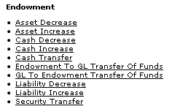

On the **Main Menu** tab, the **Transactions** submenu provides options that allow users to view and maintain endowment transactions for assets, liabilities, cash, security transfers, and transfers to and from the General Ledger.

KEM e-docs available from the Main Menu, Transactions submenu

|  |  |
| --- | --- |
| Document Type | Description |
| Asset Decrease (EAD) | Used to reduce the holdings of a KEMID, either through the cash sale of an asset or by removing it directly from the KEMID holding record. |
| Asset Increase (EAI) | Allows you to add to the holdings of a KEMID, either through the cash purchase of an asset or by depositing it directly into the KEMID holding record. |
| Cash Decrease (ECDD) | Allows you to record a reduction to the cash balance of a KEMID. |
| Cash Increase (ECI) | Used to record an increase to the cash balance of a KEMID. |
| Cash Transfer (ECT) | Allows you to you tomove cash from one location to another within a KEMID (for example, from income to principal) or between KEMIDs. |
| Endowment to GL Transfer of Funds (EGLT) | Allows you to move cash funds from one or more KEMIDs to one or more General Ledger accounts. |
| GL to Endowment Transfer of Funds (GLET) | Allows you to transfer cash funds from one or more General Ledger accounts to one or more KEMIDs. |
| Liability Decrease (ELD) | Allows you to reduce a liability for a specified KEMID. |
| Liability Increase (ELI) | Allows you to increase a liability for a specified KEMID. |
| Security Transfer (EST) | Allows you to decrease the holdings of one KEMID and increase those of another KEMID without affecting the cash balance of either. |

### Standard Activities, Rules, and Routing

All standard KEM e-docs have a Transaction Lines tab and an Accounting Lines tab that are unique in some ways to Endowment e-docs. The subsections below provide instructions for working in these Endowment-specific tabs and provide information about standard business rules, rounding rules, and routing for approval.

#### Working in the Transaction Lines Tab

All endowment transactional e-docs contain a **Transaction Lines** tab. Working in this tab, you may import multiple lines of transaction data from a spreadsheet and/or add single lines manually. After adding a line, you have the option of deleting it, refreshing the tax lot information associated with it (this option is available for securities transactions only), or performing a balance inquiry on the KEMID associated with the line. All of these activities are accomplished by clicking buttons on the tab.

To add multiple transaction lines from a file, follow these steps:

1. Retrieve the appropriate data import template from “Links to Default Data Import Templates” in the *KFS Overview and Introduction to the User Interface*.
2. Create a .csv file and import it via the button according to the instructions in “Data Import Templates” in the *KFS Overview and Introduction to the User Interface*.

To add one or more transaction lines manually, follow these steps:

1. Enter data into the fields of the empty transaction line as needed.
2. Click the  button in the **Actions** column. The system adds the line and displays a new line above it so you can enter additional transaction lines if desired.
3. To enter additional lines, repeat the steps above.

After you have added a transaction line, you have these options:

* To update the tax lot information after changing data on a line, click the  button in the **Actions** column. (For securities transactions only.)
* To delete a line, click the  button in the **Actions** column.
* To select and view balance inquiry reports for the specified KEMID, click the  button in the **Actions** column.

#### Working in the Accounting Lines Tab

A few endowment transactional e-docs contain an **Accounting Lines** tab. Working in this tab, you may import multiple lines of account data from a spreadsheet and/or add single lines manually. After adding a line, you have the option of deleting it or performing a balance inquiry on the account associated with the line. All of these activities are accomplished by clicking buttons on the tab.

To multiple transaction lines from a spreadsheet, follow these steps

1. Retrieve the appropriate data import template from “Links to Default Data Import Templates” in the *KFS Overview and Introduction to the User Interface*.
2. Create a .csv file and import it via the button according to the instructions in “Creating a .csv File” in the *KFS Overview and Introduction to the User Interface*.

To add one or more transaction lines manually, follow these steps:

1. Enter data into the fields of the empty transaction line as needed.
2. Click the  button in the **Actions** column. The system adds the line and displays a new line above it so you can enter additional transaction lines if desired.
3. To enter additional lines, repeat the steps above.

After you have added a transaction line, you have these options:

* To delete a line, click the  button in the **Actions** column.
* To perform a balance inquiry on the specified account, click the  button in the **Actions** column.

#### Standard Rounding Rules

Except where noted, calculations for all endowment transactions adhere to the following rounding rules.

* No calculated value is ever truncated based on the number of decimals in a field.
* Every calculation made by the system rounds to the proper decimal value for the field.
* For each field that has a decimal value, if the calculation results carry past the expected decimals and if the next decimal value is greater than or equal to 5, the last decimal value is incremented by 1.
* If the calculation results carry past the expected decimals and if the next decimal value is less than 5, the last decimal value is not incremented.
* After rounding is complete, the value that is stored in the field will be the actual value to the number of decimals for the field, not the calculated value. To ensure balancing consistency, it is critical that the stored values be the actual values.

#### Standard Business Rules

 This section covers business rules that apply to all standard KEM transaction e-docs. Each e-doc also adheres to e-doc-specific rules. For information on rules for specific e-docs, refer to the subsection on each e-doc.

All Endowment transactions adhere to the following business rules.

* When you initiate an endowment transaction e-doc, the system sets the **Transaction Source** value to **Manual Entry**. This value is display-only and cannot be changed.
* The security ID used for each transaction must be valid and active in the system.
* You may enter multiple transaction lines for any Endowment Transaction e-doc.
* The KEMID in each transaction line must be defined in the system. This KEMID must not be closed (that is, the record's **Closed Indicator** value must be 'No') and its **Transaction Restriction Code** value must not be **NTRAN** (which indicates that no transactions are allowed for the KEMID).
* For a principal transaction, the KEMID must not have a principal restriction of **NA** (which implies that the KEMID cannot have any activity in principal).
* All values entered must be positive values. When a transaction e-doc is reversed, the values automatically become negative for the new transaction e-doc.
* All transaction lines must have values other than zero in the **Transaction Amount** field.
* The Etran code in each transaction line must be an income or expense code (that it, the associated Etran Code record must have an **Etran Type** **Code** of 'I' or 'E').
* The Etran code in each transaction line must reference an appropriately identified General Ledger Object Code record (that is, one that matches the chart for the KEMID's associated General Ledger account).
* If the transaction is for income (that is, the transaction line's **Income or Principal** value is 'Income'), the chart specified must match the income chart specified in the **Accounting Lines** tab.
* If the transaction is for principal (that is, the transaction line's **Income or Principal** value is 'Principal'), the chart specified must match the principal chart specified in the **Accounting Lines** tab.
* The security transaction code and the transaction line Etran code must reference an appropriately identified General Ledger Object Code record (that is, one that matches the chart for the KEMID's associated General Ledger account).
* If the KEMID has a permanent principal restriction and the Endowment Transaction (Etran) Code record has the **Corpus Indicator** value of **Yes**, then all principal transaction lines affect the corpus value for the KEMID.
* For each line added, in the space below the last transaction line, the system displays separate totals for income and principal amounts.
* In the **Total Amount** field of the **Document Overview** tab, the system displays the combined total income and principal amounts of all transaction lines. The system updates this total as each line is added.
* The system verifies each transaction line when you add it and when you submit the document.
* After a transaction line has been added, it may be edited. When a line is edited, the system does not revalidate data until the document is submitted. After you add a transaction line, you may delete it.
* In order to successfully submit an e-doc, you must enter at least one transaction line in each transaction line section (**To** and/or **From**) that is required for the e-doc.
* An endowment transaction does not automatically create a pending General Ledger entry. GL entries are generated according to your institutional specifications as a batch load at the end of the endowment batch processing cycle.

#### Standard Routing

Standard routing for all endowment transactions is shown in the diagram below.



### Asset Decrease

 **>  >  >  > **

The Asset Decrease e-doc allows you to reduce the holdings of a KEMID, either through the cash sale of an asset or by removing it directly from the KEMID holding record. The same asset can be processed to multiple KEMID holding records by entering multiple transaction lines in the Asset Decrease e-doc. Only one asset may be entered on an Asset Decrease e-doc. Because assets can maintain multiple tax lots, special rules apply to the handling of the unique tax lots.

Asset decrease transactions are internal to the KEM module and may or may not involve the exchange of actual cash from a third party outside of your institution. For example, the sale of shares of pooled funds by the KEMID through the automated cash investment process does not involve a cash exchange, whereas the redemption (sale) of a gifted asset involves the receipt of cash from a third party. In both cases, the KEMID cash balance is increased, the holding of the asset is decreased, and there is a calculation of gain or loss on the transaction.

#### Document Layout

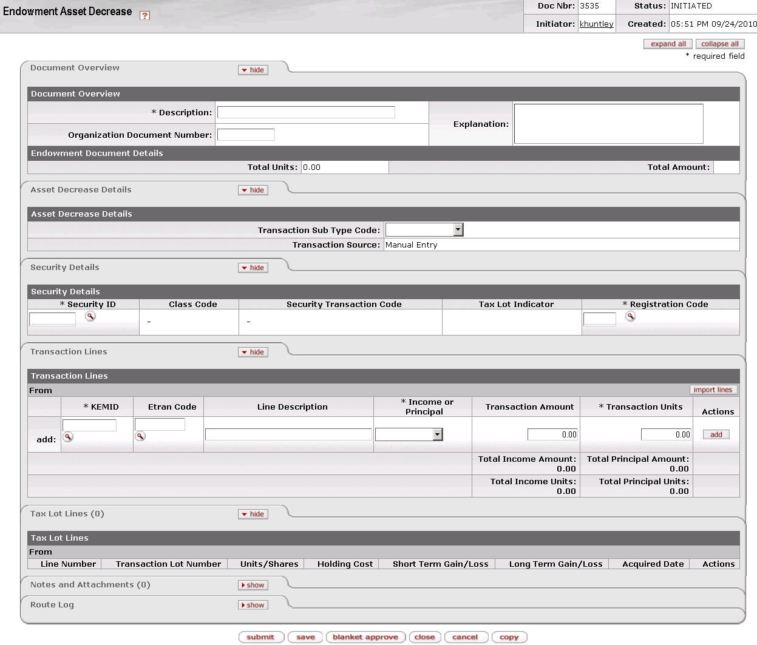

The Asset Decrease document contains four unique tabs—**Asset Decrease Details, Security Details, Transaction Lines, and Tax Lot Lines**—in addition to the standard financial transaction tabs.

 For more information about the standard tabs, see Standard Tabs|document=WordDocuments\KFS 5\_2 Overview.docx;topic=Standard Tabs“Standard Tabs” in the KFS Overview and Introduction to the User Interface.

##### Asset Decrease Details Tab

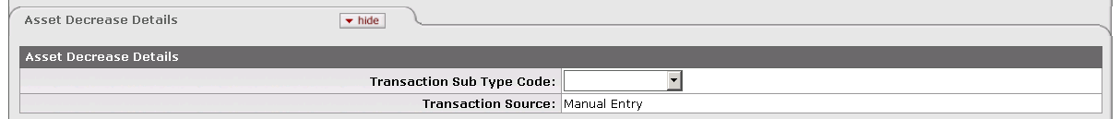

This tab indicates whether this is a cash or non-cash transaction and specifies whether it was created by the system or by a user.

Asset Decrease Details tab definition

|  |  |
| --- | --- |
| Title | Description |
| Transaction Sub Type Code | Required when you initiate a document. Indicates whether this transaction is for cash or non-cash. Select the appropriate entry from the list. |
| Transaction Source | Display only. Indicates whether this transaction was generated automatically or entered by a user. When you initiate a document, the system sets the value to 'Manual Entry.' |

##### Security Details Tab

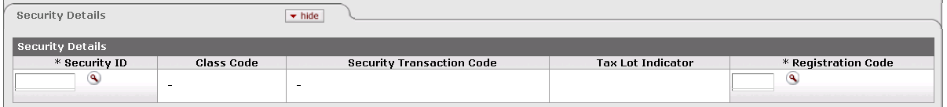

This tab identifies the security to which the transaction applies and provides pertinent information about it.

Security Details tab definition

|  |  |
| --- | --- |
| Title | Description |
| Security ID | Required. Indicates the security affected by this transaction. The security record referenced must be valid and active in the system and must not have a liability class code. Only one security record may be specified per e-doc. The KEMID(s) you specify in the **Transaction Lines** tab must own sufficient shares of this security to complete the transaction.  Enter the ID or use the lookup _searchicon.gif to find it. The system then displays the description of the security you specified along with the associated class code and description, security transaction code and description, and tax lot indicator. |
| Class Code | Display only. The class (group) to which this security belongs. |
| Security Transaction Code | Display only. The security transaction code assigned to this security. The system obtains this value from the class code for the security. |
| Tax Lot Indicator | Display only. Indicates whether affected security units (holdings) are maintained in separate accounting (tax) lots. This indicator determines how gains and losses on the sale of the security are calculated.  'Yes' = Security units are maintained in separate tax lots.  'No' = Security units are consolidated into one holding. |
| Registration Code | Required. Indicates where (for example, at a bank, at a broker, or somewhere in the institution) a security is held in custody for the institution. The registration code specified must be valid and active in the system.  Enter the appropriate code or use the lookup _searchicon.gif to find it. The system then displays the description of the registration code you specified. |

##### Transaction Lines Tab

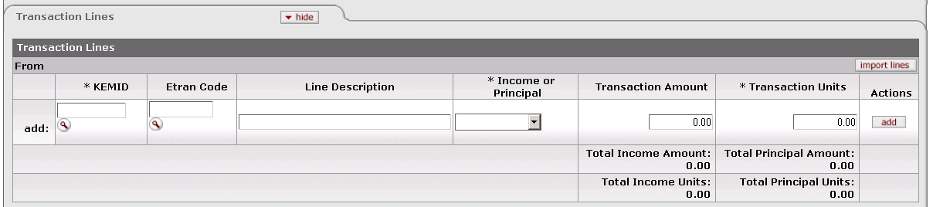

This tab contains one or more lines that specify the KEMID(s), including all relevant financial details for the transaction as it applies to each KEMID specified.

Transaction Lines tab definition

|  |  |
| --- | --- |
| Title | Description |
| KEMID | Required. The KEMID to which this cash decrease applies. Enter the KEMID or use the lookup _searchicon.gif to find it. The KEMID you specify must be valid, must not be closed, and must own sufficient shares of the security to complete the transaction. The system then displays the description of the KEMID you specified. |
| Etran Code | Required if the **Transaction Sub Type** is 'Non-Cash.' Display only if the **Transaction Sub Type** is 'Cash.' Identifies the type of processing required for this transaction.  If the **Transaction Sub Type** is 'Non-Cash,' enter the ID or use the lookup _searchicon.gif to find it. The Etran code entered must be valid for the KEMID specified on the line. The system automatically displays the description of the Etran code you specified.  If the **Transaction Sub Type** is 'Cash,' the system displays the security transaction code in this field. |
| Line Description | Describes this transaction. Enter text as desired. |
| Income or Principal | Required. Indicates whether this transaction pertains to income or principal. Enter the appropriate value from the list. |
| Transaction Amount | Required if the **Transaction Sub Type** is 'Cash' in order to calculate the gain or loss on the transaction. Display only if the **Transaction Sub Type** is 'Non-Cash.' Indicates the dollar amount of this transaction.  If the **Transaction Sub Type** is 'Cash,' enter the amount of cash received.  If the **Transaction Sub Type** is 'Non-Cash,' the system calculates and displays the amount of the transaction based on the number of units you specify. |
| Transaction Units | Required. Indicates the number of security units affected by the transaction. The number of transaction units must be greater than zero.  If the **Transaction Sub Type** is 'Non-Cash,' enter the number of units by which the asset is to be reduced. |
| Actions | Click the button to perform an action on this line. When you are adding a new line, only the **add** button is displayed. After you have added a line, the **refresh**, **bal inquiry**, and **delete** buttons are displayed. |
| Total Income Amount | Display only. Indicates the amount of income in all transaction lines. |
| Total Principal Amount | Display only. Indicates the total amount of principal in all transaction lines. |
| Total Income Units | Display only. Indicates the total number of income units (shares) in all transaction lines. |
| Total Principal Units | Display only. Indicates the total number of principal units (shares) in all transaction lines. |

 Buttons on this tab allow you to add, import data, refresh tax lot information, delete lines and perform balance inquiries on the KEMID(s) specified. For information and instructions, see Working in the Transaction Lines Tab|document=WordDocuments\KFS 5\_2 KEM.docx;topic=Working in the Transaction Lines Tab.

 For information about the layout of the data import template for this e-doc, see KEM\_EAI\_EAD\_ELI\_ELD\_Import.xls|document=WordDocuments\KFS 5\_2 Overview.docx;topic=KEM\_EAI\_EAD\_ELI\_ELD\_Import.xls “KEM\_EAI\_EAD\_ELI\_ELD\_Import.xls” in the *KFS Overview and Introduction to the User Interface*.

##### Tax Lot Lines Tab



This tab displays information about the tax lot(s) affected by each transaction line entered. All entries in this tab are system-generated after you add a transaction line. The total number of tax lot lines is displayed in parentheses to the right of the tab header. The tax lot entries are based on the tax lot indicator associated with the security you specified and on whether or not the transaction involves cash.

If you change the transaction line units or amount or delete the transaction line, the system corrects the entries in the **Tax Lots Lines** tab automatically.

The tab header indicates the number of tax lines in the e-doc.

 All calculations for tax lot lines are rounded according to the standard KFS endowment rules for rounding. For more information on these rules, see Standard Rounding Rules|document=WordDocuments\KFS 5\_2 KEM.docx;topic=Standard Rounding Rules.

Tax Lot Lines tab definition

|  |  |
| --- | --- |
| Title | Description |
| Line Number | Display only. Indicates the transaction line with which this tax lot is associated. |
| Transaction Lot Number | Display only. Identifies the tax lot affected by the transaction. The tax lot referenced must have sufficient units and value to complete the transaction. |
| Units/Shares | Display only. Indicates the number of units or shares in the tax lot. The system always displays the value as a negative number. |
| Holding Cost | Display only. Indicates the original cost of the units being reduced. When the system processes the tax lot lines, it multiplies the total of the lot holding cost in the tax lot lines by -1. The system always displays the value as a negative number. |
| Short Term Gain/Loss | Display only. Indicates the short term gain or loss realized by this transaction. The system displays a gain as a positive number and a loss as a negative number. |
| Long Term Gain/Loss | Display only. Indicates the long term gain or loss realized by this transaction. The system displays a gain as a positive number and a loss as a negative number. |
| Acquired Date | Display only. Indicates the date the security was acquired. |
| Actions | Click a button to perform an action on this tax lot. The only action allowed is delete, which removes the tax lot from the calculations for the transaction. When you delete a lot from the transaction, the system recalculates and updates the remaining lots in the tab. |

#### Process Overview

##### Business Rules

 For information about business rules that apply to all endowment transaction e-docs, see Standard Business Rules|document=WordDocuments\KFS 5\_2 KEM.docx;topic=Standard Business Rules.

In addition to the standard business rules for endowment transactions, the following business rules apply to asset decrease transactions:

* When you initiate a document, you must select a **Transaction Sub Type** value ('cash' or 'non-cash').
* You must specify or enter a valid and active security in the **Security Details** tab. Only one security record may be used per e-doc.
* The security specified must *not* have a **Class Type** **Code** of 'L' (Liabilities).
* You must enter a valid and active **Registration Code** value.
* On each transaction line, you must specify a KEMID that owns sufficient shares to complete the transaction.
* You must enter a number greater than zero for the units in the transaction line.
* You must specify a tax lot that has sufficient units and value to complete the transaction. An asset cannot have a value less than zero.
* For securities that involve tax lots, the system initially creates transaction lines based on the involvement of all lots held. If you restrict the activity to selected lots (by deleting some lots in the **Tax Lots Lines** tab from the calculation), the system recalculates and updates the remaining lots in the tab.
* This type of e-doc may be reversed.
* Although you enter all values as positive numbers in the Asset Decrease e-doc, the system creates transactions with negative values for Units and Carry Value.
* When you add a transaction line, the system checks to see whether the Etran code affects corpus. If it does, the system updates the KEMID's corpus value accordingly.
* When you add a transaction line, the system generates a Tax Lot Line record to show how the holding tax lot record(s) are affected.
* When you reverse a transaction (via the **error correction** button that displays at the bottom of the screen after a transaction has been posted), the system generates a new e-doc using all the information from the original e-doc with all signs reversed.

If the **Transaction Sub Type** is 'Cash:'

* You cannot enter an **Etran Code** value in the transaction line.
* You must enter the amount of cash received in the **Transaction Amount** field of the transaction line in order to calculate the gain or loss on the transaction.
* All system calculations for each holding tax lot are rounded according to the rules for rounding.
* The system's calculations for each transaction are based on the method your institution has specified for cash transactions (average balance, first-in-first-out [FIFO], or last-in-first-out [LIFO]).
* For each lot included in the **Tax Lot Lines** tab, the system adds a record to the Holding Lot table. This stored data includes:
* The document number from the **Doc Nbr** field in the e-doc's header.
* The line number from the transaction line on the e-doc.
* The holding lot number for both the KEMID on the corresponding transaction line and the security being reduced.
* The number of units from the security tax lots calculation times negative 1 (-1). As a result of this calculation, this value is always a negative number.
* The holding cost from the security tax lots calculation times negative 1 (-1). As a result of this calculation, this value is always stored as a negative number.
* Short and/or long term gain or loss from the security tax lots calculation.
* Acquired date. The system uses the acquired date to determine whether gains and losses are short term or long term. If the transaction date is 12 months or less from the acquired date, the gain or loss is short term. If the action date is more than 12 months from the acquired date, the gain or loss is long term.

If the **Transaction Sub Type** is 'Non-Cash:'

* You must specify an Etran code in the transaction line. The Etran code entered must be valid for the KEMID specified.
* You must specify the units of the asset to be reduced.
* You cannot enter a transaction amount in the transaction line. The system calculates the transaction amount and enters it as a positive amount. No gain or loss is recorded in the tax lot lines.
* All calculations for each holding tax lot are rounded according to the rules for rounding.
* The system's calculations for each transaction are based on the method your institution has specified for non-cash transactions (average balance, first-in-first-out [FIFO], or last-in-first-out [LIFO]).
* The system's tax lot lines calculations determine the number of units and the carry value of those units. It makes no calculations beyond this point because no gain or loss is involved in the transaction.
* For each lot included in the **Tax Lot Lines** tab, the system adds a record to the Holding Lot table. The data includes:
* The document number from the **Doc Nbr** field in the e-doc's header.
* The line number from the transaction line on the e-doc.
* The holding lot number for both the KEMID on the corresponding transaction line and the security being reduced.
* The number of units from the security tax lots calculation times negative 1 (-1). As a result of this calculation, this value is always a negative number.
* The holding cost from the security tax lots calculation times negative 1 (-1). As a result of this calculation, this value is always stored as a negative number.
* Acquired date.

##### Routing

 For information about standard routing for all endowment transaction e-docs, see Standard Routing|document=WordDocuments\KFS 5\_2 KEM.docx;topic=Standard Routing.

 Because special rules apply to true endowments, your institution may require special authorization for transactions that affect the principal of a true endowment.

#### Example

The University received 100 shares of Widget Inc. stock from a donor to support a scholarship endowment. These shares of stock were transferred into the University's brokerage account, and a corresponding deposit was made to the KEMID. The following week, the brokerage sells the 100 shares for $10,000. The value of the shares remained constant from the time they were donated until they were sold. To record this activity into the KEMID, an Asset Decrease cash transaction is initiated for 100 shares of Widget Inc. The result of this transaction is that the KEMID holdings are reduced by 100 shares of Widget Inc. and the account's cash balance is increased by $10,000.

### Asset Increase

 **>  >  >  > **

The Asset Increase e-doc allows you to add to the holdings of a KEMID, either through the cash purchase of an asset or by depositing it directly into the KEMID holding record. You may record multiple asset increase transactions for a given asset on each e-doc by entering multiple transaction lines. Only one asset may be entered on each e-doc.

Asset increase transactions are internal to the KEM system and do not result in the exchange of actual cash to a third party outside of your institution. For example, the purchase of shares of pooled funds by the KEMID through the automated cash investment process reduces the KEMID cash balance, increases the holding of pooled funds, and does not change the overall value of the KEMID.

#### Document Layout

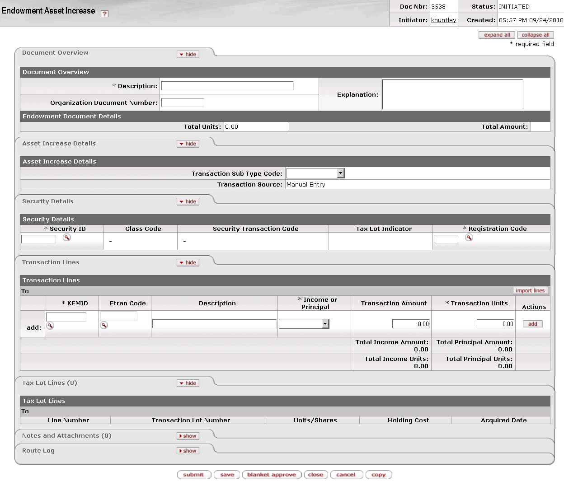

The Asset Increase document contains four unique tabs—**Asset Increase Details, Security Details, Transaction Lines, and Tax Lot Lines**—in addition to the standard financial transaction tabs.

 For more information about the standard tabs, see Standard Tabs|document=WordDocuments\KFS 5\_2 Overview.docx;topic=Standard Tabs“Standard Tabs” in the KFS Overview and Introduction to the User Interface.

##### Asset Increase Details Tab

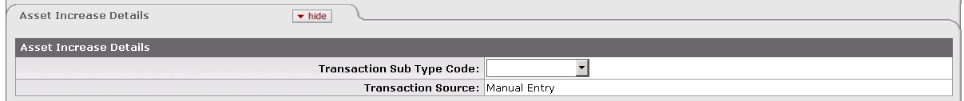

This tab indicates whether this is a cash or non-cash transaction and specifies whether it was created by the system or by a user.

Asset Increase Details tab definition

|  |  |
| --- | --- |
| Title | Description |
| Transaction Sub Type Code | Required when you initiate a document. Indicates whether this transaction is for cash or non-cash. Select the appropriate entry from the list. |
| Transaction Source | Display only. Indicates whether this transaction was generated automatically or entered by a user. When you initiate this e-doc, the system sets the value to 'Manual Entry.' |

##### Security Details Tab

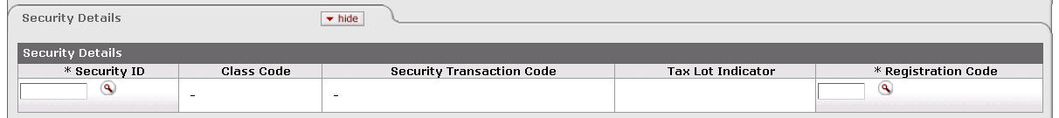

This tab identifies the security to which the transaction applies and provides pertinent information about it.

Security Details tab definition

|  |  |
| --- | --- |
| Title | Description |
| Security ID | Required. Indicates the security affected by this transaction. The security record referenced must be valid and active in the system and must not have a liability class code. Only one security record may be used per e-doc.  Enter the ID or use the lookup _searchicon.gif to find it. The system then displays the description of the security you specified along with the associated class code and description, security transaction code and description, and tax lot indicator. |
| Class Code | Display only. Describes the class (group) to which this security belongs. |
| Security Transaction Code | Display only. Indicates the security transaction code assigned to this security. The system obtains this value from the class code for the security. The code must be valid for use with the KEMID (that is, the chart for this security transaction code must match the chart for the KEMID Etran code). |
| Tax Lot Indicator | Display only. Indicates whether affected security units (holdings) are maintained in separate accounting (tax) lots. This indicator determines the way gains and losses are calculated in the eventual sale of this security.  'Yes' = Security units are maintained in separate tax lots.  'No' = Security units are consolidated into one holding. |
| Registration Code | Required. Indicates where (for example, at a bank, at a broker, or somewhere in the institution) a security is held in custody for the institution. The registration code specified must be valid and active in the system.  Enter the appropriate code or use the lookup _searchicon.gif to find it. The system then displays the description of the registration code you specified. |

##### Transaction Lines Tab

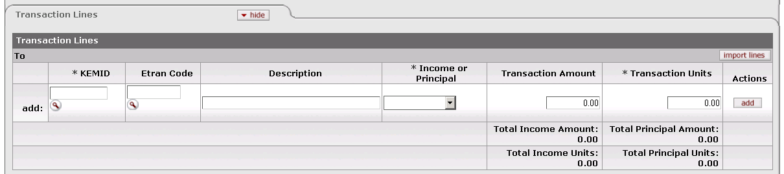

This tab contains one or more lines that specify the KEMID(s) affected, including all relevant financial details for the transaction as it applies to each KEMID specified.

Transaction Lines tab definition

|  |  |
| --- | --- |
| Title | Description |
| KEMID | Required. Identifies the KEMID to which this increase in assets applies. Enter the KEMID or use the lookup _searchicon.gif to find it. The system then displays the description of the KEMID you specified. |
| Etran Code | Required if the **Transaction Sub Type** is 'Non-Cash.' Display only if the **Transaction Sub Type** is 'Cash.' Identifies the type of processing required for this transaction.  If the **Transaction Sub Type** is 'Non-Cash,' enter the ID or use the lookup _searchicon.gif to find it. The Etran code entered must be valid for the KEMID. The system then displays the description of the Etran code you specified.  If the **Transaction Sub Type** is 'Cash,' no entry is permitted. |
| Line Description | Describes this transaction. Enter text as desired. |
| Income or Principal | Required. Indicates whether this transaction pertains to income or principal. Enter the appropriate value from the list. |
| Transaction Amount | Required. Indicates the dollar amount of this transaction. |
| Transaction Units | Required. Indicates the number of security units affected by the transaction. The number of transaction units must be greater than zero. |
| Actions | Click the button to perform an action on this line. When you are adding a new line, only the **add** button is displayed. After you have added a line, the **refresh**, **bal inquiry**, and **delete** buttons are displayed. |
| Total Income Amount | Display only. Indicates the amount of income in all transaction lines. |
| Total Principal Amount | Display only. Indicates the total amount of principal in all transaction lines. |
| Total Income Units | Display only. Indicates the total number of income units in all transaction lines. |
| Total Principal Units | Display only. Indicates the total number of principal units in all transaction lines. |

 Buttons on this tab allow you to add, import data, refresh tax lot information, delete lines and perform balance inquiries on the KEMID(s) specified. For information and instructions, see Working in the Transaction Lines Tab|document=WordDocuments\KFS 5\_2 KEM.docx;topic=Working in the Transaction Lines Tab.

 For information about the layout of the data import template for this e-doc, see KEM\_EAI\_EAD\_ELI\_ELD\_Import.xls|document=WordDocuments\KFS 5\_2 Overview.docx;topic=KEM\_EAI\_EAD\_ELI\_ELD\_Import.xls “KEM\_EAI\_EAD\_ELI\_ELD\_Import.xls” in the *KFS Overview and Introduction to the User Interface*.

##### Tax Lot Lines Tab



This tab displays information about the tax lot(s) affected by each transaction line entered. All entries in this tab are system-generated after you add a transaction line. The total number of tax lot lines is displayed in parentheses to the right of the tab header. The total number of tax lot lines is displayed in parentheses to the right of the tab header. The tax lot entries are based on the tax lot indicator associated with the security you specified and whether or not the transaction involves cash.

If you change the transaction line units or amount or delete the transaction line, the system corrects the entries in the **Tax Lots Lines** tab automatically.

The tab header indicates the number of tax lines in the e-doc.

 All calculations for tax lot lines are rounded according to the standard KFS endowment rules for rounding. For more information on these rules, see Standard Rounding Rules|document=WordDocuments\KFS 5\_2 KEM.docx;topic=Standard Rounding Rules.

Tax Lot Lines tab definition

|  |  |
| --- | --- |
| Title | Description |
| Line Number | Display only. Indicates the transaction line with which this tax lot is associated. |
| Transaction Lot Number | Display only. Identifies the tax lot affected by the transaction line.  If the tax lot indicator for the security is 'No,' the holding lot number is set at 1. If the tax lot indicator for the security is 'Yes,' the holding lot number is set at the next sequential number for the KEMID and security. |
| Units/Shares | Display only. Indicates the number of units or shares in the tax lot. Reflects the number of units in the associated transaction line. |
| Holding Cost | Display only. Indicates the original cost of the units being increased. Reflects the holding cost in the associated transaction line. |
| Acquired Date | Display only. Indicates the date the security was acquired. |

#### Process Overview

##### Business Rules

 For information about business rules that apply to all endowment transaction e-docs, see Standard Business Rules|document=WordDocuments\KFS 5\_2 KEM.docx;topic=Standard Business Rules.

In addition to the standard business rules for endowment transactions, the following business rules apply to asset increase transactions:

* When you initiate this e-doc, you must select a transaction subtype ('Cash' or 'Non-Cash'). Each subtype has selected business rules attached (see below).
* You must select or enter a valid and active security in the **Security Details** tab. The security entered must not have a **Class Code** value of 'L' (Liability).
* You may specify only one security record in each transaction e-doc.
* After you specify a security, the system displays the associated security name, class code, security transaction code and description, and tax lot indicator.
* You must enter a valid, active registration code.
* If the transaction sub type is cash, you cannot enter an Etran code in the **Transaction Lines** tab.
* If the transaction sub type is non-cash, you must enter an Etran code in the **Transaction Lines** tab. The Etran code entered must be valid for the KEMID specified on the line.
* You must enter a number greater than zero in the **Transaction Units** field in the **Transaction Lines** tab.
* When you add a transaction line, the system checks to see whether the Etran code affects corpus. If it does, the system updates the KEMID's corpus value accordingly.
* If the security ID has a class code type of 'A' (Alternative Investments), the total holding cost for the security plus the transaction amount cannot exceed the commitment amount for the security. If it does, the transaction is not allowed.
* When you reverse a transaction (via the **error correction** button that displays at the bottom of the screen after a transaction has been posted), the system verifies that the tax lot referenced in each tax lot line has sufficient units and value to complete the transaction. If either is insufficient, the transaction is not allowed.
* When you reverse a transaction, the system generates a new e-doc using all the information from the original e-doc with all signs reversed for units and amounts in both the transaction lines and the tax lot lines.

##### Routing

 For information about standard routing for all endowment transaction e-docs, see Standard Routing|document=WordDocuments\KFS 5\_2 KEM.docx;topic=Standard Routing.

 Because special rules apply to true endowments, your institution may require special authorization for transactions that affect the principal of a true endowment.

#### Example

An expendable KEMID has a cash balance of $1,000. Per University policy these funds are to be invested in a short term money market account. The money market account is represented by security 99MMKT01 and priced at $1 per share. To accomplish this investment, an Asset Increase e-doc, sub type Cash, is initiated. The e-doc adds 1,000 units of the money market security 99MMKT01 to the KEMID's holdings and reduces the KEMID's cash balance by $1,000.

### Cash Decrease

 **>  >  >  > **

The Cash Decrease e-doc allows you to record a reduction to the cash balance of a KEMID. The reduction may be the result of an internal expense such as a fee, the result of the return of a cash gift or other income, or the purchase of a security. A reduction may also represent interest expense for purchased bonds or taxes withheld from the dividends on a foreign holding. The decrease or reduction of cash may take place in either income (spending) or principal cash, but not both on the same transaction line.

This e-doc contains a section in which you may specify a security ID if the transaction references a holding of the KEMID. Input of a security ID is not required, and it has no impact on the holding tax lot table records, but you may find it helpful to identify the security that generated the expense (e.g., foreign taxes withheld from the dividend or interest payment).

#### Document Layout

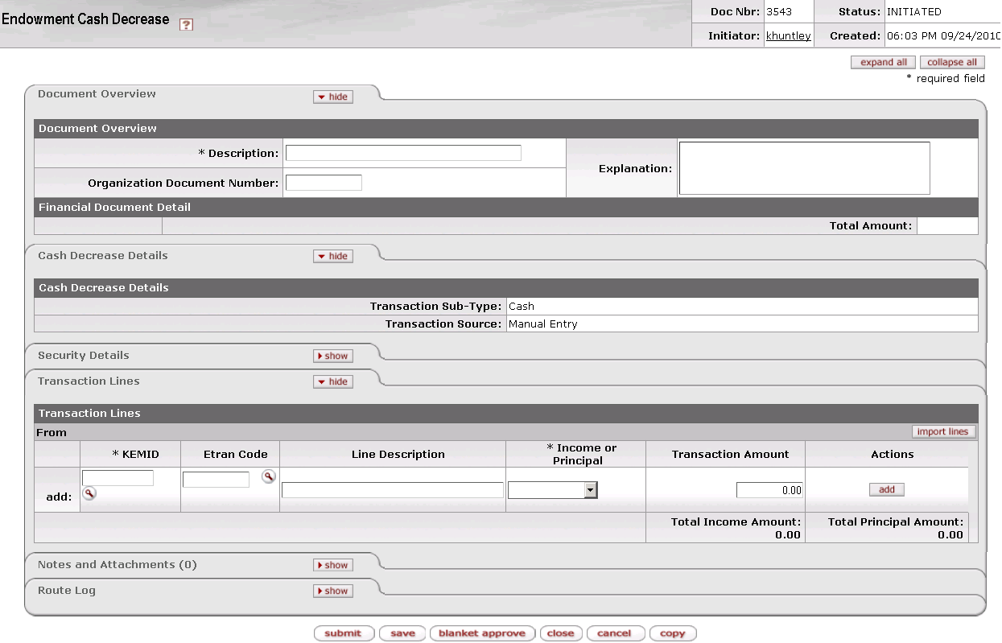

The Cash Decrease document contains three unique tabs—**Cash Decrease Details, Security Details, and Transaction Lines**—in addition to the standard financial transaction tabs.

 For more information about the standard tabs, see Standard Tabs|document=WordDocuments\KFS 5\_2 Overview.docx;topic=Standard Tabs“Standard Tabs” in the KFS Overview and Introduction to the User Interface.

##### Cash Decrease Details Tab



This tab indicates that this is a cash transaction and specifies whether it was created by the system or by a user.

Cash Decrease Details tab definition

|  |  |
| --- | --- |
| Title | Description |
| Transaction Sub-Type | Display only. Indicates whether this transaction is for cash or non-cash. When you initiate this e-doc, the system sets the **value** to 'Cash.' |
| Transaction Source | Display only. Indicates whether this transaction was generated automatically or entered by a user. When you initiate this e-doc, the system sets the value to 'Manual Entry.' |

##### Security Details Tab

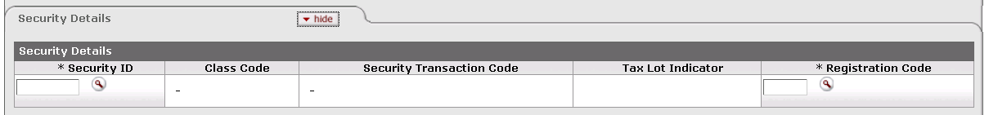

This tab identifies the security to which the transaction applies and provides pertinent information about it.

Security Details tab definition

|  |  |
| --- | --- |
| Title | Description |
| Security ID | Required in order to associate a security with this e-doc. Otherwise, not used.  Indicates the security affected by these transactions. Any security information you enter is for reference only; it is not used in system processing. The security record referenced must be valid and active. Only one security record may be used per e-doc.  Enter the ID or use the lookup _searchicon.gif to find it. The system then displays the description of the security you specified along with the associated class code and description, security transaction code and description, and tax lot indicator. |
| Class Code | Display only. Describes the class (group) to which this security belongs. |
| Security Transaction Code | Display only. Indicates the security transaction code assigned to this security. The system obtains this value from the class code for the security. |
| Tax Lot Indicator | Display only. Indicates whether the security entered is eligible for tax lot tracking. Not relevant for cash decrease transactions. |

##### Transaction Lines Tab

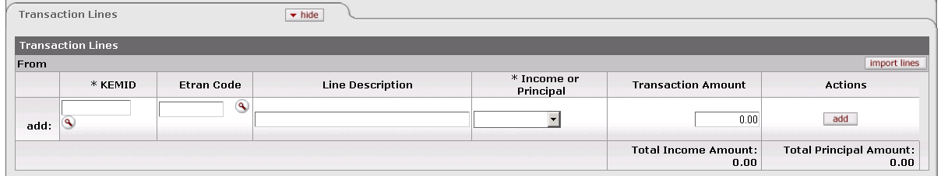

This tab contains one or more lines that specify the KEMID(s) affected, including all relevant financial details for the transaction as it applies to each KEMID specified.

Transaction Lines tab definition

|  |  |
| --- | --- |
| Title | Description |
| KEMID | Required. The KEMID to which this transaction applies. Enter the KEMID to which this cash decrease applies or use the lookup _searchicon.gif to find it. The KEMID you specify must be valid and must not be closed. The system then displays the description of the KEMID you specified.  exclaim.gif If the KEMID specified has a permanent restriction code and if the transaction line is for principal, the system displays a warning message in the transaction line indicating that the transaction will reduce the value of the endowment when the line is added. |
| Etran Code | Identifies the type of processing required for this transaction. Enter the ID or use the lookup _searchicon.gif to find it. The Etran code entered must be valid for the KEMID specified on the line. The system then displays the description of the code you specified. |
| Line Description | Describes this transaction. Enter text as desired. |
| Income or Principal | Required. Indicates whether this transaction pertains to income or principal. Enter the appropriate value from the list. |
| Transaction Amount | Required. Indicates the dollar amount of this transaction. |
| Actions | Click the button to perform an action on this line. When you are adding a new line, only the **add** button is displayed. After you have added a line, the **refresh**, **bal inquiry**, and **delete** buttons are displayed. |
| Total Income Amount | Display only. Indicates the amount of income in all transaction lines. |
| Total Principal Amount | Display only. Indicates the total amount of principal in all transaction lines. |

 Buttons on this tab allow you to add, import data, refresh tax lot information, delete lines and perform balance inquiries on the KEMID(s) specified. For information and instructions, see Working in the Transaction Lines Tab|document=WordDocuments\KFS 5\_2 KEM.docx;topic=Working in the Transaction Lines Tab.

 For information about the layout of the data import template for this e-doc, see KEM\_ECI\_ECDD\_ECT\_Import.xls|document=WordDocuments\KFS 5\_2 Overview.docx;topic=KEM\_ECI\_ECDD\_ECT\_Import.xls“KEM\_ECI\_ECDD\_ECT\_Import.xls” in the *KFS Overview and Introduction to the User lnterface*.

#### Process Overview

##### Business Rules

 For information about business rules that apply to all endowment transaction e-docs, see Standard Business Rules|document=WordDocuments\KFS 5\_2 KEM.docx;topic=Standard Business Rules.

In addition to the standard business rules for endowment transactions, the following business rules apply to cash decrease transactions:

* When you initiate this e-doc, the system sets the **Transaction Sub Type** to 'C' (Cash). You cannot change this value.
* When you access the document, the **Security Details** tab is closed because input of a security ID is optional.
* If you specify a security, only one security may be entered and it will apply to all transaction lines. Any security information you enter is for reference only; it does not generate an entry to the Holding Tax Lot table.
* The Etran code entered must be valid for the KEMID specified on the transaction line.
* If a transaction line's Etran code affects corpus, the system updates the KEMID's corpus value accordingly.
* If the KEMID specified has a permanent restriction code and if the transaction line is for principal, the system displays a warning message in the transaction line indicating that the transaction will reduce the value of the endowment when the transaction line is added.
* When you add a transaction line, the system checks to see whether the KEMID has sufficient funds for the transaction. If it does not, the system generates a warning message for the transaction line indicating that there are insufficient funds and the transaction will create a negative balance for the KEMID. Note that:
* For an income transaction, the system verifies against available total cash.
* For a principal transaction, the system verifies against available principal cash.

##### Routing

 For information about standard routing for all endowment transaction e-docs, see Standard Routing|document=WordDocuments\KFS 5\_2 KEM.docx;topic=Standard Routing.

#### Example

A permanently endowed KEMID owns 100 shares of a pooled long term fund represented by security ID 99PLTF123. On December 1 a fee is assessed of $1.00 per share held. To record this fee into the endowed KEMID, a Cash Decrease e-doc is initiated. The e-doc subtracts $100 of cash and includes an Etran code that indicates investment fees. Since this expense is tied to security 99PLTF123, the user enters the security ID in the optional **Security Details** tab.

### Cash Increase

 **>  >  >  > **

The Cash Increase e-doc allows you to record an increase to the cash balance of a KEMID. The increase may be the result of a cash gift or other income such as the income distributed from pooled funds to be credited to the KEMID. The increase of cash may take place in either income (spending) or principal cash, but both cannot be represented on the same transaction line.

This e-doc has a section where you may input a security ID if the transaction references a holding of the KEMID. Input of the security ID is not required, and it has no impact on the holding tax lot table records, but you may find it helpful to enter the security ID to identify the security that earned the dividend or interest.

#### Document Layout

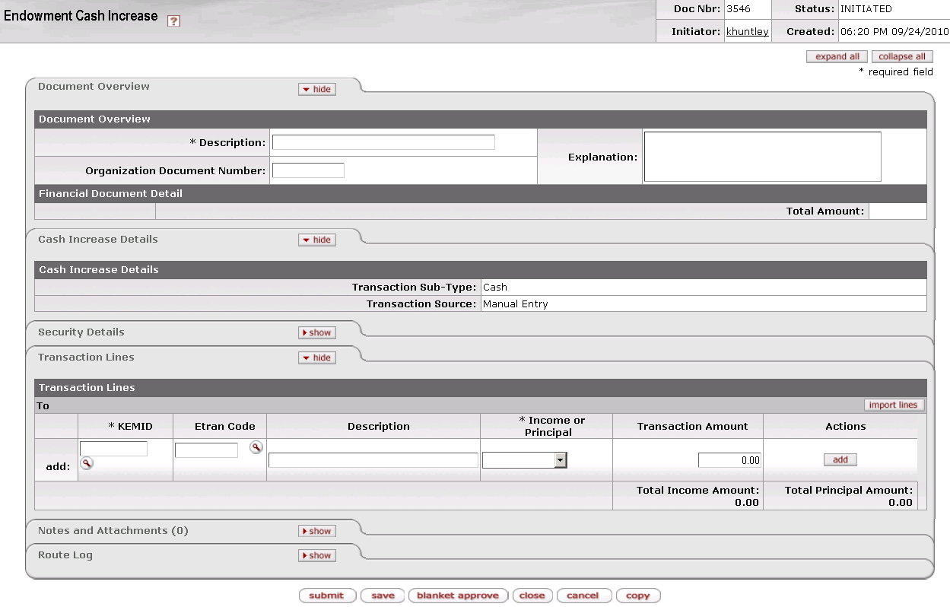

The Cash Increase document contains three unique tabs—**Cash Increase Details, Security Details, and Transaction Lines**—in addition to the standard financial transaction tabs.

 For more information about the standard tabs, see Standard Tabs|document=WordDocuments\KFS 5\_2 Overview.docx;topic=Standard Tabs“Standard Tabs” in the KFS Overview and Introduction to the User Interface.

##### Cash Increase Details Tab



This tab indicates that this is a cash transaction and specifies whether it was created by the system or by a user.

Cash Increase Details tab definition

|  |  |
| --- | --- |
| Title | Description |
| Transaction Sub-Type | Display only. Indicates whether this transaction is for cash or non-cash. When you initiate this e-doc, the system sets the **value** to 'Cash.' |
| Transaction Source | Display only. Indicates whether this transaction was generated automatically or entered by a user. When you initiate this e-doc, the system sets the value to 'Manual Entry.' |

##### Security Details Tab

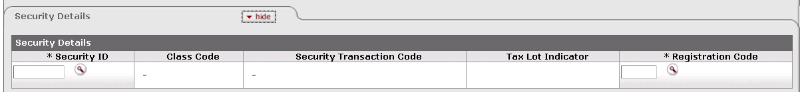

This tab identifies the security to which the transaction applies and provides pertinent information about it.

Security Details tab definition

|  |  |
| --- | --- |
| Title | Description |
| Security ID | Required in order to associate a security with this e-doc. Otherwise, not used.  Indicates the security affected by these transactions. Any security information you enter is for reference only; it is not used in system processing. The security record referenced must be valid and active. Only one security record may be used per e-doc.  Enter the ID or use the lookup _searchicon.gif to find it. The system then displays the description of the security you specified along with the associated class code and description, security transaction code and description, and tax lot indicator. |
| Class Code | Display only. Describes the class (group) to which this security belongs. |
| Security Transaction Code | Display only. The security transaction code assigned to this security. The system obtains this value from the class code for the security. |
| Tax Lot Indicator | Display only. Indicates whether the security entered is eligible for tax lot tracking. Not relevant for cash increase transactions. |

##### Transaction Lines Tab

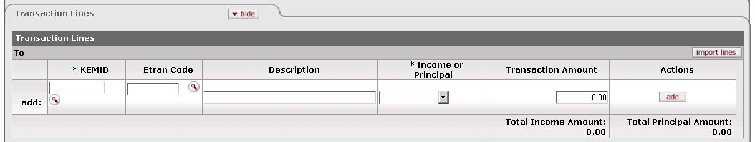

This tab contains one or more lines that specify the KEMID(s) affected, including all relevant financial details for the transaction as it applies to each KEMID specified.

Transaction Lines tab definition

|  |  |
| --- | --- |
| Title | Description |
| KEMID | Required. The KEMID to which this transaction applies. Enter the KEMID to which this cash increase applies or use the lookup _searchicon.gif to find it. The KEMID you specify must be valid and must not be closed. The system then displays the description of the KEMID you specified. |
| Etran Code | Identifies the type of processing required for this transaction. Enter the ID or use the lookup _searchicon.gif to find it. The system then displays the description of the code you specified. |
| Line Description | Describes this transaction. Enter text as desired. |
| Income or Principal | Required. Indicates whether this transaction pertains to income or principal. Enter the appropriate value from the list. |
| Transaction Amount | Required. Indicates the dollar amount of this transaction. |
| Actions | Click the button to perform an action on this line. When you are adding a new line, only the **add** button is displayed. After you have added a line, the **refresh**, **bal inquiry**, and **delete** buttons are displayed. |
| Total Income Amount | Display only. Indicates the amount of income in all transaction lines. |
| Total Principal Amount | Display only. Indicates the total amount of principal in all transaction lines. |

 Buttons on this tab allow you to add, import data, refresh tax lot information, delete lines and perform balance inquiries on the KEMID(s) specified. For information and instructions, see Working in the Transaction Lines Tab|document=WordDocuments\KFS 5\_2 KEM.docx;topic=Working in the Transaction Lines Tab.

 For information about the layout of the data import template for this e-doc, see KEM\_ECI\_ECDD\_ECT\_Import.xls|document=WordDocuments\KFS 5\_2 Overview.docx;topic=KEM\_ECI\_ECDD\_ECT\_Import.xls“KEM\_ECI\_ECDD\_ECT\_Import.xls” in the *KFS Overview and Introduction to the User lnterface*.

#### Process Overview

##### Business Rules

 For information about the layout of the data import template for this e-doc, see Standard Business Rules|document=WordDocuments\KFS 5\_2 KEM.docx;topic=Standard Business Rules.

In addition to the standard business rules for endowment transactions, the following business rules apply to cash increase transactions:

* When you initiate an e-doc, the system sets the **Transaction Sub Type** value to 'Cash.' You cannot change this value.
* When you access the document, the **Security Details** tab is closed because input of a security ID is optional.
* If you specify a security, only one security may be entered and it will apply to all transaction lines. Any security information you enter is for reference only; it is not used for system processing.
* The KEMID you specify on each transaction line must be valid and must not be closed.
* The Etran code you specify must be valid for use with the KEMID.
* If you add a transaction for which the Etran code affects corpus, the system updates the KEMID's corpus value accordingly.

##### Routing

 For information about standard routing for all endowment transaction e-docs, see Standard Routing|document=WordDocuments\KFS 5\_2 KEM.docx;topic=Standard Routing.

#### Example

A permanently endowed KEMID owns 100 shares of a pooled long term fund represented by security ID 99PLTF123. On December 1 a dividend is paid of $1.00 per share held. To record this dividend into the endowed KEMID, a Cash Increase e-doc is initiated. The e-doc adds $100 of cash and includes an Etran code that indicates dividend income. Since this income is tied to security 99PLTF123, the user enters the security ID in the optional **Security Details** tab.

### Cash Transfer

 **>  >  >  > 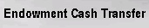**

 Although transfers may move cash between a KEMID and the General Ledger, this e-doc allows you to transfer cash within or between KEMIDs only.

The Cash Transfer e-doc allows you tomove cash from one location to another. You may move cash within a KEMID (for example, from income to principal) or between KEMIDs according to the guidelines established by your institution. The transfer always results in the generation of at least two distinct transaction lines.

The document has a section where you may enter a security ID if the transaction references a holding of the KEMID. Entering a security ID is not required and has no impact on the holding tax lot table records. You may want to enter a security ID, however, to show which security earned a dividend or interest.

#### Document Layout

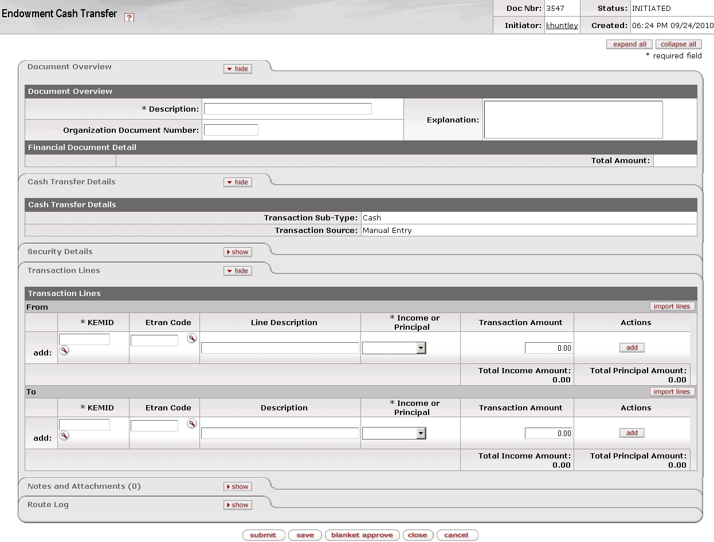

The Cash Transfer document contains three unique tabs—**Cash Transfer** **Details, Security Details, and Transaction Lines**—in addition to the standard financial transaction tabs.

 For more information about the standard tabs, see Standard Tabs|document=WordDocuments\KFS 5\_2 Overview.docx;topic=Standard Tabs“Standard Tabs” in the KFS Overview and Introduction to the User Interface.

##### Cash Transfer Details Tab

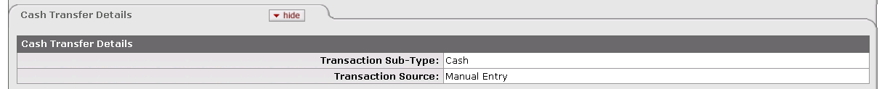

This tab indicates that this is a cash transaction and specifies whether it was created by the system or by a user.

Cash Transfer Details tab definition

|  |  |
| --- | --- |
| Title | Description |
| Transaction Sub-Type | Display only. Indicates whether this transaction is for cash or non-cash. When you initiate this e-doc, the system sets the value to 'Cash.' |
| Transaction Source | Display only. Indicates whether this transaction was generated automatically or entered by a user. When you initiate this e-doc, the system sets the value to 'Manual Entry.' |

##### Security Details Tab

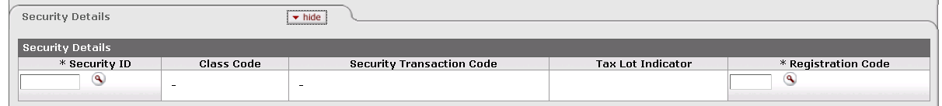

This tab identifies the security to which the transaction applies and provides pertinent information about it.

Security Details tab definition

|  |  |
| --- | --- |
| Title | Description |
| Security ID | Required in order to associate a security with this e-doc. Otherwise, not used.  Indicates the security affected by this transaction. The security record referenced must be valid and active in the system. Only one security record may be used per e-doc, and it will reference all transaction lines. The KEMID(s) you specify in the **From** section of the **Transaction Lines** tab must own sufficient shares of this security to complete the transaction.  Enter the ID or use the lookup _searchicon.gif to find it. The system then displays the description of the security you specified along with the associated class code and description, security transaction code and description, and tax lot indicator. |
| Class Code | Display only. Describes the class (group) to which this security belongs. |
| Security Transaction Code | Display only. The security transaction code assigned to this security. The system obtains this value from the class code for the security. |
| Tax Lot Indicator | Display only. Indicates whether the security entered is eligible for tax lot tracking. Not relevant for cash transfer transactions. |
| Registration Code | Indicates where (for example, at a bank, at a broker, or somewhere in the institution) a security is held in custody for the institution. The registration code specified must be valid and active in the system.  Enter the appropriate code or use the lookup _searchicon.gif to find it. The system then displays the description of the registration code you specified. |

##### Transaction Lines Tab

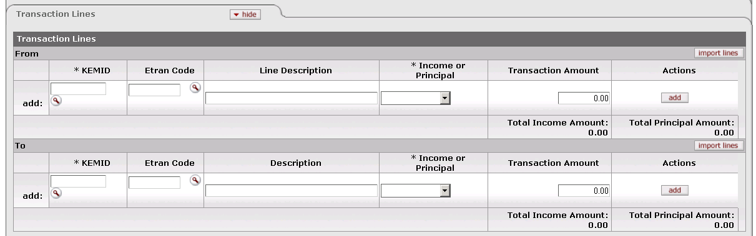

This tab contains one or more lines that specify the KEMID(s) for both the From and To sides of the transaction. It also includes all relevant financial details for the transaction as it applies to each KEMID specified.

Transaction Lines tab definition

|  |  |
| --- | --- |
| Title | Description |
| KEMID | Required for both the From and To sides of the transaction. The KEMID to which this transaction applies.  Enter the KEMID to which this cash transfer applies or use the lookup _searchicon.gif to find it. Both KEMIDs you specify must be valid and must not be closed. The system then displays the description of the KEMID you specified. |
| Etran Code | Identifies the type of processing required for this transaction. Enter the appropriate code or use the lookup _searchicon.gif to find it. The Etran code must be valid for use with the KEMID. The system then displays the description of the code you specified. |
| Line Description | Describes this transaction. Enter text as desired. |
| Income or Principal | Required for both the From and To sides of the transaction. Indicates whether this transaction affects income or principal. Select the appropriate value from the list. |
| Transaction Amount | Required. Indicates the dollar amount of this transaction. |
| Actions | Click the button to perform an action on this line. When you are adding a new line, only the **add** button is displayed. After you have added a line, the **refresh**, **bal inquiry**, and **delete** buttons are displayed. |
| Total Income Amount | Display only. Indicates the amount of income in all transaction lines in one section of the tab. Income totals are maintained separately in the To and From sections of this tab. |
| Total Principal Amount | Display only. Indicates the total amount of principal in all transaction lines in one section of the tab. Principal totals are maintained separately in the To and From sections of this tab. |

 Buttons on this tab allow you to add, import data, refresh tax lot information, delete lines and perform balance inquiries on the KEMID(s) specified. For information and instructions, see Working in the Transaction Lines Tab|document=WordDocuments\KFS 5\_2 KEM.docx;topic=Working in the Transaction Lines Tab.

 For information about the layout of the data import template for this e-doc, see KEM\_ECI\_ECDD\_ECT\_Import.xls|document=WordDocuments\KFS 5\_2 Overview.docx;topic=KEM\_ECI\_ECDD\_ECT\_Import.xls“KEM\_ECI\_ECDD\_ECT\_Import.xls” in the *KFS Overview and Introduction to the User lnterface*.

#### Process Overview

##### Business Rules

 For information about business rules that apply to all endowment transaction e-docs, see Standard Business Rules|document=WordDocuments\KFS 5\_2 KEM.docx;topic=Standard Business Rules.

In addition to the standard business rules for endowment transactions, the following business rules apply to cash transfer transactions:

* When you initiate this e-doc, the system sets the **Transaction Sub Type** to 'C' (Cash). You cannot change this value.
* You may enter multiple transaction lines in this e-doc in either or both the **From** and **To** sections. You must make at least one entry in each section.
* When you access the document, the **Security Details** tab is closed because input of a security ID is optional.
* If you specify a security, only one security may be entered and it will reference all transaction lines.
* When you add a transaction line in the **From** portion of the transaction lines, if the KEMID specified has a permanent restriction code and if the transaction line is for principal, the system displays a warning message in the transaction line indicating that the transaction will reduce the value of the endowment.
* When you add a transaction line in the **From** portion of the transaction lines, the system checks to see if there are sufficient funds to process the transaction. If there are not, the system generates a warning message for the transaction line indicating that there are insufficient funds.
* For an income transaction, the system verifies against available total cash.
* For a principal transaction, the system verifies against available principal cash.
* When you add a transaction line, the system checks to see whether the Etran code affects corpus. If it does, the system updates the KEMID's corpus value accordingly.
* This e-doc cannot be reversed. In order to reverse a transaction, you must generate a new transfer with the required information.
* The total of the transaction amount (income plus principal) in the **From** transaction lines must equal the total of the transaction amount in the **To** transaction lines.

##### Routing

 For information about standard routing for all endowment transaction e-docs, see Standard Routing|document=WordDocuments\KFS 5\_2 KEM.docx;topic=Standard Routing.

#### Example

A donor replied to a direct mail appeal by sending a $100 check to support the School of Journalism Dean's Unrestricted Fund. The funds were deposited as income for the KEMID representing this fund. Upon receiving a receipt, the donor realized that he meant to direct the money to the School of Engineering Dean's Unrestricted Fund. The donor contacted the institution and appropriate entries were made on the institution's gift system to correct the donor's giving history.

To make the change in KEM, a cash transfer was initiated. On the Cash Transfer e-doc, the From transaction line specified $100, the Journalism Fund KEMID, and Income. The **To** transaction line specified $100, the Engineering Fund KEMID, and Income. After this transaction was approved through workflow and processed in KEM, the Journalism KEMID showed its income cash balance reduced by $100 and the Engineering KEMID showed its income cash balance increased by $100.

### Endowment To GL Transfer Of Funds

 **>  >  >  > **

The Endowment To GL Transfer Of Funds e-doc allows you to move cash balances from one or more KEMID balances to one or more General Ledger accounts. This transaction generates the appropriate General Ledger accounting lines as a part of the KEM-to-General Ledger interface.

#### Document Layout

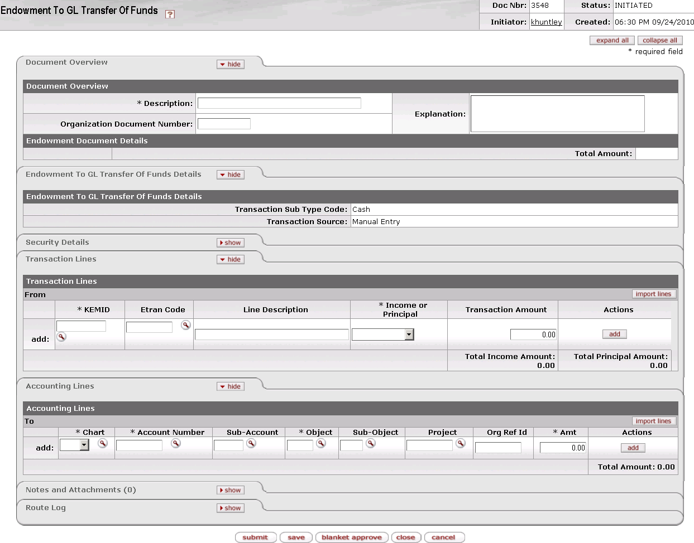

The Endowment To GL Transfer Of Funds document contains four unique tabs—**Endowment To GL Transfer Of Funds** **Details, Security Details, Transaction Lines**, and **Accounting Lines**—in addition to the standard financial transaction tabs.

 For more information about the standard tabs, see Standard Tabs|document=WordDocuments\KFS 5\_2 Overview.docx;topic=Standard Tabs“Standard Tabs” in the KFS Overview and Introduction to the User Interface.

##### Endowment To GL Transfer Of Funds Details Tab

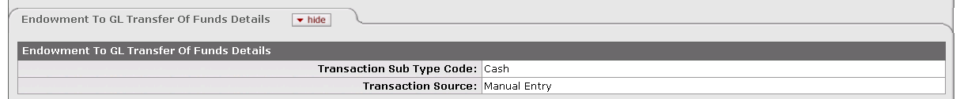

This tab indicates that this is a cash transaction and specifies whether it was created by the system or by a user.

Endowment To GL Transfer Of Funds Details tab definition

|  |  |
| --- | --- |
| Title | Description |
| Transaction Sub Type Code | Display only. Indicates whether this transaction is for cash or non-cash. When you initiate this e-doc, the system sets the value to 'Cash.' |
| Transaction Source | Display only. Indicates whether this transaction was generated automatically or entered by a user. When you initiate this e-doc, the system sets the value to 'Manual Entry.' |

##### Security Details Tab

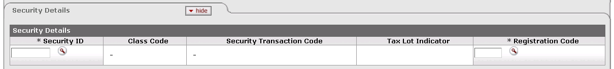

This tab identifies the security to which the transaction applies and provides pertinent information about it.

Security Details tab definition

|  |  |
| --- | --- |
| Title | Description |
| Security ID | Required in order to associate a security with this e-doc. Otherwise, not used. Indicates the security affected by this transaction. The security record referenced must be valid and active in the system and must not have a liability class code. Only one security record may be used per e-doc.  Enter the ID or use the lookup _searchicon.gif to find it. The system then displays the description of the security you specified along with the associated class code and description, security transaction code and description, and tax lot indicator. |
| Class Code | Display only. Describes the class (group) to which this security belongs. |
| Security Transaction Code | Display only. The security transaction code assigned to this security. The system obtains this value from the class code for the security. |
| Tax Lot Indicator | Display only. Indicates whether affected security units (holdings) are maintained in separate accounting (tax) lots. This indicator determines how gains and losses on the sale of the security are calculated.  'Yes' = Security units are maintained in separate tax lots.  'No' = Security units are consolidated into one holding. |
| Registration Code | Required. Indicates where (for example, at a bank, at a broker, or somewhere in the institution) a security is held in custody for the institution. The registration code specified must be valid and active in the system.  Enter the appropriate code or use the lookup _searchicon.gif to find it. The system then displays the description of the registration code you specified. |

##### Transaction Lines Tab

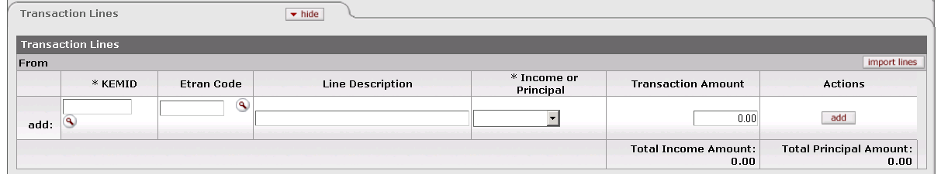

This tab contains one or more lines that specify the KEMID(s) for the From line(s) for the e-doc. It also includes all relevant financial details for the transaction as it applies to each KEMID specified. Multiple entries are allowed in this tab.

Transaction Lines tab definition

|  |  |
| --- | --- |
| Title | Description |
| KEMID | Required. Indicates the KEMID from which the transfer is being made. Enter the ID or use the lookup _searchicon.gif to find it. |
| Etran Code | Required. Identifies the type of processing required for this transaction. Enter the ID of a valid Etran code for the KEMID or use the lookup _searchicon.gif to find it. The system then displays the description of the code you specified. |
| Line Description | Describes this transaction. Enter text as desired. |
| Income or Principal | Required. Indicates whether this transaction affects income or principal. Select the appropriate value from the list. |
| Transaction Amount | Required. Indicates the dollar amount of this transaction. |
| Actions | Click the appropriate button to perform an action on this line. When you are adding a new line, only the **add** button is displayed. After you have added a line, the **refresh**, **bal inquiry**, and **delete** buttons are displayed.  go-arrow-red For information and instructions on using these buttons, see Working in the Transaction Lines Tab|document=WordDocuments\KFS 5\_2 KEM.docx;topic=Working in the Transaction Lines Tab. |
| Total Income Amount | Display only. Indicates the amount of income in all transaction lines. |
| Total Principal Amount | Display only. Indicates the total amount of principal in all transaction lines. |

 For information about importing multiple transaction lines into this e-doc, see Working in the Transaction Lines Tab|document=WordDocuments\KFS 5\_2 KEM.docx;topic=Working in the Transaction Lines Tab.

 For information about the layout of the data import template for this e-doc, see KEM\_EGLT\_Import.xls|document=WordDocuments\KFS 5\_2 Overview.docx;topic=KEM\_EGLT\_Import.xls“KEM\_EGLT\_Import.xls” in the *KFS Overview and Introduction to the User lnterface*.

##### Accounting Lines Tab

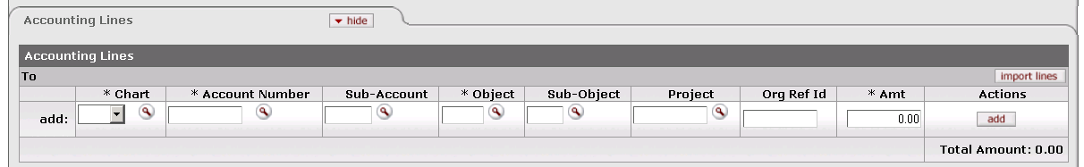

This tab contains information about the General Ledger lines for the **To** side of this e-doc. Multiple entries are allowed in this tab.

Accounting Lines tab definition

|  |  |
| --- | --- |
| Title | Description |
| Chart | Required. Enter the ID or use the lookup _searchicon.gif to find it. The chart specified must be valid and active.  C:\Users\jonny\Desktop\KFS 5.0.2\User Guide Images\pencil-small.gif When the parameter Accounts\_Can\_Cross\_Charts is set to 'No', the system derives the chart code from the account number entered, and an entry in this field is not required. |
| Account Number | Required. Indicates the account to which the transfer is being made. Enter the account number or use the lookup _searchicon.gif to find it. The account must be valid and active, it must be associated with the chart, and it must not be expired. |
| Sub-Account | Enter the number or use the lookup _searchicon.gif to find it. If a sub-account is specified, it must be valid and active, and it must be associated with the account and chart in combination. |
| Object | Required. Each GL line must have a valid, active object code for the accounting entry(ies). The object code must be associated with the fiscal year and account's chart.  Enter the code or use the lookup _searchicon.gif to find it.  exclaim.gif Object codes representing assets, liabilities, and fund balances (as indicated by the object code's object consolidation) may not be used on a transfer of funds document.  exclaim.gif Object codes belonging to the object types of 'Expense not Expenditure' and 'Income not Cash' may not be used on a transfer of funds document. |
| Sub-Object | If a sub-object is specified, it must be valid and active, and it must be associated with the object code, account, chart, and fiscal year in combination. Enter the code or use the lookup _searchicon.gif to find it. |
| Project | The project code must be valid and active. Enter the code or use the lookup _searchicon.gif to find it. |
| Org Ref Id | Enter the ID or use the lookup _searchicon.gif to find it. |
| Amt | Required. Indicates the dollar amount of this transaction. |
| Actions | Click the appropriate button to perform an action on this line. When you are adding a new line, only the **add** button is displayed. After you have added a line, the **refresh**, **bal inquiry**, and **delete** buttons are displayed.  go-arrow-red For information about working with the buttons in this column, see Working in the Accounting Lines Tab|document=WordDocuments\KFS 5\_2 KEM.docx;topic=Working in the Accounting Lines Tab. |
| Total Amount | Display only. Indicates the total dollar amount of all To lines. |

 For information about importing multiple accounting lines into this e-doc, see Working in the Accounting Lines Tab|document=WordDocuments\KFS 5\_2 KEM.docx;topic=Working in the Accounting Lines Tab. For information about the layout of the data import template for this e-doc, see KEM\_EGLT\_Import.xls|document=WordDocuments\KFS 5\_2 Overview.docx;topic=KEM\_EGLT\_Import.xls“KEM\_EGLT\_Import.xls” in the *KFS Overview and Introduction to the User lnterface*.

#### Process Overview

##### Business Rules

 For information about business rules that apply to all endowment transaction e-docs, see Standard Business Rules|document=WordDocuments\KFS 5\_2 KEM.docx;topic=Standard Business Rules.

In addition to the standard business rules for endowment transactions, the following business rules apply to Endowment to GL transfer transactions:

* When you initiate the e-doc, the system sets the **Transaction Sub Type Code** to 'Cash.' You cannot change this value.
* This e-doc cannot be reversed. To reverse a transaction, you must generate a new transfer with the required information.
* The system tracks totals separately in the **From** and **To** transaction line sections The totals are updated and shown in the space below each section as you add each line.
* You must make at least one entry into each line section (**From** and **To**) of the e-doc.
* Multiple entries are allowed in either or both the **From** and **To** line sections of the e-doc.
* Each endowment transaction line must have a valid Etran code for the KEMID(s), and each GL line must have a valid object code for the accounting entry(ies).
* For the **Accounting Lines** tab:
* Object codes representing assets, liabilities, and fund balances (as indicated by the object code's object consolidation) may not be used on a transfer of funds document.
* Object codes belonging to the object types of 'Expense not Expenditure' and 'Income not Cash' may not be used on a transfer of funds document.
* The chart specified must be valid and active.
* The account must be valid and active, it must be associated with the chart, and it must not be expired.
* If a sub-account is specified, it must be valid and active, and it must be associated with the account and chart in combination.
* The object code must be valid and active, and it must be associated with the fiscal year and account's chart.
* If a sub-object is specified, it must be valid and active, and it must be associated with the object code, account, chart, and fiscal year in combination.
* The project code must be valid and active.
* In order for a document to be submitted successfully, the total amount in the **From** section must equal the total amount in the **To** section.
* Only KEMID entries are allowed in the **From** lines of the e-doc.
* Only General Ledger entries are allowed in the **To** lines of the e-doc.
* When you add the transaction line in the **From** section, if the KEMID specified has a permanent restriction code and if the transaction is for principal, the system displays a warning message in the transaction line indicating that this transaction will reduce the value of the endowment.
* When you add the transaction line in the **From** portion of the transaction lines, the system checks to see if there are sufficient funds to process the transaction. If there are insufficient funds, the system displays a warning message in the document transaction line.
* For an income transaction, the system verifies against total available cash.
* For a principal transaction, the system verifies against available principal cash.
* When you add a transaction line, the system checks to see whether the Etran code affects corpus. If it does, the system updates the KEMID's corpus value accordingly.

##### Routing

 For information about standard routing for all endowment transaction e-docs, see Standard Routing|document=WordDocuments\KFS 5\_2 KEM.docx;topic=Standard Routing.

The standard document workflow includes the fiscal officer of the General Ledger account(s) in the GL accounting lines as a final approver. This individual also has the ability to modify the General Ledger lines as is standard in KFS.

#### Example

The Department of English has a permanent endowment to support general operating needs. Annually the department transfers the income that has accumulated over the year into its General Operating account in the General Ledger. This year the department needs to transfer $50,000. To accomplish this action, an Endowment to GL Transfer of Funds transaction is initiated. In this transaction, the department specifies the Department of English Endowment KEMID on the From transaction line and $50,000 as the transaction amount. On the To side, the department specifies the Department of English operating General Ledger account number and $50,000 as the transaction amount. After this transaction is approved through workflow and processed in KEM and KFS, the KEMID cash balance shows a $50,000 reduction and the GL Account Available Balance shows a $50,000 increase.

### GL To Endowment Transfer Of Funds

 **>  >  >  >** 

The GL To Endowment Transfer Of Funds e-doc allows you to transfer cash balances from one or more General Ledger accounts to one or more KEMIDs.

#### Document Layout

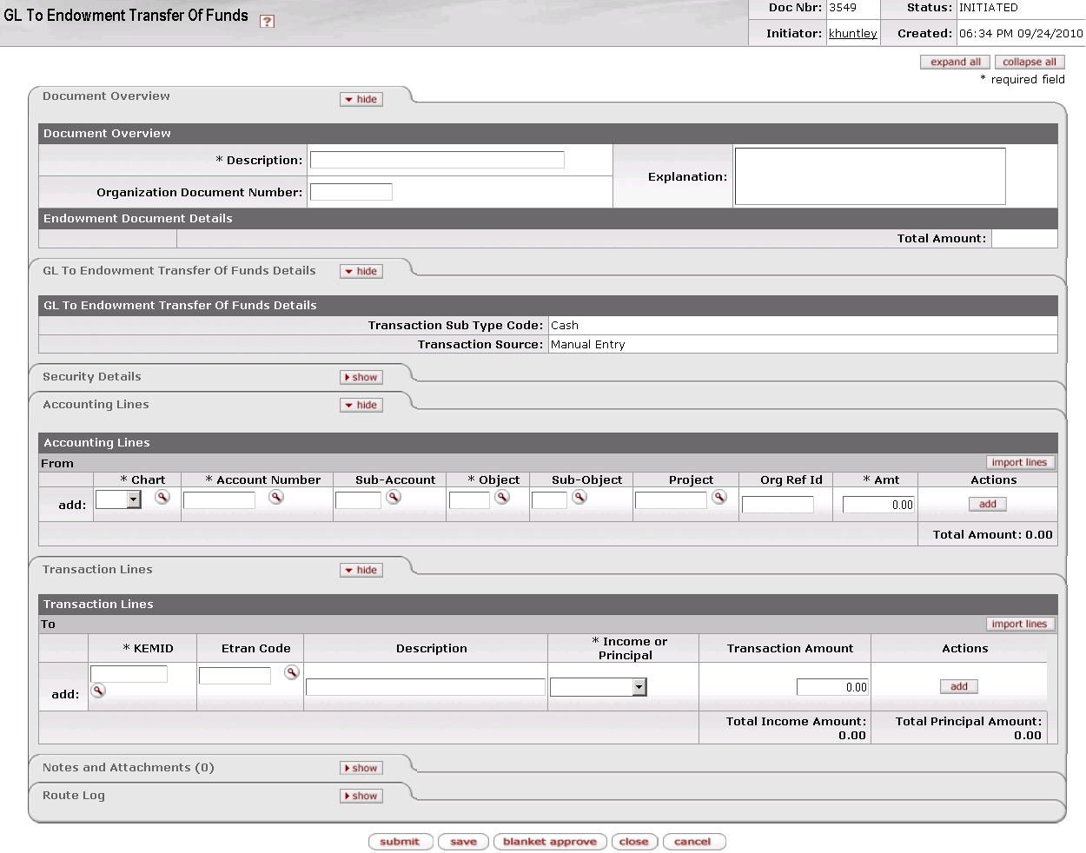

The Endowment To GL Transfer Of Funds document contains four unique tabs— **GL To Endowment Transfer Of Funds** **Details, Security Details, Accounting Lines**, and **Transaction Lines,** —in addition to the standard financial transaction tabs.

 For more information about the standard tabs, see Standard Tabs|document=WordDocuments\KFS 5\_2 Overview.docx;topic=Standard Tabs“Standard Tabs” in the KFS Overview and Introduction to the User Interface.

##### GL To Endowment Transfer Of Funds Details Tab



This tab indicates that this is a cash transaction and specifies whether it was created by the system or by a user.

GL To Endowment Transfer Of Funds Details tab definition

|  |  |
| --- | --- |
| Title | Description |
| Transaction Sub Type Code | Display only. Indicates whether this transaction is for cash or non-cash. When you initiate this e-doc, the system sets the value to 'Cash.' |
| Transaction Source | Display only. Indicates whether this transaction was generated automatically or entered by a user. When you initiate this e-doc, the system sets the value to 'Manual Entry.' |

##### Security Details Tab

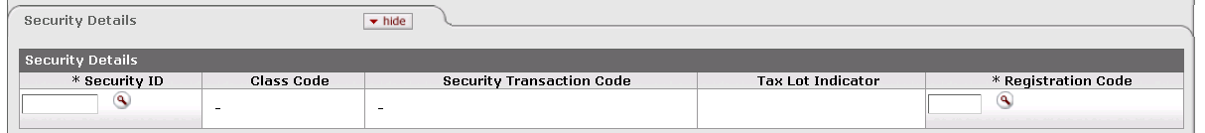

Security Details tab definition

|  |  |
| --- | --- |
| Title | Description |
| Security ID | Required in order to associate a security with this e-doc. Otherwise, not used. Indicates the security affected by this transaction. The security record referenced must be valid and active in the system and must not have a liability class code. Only one security record may be used per e-doc.  Enter the ID or use the lookup _searchicon.gif to find it. The system then displays the description of the security you specified along with the associated class code and description, security transaction code and description, and tax lot indicator. |
| Class Code | Display only. Describes the class (group) to which this security belongs. |
| Security Transaction Code | Display only. The security transaction code assigned to this security. The system obtains this value from the class code for the security. |
| Tax Lot Indicator | Display only. Indicates whether affected security units (holdings) are maintained in separate accounting (tax) lots. This indicator determines how gains and losses on the sale of the security are calculated.  'Yes' = Security units are maintained in separate tax lots.  'No' = Security units are consolidated into one holding. |
| Registration Code | Required. Indicates where (for example, at a bank, at a broker, or somewhere in the institution) a security is held in custody for the institution. The registration code specified must be valid and active in the system.  Enter the appropriate code or use the lookup _searchicon.gif to find it. The system then displays the description of the registration code you specified. |

##### Accounting Lines Tab

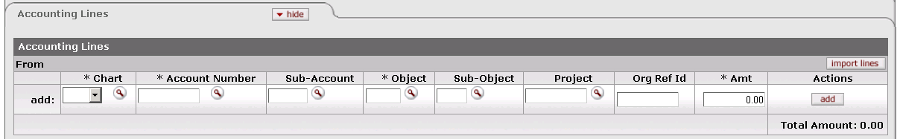

This tab contains information about the General Ledger lines for the From side of this e-doc. Multiple entries are allowed in this tab.

Accounting Lines tab definition

|  |  |
| --- | --- |
| Title | Description |
| Chart | Required. Enter the ID or use the lookup _searchicon.gif to find it. The chart specified must be valid and active.  C:\Users\jonny\Desktop\KFS 5.0.2\User Guide Images\pencil-small.gif When the parameter Accounts\_Can\_Cross\_Charts is set to 'No', the system derives the chart code from the account number entered, and an entry in this field is not required. |
| Account Number | Required. Identifies the account from which the transfer is being made. Enter the account number or use the lookup _searchicon.gif to find it. The account must be valid and active, it must be associated with the chart, and it must not be expired. |
| Sub-Account | Enter the number or use the lookup _searchicon.gif to find it. If a sub-account is specified, it must be valid and active, and it must be associated with the account and chart in combination. |
| Object | Required. Each GL line must have a valid object code for the Accounting entry(ies). The object code must be valid and active, and it must be associated with the fiscal year and account's chart. Enter the code or use the lookup _searchicon.gif to find it.  exclaim.gif Object codes representing assets, liabilities, and fund balances (as indicated by the object code's object consolidation) may not be used on a transfer of funds document.  exclaim.gif Object codes belonging to the object types of 'Expense not Expenditure' and 'Income not Cash' may not be used on a transfer of funds document. |
| Sub-Object | If a sub-object is specified, it must be valid and active, and it must be associated with the object code, account, chart, and fiscal year in combination. Enter the code or use the lookup _searchicon.gif to find it. |
| Project | The project code must be valid and active. Enter the code or use the lookup _searchicon.gif to find it. |
| Org Ref Id | Enter the ID or use the lookup _searchicon.gif to find it. |
| Amt | Required. Indicates the dollar amount of this transaction. |
| Actions | Click the appropriate button to perform an action on this line. When you are adding a new line, only the **add** button is displayed. After you have added a line, the **refresh**, **bal inquiry**, and **delete** buttons are displayed.  go-arrow-red For information about working with the buttons in this column, see Working in the Accounting Lines Tab|document=WordDocuments\KFS 5\_2 KEM.docx;topic=Working in the Accounting Lines Tab. |
| Total Amount | Display only. Indicates the total dollar amount of all To lines. |

 For information about importing multiple accounting lines into this e-doc, see Working in the Accounting Lines Tab|document=WordDocuments\KFS 5\_2 KEM.docx;topic=Working in the Accounting Lines Tab. For information about the layout of the data import template for this e-doc, see KEM\_GLET\_Import.xls|document=WordDocuments\KFS 5\_2 Overview.docx;topic=KEM\_GLET\_Import.xls“KEM\_GLET\_Import.xls” in the *KFS Overview and Introduction to the User lnterface*.

##### Transaction Lines Tab

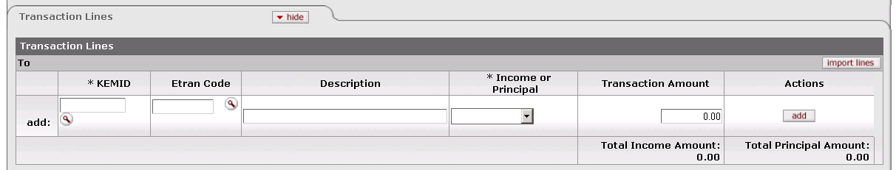

This tab contains one or more lines that specify the KEMID(s) for the To line(s) for the e-doc. It also includes all relevant financial details for the transaction as it applies to each KEMID specified. Multiple entries are allowed in this tab.

Transaction Lines tab definition

|  |  |
| --- | --- |
| Title | Description |
| KEMID | Required. Indicates the KEMID to which the transfer is being made. Enter the ID or use the lookup _searchicon.gif to find it. |
| Etran Code | Required. Identifies the type of processing required for this transaction. Enter an Etran code that is valid for use with the KEMID or use the lookup _searchicon.gif to find it. The system then displays the description of the code you specified. |
| Line Description | Describes this transaction. Enter text as desired. |
| Income or Principal | Required. Indicates whether this transaction affects income or principal. Select the appropriate value from the list. |
| Transaction Amount | Required. Indicates the dollar amount of this transaction. |
| Actions | Click the appropriate button to perform an action on this line. When you are adding a new line, only the **add** button is displayed. After you have added a line, the **refresh**, **bal inquiry**, and **delete** buttons are displayed.  go-arrow-red For information and instructions on using these buttons, see Working in the Transaction Lines Tab|document=WordDocuments\KFS 5\_2 KEM.docx;topic=Working in the Transaction Lines Tab. |
| Total Income Amount | Display only. Indicates the amount of income in all transaction lines. |
| Total Principal Amount | Display only. Indicates the total amount of principal in all transaction lines. |

 For information about importing multiple transaction lines into this e-doc, see Working in the Transaction Lines Tab|document=WordDocuments\KFS 5\_2 KEM.docx;topic=Working in the Transaction Lines Tab.

 For information about the layout of the data import template for this e-doc, see KEM\_GLET\_Import.xls|document=WordDocuments\KFS 5\_2 Overview.docx;topic=KEM\_GLET\_Import.xls“KEM\_GLET\_Import.xls” in the *KFS Overview and Introduction to the User lnterface*.

#### Process Overview

##### Business Rules

 For information about business rules that apply to all endowment transaction e-docs, see Standard Business Rules|document=WordDocuments\KFS 5\_2 KEM.docx;topic=Standard Business Rules.

In addition to the standard business rules for endowment transactions, the following business rules apply to GL to Endowment transfer transactions:

* When you initiate the e-doc, the system sets the **Transaction Sub Type** to 'Cash.' You cannot change this value.
* This e-doc cannot be reversed. To reverse a transaction, you must generate a new transfer with the required information.
* The system tracks totals separately in the **From** and **To** transaction line sections The totals are updated and shown in the space below each section as you add each line.
* Multiple entries are allowed in either or both the **From** and **To** line sections of the e-doc.
* You may import line entries into the **From** and/or **To** line sections.
* You must make at least one entry into each line section (**From** and **To**) of the e-doc.
* Each endowment transaction line must have a valid Etran code for the KEMID(s).
* Each accounting line must have a valid object code for the GL entry(ies).
* For the GL lines:
* Object codes representing assets, liabilities, and fund balances (as indicated by the object code's object consolidation) may not be used on a transfer of funds document
* Object codes belonging to the object types of 'Expense not Expenditure' and 'Income not Cash' may not be used on a transfer of funds document.
* The chart specified must be valid and active.
* The account must be valid and active, it must be associated with the chart, and it must not be expired.
* If a sub-account is specified, it must be valid and active, and it must be associated with the account and chart in combination.
* The object code must be valid and active, and it must be associated with the fiscal year and account's chart.
* If a sub-object is specified, it must be valid and active, and it must be associated with the object code, account, chart, and fiscal year in combination.
* The project code must be valid and active.
* In order for a document to be submitted successfully, the total amount in the **From** section must equal the total amount in the **To** section.
* In the standard workflow, the fiscal officer of the General Ledger account(s) in the GL accounting lines is a final approver. This individual may modify the General Ledger lines (as is standard throughout KFS).
* Only General Ledger entries are allowed in the **From** lines.
* Only KEMID entries are allowed in the **To** lines.
* The system performs no balance verifications on the General Ledger account from which funds are transferred.
* When you add a transaction line, the system checks to see whether the Etran code affects corpus. If it does, the system updates the KEMID's corpus value accordingly.

##### Routing

 For information about standard routing for all endowment transaction e-docs, see Standard Routing|document=WordDocuments\KFS 5\_2 KEM.docx;topic=Standard Routing.

The standard document workflow includes the fiscal officer of the General Ledger account(s) in the GL accounting lines as a final approver. This individual also has the ability to modify the General Ledger lines as is standard in KFS.

#### Example

At the start of the fiscal year, the Department of English transferred $50,000 from an endowment into its General Operating Account. Over the course of the year, the department used only $40,000. Per the terms of the donor agreement, the department must now transfer the unspent $10,000 back to the endowment. To accomplish this action, the department initiates a GL to Endowment Transfer of Funds transaction. In the transaction, the department specifies the Department of English operating General Ledger account number in the From transaction line and $10,000 as the transaction amount. The department lists the Department of English Endowment KEMID on the To transaction line and $10,000 as the transaction amount. After this transaction is approved through workflow and processed in KEM and KFS, the GL available balance has been reduced by $10,000 and the KEMID available cash has been increased by the same amount.

### Liability Decrease

 **>  >  >  > **

 A liability represents an amount the KEMID owes to the institution or another KEMID. It represents a borrowing, perhaps to cover an overdrawn balance or to relieve an expense incurred where the funds to cover the expense were not available. Liabilities are not marketable securities and typically have a security ID that reflects an internal security (beginning with 9 or an alpha character).

 In the KFS Endowment module, liability units and liability value for a KEMID are inversely related (decreasing units = increasing value). Liabilities are recorded in the holding table as a negative cost, while units held are positive.

The Liability Decrease e-doc allows you to reduce the holdings of a liability for a specified KEMID. Reducing the number of liability units held increases the KEMID's liability balance for the KEMID.

When a liability decrease transaction is cash-based, it decreases the cash balance of the KEMID, decreases the number of liability units held, increases the liability value or balance, and does not change the overall value of the KEMID. When no cash is involved, the transaction has no effect on the cash balance, but an expense or (more rarely) an income entry is made to the KEMID to offset the reduction in the liability value. This activity changes the overall value of the KEMID.

You may enter only one liability per e-doc. The same liability may be processed to multiple KEMID holding records by entering multiple transaction lines in the document.

#### Document Layout

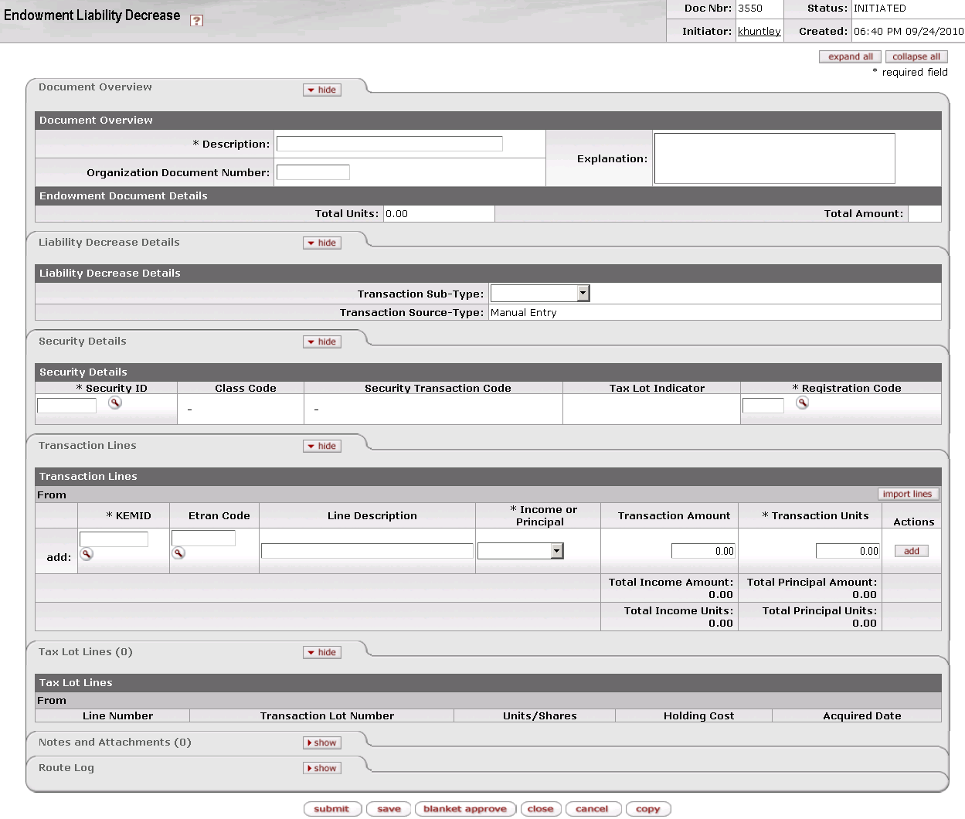

The Liability Decrease document contains three unique tabs— **Liability Decrease Details, Security Details, Transaction Lines, and Tax Lot Lines**—in addition to the standard financial transaction tabs.

 For more information about the standard tabs, see Standard Tabs|document=WordDocuments\KFS 5\_2 Overview.docx;topic=Standard Tabs“Standard Tabs” in the KFS Overview and Introduction to the User Interface.

##### Liability Decrease Details Tab

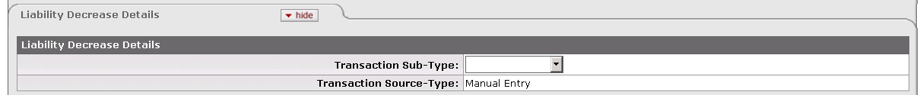

This tab indicates whether this is a cash or non-cash transaction and specifies whether it was created by the system or by a user.

Liability Decrease Details tab definition

|  |  |
| --- | --- |
| Title | Description |
| Transaction Sub-Type | Indicates whether this transaction is for cash or non-cash. Required. Select the appropriate value from the list. |
| Transaction Source-Type | Display only. Indicates whether this transaction was generated automatically or entered by a user. When you initiate this e-doc, the system sets the value to 'Manual Entry.' |

##### Security Details Tab

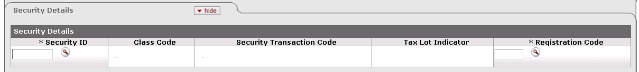

This tab identifies the security to which the transaction applies and provides pertinent information about it.

Security Details tab definition

|  |  |
| --- | --- |
| Title | Description |
| Security ID | Required. Indicates the security affected by this transaction. The security record referenced must be valid and active in the system and must have a liability class code. Only one security record may be used per e-doc.  Enter the ID or use the lookup _searchicon.gif to find it. The system then displays the description of the security you specified along with the associated class code and description, security transaction code and description, and tax lot indicator. |
| Class Code | Display only. Describes the class (group) to which this security belongs. |
| Security Transaction Code | Display only. The security transaction code assigned to this security. The system obtains this value from the class code for the security. |
| Tax Lot Indicator | Indicates whether affected security units (holdings) are maintained in separate accounting (tax) lots. This indicator determines how gains and losses on the sale of the security are calculated.  'Yes' = Security units are maintained in separate tax lots.  'No' = Security units are consolidated into one holding. |
| Registration Code | Required. Indicates where (for example, at a bank, at a broker, or somewhere in the institution) a security is held in custody for the institution. The registration code specified must be valid and active in the system.  Enter the appropriate code or use the lookup _searchicon.gif to find it. The system then displays the description of the registration code you specified. |

##### Transaction Lines Tab

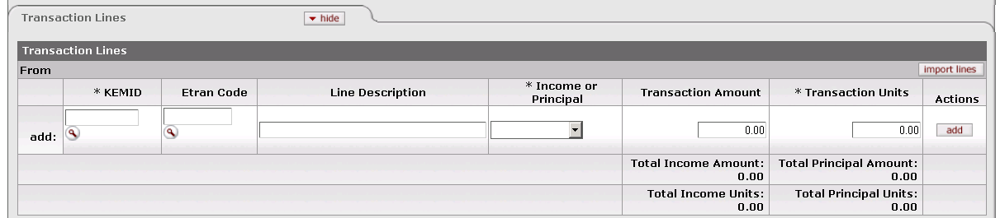

This tab contains one or more lines that specify the KEMID(s) affected, including all relevant financial details for the transaction as it applies to each KEMID specified.

Transaction Lines tab definition

|  |  |
| --- | --- |
| Title | Description |
| KEMID | Required. The KEMID to which this transaction applies. Enter the KEMID to which this liability decrease applies or use the lookup _searchicon.gif to find it. The system then displays the description of the KEMID you specified. |
| Etran Code | Identifies the type of processing required for this transaction.  If the **Transaction** **Sub-Type** is 'Cash,' you cannot enter an Etran code.  If the **Transaction** **Sub-Type** is 'Non-cash,' you must enter an Etran code. The Etran code for the security must have an appropriately identified General Ledger object code record—one that matches the chart for the KEMID-associated General Ledger account in the transaction line. The Etran code must have a type of expense or (more rarely) income. Enter the code or use the lookup _searchicon.gif to find it. |
| Line Description | Describes this transaction. Enter text as desired. |
| Income or Principal | Required. Indicates whether this transaction pertains to income or principal. Enter the appropriate value from the list. |
| Transaction Amount | Required. When a transaction line is added, the transaction amount must equal the number of units/shares because liabilities are priced at $1 per unit. |
| Transaction Units | Required. Indicates the number of security units affected by the transaction. Enter a positive number. |
| Actions | Click the button to perform an action on this line. When you are adding a new line, only the **add** button is displayed. After you have added a line, the **refresh**, **bal inquiry**, and **delete** buttons are displayed. |
| Total Income Amount | Display only. Indicates the amount of income in all transaction lines. |
| Total Principal Amount | Display only. Indicates the total amount of principal in all transaction lines. |
| Total Income Units | Display only. Indicates the total number of income units in all transaction lines. |
| Total Principal Units | Display only. Indicates the total number of principal units in all transaction lines. |

 Buttons on this tab allow you to add, import data, refresh tax lot information, delete lines and perform balance inquiries on the KEMID(s) specified. For information and instructions, see Working in the Transaction Lines Tab|document=WordDocuments\KFS 5\_2 KEM.docx;topic=Working in the Transaction Lines Tab.

 For information about the layout of the data import template for this e-doc, see KEM\_EAI\_EAD\_ELI\_ELD\_Import.xls|document=WordDocuments\KFS 5\_2 Overview.docx;topic=KEM\_EAI\_EAD\_ELI\_ELD\_Import.xls “KEM\_EAI\_EAD\_ELI\_ELD\_Import.xls” in the *KFS Overview and Introduction to the User Interface*.

##### Tax Lot Lines Tab



This tab displays information about the tax lot(s) affected by each transaction line entered. All entries in this tab are system-generated after you add a transaction line. The total number of tax lot lines is displayed in parentheses to the right of the tab header. The tax lot entries are based on the tax lot indicator associated with the security you specified and whether or not the transaction involves cash.

If you change the transaction line units or amount or delete the transaction line, the system corrects the entries in the **Tax Lots Lines** tab automatically.

 All calculations for tax lot lines are rounded according to the standard KFS endowment rules for rounding. For more information on these rules, see Standard Rounding Rules|document=WordDocuments\KFS 5\_2 KEM.docx;topic=Standard Rounding Rules.

Tax Lot Lines tab definition

|  |  |
| --- | --- |
| Title | Description |
| Line Number | Display only. Indicates the transaction line with which this tax lot is associated. |
| Transaction Lot Number | Display only. Identifies the tax lot affect by the transaction line. Display only. The tax lot referenced must have sufficient units and value to complete the transaction. |
| Units/Shares | Display only. Indicates the number of units or shares in the tax lot. |
| Holding Cost | Display only. Indicates the original cost of the units being reduced. When the system processes the tax lot lines, it multiplies the total of the lot holding cost in the tax lot lines by -1 and displays the value as a negative number. |
| Acquired Date | Display only. Indicates the date the security was acquired. |
| Actions | Click a button to perform an action on this tax lot. The only action allowed is delete, which removes the tax lot from the calculations for the transaction. When you delete a lot, the system recalculates and updates the remaining lots in the tab. |

#### Process Overview

##### Business Rules

 For information about business rules that apply to all endowment transaction e-docs, see Standard Business Rules|document=WordDocuments\KFS 5\_2 KEM.docx;topic=Standard Business Rules.

In addition to the standard business rules for endowment transactions, the following business rules apply to liability decrease transactions:

* When you initiate the e-doc, you must select a **Transaction Sub-Type** ('Cash' or 'Non-cash').
* You must select or enter a valid, active security. Only one security record may be inserted in each transaction.
* The security specified must have a liability class code.
* After you enter a security, the system displays the associated security name, class code, class code description, security transaction code and description, and tax lot indicator.
* You must enter a valid, active registration code.
* You must enter a number greater than zero for the transaction units in the transaction line.
* When a transaction line is added, the transaction amount must equal units/shares because liabilities are priced at $1 per unit.
* The tax lot indicator for the security is 'No'.Consequently, for each transaction line added, the system adds a record to the Holding Lot table and shows the data in the **Tax Lot Lines** tab. This stored data includes:
* The document number from the **Doc Nbr** field in the e-doc's header.
* The line number from the transaction line on the e-doc.
* The holding lot number set at 1.
* The number of units from the security tax lots calculation times negative 1 (-1).
* The holding cost from the transaction amount.
* Acquired date.
* The system verifies that the tax lot referenced in each tax lot line has sufficient units and value to complete the transaction. (Keep in mind that liability units are represented by a positive number while liability value is always displayed as a negative amount. Therefore, 100 liability units = -$100 liability balance or value.)
* The Etran code for the security must have an appropriately identified General Ledger object code record—one that matches the chart for the KEMID-associated General Ledger account in the transaction line.
* For an income transaction, the chart must match the chart of the active KEMID-GL Link record for income.
* For a principal transaction, the chart must match the chart of the active KEMID-GL Link record for Principal.
* When you submit a reversing transaction, the system verifies that the tax lot referenced in each tax lot line has sufficient units and value to complete the transaction. A liability cannot have a carry value (holding cost) greater than zero or units less than zero.
* When you initiate a reversing transaction (via the **error correction** button), the system generates a new e-doc using all of the information in the original e-doc with all signs reversed for units and amounts.
* If the **Transaction** **Sub-Type** is 'Cash,' you cannot enter an Etran code in the transaction line.
* If the **Transaction** **Sub-Type** is 'Non-cash,' you must enter an Etran code in the transaction line. The Etran code in the transaction line must have an **Etran Type Code** of 'I' (Income) or 'E' (Expense).

##### Routing

 For information about standard routing for all endowment transaction e-docs, see Standard Routing|document=WordDocuments\KFS 5\_2 KEM.docx;topic=Standard Routing.

#### Example

Liability Increase: An endowment was awaiting the sale of real property to fund scholarships. Rather than wait for the sale to be final, it was decided to allow the first $5,000 scholarship to be awarded. This resulted in a -$5,000 balance in the scholarship account, which was then covered by the KEMID. This left the KEMID with a -$5,000 cash balance. Rather than allow the KEMID to show a negative cash balance, a Liability Increase transaction was initiated. The transaction had a Type value of 'Cash' and the transaction line indicated 5,000 units and a transaction amount of $5,000. After this transaction was routed, approved, and posted in KEM, the result was an increase in cash of $5,000 and an increase of 5,000 units held of 99LIAB123. The total KEMID balance remained unchanged, but rather than showing negative cash, the KEMID owned 5,000 units of a security representing a liability.

Liability Decrease: After the real property was sold and the account had available cash, a Liability Decrease transaction was initiated. The transaction had a Type value of 'Cash' and the transaction line indicated 5,000 units and a transaction amount of $5,000. After this transaction was routed, approved, and posted in KEM, the result was a decrease in cash of $5,000 and a decrease of 5,000 units held of 99LIAB123. The total KEMID balance remained unchanged, but the available cash was reduced by $5,000 and the units held of 99LIAB123 were reduced by 5,000 units.

### Liability Increase

 **>  >  >  > **

 A liability represents an amount the KEMID owes to the institution or another KEMID. It represents a borrowing, perhaps to cover an overdrawn balance or to relieve an expense incurred where the funds to cover the expense were not available. Liabilities are not marketable securities and typically have a security ID that reflects an internal security (beginning with 9 or an alpha character).

 In the KFS Endowment module, liability units and liability value for a KEMID are inversely related (increasing units = decreasing value). Liabilities are recorded in the holding table as a negative cost, while units held are positive. When you create a Liability Increase e-doc, you enter units and cost as positive numbers, and the system automatically converts the holding cost to a negative number.

The Liability Increase e-doc allows you to increase the holdings of a liability for a specified KEMID. Reducing the number of liability units held decreases the KEMID's liability balance for the KEMID.

When a liability increase transaction is cash-based, it increases the cash balance of the KEMID, increases the number of liability units held, decreases the liability value or balance, and does not change the overall value of the KEMID. When no cash is involved, the transaction has no effect on the cash balance, but an expense or (more rarely) an income entry is made to the KEMID to offset the increase in the liability balance. This activity changes the overall value of the KEMID.

You may enter only one liability per e-doc. The same liability may be processed to multiple KEMID holding records by entering multiple transaction lines in the document.

#### Document Layout

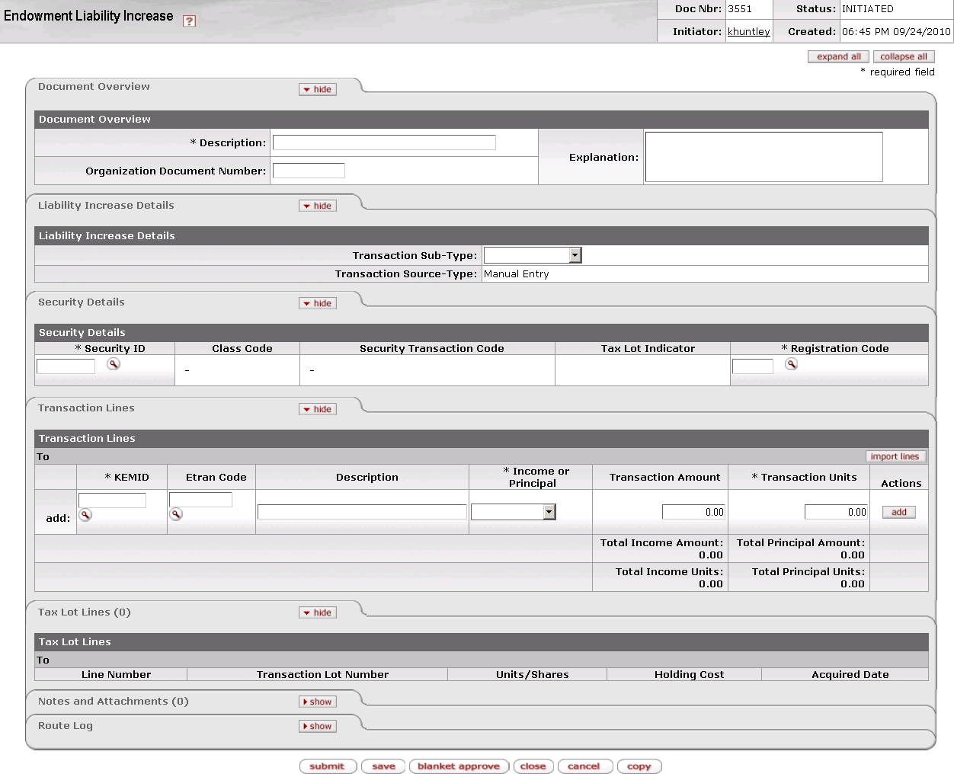

The Liability Increase document contains four unique tabs— **Liability Increase Details, Security Details, Transaction Lines, and Tax Lot Lines**—in addition to the standard financial transaction tabs.

 For more information about the standard tabs, see Standard Tabs|document=WordDocuments\KFS 5\_2 Overview.docx;topic=Standard Tabs“Standard Tabs” in the KFS Overview and Introduction to the User Interface.

##### Liability Increase Details Tab

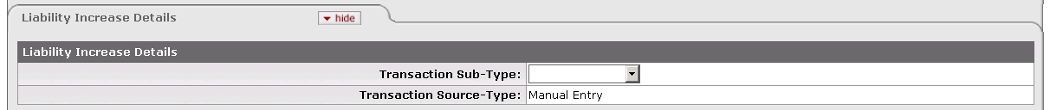

This tab indicates whether this is a cash or non-cash transaction and specifies whether it was created by the system or by a user.

Liability Increase Details tab definition

|  |  |
| --- | --- |
| Title | Description |
| Transaction Sub-Type | Required when you initiate a document. Indicates whether this transaction is for cash or non-cash. Select the appropriate value from the list. |
| Transaction Source-Type | Display only. Indicates whether this transaction was generated automatically or entered by a user. When you initiate this e-doc, the system sets the value to 'Manual Entry.' |

##### Security Details Tab

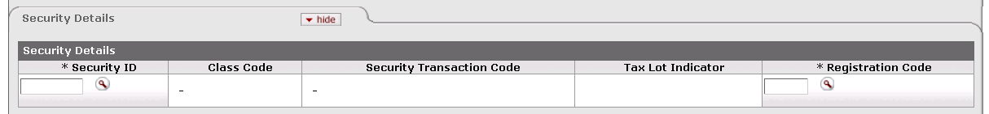

This tab identifies the security to which the transaction applies and provides pertinent information about it.

Security Details tab definition

|  |  |
| --- | --- |
| Title | Description |
| Security ID | Required. Indicates the security affected by this transaction. The security record referenced must be valid and active in the system and must have a liability class code. Only one security record may be used per e-doc.  Enter the ID or use the lookup _searchicon.gif to find it. The system then displays the description of the security you specified along with the associated class code and description, security transaction code and description, and tax lot indicator. |
| Class Code | Display only. Describes the class (group) to which this security belongs. |
| Security Transaction Code | Display only. The security transaction code assigned to this security. The system obtains this value from the class code for the security. |
| Tax Lot Indicator | Indicates whether affected security units (holdings) are maintained in separate accounting (tax) lots. This indicator determines how gains and losses on the sale of the security are calculated.  'Yes' = Security units are maintained in separate tax lots.  'No' = Security units are consolidated into one holding. |
| Registration Code | Required. Indicates where (for example, at a bank, at a broker, or somewhere in the institution) a security is held in custody for the institution. The registration code specified must be valid and active in the system.  Enter the appropriate code or use the lookup _searchicon.gif to find it. The system then displays the description of the registration code you specified. |

##### Transaction Lines Tab

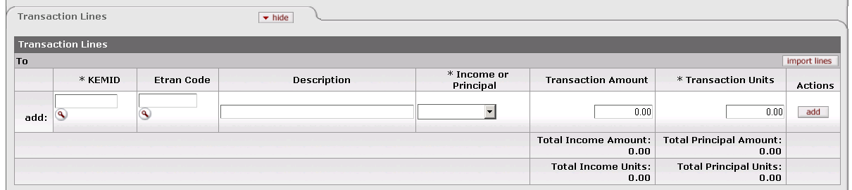

This tab contains one or more lines that specify the KEMID(s) affected, including all relevant financial details for the transaction as it applies to each KEMID specified.

Transaction Lines tab definition

|  |  |
| --- | --- |
| Title | Description |
| KEMID | Required. The KEMID to which this transaction applies. If the transaction is for principal, the KEMID must have an active General Ledger account for principal.  Enter the KEMID to which this liability decrease applies or use the lookup _searchicon.gif to find it. The system then displays the description of the KEMID you specified. |
| Etran Code | Identifies the type of processing required for this transaction.  If the **Transaction** **Sub-Type** is 'Cash,' you cannot enter an Etran code.  If the **Transaction** **Sub-Type** is 'Non-cash,' you must enter an Etran code. The Etran code for the security must have an appropriately identified General Ledger object code record—one that matches the chart for the KEMID-associated General Ledger account in the transaction line. The Etran code must have a type of expense or (more rarely) income and must be valid for use with the KEMID. Enter the code or use the lookup _searchicon.gif to find it. |
| Line Description | Describes this transaction. Enter text as desired. |
| Income or Principal | Required. Indicates whether this transaction pertains to income or principal. Enter the appropriate value from the list. |
| Transaction Amount | Required. When a transaction line is added, the transaction amount must equal units/shares because liabilities are priced at $1 per unit. |
| Transaction Units | Required. Indicates the number of security units affected by the transaction. Enter a positive number. |
| Actions | Click the button to perform an action on this line. When you are adding a new line, only the **add** button is displayed. After you have added a line, the **refresh**, **bal inquiry**, and **delete** buttons are displayed. |
| Total Income Amount | Display only. Indicates the amount of income in all transaction lines. |
| Total Principal Amount | Display only. Indicates the total amount of principal in all transaction lines. |
| Total Income Units | Display only. Indicates the total number of income units in all transaction lines. |
| Total Principal Units | Display only. Indicates the total number of principal units in all transaction lines. |

 Buttons on this tab allow you to add, import data, refresh tax lot information, delete lines and perform balance inquiries on the KEMID(s) specified. For information and instructions, see Working in the Transaction Lines Tab|document=WordDocuments\KFS 5\_2 KEM.docx;topic=Working in the Transaction Lines Tab.

 For information about the layout of the data import template for this e-doc, see KEM\_EAI\_EAD\_ELI\_ELD\_Import.xls|document=WordDocuments\KFS 5\_2 Overview.docx;topic=KEM\_EAI\_EAD\_ELI\_ELD\_Import.xls “KEM\_EAI\_EAD\_ELI\_ELD\_Import.xls” in the *KFS Overview and Introduction to the User Interface*.

##### Tax Lot Lines Tab



This tab displays information about the tax lot(s) affected by each transaction line entered. All entries in this tab are system-generated after you add a transaction line. The total number of tax lot lines is displayed in parentheses to the right of the tab header. The tax lot entries are based on the tax lot indicator associated with the security you specified and whether or not the transaction involves cash.

If you change the transaction line units or amount or delete the transaction line, the system corrects the entries in the **Tax Lots Lines** tab automatically.

 All calculations for tax lot lines are rounded according to the standard KFS endowment rules for rounding. For more information on these rules, see Standard Rounding Rules|document=WordDocuments\KFS 5\_2 KEM.docx;topic=Standard Rounding Rules.

Tax Lot Lines tab definition

|  |  |
| --- | --- |
| Title | Description |
| Line Number | Display only. Indicates the transaction line with which this tax lot is associated. |
| Transaction Lot Number | Display only. Identifies the tax lot affect by the transaction line. Display only. The tax lot referenced must have sufficient units and value to complete the transaction. |
| Units/Shares | Display only. Indicates the number of units or shares in the tax lot. The system always displays the value as a positive number. |
| Holding Cost | Display only. Indicates the original cost of the units being increased. When the system processes the tax lot lines, it multiplies the total of the lot holding cost in the tax lot lines by -1. The system always displays the value as a negative number. |
| Acquired Date | Display only. Indicates the date the security was acquired. |

#### Process Overview

##### Business Rules

 For information about business rules that apply to all endowment transaction e-docs, see Standard Business Rules|document=WordDocuments\KFS 5\_2 KEM.docx;topic=Standard Business Rules.

In addition to the standard business rules for endowment transactions, the following business rules apply to liability increase transactions:

* When you initiate a document, you must select a **Transaction Sub Type** value ('cash' or 'non-cash').
* You must select or enter a valid, active security. Only one security record may be inserted in each transaction.
* The security specified must have a liability class code.
* After you enter a security, the system displays the associated security name, class code, class code description, security transaction code and description, and tax lot indicator.
* You must enter a valid, active registration code.
* You must enter a number greater than zero for the transaction units in the transaction line.
* When a transaction line is added, the transaction amount must equal units/shares because liabilities are priced at $1 per unit.
* The tax lot indicator for the security is 'No'. Consequently, for each transaction line added, the system adds a record to the Holding Lot table and shows the data in the **Tax Lot Lines** tab. This stored data includes:
* The document number from the **Doc Nbr** field in the e-doc's header.
* The line number from the transaction line on the e-doc.
* The holding lot number set at 1.
* The number of units from the transaction units.
* The holding cost from the transaction amount times negative 1 (-1).
* Acquired date.
* The Etran code for the security must have an appropriately identified General Ledger object code record—one that matches the chart for the KEMID-associated General Ledger account in the transaction line:
* For an income transaction, the chart must match the chart of the active KEMID-GL Link record for income.
* For a principal transaction, the chart must match the chart of the active KEMID-GL Link record for Principal.
* When a transaction is reversed (via the **error correction** button), the system generates a new e-doc using all of the information in the original e-doc with all signs reversed for units and amounts.
* If the transaction is for principal, the KEMID must have an active General Ledger account for principal.
* If the **Transaction** **Sub-Type** is 'Cash,' you cannot enter an Etran code in the transaction line.
* If the **Transaction** **Sub-Type** is 'Non-cash,' you must enter an Etran code in the transaction line.
* When you add a transaction line, the system checks to see whether the Etran code affects corpus. If it does, the system updates the KEMID's corpus value accordingly.

##### Routing

 For information about standard routing for all endowment transaction e-docs, see Standard Routing|document=WordDocuments\KFS 5\_2 KEM.docx;topic=Standard Routing.

#### Example

An endowment was awaiting the sale of real property to fund scholarships. Rather than wait for the sale to be final, it was decided to allow the first $5,000 scholarship to be awarded. This resulted in a -$5,000 balance in the scholarship account, which was then covered by the KEMID. This left the KEMID with a -$5,000 cash balance. Rather than allow the KEMID to show a negative cash balance, a Liability Increase transaction was initiated. The transaction had a Type value of 'Cash' and the transaction line indicated 5,000 units and a transaction amount of $5,000. After this transaction was routed, approved, and posted in KEM, the result was an increase in cash of $5,000 and an increase of 5,000 units held of 99LIAB123. The total KEMID balance remained unchanged, but rather than showing negative cash, the KEMID owned 5,000 units of a security representing a liability.

### Security Transfer

 **>  >  >  > **

 Transfers may be designed to comply with a change in donor intent and /or designation. They may also be used to correct posting errors or to split or merge KEMIDS.

The Security Transfer e-doc allows you to decrease the holdings of one KEMID and increase those of another KEMID without affecting the cash balance of either. Because cash is not involved, all transactions moving the security are recorded at the holding cost, not at the market value of the holding.

Each e-doc records the transfer of only one KEMID security, but it may include more than one destination KEMID. You must indicate whether the security is held (or to be held) in income or principal. Each transfer begins with the reduction of the asset in the 'From' KEMID and is completed with the increase of the asset in the 'To' KEMID. This security movement may result in transfers within a KEMID (e.g., income to principal) or between KEMIDs according to specific guidelines established by your institution.

#### Document Layout

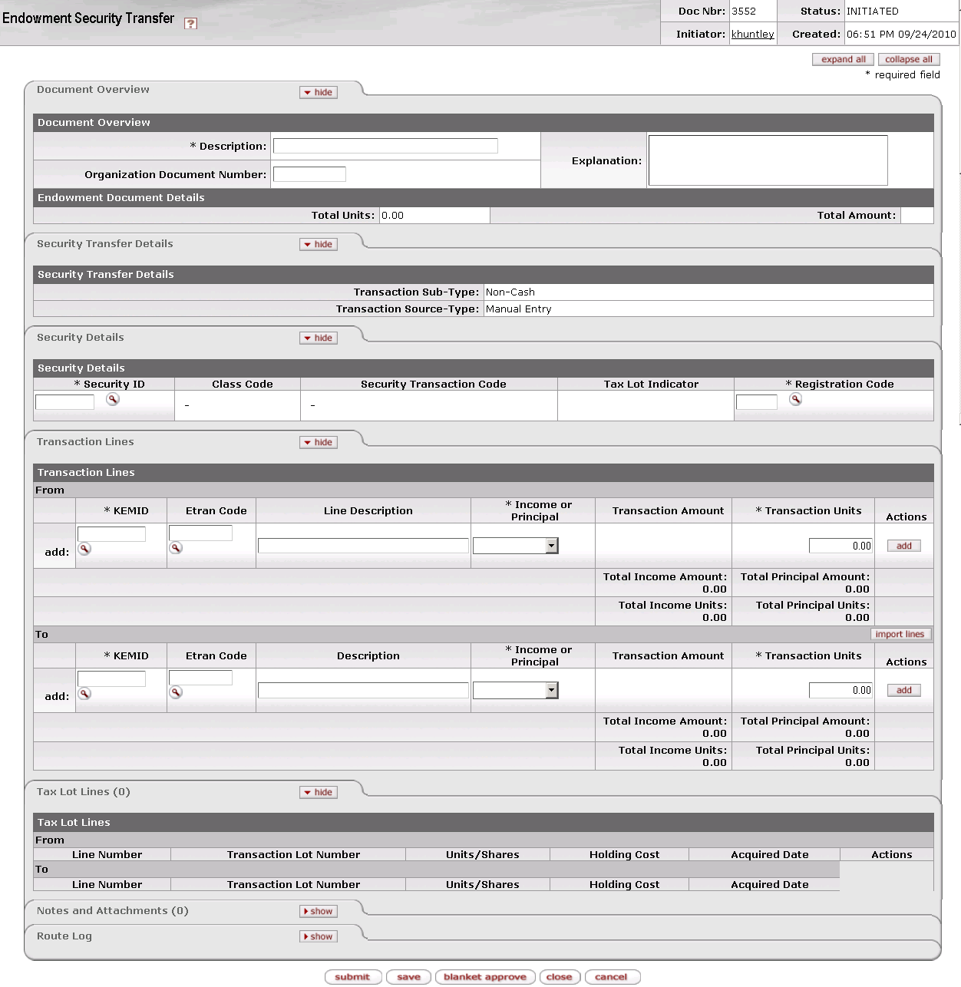

The Security Transfer document contains four unique tabs— **Security Transfer Details, Security Details, Transaction Lines, and Tax Lot Lines**—in addition to the standard financial transaction tabs.

 For more information about the standard tabs, see Standard Tabs|document=WordDocuments\KFS 5\_2 Overview.docx;topic=Standard Tabs“Standard Tabs” in the KFS Overview and Introduction to the User Interface.

##### Security Transfer Details Tab

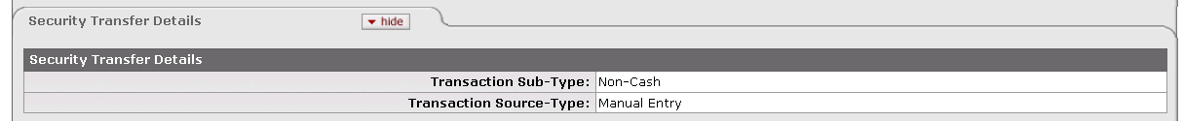

This tab indicates that this is a non-cash transaction and specifies whether it was created by the system or by a user.

Security Transfer tab definition

|  |  |
| --- | --- |
| Title | Description |
| Transaction Sub Type Code | Display only. Indicates whether this transaction is for cash or non-cash. When you initiate this e-doc, the system sets the value to 'Non-Cash.' |
| Transaction Source | Display only. Indicates whether this transaction was generated automatically or entered by a user. When you initiate this e-doc, the system sets the value to 'Manual Entry.' |

##### Security Details Tab

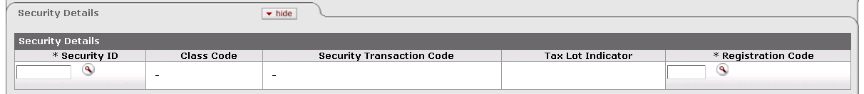

This tab identifies the security to which the transaction applies and provides pertinent information about it.

Security Details tab definition

|  |  |
| --- | --- |
| Title | Description |
| Security ID | Required. Indicates the security affected by this transaction. The security record referenced must be valid and active in the system. Only one security record may be used per e-doc.  Enter the ID or use the lookup _searchicon.gif to find it. The system then displays the description of the security you specified along with the associated class code and description, security transaction code and description, and tax lot indicator. |
| Class Code | Display only. Describes the class (group) to which this security belongs. |
| Security Transaction Code | Display only. The security transaction code assigned to this security. The system obtains this value from the class code for the security. |
| Tax Lot Indicator | Display only. Indicates whether affected security units (holdings) are maintained in separate accounting (tax) lots. This indicator determines how gains and losses on the sale of the security are calculated.  'Yes' = Security units are maintained in separate tax lots.  'No' = Security units are consolidated into one holding. |
| Registration Code | Required. Indicates where (for example, at a bank, at a broker, or somewhere in the institution) a security is held in custody for the institution. The registration code specified must be valid and active in the system.  Enter the appropriate code or use the lookup _searchicon.gif to find it. The system then displays the description of the registration code you specified. |

##### Transaction Lines Tab

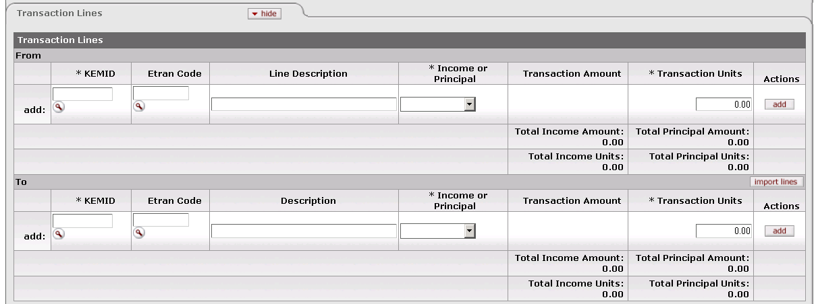

This tab contains one or more lines that specify the KEMID(s) for both the From and To sides of the transaction. It also includes all relevant financial details for the transaction as it applies to each KEMID specified.

Transaction Lines tab definition

|  |  |
| --- | --- |
| Title | Description |
| KEMID | Required for both the From and To sides of the transaction. The KEMID to which this transaction applies.  The KEMID you specify on each line must be valid and must not be closed. You may specify only one KEMID on the From line. The From KEMID must hold sufficient units of the security to complete the transfer.  Enter the KEMID to which this security transfer applies or use the lookup _searchicon.gif to find it. The system then displays the description of the KEMID you specified. |
| Etran Code | Required. Identifies the type of processing required for this transaction.  Enter a valid code or use the lookup _searchicon.gif to find it. The Etran code must be valid and must have an appropriately identified General Ledger object code record—one that matches the chart for the KEMID's General Ledger account. |
| Line Description (From line)  Description (To line) | Describes this transaction. Enter text as desired. |
| Income or Principal | Required for both the From and To sides of the transaction. Indicates whether this transaction affects income or principal. Select the appropriate value from the list. |
| Transaction Amount | Display only. Indicates the dollar amount of this transaction.  After the system calculates the tax lot lines records, it displays the total of the lot holding cost in thisfield. This value is a positive value for both assets and liabilities. |
| Transaction Units | Required in both the **From** and **To** sections. Indicates the number of units affected by this transaction. |
| Actions | Click the button to perform an action on this line. When you are adding a new line, only the **add** button is displayed. After you have added a line, the **refresh**, **bal inquiry**, and **delete** buttons are displayed. |
| Total Income Amount | Display only. Indicates the amount of income in all transaction lines in one section of the tab. Income totals are maintained separately in the To and From sections of this tab. |
| Total Principal Amount | Display only. Indicates the amount of principal in all transaction lines in one section of the tab. Principal totals are maintained separately in the To and From sections of this tab. |
| Total Income Units | Display only. Indicates the total number of income units in one section of the tab. Income totals are maintained separately in the To and From sections of this tab. |
| Total Principal Units | Display only. Indicates the total number of principal units in one section of the tab. Principal totals are maintained separately in the To and From sections of this tab. |

 Buttons on this tab allow you to add, import data, refresh tax lot information, delete lines and perform balance inquiries on the KEMID(s) specified. For information and instructions, see Working in the Transaction Lines Tab|document=WordDocuments\KFS 5\_2 KEM.docx;topic=Working in the Transaction Lines Tab.

 For information about the layout of the data import template for this e-doc, see KEM\_EST\_Import.xls|document=WordDocuments\KFS 5\_2 Overview.docx;topic=KEM\_EST\_Import.xls“KEM\_EST\_Import.xls” in the *KFS Overview and Introduction to the User lnterface*.

##### Tax Lot Lines Tab

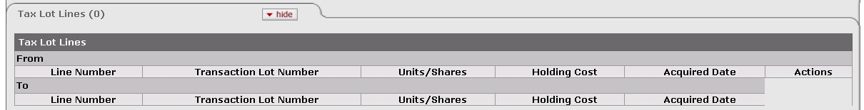

This tab displays information about the tax lot(s) affected by each transaction line entered. All entries in this tab are system-generated after you add a transaction line. The total number of tax lot lines is displayed in parentheses to the right of the tab header. The tax lot entries are based on the tax lot indicator associated with the security you specified and whether or not the transaction involves cash.

If you change the transaction line units or amount or delete the transaction line, the system corrects the entries in the **Tax Lots Lines** tab automatically.

 All calculations for tax lot lines are rounded according to the standard KFS endowment rules for rounding. For more information on these rules, see Standard Rounding Rules|document=WordDocuments\KFS 5\_2 KEM.docx;topic=Standard Rounding Rules.

Tax Lot Lines tab definition

|  |  |
| --- | --- |
| Title | Description |
| Line Number | Display only. Indicates the transaction line with which this tax lot is associated. |
| Transaction Lot Number | Display only. Identifies the tax lot affect by the transaction line. Display only. The tax lot referenced must have sufficient units and value to complete the transaction. |
| Units/Shares | Display only. Indicates the number of units or shares in the tax lot. |
| Holding Cost | Display only. Indicates the original cost of the units being reduced. In the **From** lines, the system always displays the value as a negative number. In the **To** lines, the number is positive. |
| Acquired Date | Display only. Indicates the date the security was acquired. |
| Actions | To delete a tax line, click . |

#### Process Overview

##### Business Rules

 For information about business rules that apply to all endowment transaction e-docs, see Standard Business Rules|document=WordDocuments\KFS 5\_2 KEM.docx;topic=Standard Business Rules.

In addition to the standard business rules for endowment transactions, the following business rules apply to security transfer transactions:

* When you initiate the e-doc, the system displays a **Transaction Sub-Type** value of 'Non-Cash.' You cannot change this entry.
* You must select or enter an active, valid security in the **Security Details** tab. Only one security record may be inserted in each transaction.
* After you enter a security, the system displays the security name and class code, the class code description, security transaction code and description, and the tax lot indicator.
* You must enter a valid, active registration code.
* You must enter a valid Etran code in the transaction line.
* After you add a transaction line, the system displays the appropriate entries in the **Tax Lot Lines** tab. If the transaction line units/shares are edited or the transaction line is deleted, the records in the **Tax Lot Lines** tab are adjusted automatically.
* The Etran codes for the security and in the transaction line(s) must have an appropriately identified General Ledger object code record—one that matches the chart for the KEMID's General Ledger account in the transaction line:
* For an income transaction, the chart must match the chart of the active KEMID-GL Link record for income.
* For a principal transaction, the chart must match the chart of the active KEMID-GL Link record for principal.
* The total of the transaction amount (income plus principal) in the **From** transaction lines must equal the total of the transaction amount in the **To** Transaction lines (income plus principal).
* The total of the transaction units/shares (income plus principal) in the **From** transaction lines must equal the total of the transaction units/shares in the **To** Transaction lines (income plus principal).

The following business rules are unique to the **From** transaction lines:

* You may specify only one KEMID in the **From** transaction line.
* This transaction can take place only at the original cost (carry value) of the security. You specify only the units of the asset to be reduced. The system calculates the amount of the transaction based on the rules for the tax lot indicator as it does for an asset decrease non-cash transaction. No gain or loss is recorded in the tax lot line(s).

 For information about the rules for the tax lot indicator for an Asset Decrease non-cash transaction, see Asset Decrease|document=WordDocuments\KFS 5\_2 KEM.docx;topic=Asset Decrease.

* The KEMID must hold sufficient units of the security to complete the transaction.
* When you add a **From** transaction line, if the KEMID on that line has a permanent restriction and if the transaction is for principal, the system displays a warning message indicating that the transaction will reduce the value of the endowment.
* All calculations for each holding tax lot are rounded according to the rules for rounding.
* The tax lot lines calculations determine only the number of units and the carry value of those units. The system makes no calculations beyond that point because no gain or loss is involved in the transaction.
* For each lot in the **Tax Lot Lines** tab, the system adds a record to the Holding Lot table and shows the data in the **Tax Lot Lines** tab. The data includes:
* The document number from the **Doc Nbr** field in the e-doc's header.
* The line number from the transaction line on the e-doc.
* The holding lot number from the holding lot number for the KEMID and security.
* The number of units from the tax lots line times negative 1 (-1).
* The holding cost from the tax lots line times negative 1 (-1).
* Acquired date.
* After the system calculates the tax lot lines records, it displays the total of the lot holding cost in the **Transaction Amount** field on the transaction line. This value is a positive value for both assets and liabilities. The system also updates the amount totals at the bottom of the **From** section of the e-doc.

The following business rules are unique to the **To** transaction lines:

* You may specify more than one KEMID in the **To** transaction lines.
* You must enter only the number of units being transferred to the KEMID in the transaction line. The system calculates and displays the transaction amount.
* The system automatically generates the transaction lot line(s) when the non-cash transaction line is added.
* If the tax lot indicator for the security is 'No,' all transaction lines in the **Tax Lot Lines** tab are created for the default tax lot (tax lot 1). This stored data includes:
* The document number from the **Doc Nbr** field in the e-doc's header.
* The line number from the transaction line on the e-doc.
* The holding lot number set at 1.
* The number of units from the transaction units.
* The holding cost from the transaction amount.
* Acquired date.
* If the tax lot indicator for the security is 'Yes,' for each transaction line added, the system adds a record to the Holding Lot table and shows the data in the **Tax Lot Lines** tab. This stored data includes:
* The document number from the **Doc Nbr** field in the e-doc's header.
* The line number from the transaction line on the e-doc.
* The holding lot number set at the next sequential number for the KEMID and security.
* The number of units from the transaction units.
* The holding cost from the transaction amount.
* Acquired date.

##### Routing

 For information about standard routing for all endowment transaction e-docs, see Standard Routing|document=WordDocuments\KFS 5\_2 KEM.docx;topic=Standard Routing.

#### Example

A donor, Mr. Miyagi, contributed $100,000 to a general endowment, the English Majors Scholarship Fund. This money was invested in shares of the institution's long term fund, which was priced at $1 per share. A few years later the donor contacted the school and asked to move the gift to a new KEMID, the Mr. Miyagi Scholarship Fund. The institution initiated a Security Transfer transaction with the From KEMID representing the English Majors Scholarship Fund and the To KEMID representing the Mr. Miyagi Scholarship Fund. Transaction units on both transaction lines were 100,000 units. After the transaction was routed, approved and posted to KEM, the English Majors Scholarship Fund's holdings of the long term fund showed a reduction of 100,000 units and the Mr. Miyagi Fund showed that its holdings of the long term fund had increased by 100,000 units.

## Administrative Transaction E-Docs

 **>  > 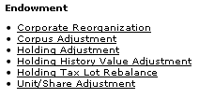**

Several administrative e-docs are available to support the Endowments module. These e-docs, which are available from the **Administrative Transactions** submenu on the **Main Menu** tab, allow your institution to accommodate corporate reorganizations, various adjustments in holdings and value, and tax lot rebalancing.

Endowment e-docs available from the Main Menu, Administrative Transactions submenu

|  |  |
| --- | --- |
| Document Type | Description |
| Corporate Reorganization (ECR) | Allows you to record the conversion of shares of one security to shares of another as a result of a corporate action (corporate spinoff, CUSIP change, merger, buyout, etc.). |
| Corpus Adjustment (ECA) | Allows you to record a change in the corpus value of a true endowment that is deemed necessary due to receipt of additional information after the corpus value was recorded in the system. |
| Holding Adjustment (EHA) | Allows you to adjust the carry value of a security held by a KEMID without affecting the number of units that make up the holding. These adjustments affect the KEMID balances and, therefore, are reflected on the General Ledger. |
| Holding History Value Adjustment (EHVA) | Allows you to update the market value of a record or group of records in the holding history table with a single entry. |
| Holding Tax Lot Rebalance (HoldingTaxLotRebalanceMaintenance-document) | Allows you to you to edit the tax lots held by a KEMID. |
| Unit\_Share Adjustment (EUSA) | Allows you to change the number of units of a security held by a KEMID without affecting the original cost or carry value of the security tax lot(s). |

### Corporate Reorganization

 **>  >  >  > **

The Corporate Reorganization e-doc allows you to accommodate situations in which the shares of one security are converted to another as a result of a corporate action (corporate spinoff, Committee on Uniform Security Identification Procedures (CUSIP) change, merger, buyout, etc.). In this situation, the total carry value of the resulting holding(s) is not affected, yet the units and the security identification have changed.

 Use of this e-doc does not result in a General Ledger entry. Keep in mind, however, that depending on the nature of the corporate action, use of this e-doc may result in fractional shares that may be converted to cash at some point.

This transaction is similar to a security transfer transaction except that it involves two securities and only one KEMID.

#### Document Layout

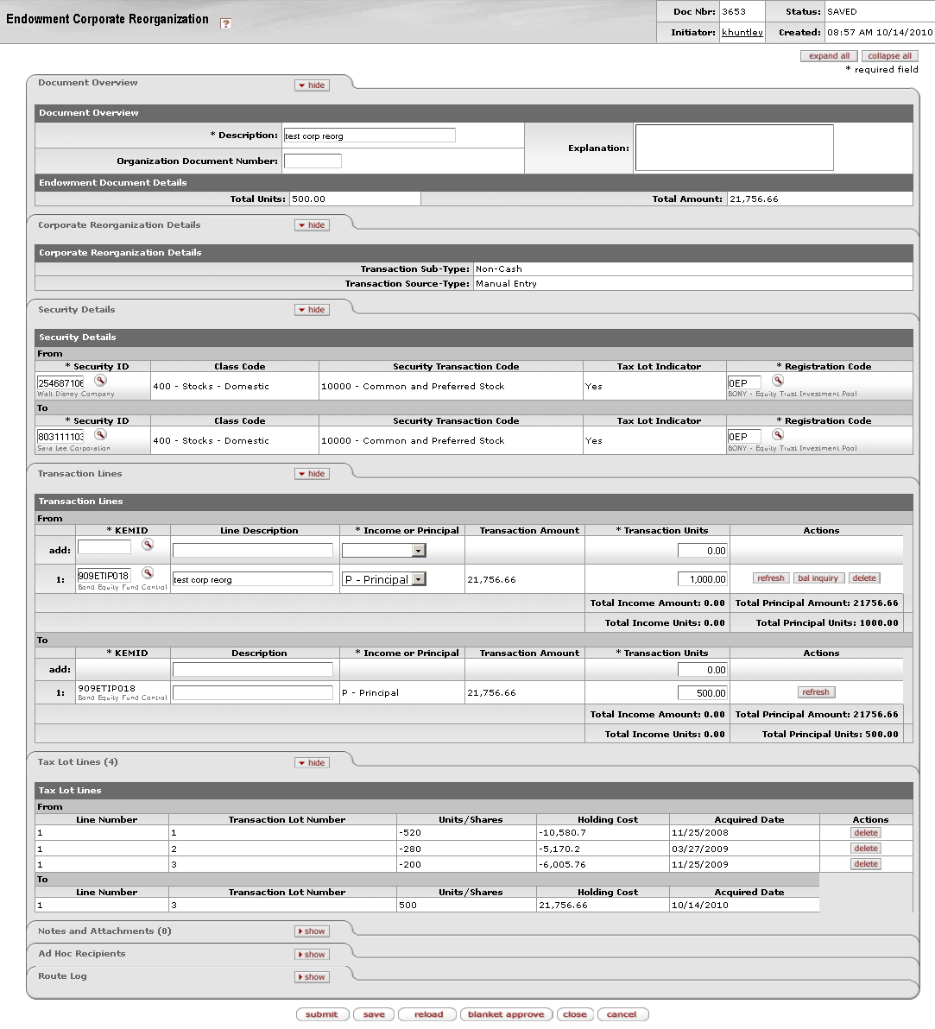

The Corporate Reorganization document contains four unique tabs— **Corporate Reorganization Details**, **Security Details**, **Transaction Lines**, and **Tax Lot Lines**—in addition to the standard tabs.

 For more information about the standard tabs, see Standard Tabs|document=WordDocuments\KFS 5\_2 Overview.docx;topic=Standard Tabs“Standard Tabs” in the KFS Overview and Introduction to the User Interface.

##### Corporate Reorganization Details Tab

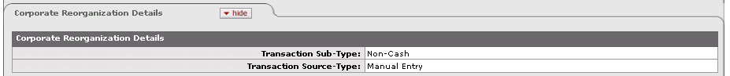

This tab indicates whether this is a cash or non-cash transaction and specifies whether it was created by the system or by a user.

Corporate Reorganization Details tab definition

|  |  |
| --- | --- |
| Title | Description |
| Transaction Sub-Type | Display only. Indicates whether this transaction is for cash or non-cash. When you initiate this e-doc, the system sets the value to 'Non-Cash.' |
| Transaction Source-Type | Display only. Indicates whether this transaction was generated automatically or entered by a user. When you initiate this e-doc, the system sets the value to 'Manual Entry.' |

##### Security Details Tab

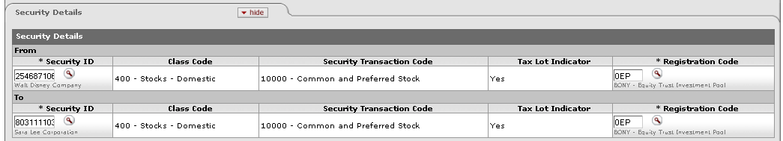

This tab contains the securities involved in the reorganization. The source security is identified in the **From** section, where only one transaction line is allowed. The target security is identified in the **To** section.

If more than one KEMID holds the security, a separate e-doc is required for each KEMID.

Security Details tab definition

|  |  |
| --- | --- |
| Title | Description |
| Security ID | Required in both the **To** and **From** sections. The security involved in this transaction. Only one security may be specified in each section. The security records referenced in the **To** and **From** sections cannot be the same, must be valid and active in the system, and must not have a liability class code. The KEMID(s) you specify in the **Transaction Lines** tab must own sufficient shares of this security to complete the transaction.  Enter the ID of a valid security or use the lookup _searchicon.gif to find it. After you enter the security ID, the system displays the description of the security you specified along with its class code and description, security transaction code and description, and tax lot indicator. |
| Class Code | Display only. The class (group) to which this security belongs. Examples include: Alternative Investment, Bond, Cash Equivalents, Liability, Other, Pooled Investment and Stock. |
| Security Transaction Code | Display only. The security transaction code assigned to this security. The system obtains this value from the class code for the security. |
| Tax Lot Indicator | Display only. Indicates whether affected security units (holdings) are maintained in separate accounting (tax) lots. This indicator determines how gains and losses on the sale of the security are calculated.  'Yes' = Security units are maintained in separate tax lots.  'No' = Security units are consolidated into one holding. |
| Registration Code | Required. Indicates where (for example, at a bank, at a broker, or somewhere in the institution) a security is held in custody for the institution. The registration code specified must be valid and active in the system.  Enter a valid, active registration code or use the lookup _searchicon.gif to find it. The system then displays the description of the registration code you specified. |

##### Transaction Lines Tab

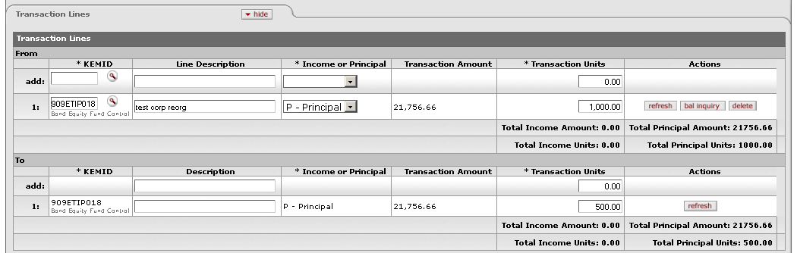

This tab contains a **From** section that specifies the KEMID that holds the security along with all relevant financial details for the transaction. Only one KEMID is allowed in the **From** section. The system copies the KEMID from the **From** section to the **To** section. You cannot change the KEMID in the **To** section.

Transaction Lines tab definition

|  |  |
| --- | --- |
| Title | Description |
| KEMID | Required in the **From** section; display only in the **To** section. The KEMID affected by the transaction. The KEMID must be a permanent endowment. Enter the ID or use the lookup _searchicon.gif to find it. The system copies the KEMID from the **From** section to the **To** section. |
| Line Description (From line)  Description (To line) | Optional. A description of the transaction, such as 'Merger with Walt Disney.' |
| Income or Principal | Required in the **From** section; display only in the **To** section. Indicates whether the affected securities are held in income or principal. Select the appropriate value from the list in the **From** section. The options are 'P' (Principal) and 'I' (Income). The system automatically copies this value from the **From** section to the **To** section. |
| Transaction Amount | Display only. The total holding cost for all tax lots in the transaction. Automatically displayed in both the **From** and **To** sections after the system calculates amounts for the tax lot lines. |
| Transaction Units | Required. The number of units or shares involved in the transaction. In the **To** section, enter the number of units being transferred. The number of units in the **To** section does not need to match the number in the **From** section. |
| Actions | Click the appropriate button to perform an action on this line. When you are adding a new line, only the **add** button is displayed.  After you have added a line to the **From** section, the **refresh** (which forces the system to update the tax lot information after you have changed data on a line), **bal inquiry** (which allows you to select and view balance inquiry reports for the KEMID), and **delete** (which allows you to delete the line) buttons are displayed.  After you have added a line to the **To** section, only the **refresh** button (which forces the system to update the tax lot information after you have changed data on a line) is displayed. |
| Total Income Amount | Display only. In the **From** section, if the **Income/Principal** indicator is set to 'Income,' this value is the total income amount. In the **To** section, this value is automatically populated by the system. |
| Total Principal Amount | Display only. In the **From** section, if the **Income/Principal** indicator is set to 'Principal,' this value is the total principal amount. In the **To** section, this value is automatically populated by the system. |
| Total Income Units | Display only. The total number of shares affecting income on the transaction lines. Calculated and displayed separately for the **From** and **To** sections of the tab. |
| Total Principal Units | Display only. The total number of shares affecting principal on the transaction lines. Calculated and displayed separately for the **From** and **To** sections of the tab. |

##### Tax Lot Lines Tab

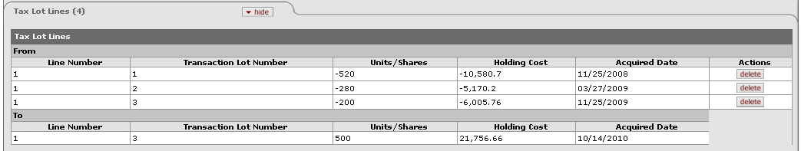

This tab displays information about the affected tax lot(s). The tab header indicates the number of tax lines in the e-doc. All entries in this tab are system-generated after you add a transaction line. These entries are based on the tax lot indicator associated with the security you specified. If you change the transaction line units or amount or delete the transaction line, the system corrects the entries in the **Tax Lot Lines** tab automatically.

 All calculations for tax lot lines are rounded according to the standard KFS endowment rules for rounding. For more information on these rules, see Standard Rounding Rules|document=WordDocuments\KFS 5\_2 KEM.docx;topic=Standard Rounding Rules.

Tax Lot Lines tab definition

|  |  |
| --- | --- |
| Title | Description |
| Line Number | Display only. The line number of the corresponding **From** or **To** transaction line. |
| Transaction Lot Number | Display only. A system-generated ID number for the tax lot based on the tax lot holding number. |
| Units/Shares | Display only. The number of units or shares calculated by the system based on the number of units in the original tax lots as a percentage of the total units of the security tax lots in the record held by the KEMID. |
| Holding Cost | Display only. The system-calculated proportional cost of the security for this tax lot. |
| Acquired Date | Display only. The acquisition date for the holdings in this tax lot. |
| Actions | Click tinybutton-delete1 to delete a tax lot from the calculation. At least one tax lot must remain. Deleting a line causes the system to recalculate the distribution among the remaining lines. |

#### Process Overview

##### Business Rules

 For information about business rules that apply to all endowment transaction e-docs, see Standard Business Rules|document=WordDocuments\KFS 5\_2 KEM.docx;topic=Standard Business Rules.

In addition to the standard business rules for endowment transactions, the following business rules apply to Corporate Reorganization transactions:

* When you initiate a Corporate Reorganization e-doc, the system displays 'Non-Cash' in the **Transaction Sub-Type** field. You cannot change this value.
* You may enter multiple transaction lines in this e-doc.

These rules are specific to the **From** transaction lines:

* You must specify a valid security in the **From** section of the **Security Details** tab.
* You must specify a valid and active registration code in the **From** section of the **Security Details** tab.

These rules are specific to the **To** transaction lines:

* You must specify a valid security in the **To** section of the **Security Details** tab, and it cannot be the same security as that entered in the **From** section.
* You must specify a valid and active registration code in the **To** section of the **Security Details** tab.

##### Routing

 For information about standard routing for all endowment transaction e-docs, see Standard Routing|document=WordDocuments\KFS 5\_2 KEM.docx;topic=Standard Routing.

#### Example

A KEMID owns 100 shares of stock from a telecommunications firm (ABC). ABC decides to split off their West Coast Operations into a new entity (ABCW). Fifty percent of ABC stock is converted into ABCW stock. To record this information into the KEMID, a Corporate Reorganization transaction is entered using ABC as the From: security and ABCW as the To security. On the transaction lines, both the From and To lines indicate 50 transaction units. After this transaction is posted to the KEMID, the KEMID's holdings of ABC show a reduction of 50 units and its holdings of ABCW show an increase of 50 units. The cost of the 50 units is transferred from the ABC holding to the ABCW holding for the KEMID.

### Corpus Adjustment

 **>  >  >  > **

 This document serves as an error correction e-doc for corpus value. **Whenever possible, however, it is preferable to reverse and re-enter a transaction that incorrectly indicated the corpus value of an endowment.**

The Corpus Adjustment e-doc allows you to record a change in the corpus value of a true endowment that is deemed necessary due to receipt of additional information after the corpus value was recorded in the system. This transaction can only affect the principal for a KEMID.

#### Document Layout

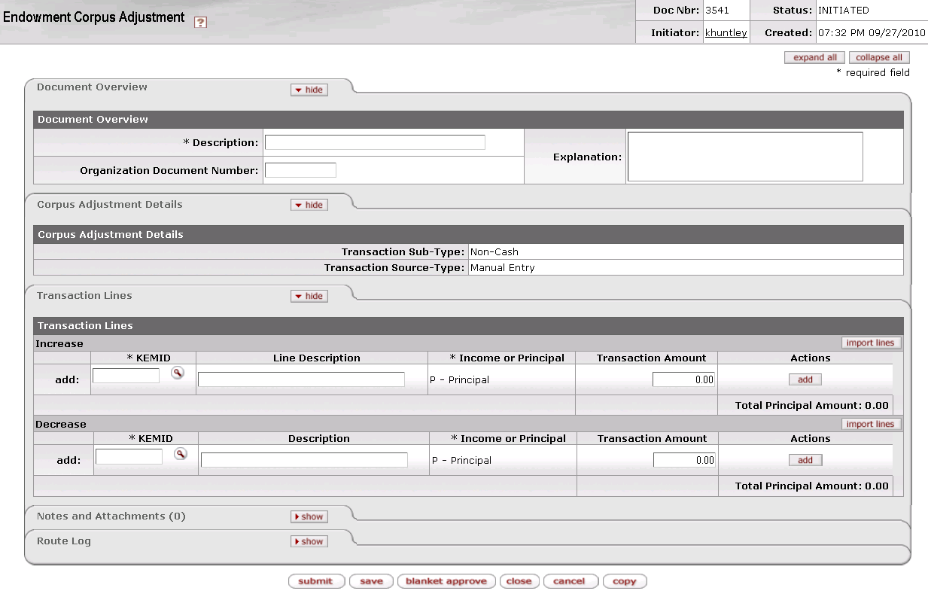

The Corpus Adjustment document contains two unique tabs— **Corpus Adjustment Details and Transaction Lines**—in addition to the standard tabs.

 For more information about the standard tabs, see Standard Tabs|document=WordDocuments\KFS 5\_2 Overview.docx;topic=Standard Tabs“Standard Tabs” in the KFS Overview and Introduction to the User Interface.

##### Corpus Adjustment Details Tab

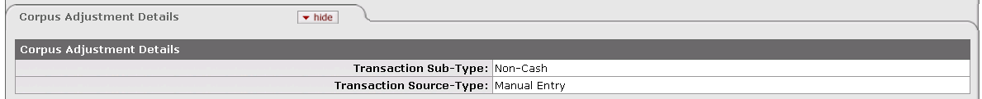

This tab indicates whether this is a cash or non-cash transaction and specifies whether it was created by the system or by a user.

Corpus Adjustment Details tab definition

|  |  |
| --- | --- |
| Title | Description |
| Transaction Sub-Type | Display only. Indicates whether this transaction is for cash or non-cash. When you initiate this e-doc, the system sets the value to 'Non-Cash.' |
| Transaction Source-Type | Display only. Indicates whether this transaction was generated automatically or entered by a user. When you initiate this e-doc, the system sets the value to 'Manual Entry.' |

##### Transaction Lines Tab

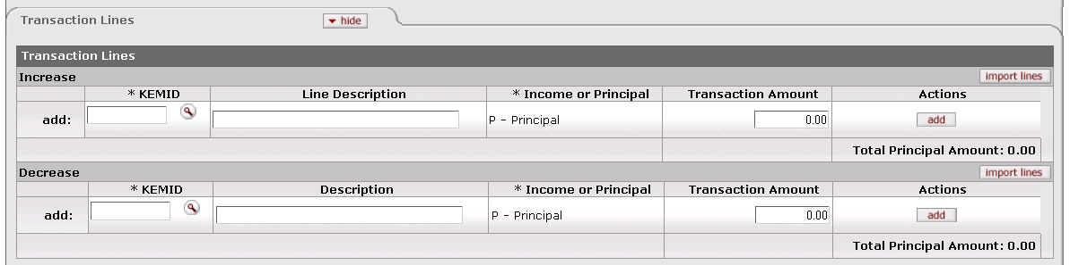

The **Transaction Lines** tab allows you to increase or decrease the corpus amount for a true endowment.

Transaction Lines tab definition

|  |  |
| --- | --- |
| Title | Description |
| KEMID | Required. Indicates the KEMID affected by the transaction. The KEMID specified must be a permanent endowment. Enter the ID or use the lookup _searchicon.gif to find it. |
| Line Description (Increase)  Description (Decrease) | Optional. The reason for the corpus adjustment. |
| Income or Principal | Display only. Indicates whether the transaction affects income or principal. For this e-doc, the value is automatically set to 'P' (Principal). |
| Transaction Amount | Required. The dollar amount by which the KEMID's corpus is to be increased or decreased. |
| Actions | Click a button to perform an action on this line. When you are adding a new line, only the **add** button is displayed. After you have added a line, the **bal inquiry** button (which allows you to select and view balance inquiry reports) and **delete** button (which allows you to delete the line from the document) are displayed. |
| Total Principal Amount | Display only. The sum of all amounts affecting principal in the transaction lines. Calculated and displayed separately for the **Increase** and **Decrease** sections of the tab. |

###### Importing Transaction Lines

If you have a number of transaction lines to enter, you may create a .csv file containing the information and import it into the Corpus Adjustment e-doc. To add multiple transaction lines from a file, follow these steps:

1. Retrieve the data import template from “KEM\_ECA\_Import.xls” in the *KFS Overview and Introduction to the User lnterface*.
2. Create a .csv file and import it via the button according to the instructions in “Creating a .csv File” in the *KFS Overview and Introduction to the User lnterface*.

#### Process Overview

##### Business Rules

 For information about business rules that apply to all endowment transaction e-docs, see Standard Business Rules|document=WordDocuments\KFS 5\_2 KEM.docx;topic=Standard Business Rules.

In addition to the standard business rules for endowment transactions, the following business rules apply to corpus adjustment transactions:

* When you initiate an e-doc, the system displays 'Non-Cash' in the **Transaction Sub-Type** field. You cannot change this value.
* You may input both **Increase** and **Decrease** transaction lines in one e-doc.
* The KEMID specified in each transaction line must be a permanent endowment.
* The system displays the value 'P' (Principal) in the **Income or Principal** field. You cannot change this value.
* You cannot enter an Etran code in this type of e-doc.
* For each transaction line,the system sets the corpus indicator to 'Yes.'
* No security record is associated with this e-doc.

##### Routing

 For information about standard routing for all endowment transaction e-docs, see Standard Routing|document=WordDocuments\KFS 5\_2 KEM.docx;topic=Standard Routing.

#### Example

In reviewing a gift of real property that was deposited into a new permanently endowed KEMID, a staff member determined that the $50,000 valuation originally used was incorrect and should have been $40,000. Since the property was donated it has been sold and the resulting cash placed into the KEMID. At this point, the KEMID has an Endowment Corpus of $50,000. Given the new valuation information, a Corpus Adjustment transaction is initiated for the KEMID. In the Decrease section $10,000 is entered as the transaction amount. After this transaction has been posted to the KEMID, the KEMID shows an endowment corpus of $40,000.

### Holding Adjustment

 >**** >> > 

The Holding Adjustment e-doc allows you to adjust the carry value of a security held by a KEMID without affecting the number of units that make up the holding. This transaction may affect some or all lots of the security holdings, depending on your instructions.

This type of transaction changes the overall per-share value of the holding for future transactions. Both the changes in carry value and in income or expense are carried forward to the General Ledger.

You may use this e-doc in a number of situations, including:

* Distributing gains or losses.
* Adjusting the cost of an acquired asset if reversing the original transaction and re-entering the corrected transaction is not feasible.
* Revaluing a security by expensing (writing off) a portion of the original cost.
* Adjusting the valuation of a security to conform to the bank, manager or broker statement.

#### Document Layout

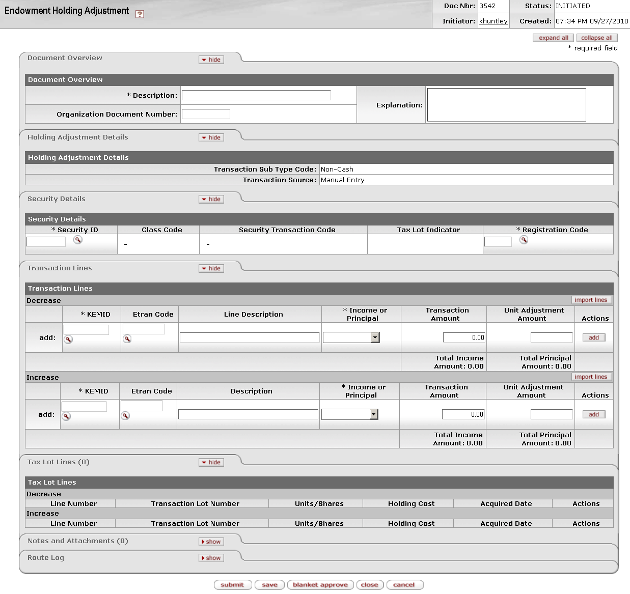

The Holding Adjustment document contains four unique tabs— **Holding Adjustment Details, Security Details, Transaction Lines**, and **Tax Lot Lines**—in addition to the standard tabs.

 For more information about the standard tabs, see Standard Tabs|document=WordDocuments\KFS 5\_2 Overview.docx;topic=Standard Tabs“Standard Tabs” in the KFS Overview and Introduction to the User Interface.

##### ****Holding Adjustment Details**** Tab

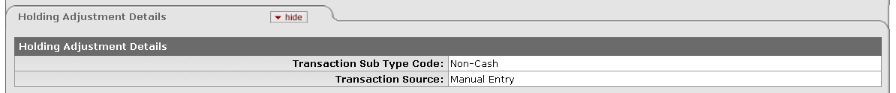

This tab indicates whether this is a cash or non-cash transaction and specifies whether it was created by the system or by a user.

Holding Adjustment Details tab definition

|  |  |
| --- | --- |
| Title | Description |
| Transaction Sub Type Code | Display only. Indicates whether this transaction is for cash or non-cash. When you initiate this e-doc, the system sets the value to 'Non-Cash.' |
| Transaction Source | Display only. Indicates whether this transaction was generated automatically or entered by a user. When you initiate this e-doc, the system sets the value to 'Manual Entry.' |

##### Security Details Tab

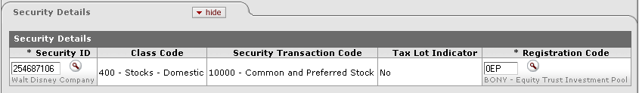

This tab identifies the security to which the transaction applies and provides pertinent information about it.

Security Details tab definition

|  |  |
| --- | --- |
| Title | Description |
| Security ID | Required. The security affected by this transaction. The security record referenced must be valid and active in the system and must not have a liability class code. Only one security may be specified per e-doc. The KEMID(s) you specify in the **Transaction Lines** tab must own sufficient shares of this security to complete the transaction.  Enter the security ID or use the lookup _searchicon.gif to find it. The system then displays the description of the security you specified along with the associated class code and description, security transaction code and description, and tax lot indicator. |
| Class Code | Display only. The class (group) to which this security belongs. Examples include: Alternative Investment, Bond, Cash Equivalents, Liability, Other, Pooled Investment and Stock. |
| Security Transaction Code | Display only. The security transaction code assigned to this security. The system obtains this value from the class code for the security. |
| Tax Lot Indicator | Display only. Indicates whether affected security units (holdings) are maintained in separate accounting (tax) lots. This indicator determines how gains and losses on the sale of the security are calculated.  'Yes' = Security units are maintained in separate tax lots.  'No' = Security units are consolidated into one holding. |
| Registration Code | Required. Indicates where (for example, at a bank, at a broker, or somewhere in the institution) a security is held in custody for the institution. The registration code specified must be valid and active in the system.  Enter the appropriate code or use the lookup _searchicon.gif to find it. The system then displays the description of the registration code you specified. |

##### Transaction Lines Tab

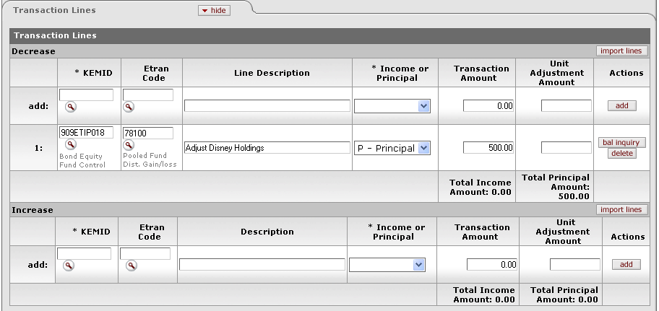

This tab contains one or more lines that specify the KEMID(s) affected, including all relevant financial details for the transaction as it applies to each KEMID specified.

Transaction Lines tab definition

|  |  |
| --- | --- |
| Title | Description |
| KEMID | Required. The KEMID affected by the transaction. Enter the appropriate KEMID or use the lookup _searchicon.gif to find it. |
| Etran Code | Required. Identifies the type of processing required for this transaction. Enter the appropriate code or use the lookup _searchicon.gif to find it. |
| Line Description (Decrease line)  Description (Increase line) | Optional. The reason for this adjustment. |
| Income or Principal | Required. Indicates whether the adjustment affects the KEMID's income or principal. Using the list, select 'Income' if the carry value is to adjust the income holding. Select 'Principal' if the transaction is to adjust the principal holding carry value. |
| Transaction Amount | The dollar amount of the transaction. An entry is required in either this field or the **Unit Adjustment Amount** field. If you enter a value in this field, no entry in the **Unit Adjustment Amount** field is allowed. If you enter an amount in the **Unit Adjustment Amount** field, no entry is permitted in this field. Instead, the system generates an entry for this field as a result of the calculations made for the tax lot lines. |
| Unit Adjustment Amount | The number of units or shares by which to adjust the KEMID's holding. An entry is required in either this field or the **Transaction Amount** field. If you enter an amount in this field, no entry is permitted in the **Transaction Amount** field. If you enter an amount in the **Transaction Amount** field, no entry is permitted in this field and no calculated value is displayed here. |
| Actions | Click a button to perform an action on this line. When you are adding a new line, only the **add** button is displayed. After you have added a line, the **bal inquiry** button (which allows you to select and view balance inquiry reports) and **delete** button (which allows you to delete the line from the document) are displayed. |
| Total Income Amount | Display only. The total amount of income on all lines. The system updates this field as income-based transaction lines are added. Calculated and displayed separately for the **Increase** and **Decrease** sections of the tab. |
| Total Principal Amount | Display only. The total amount of principal on all lines. The system updates this field as principal-based transaction lines are added. Calculated and displayed separately for the **Increase** and **Decrease** sections of the tab. |

###### Importing Transaction Lines

If you have a number of transaction lines to enter, you may create a .csv file containing the information and import it into the Holding Adjustment e-doc. To add multiple transaction lines from a file, follow these steps:

1. Retrieve the data import template from “KEM\_EHA\_Import.xls” in the *KFS Overview and Introduction to the User lnterface*.
2. Create a .csv file and import it via the button according to the instructions in “Creating a .csv File” in the *KFS Overview and Introduction to the User lnterface*.

##### Tax Lot Lines Tab

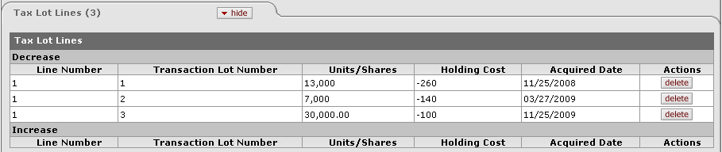

This tab displays information about the tax lot(s) affected by each transaction line entered. All entries in this tab are system-generated after you add a transaction line. The total number of tax lot lines is displayed in parentheses to the right of the tab header. The tax lot entries are based on the tax lot indicator associated with the security you specified.

If you change the transaction line units or amount or delete the transaction line, the system corrects the entries in the **Tax Lots Lines** tab automatically.

The tab header indicates the number of tax lines in the e-doc.

 All calculations for tax lot lines are rounded according to the standard KFS endowment rules for rounding. For more information on these rules, see Standard Rounding Rules|document=WordDocuments\KFS 5\_2 KEM.docx;topic=Standard Rounding Rules.

Tax Lot Lines tab definition

|  |  |
| --- | --- |
| Title | Description |
| Line Number | Display only. The line number of the corresponding **Increase** or **Decrease** transaction line. |
| Transaction Lot Number | Display only. A system-generated ID number for the tax lot based on the tax lot holding number. |
| Units/Shares | Display only. The number of units or shares calculated by the system based on the number of units in the original tax lots as a percentage of the total units of the security tax lots in the record held by the KEMID. |
| Holding Cost | Display only. The system-calculated proportional cost of the security for this tax lot. |
| Acquired Date | Display only. The acquisition date for the holdings in this tax lot. |
| Actions | Click tinybutton-delete1 to delete a tax lot from this calculation. At least one tax lot must remain. Deleting a line causes the system to recalculate the distribution among the remaining lines. |

#### Process Overview

##### Business Rules

 For information about business rules that apply to all endowment transaction e-docs, see Standard Business Rules|document=WordDocuments\KFS 5\_2 KEM.docx;topic=Standard Business Rules.

In addition to the standard business rules for endowment transactions, the following business rules apply to holding adjustment transactions:

* When you initiate the e-doc, the system sets the **Transaction Sub Type Code** to 'Non-Cash.' You cannot change this value.
* You must enter or select a valid, active security in the **Security Details** tab. Only one security record may be inserted in each transaction.
* The security entered must not have a liability class code.
* When you submit or save the e-doc, the system sets the security line type code to match that of the transaction lines entered.
* After you enter a security, the system displays the associated security name and class code, class code description, tax lot indicator, and security transaction code.
* You must enter a valid, active registration code.
* You must enter an Etran code for the transaction line.
* You may enter data into either the Increase or Decrease transaction lines, but not both.
* For each transaction line entered, you must specify whether it is to affect securities held in income or principal.
* You must enter a number greater than zero for either the unit adjustment amount or the transaction amount in the transaction line.
* After you add a transaction line, the system creates the appropriate entries in the **Tax Lot Lines** tab. If the transaction line units are edited or the transaction line is deleted, the records in the tax lot lines tab are corrected automatically.
* You may delete tax lot lines, but at least one tax lot line must remain in the transaction.
* As a tax lot line is deleted, the system recalculates the unit distribution among the remaining lots.
* This e-doc is reversible.
* If the system is unable to locate tax lot records to match the criteria set for the **Security**/ **Registration Code**/ **KEMID**/ **Income or Principal** indicator, the transaction cannot proceed. To alert you to this condition, the system highlights the KEMID in the transaction line.

If you enter a value in the **Unit Adjustment Amount** field, the following business rules apply:

* You cannot enter a value into the **Transaction Amount** field. The system generates an entry for this field as a result of the calculations made for the tax lot lines.
* When the transaction line is created, the system retrieves from the holding lot all appropriate tax lot records. The system also creates a record for each appropriate holding lot and calculates and displays the lot holding cost as follows:
* For each lot in the **Tax Lot Lines** tab, multiply the unit adjustment amount by the number of units in the lot.
* If you enter an amount in the **Decrease** section, the value is negative. If you enter an amount in the **Increase** section, it is positive.
* After the holding cost for the lot lines has been calculated, the system displays the absolute value of the total holding cost in the **Transaction Amount** field and generates the proper total values for the **Transaction Lines** tab.

If you enter a value in the **Transaction Amount** field, the following business rules apply:

* No entry in the **Unit Adjustment Amount** field is allowed.
* No calculated value will be displayed in the **Unit Adjustment Amount** field.
* The system distributes the value in the **Transaction Amount** field proportionately among the tax lots held by the KEMID based upon the number of units in each lot.
* When the transaction line is created, the system retrieves from the holding lot all appropriate tax lot records. The system also creates a record for each appropriate holding lot and calculates and displays the lot holding cost as follows:
* From transaction amount, distribute the value based upon the number of units in the original lots as a percentage of the total units of the security tax lots in the record held by the KEMID.
* If you enter an amount in the **Decrease** section, the value is negative. If you enter an amount in the **Increase** section, it is positive.

##### Routing

 For information about standard routing for all endowment transaction e-docs, see Standard Routing|document=WordDocuments\KFS 5\_2 KEM.docx;topic=Standard Routing.

#### Example

A donor, Mr. Miyagi, contributed $100,000 to a general endowment, English Majors Scholarship Fund. This money was invested in shares of the school's long term fund, which happened to be priced at $1 per share. A few years later, the donor contacted the school and asked to move their gift to a new KEMID, the Mr. Miyagi Scholarship Fund. The school entered a security transfer for 100,000 units, but the carry value that transferred ($150,000) was based on the average of all the gifts into the General Endowment. To correct this calculation, a Holding Adjustment was entered for the Mr. Miyagi Scholarship Fund. The transaction line was entered as a decrease with a transaction amount of $50,000. Another holding adjustment was also entered for the English Majors Scholarship Fund with an increase transaction line with an amount of $50,000.

### Holding History Value Adjustment

 **>  >  >  > **

The Holding History Value Adjustment e-doc allows you to update the market value of a record or group of records in the holding history table with a single entry. Because the history table is generated at the end of processing on the last day of each month, after the end of the process new information is sometimes received that requires a restatement of the value of a security. Consequently, this e-doc allows you to ensure that all reporting of market values as of the last day of the month are correct.

When this e-doc is processed, the change to the historical valuation is made to all holdings of the specified security regardless of whether it is held in income or principal.

#### Document Layout

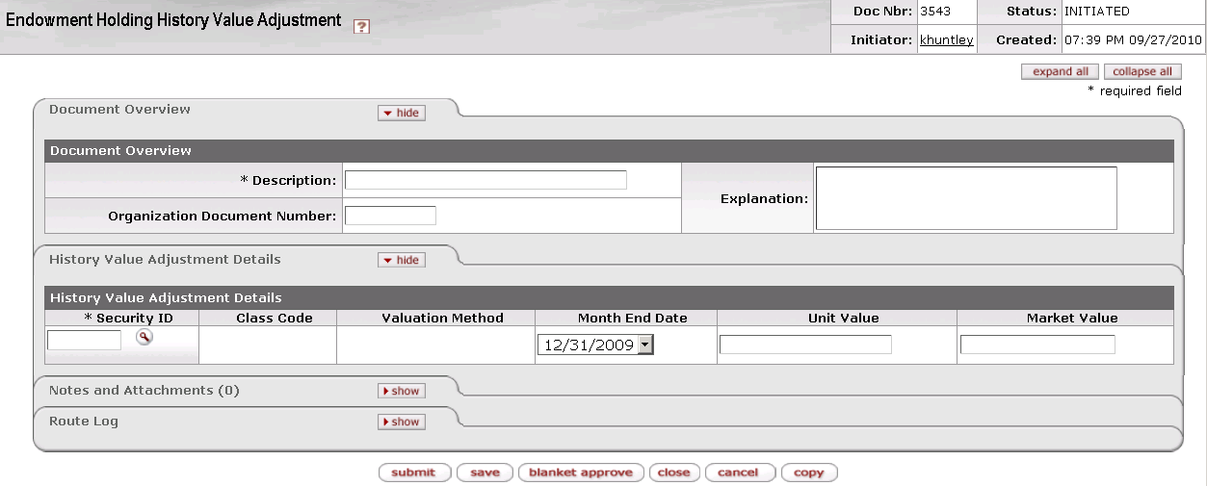

The Holding History Value Adjustment document contains one unique tab— **History Value Adjustment Details**—in addition to the standard tabs.

 For more information about the standard tabs, see Standard Tabs|document=WordDocuments\KFS 5\_2 Overview.docx;topic=Standard Tabs“Standard Tabs” in the KFS Overview and Introduction to the User Interface.

##### History Value Adjustment Details Tab

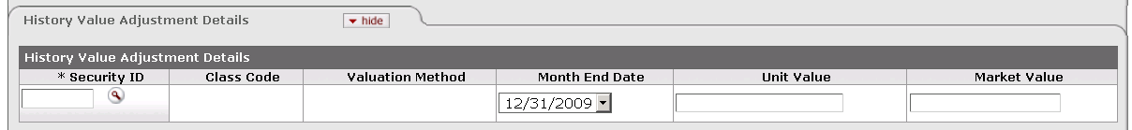

This tab allows you to update the market value of a record or group of records in the Holding History table.

History Value Adjustment Details tab definition

|  |  |
| --- | --- |
| Title | Description |
| Security ID | Required. The security involved in this transaction. Enter the ID of a valid, active security or use the lookup _searchicon.gif to find it. The security entered must not have a liability class code. After you enter the security ID, the system displays the description of the security you specified along with its class code and description, and valuation method. |
| Class Code | Display only. The class (group) to which this security belongs. Examples include: Alternative Investment, Bond, Cash Equivalents, Liability, Other, Pooled Investment and Stock. |
| Valuation Method | Display only. The valuation method for the security. The value is 'U- Unit Value' or 'M – Market Value'. |
| Month End Date | The applicable month-end date for the adjustment. This date defaults to the most recent month end. |
| Unit Value | If the valuation method for the security is '**U'** (Unit Value), an entry in this field is required. If the valuation method for the security is '**M'** (Market Value), no entry is permitted. If the valuation method is '**M**,' the system calculates the unit value and places it in this field after you submit the e-doc. |
| Market Value | If the valuation method for the security is '**U'** (Unit Value), no entry is permitted. If the valuation method for the security is '**M'** (Market Value), an entry in this field is required. |

#### Process Overview

##### Business Rules

 For information about business rules that apply to all endowment transaction e-docs, see Standard Business Rules|document=WordDocuments\KFS 5\_2 KEM.docx;topic=Standard Business Rules.

In addition to the standard business rules for endowment transactions, the following business rules apply to holding history value adjustment transactions:

* You must enter or select a valid, active security in the **History Value Adjustment Details** tab. Only one security record can be inserted in the e-doc.
* The security entered must not have a liability class code.
* After you enter a security, the system displays the associated security name and class code, class code description, and valuation method description.
* The month-end date defaults to the most recent month end value.
* All values entered must be positive values.
* If the valuation method for the security is 'U' (Unit Value), you must enter a value in the **Unit Value** field and no value in the **Market Value** field.
* If the valuation method for the security is 'M' (Market Value), you must enter a value in the **Market Value** field and no value in the **Unit Value** field.
* If the valuation method for the security is 'M,' after you submit the e-doc the system calculates the unit value and places it in the **Unit Value** field.
* This action is not reversible. To correct entry errors before the next month end, you must initiate a new Holding History Value Adjustment transaction. If the error is not caught until after the next month end, programming assistance is required to modify the record(s) in the data base. In this situation, audit records of all database changes must be maintained.

##### Routing

 For information about standard routing for all endowment transaction e-docs, see Standard Routing|document=WordDocuments\KFS 5\_2 KEM.docx;topic=Standard Routing.

#### Example

On June 30 a new price of $5.00 per unit is entered for Stock ABC, and during month end processing an entry is made to the monthly holding for all KEMIDS which hold ABC stock. A week later the bank sends notification that they made a pricing error and indicating that the price was actually $10 per share. In order to update the entire month end market values stored for 6/30, a Holding History Adjustment transaction is entered for the security ID for stock ABC and the month-end date of 6/30.

### Holding Tax Lot Rebalance

 **>  >  >  > **

The Holding Tax Lot Rebalance e-doc allows you to edit the tax lots held by a KEMID. In this e-doc, you may modify the units and/or the carry value of the tax lots but you cannot change the overall total of the holding for the KEMID (units and carry value). You may bring one tax lot to zero units and zero carry value, but you cannot create a new tax lot.

This e-doc is useful when reversing an original transaction and re-entering a new one is not feasible.

 The Holding Tax Lot Rebalance e-doc does not create a record in the transaction archive table even though it affects the balance tables. Use of this e-doc should, therefore, be very carefully documented and controlled because such documentation is the only audit trail for the change.

When you select **Holding Tax Lot Rebalance** from the menu, the system displays the KEMID Tax Lot Rebalance Lookup screen.

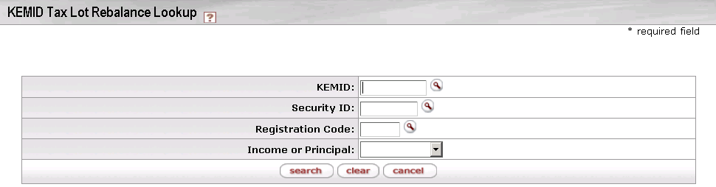

Here you may enter information into any combination of search fields in order to retrieve a tax lot you want to work with.

KEMID Tax Lot Rebalance Lookup definition

|  |  |
| --- | --- |
| Title | Description |
| KEMID | The KEMID that holds the tax lot you want to rebalance. |
| Security ID | The security associated with the tax lot you want to rebalance. |
| Registration Code | The registration code associated with the tax lot you want to rebalance. |
| Income or Principal | Type of funds (income or principal) associated with the tax lot you want to rebalance. |

After you enter search criteria and click **search**, the system displays a list of matching records at the bottom of the screen.

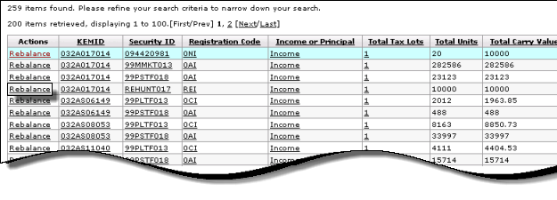

 For more information about the columns in the search results display, see Document Layout|tag=Document\_Layout\_Rebalance“Document Layout” below.

To rebalance one of these records, click the  link in the **Actions** column.

#### Document Layout|linktag=Document\_Layout\_Rebalance

After you click a **rebalance** link on the Lookup screen, the system displays the Holding Tax Lot Rebalance Document screen.

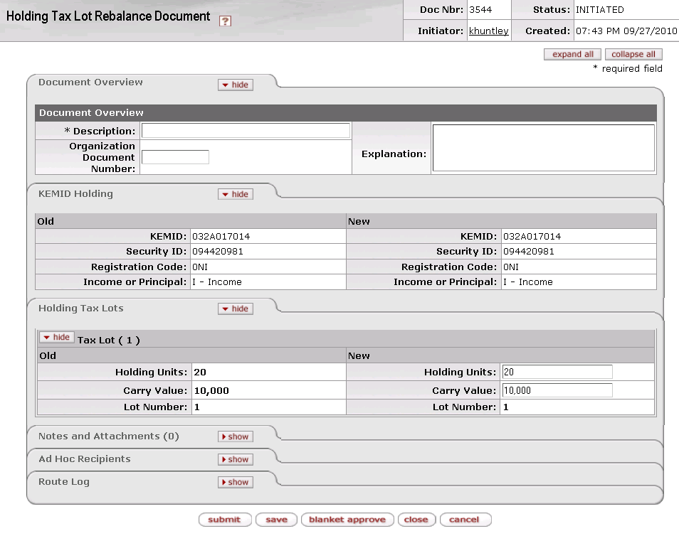

The Holding Tax Lot Rebalance document contains two unique tabs— **KEMID Holding and Holding Tax Lots**—in addition to the standard tabs.

 For more information about the standard tabs, see Standard Tabs|document=WordDocuments\KFS 5\_2 Overview.docx;topic=Standard Tabs“Standard Tabs” in the KFS Overview and Introduction to the User Interface.

##### KEMID Holding Tab

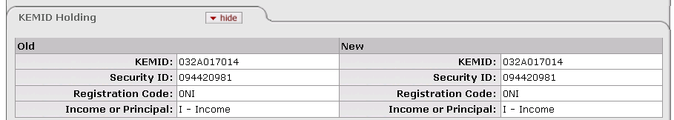

This tab contains the basic information identifying the KEMID and Security to be rebalanced. It is not editable.

KEMID ****Holding**** tab definition

|  |  |
| --- | --- |
| Title | Description |
| KEMID | Display only. The KEMID affected by this transaction. |
| Security ID | Display only. The security affected by this transaction. |
| Registration Code | Display only. The registration code associated with the security to be rebalanced. |
| Income or Principal | Display only. Indicates whether the affected securities are held in income or principal. |

##### ****Holding Tax Lots Tab****

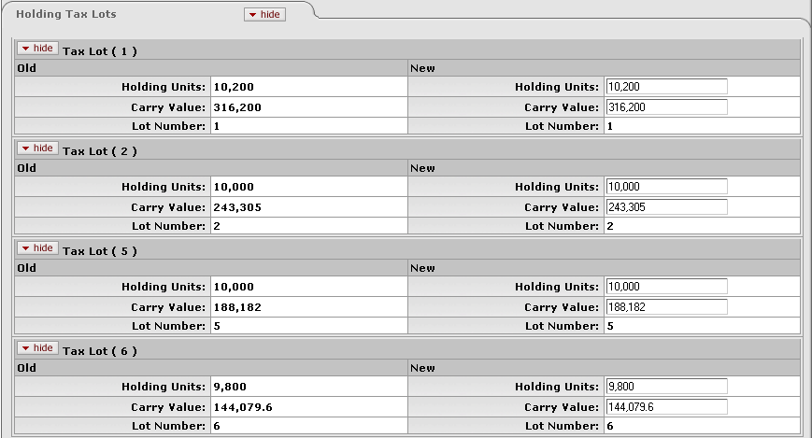

This tab lists the tax lots associated with the KEMID/security combination to be rebalanced. Each lot held by the KEMID is shown in a separate tab displaying the lot number in the tab header. The **Holding Units** and **Carry Value** are editable fields, so you may change the entries there.

Holding Tax Lots tab definition

|  |  |
| --- | --- |
| Title | Description |
| Holding Units | The number of units of the security held by the KEMID. Only positive values may be entered. You may bring the value of units to zero. The total number of units before the change must equal the total number of units after the change.  If the units are zero, the carry value must also be zero. If the carry value is zero, the units must also be zero. |
| Carry Value | The carry value of the security held by the KEMID. Only positive values may be entered. You may bring the carry value to zero. The total carry value before the change must equal the total carry value after the change.  If the carry value is zero, the units must also be zero. If the units are zero, the carry value must also be zero. |
| Lot Number | Display only. A sequence number identifying individual acquisitions of the same security by a KEMID. |

#### Process Overview

##### Business Rules

 For information about business rules that apply to all endowment transaction e-docs, see Standard Business Rules|document=WordDocuments\KFS 5\_2 KEM.docx;topic=Standard Business Rules.

In addition to the standard business rules for endowment transactions, the following business rules apply to holding tax lot rebalance transactions:

* You may edit the number of units in each tax lot. The total number of units before the change must equal the total number of units after the change.
* You may edit the carry value in each tax lot. The total carry value before the change must equal the total carry value after the change.
* Only positive values may be entered.
* You may bring the value of units and carry value to zero in a tax lot, but you cannot create a new tax lot with the e-doc.
* If you make one of the values zero, both MUST be zero (that is, if the units are zero, the carry value must also be zero and vice versa).

##### Routing

The figure below shows the standard routing for this e-doc. Your institution's routing may vary.



#### Example

An asset deposit is made to a KEMID and the units are placed into a new tax lot (tax lot 3). Later it is discovered that the units should have been placed into existing tax lot 1. A tax lot rebalance e-doc is entered to remove the units and their associated carry value from tax lot 3 and add them to the existing holdings in tax lot 1.

### Unit Share Adjustment

 **>  >  >  > **

The Unit/Share Adjustment e-doc allows you to change the number of units of a security held by a KEMID without affecting the original cost or carry value of the security tax lot(s). You input the number of units to be adjusted up or down, and the system spreads that change across all tax lots for the KEMID. If this transaction should not affect multiple tax lots, you may select only a specific tax lot or set of lots to be adjusted.

This e-doc does not affect the General Ledger because it does not change the carry value as recorded on the General Ledger. It does, however, affect the market value of the security held by the KEMID because it is a calculated value based on the number of units held.

Some situations in which you might want to use this e-doc include:

* Stock splits.
* Reverse stock splits.
* Adjustments to bring the information in line with that provided by a bank, manager or broker statement.

#### Document Layout

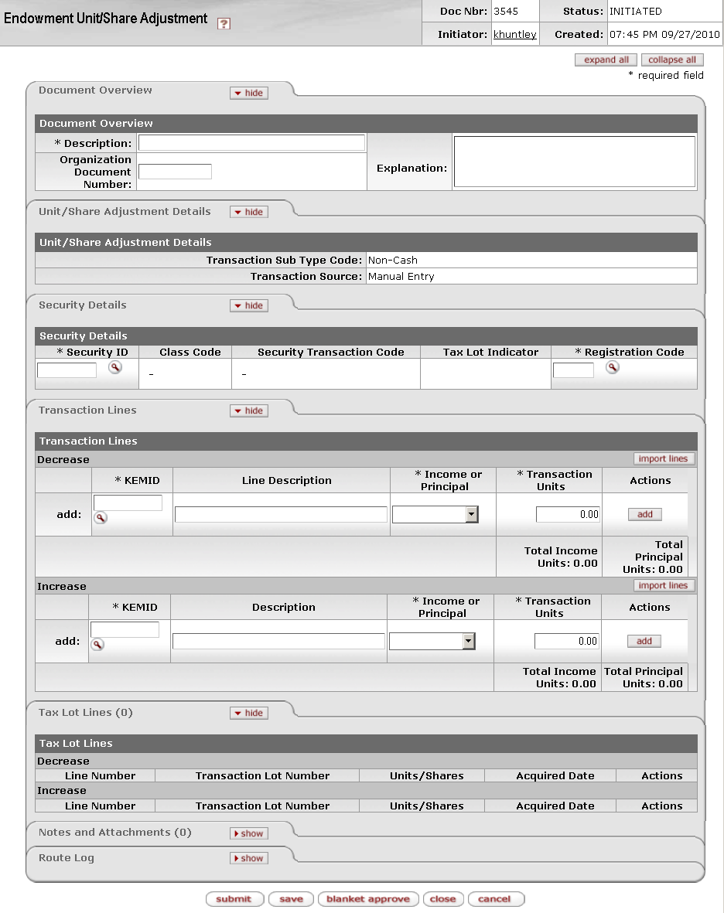

The Unit/Share Adjustment document contains four unique tabs— **Unit/Share Adjustment Details**, **Security Details, Transaction Lines, and Tax Lot Lines**—in addition to the standard tabs.

 For more information about the standard tabs, see Standard Tabs|document=WordDocuments\KFS 5\_2 Overview.docx;topic=Standard Tabs“Standard Tabs” in the KFS Overview and Introduction to the User Interface.

##### Unit/Share Adjustment ****Details**** Tab

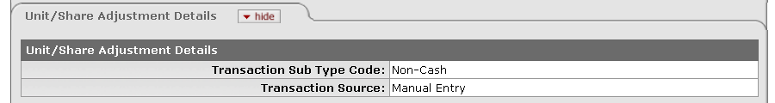

This tab indicates whether this is a cash or non-cash transaction and specifies whether it was created by the system or by a user.

Unit/Share Adjustment Details tab definition

|  |  |
| --- | --- |
| Title | Description |
| Transaction Sub Type Code | Display only. Indicates whether this transaction is for cash or non-cash. When you initiate this e-doc, the system sets the value to 'Non-Cash.' |
| Transaction Source | Display only. Indicates whether this transaction was generated automatically or entered by a user. When you initiate this e-doc, the system sets the value to 'Manual Entry.' |

##### Security Details Tab

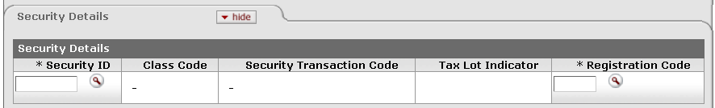

This tab contains details about the security being adjusted. You enter the Security ID and registration code, and the system populates the remainder of the tab.

Security Details tab definition

|  |  |
| --- | --- |
| Title | Description |
| Security ID | Required. The security involved in this transaction. The security record referenced must be valid and active in the system and must not have a liability class code. Only one security record may be used per transaction. The KEMID(s) you specify in the **Transaction Lines** tab must own sufficient shares of this security to complete the transaction.  Enter the ID or use the lookup _searchicon.gif to find it. The system then displays the description of the security you specified along with the associated class code and description, security transaction code and description, and tax lot indicator. |
| Class Code | Display only. The class (group) to which this security belongs. Examples include: Alternative Investment, Bond, Cash Equivalents, Liability, Other, Pooled Investment and Stock. |
| Security Transaction Code | Display only. The security transaction code assigned to this security. The system obtains this value from the class code for the security. |
| Tax Lot Indicator | Display only. Indicates whether affected security units (holdings) are maintained in separate accounting (tax) lots. This indicator determines how gains and losses on the sale of the security are calculated.  'Yes' = Security units are maintained in separate tax lots.  'No' = Security units are consolidated into one holding. |
| Registration Code | Required. The location where the actual investment security is housed for safekeeping (for example, a bank).  Enter a valid, active registration code or use the lookup _searchicon.gif to find it. The system then displays the description of the registration code you specified. |

##### Transaction Lines Tab

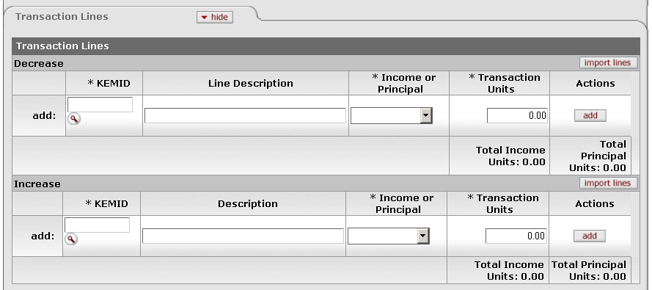

This tab contains information that changes the number of units of a security held by a KEMID without affecting the original cost or carry value of the security. You may enter data into the **Increase** or **Decrease** section but not both.

Transaction Lines tab definition

|  |  |
| --- | --- |
| Title | Description |
| KEMID | Required. The KEMID that holds the security. Enter the KEMID or use the lookup _searchicon.gif to find it. |
| Line Description (Decrease line)  Description (Increase line) | Optional. The reason for decreasing or increasing the shares (for example, 'Record reverse stock split' or 'Record stock split'). |
| Income or Principal | Required. Indicates whether the affected securities are held in income or principal. Select the appropriate value from the list. |
| Transaction Units | Required. The number of shares by which to decrease or increase this holding. Enter the value as a positive number. |
| Actions | Click a button to perform an action on this line. When you are adding a new line, only the **add** button is displayed. After you have added a line, the **bal inquiry** button (which allows you to select and view balance inquiry reports) and **delete** button (which allows you to delete the line from the document) are displayed. |
| Total Income Units | Display only. The total number of shares affecting income on the transaction lines. Calculated and displayed separately for the **Increase** and **Decrease** sections of the tab. |
| Total Principal Units | Display only. The total number of shares affecting principal on the transaction lines. Calculated and displayed separately for the **Increase** and **Decrease** sections of the tab. |

If you have a number of transaction lines to enter, you may create a .csv file containing the information and import it into the Unit/Share Adjustment e-doc. To add multiple transaction lines from a file, follow these steps:

1. Retrieve the data import template from “KEM\_EUSA\_Import.xls” in the *KFS Overview and Introduction to the User lnterface*.
2. Create a .csv file and import it via the button according to the instructions in “Creating a .csv File” in the *KFS Overview and Introduction to the User lnterface*.

##### Tax Lot Lines Tab

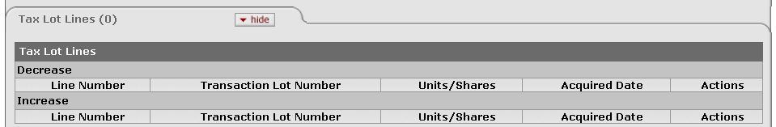

When you initiate an increase or decrease transaction and make the necessary entries in the **Security Details** and **Transaction Lines** tabs, the system calculates impact of the transaction on the tax lots. It then displays information in this tab to show how the change is distributed among the individual tax lots for the security. The tab header indicates the number of tax lines in the e-doc.

After data is displayed in the tax lot lines, you may delete any line that should not be a part of this adjustment. (For example, you might delete a tax lot line for a lot that was received after a stock split cutoff date). If one or more lines are deleted, the system recalculates the unit distribution among the remaining lots.

 All calculations for tax lot lines are rounded according to the standard KFS endowment rules for rounding. For more information on these rules, see Standard Rounding Rules|document=WordDocuments\KFS 5\_2 KEM.docx;topic=Standard Rounding Rules.

Tax Lot Lines tab definition

|  |  |
| --- | --- |
| Title | Description |
| Line Number | Display only. The line number from the corresponding **Increase** or **Decrease** transaction line. |
| Transaction Lot Number | Display only. A system-generated ID number for the tax lot based on the tax lot holding number. |
| Units/Shares | Display only. The number of units or shares calculated by the system based on the number of units in the original tax lots as a percentage of the total units of the security tax lots in the record held by the KEMID. |
| Acquired Date | Display only. The acquisition date for the holdings in this tax lot. |
| Actions | Click tinybutton-delete1 to delete a tax lot. At least one tax lot must remain. Deleting a line causes the system to recalculate the distribution among the remaining lines. |

#### Process Overview

##### Business Rules

 For information about business rules that apply to all endowment transaction e-docs, see Standard Business Rules|document=WordDocuments\KFS 5\_2 KEM.docx;topic=Standard Business Rules.

In addition to the standard business rules for endowment transactions, the following business rules apply to unit/share adjustment transactions:

* When you initiate the e-doc, the system sets the **Transaction Sub Type Code** to 'Non-Cash.' You cannot change this entry.
* A valid, active security must be selected or entered in the Security Details tab. Only one security record may be inserted in each transaction.
* The security entered must not have a liability class code.
* When you submit or save the e-doc, the system sets the security line type code to match that of the transaction lines entered.
* After you enter a security, the system displays the associated security name and class code, class code description, tax lot indicator, and security transaction code.
* You must enter a valid, active registration code.
* You may enter data into either the Increase or Decrease transaction lines, but not both.
* You may enter multiple transaction lines on this e-doc.
* For each transaction line entered, you must specify whether it is to affect securities held in income or principal.
* You must enter a number greater than zero for the unit adjustment amount in the transaction line.
* After you add a transaction line, the system creates the appropriate entries in the **Tax Lot Lines** tab. If the transaction line units are edited or the transaction line is deleted, the records in the tax lot lines tab are corrected automatically.
* You may delete tax lot lines, but at least one tax lot line must remain in the transaction.
* As a tax lot line is deleted, the system recalculates the unit distribution among the remaining lots.
* No value is placed in the **Transaction Amount** field, so no values are totaled for the Endowment **Document Detail Line** or **Transaction Lines** tab.
* This e-doc is not reversible.
* IF the system is unable to locate tax lot records to match the criteria set for the **Security**/ **Registration Code**/ **KEMID**/ **Income or Principal** indicator, the transaction cannot proceed. To alert you to this condition, the system highlights the KEMID in the transaction line.

##### Routing

 For information about standard routing for all endowment transaction e-docs, see Standard Routing|document=WordDocuments\KFS 5\_2 KEM.docx;topic=Standard Routing.

#### Example

After deciding that the share price was too high, Company ABC issued a 2-for-1 stock split. To record this split into a KEMID which owns 100 shares of ABC, a Unit / Share adjustment transaction was entered. The transaction line included the 100 new units as an increase. As a result of the transaction, the KEMID held twice as many units and the carry value remained unchanged.

## Lookup and Maintenance E-Docs

 > >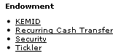

The **Lookup and Maintenance** submenu on the **Main Menu** tab provides access to e-docs through which you view, create, and maintain institutionally held endowment and security records as well as records for ticklers and recurring cash transfers.

Endowment e-docs available on the Main Menu, Lookup and Maintenance submenu

|  |  |
| --- | --- |
| Document Type | Description |
| KEMID|document=WordDocuments\KFS 5\_2 KEM.docx;topic=KEMID (KEMIDMaintenancedocument) | Allows you to create and work with a KEMID record that identifies a specific set of funds held by your institution as an endowment or a specific set of funds functioning as an endowment. |
| Recurring Cash Transfer|document=WordDocuments\KFS 5\_2 KEM.docx;topic=Recurring Cash Transfer (RecurringCashTransferMaintenanceDocument) | Allows you to schedule recurring cash transfers, each of which is associated with a single KEMID and occurs on a regular, periodic basis. |
| Security|document=WordDocuments\KFS 5\_2 KEM.docx;topic=Security (SecurityMaintenancedocument) | Allows you to create and work with a Security record for a security held by your institution. |
| TIckler|document=WordDocuments\KFS 5\_2 KEM.docx;topic=Tickler (TicklerMaintenancedocument) | Allows you to create and work with ticklers (reminders) associated with your KEMIDs, funds, and securities. |

### KEMID

 > > > > 

The KEMID e-doc allows you to create and work with the KEMID record that identifies a specific set of funds held by your institution as an endowment or a specific set of funds functioning as an endowment. KEMID records contain information that specifies the sort of activity that may take place for the KEMID and that specifies how and when automated activity is to occur.

When you select **KEMID** from the menu, the system displays the KEMID Lookup screen.

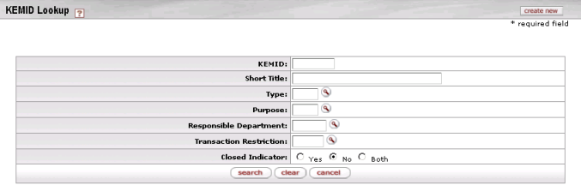

On this screen, you have two options:

* To set up a new KEMID, click the **create new** button in the upper right corner of the screen. The system displays the screen in create mode. Complete the fields as indicated in Document Layout below.
* To display information for one or more existing KEMIDs, enter search criteria in the fields on this screen as explained in the table below and click **search**.

KEMID Lookup definition

|  |  |
| --- | --- |
| Title | Description |
| KEMID | The KEMID for a record you want to work with. A KEMID identifies a specific set of funds held by your institution as an endowment or a specific set of funds functioning as an endowment. |
| Short Title | The short title associated with the KEMID you want to work with. |
| Type | The reporting group to which the KEMID belongs. |
| Purpose | The purpose of the KEMID you want to work with. |
| Responsible Department | The department responsible for administering the KEMID with which you want to work. |
| Transaction Restriction | The transaction restriction associated with the KEMID you want to work with. |
| Closed Indicator | Open/closed status of the KEMID you want to work with. |

* After you enter search criteria and click **search**, the system displays a list of matching records at the bottom of the screen.

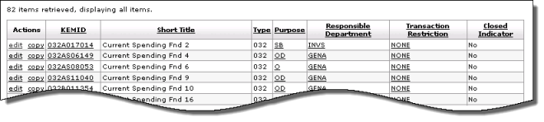

KEMID Search results definition

|  |  |
| --- | --- |
| Title | Description |
| KEMID | A specific set of funds held by your institution as an endowment or a specific set of funds functioning as an endowment. |
| Short Title | An abbreviated title for internal reporting use. |
| Type | A code identifying the group to which this KEMID belongs for reporting purposes. Your university's groupings might include University General Endowed Funds, Discretionary Funds, and Expendable Funds. |
| Purpose | A code identifying the allowable use(s) of this endowment fund. Examples at your institution might include Scholarships, Professorships, Chairs, and/or General Use. |
| Responsible Department | A code identifying the department or group responsible for administering the KEMID. |
| Transaction Restriction | A code identifying the set of rules governing allowable transactions for the KEMID. |
| Closed Indicator | Indicates whether this KEMID is open or closed. |

To edit or copy one of these records, click the or link in the **Actions** column.

From the results table, you may drill down into detail for a KEMID. To do so, click an underlined KEMID. The system displays the KEMID Inquiry screen.

 To see images of the KEMID Inquiry screen in three parts, see Drilldown into KEMID Inquiry Screen|topic=Drilldown into KEMID Inquiry Screen. For information about the fields on the Inquiry screen, see “Document Layout” below.

#### Document Layout

When you click an underlined KEMID in the search results after searching on the KEMID Lookup screen, the system displays the KEMID record in inquiry (view-only) mode. When you click **create new** in the top right corner of the KEMID Lookup screen or click the **edit** link for any row in the search results display, the system displays the KEMID Maintenance Document screen. If you are creating a new KEMID, the screen is displayed in create mode (as shown below). If you are editing a KEMID, the screen is displayed in edit mode.

The screen is quite long. It is shown below in three segments.

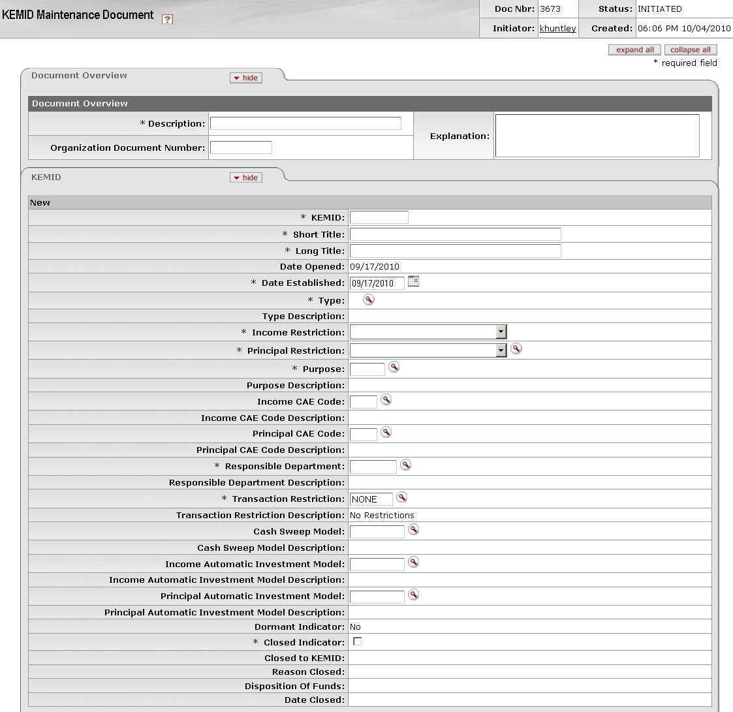

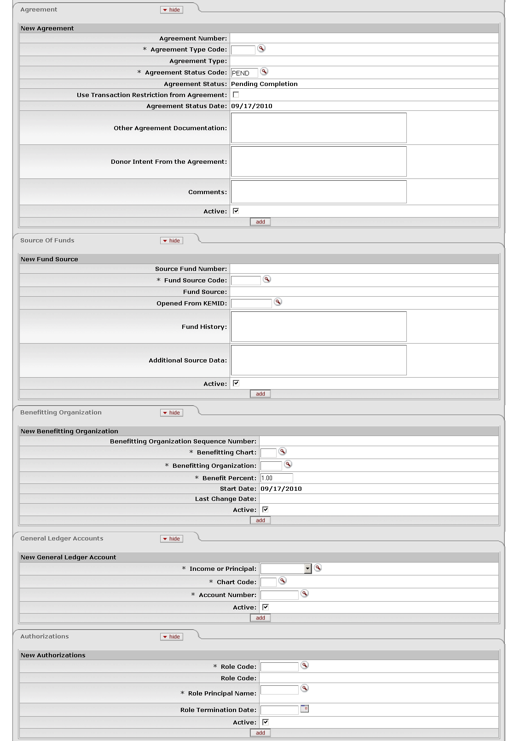

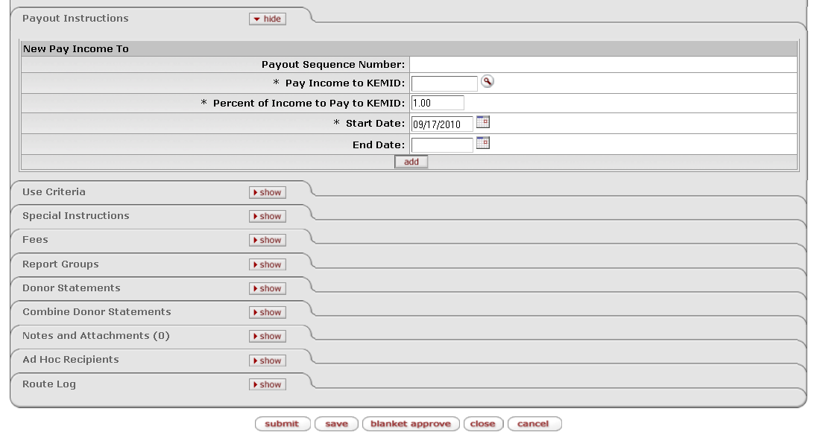

The KEMID document contains 13 unique tabs— **KEMID**, **Agreement**, **Source of Funds**, **Benefitting Organization**, **General Ledger Accounts**, **Authorizations**, **Payout Instructions**, **Use Criteria**, **Special Instructions**, **Fees**, **Report Groups**, **Donor Statements**, and **Combine Donor Statements**—in addition to the standard tabs.

 For more information about the standard tabs, see Standard Tabs|document=WordDocuments\KFS 5\_2 Overview.docx;topic=Standard Tabs“Standard Tabs” in the KFS Overview and Introduction to the User Interface.

##### KEMID Tab

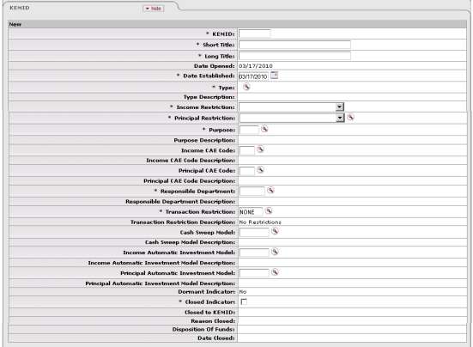

This tab contains the basic attributes for an endowment account—title, account purpose, date the account was created, restrictions on the use of funds or types of transactions that can be initiated for the account, and more. One and only one KEMID record may be created per e-doc.

KEMID tab definition

|  |  |
| --- | --- |
| Title | Description |
| KEMID | May be either required or system-generated when you initiate the e-doc; display only when the e-doc is in edit mode. A KEMID identifies a specific set of funds held by your institution as an endowment or a specific set of funds functioning as an endowment. |
| Short Title | Required. An abbreviated title for internal reporting use. |
| Long Title | Required. The full title for the endowment. This title may be determined by the donors and/or department. It is part of the signed endowment agreement and is used in all correspondence with the university and donors. |
| Date Opened | Display only. Defaults to the associated value in the restriction code in your institution's PEND (Pending Completion) Agreement Status Code record. |
| Date Established | Required. The date the original account was established for the benefit of the university. Enter the date or select it from the calendar cal. |
| Type | Required. The group to which this KEMID belongs for reporting purposes. Your university's groupings might include University General Endowed Funds, Discretionary Funds, and Expendable Funds. Use the lookup _searchicon.gif to find the appropriate type. This value must already exist in the system. |
| Type Description | Display only. Your institution's description of the type specified. |
| Income Restriction | Required. The type of restriction (if any) that affects transaction processing for the endowment's income. Select the appropriate value from the list. |
| Principal Restriction | Required. The type of restriction (if any) that affects transaction processing for the endowment's principal. Select the appropriate value from the list. |
| Purpose | Required. Specifies the allowable uses of this endowment fund. Examples at your institution might include Scholarships, Professorships, Chairs, and/or General Use. Enter the code or use the lookup _searchicon.gif to find it. This value must already exist in the system. |
| Purpose Description | Display only. Your institution's description for the purpose code specified. |
| Income CAE Code | The appropriate Council for Advancement in Education (CAE) code for use in reporting based on the intended use of the KEMID's income. Enter the code or use the lookup _searchicon.gif to find it. This value must already exist in the system. |
| Income CAE Code Description | Display only. The description associated with the income CAE code specified. |
| Principal CAE Code | The appropriate Council for Advancement in Education (CAE) code for use in reporting based on the intended use of the KEMID's principal. Enter the code or use the lookup _searchicon.gif to find it. This value must already exist in the system. |
| Principal CAE Code Description | Display only. The description associated with the principal CAE code specified. |
| Responsible Department | Required. The department or group responsible for administering the KEMID. This is not the department or organization that is the beneficiary of the funds. Enter the code or use the lookup _searchicon.gif to find it. This value must already exist in the system. |
| Responsible Department Description | Display only. The familiar name of the responsible department. |
| Transaction Restriction | Required. The set of rules that is to govern allowable transactions for the KEMID. Defaults to the associated value in your institution's PEND (Pending Completion) Agreement Status Code record, but you may enter another code or use the lookup _searchicon.gif to find it. This value must already exist in the system. |
| Transaction Restriction Description | Display only. The description for the transaction restriction specified. |
| Cash Sweep Model | The ID code of the cash sweep model that is to control the periodic sweeping of uninvested cash into short-term investment vehicles. Each KEMID may be associated with only one cash sweep model that controls separate investments in the KEMID's income and principal. |
| Cash Sweep Model Description | Display only. Your institution's description of the cash sweep model specified. |
| Income Automatic Investment Model | The automated cash investment model to be used for income for this endowment fund. This value defaults from the Type record, but you may enter another code or use the lookup _searchicon.gif to find it. This value must already exist in the system. |
| Income Automatic Investment Model Description | Display only. Your institution's description of the income investment model specified. |
| Principal Automatic Investment Model | This is the automated cash investment model to be used for the principal for this endowment fund. This value defaults from the Type record, but you may enter another code or use the lookup _searchicon.gif to find it. This value must already exist in the system. |
| Principal Automatic Investment Model Description | Display only. Your institution's description of the principal investment model specified. |
| Dormant Indicator | Display only when you create the e-doc; editable when the e-doc is in edit mode. Indicates whether this KEMID is dormant. If a KEMID is dormant, it has not processed any disbursements for a period of time determined by your institution.  Defaults to 'No' when you create the KEMID, but you may check the box to change the indicator to 'Yes' when the screen is in edit mode. |
| Closed Indicator | Indicates whether this KEMID is closed. Defaults to 'No' when you create the KEMID, but you may change it.  exclaim You cannot mark a KEMID record as closed if the KEMID has open current cash records (records with values greater or less than zero).  exclaim You cannot mark a KEMID record as closed if the KEMID has holding tax lot records with values greater or less than zero in the **Holding Units**, **Holding Cost**, and/or **Accrued Income Due** field. |
| Closed to KEMID | Display only when you initiate an e-doc. For a closed KEMID, indicates the KEMID to which funds were moved when this KEMID was closed. |
| Reason Closed | Display only when you initiate an e-doc; may be edited in edit mode. The reason for closing this KEMID. Examples include 'Terminated,' 'Expended,' 'Merged,' and 'Refunded to Donor.' Enter the appropriate value or use the lookup _searchicon.gif to find it. |
| Disposition of Funds | Display only when you initiate an e-doc; may be edited in edit mode. Additional comments as needed regarding the closure. |
| Date Closed | Display only when you initiate an e-doc; may be edited in edit mode. Entry is valid only if the Closed Indicator field is set to 'Yes.' |

##### Agreement Tab

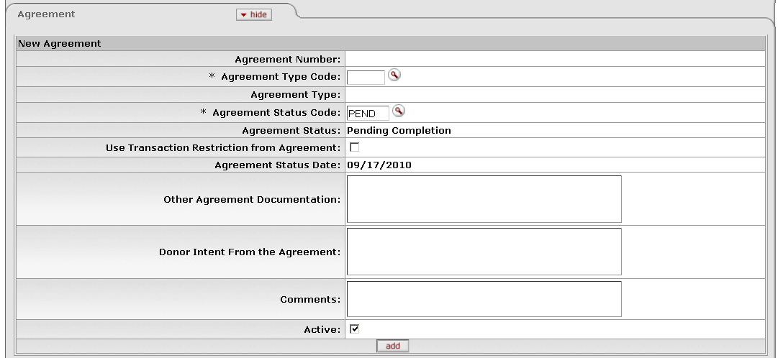

Agreement tab

This tab contains information regarding the agreement and/or instructions from the donor in establishing the KEMID. You must enter at least one agreement record for each KEMID. You may specify multiple agreements if your organization is combining endowments.

Agreement tab definition

|  |  |
| --- | --- |
| Title | Description |
| Agreement Number | Display only. A sequential, system-assigned number that uniquely identifies the donor agreement. |
| Agreement Type Code | Required. Identifies the type of agreement between the donor or unit and the organization. Indicates how the account will be managed. Examples of agreement types include grant, gift, pledge or last will and testament agreement. Enter an existing code or use the lookup _searchicon.gif to find it. |
| Agreement Type | Display only. Your institution's description for the specified agreement type code. |
| Agreement Status Code | Required. The current status of this agreement. Defaults to 'PEND' (Pending Completion), but you may change it or use the lookup _searchicon.gif to find another code. |
| Agreement Status | Display only. Your institution's description for the specified agreement status code. |
| Use Transaction Restriction from Agreement | Indicates whether to use the transaction restriction for this agreement for the KEMID. The default value is 'No' (box is unchecked).  If you change the **Agreement Status Code** value and if this box is set to 'Yes,' the system displays the default transaction restriction code.  If this KEMID has multiple active agreements, only one agreement may have this box set to 'Yes.' |
| Agreement Status Date | Display only. Defaults to the current date. If you change the **Agreement Status Code** value, this value is automatically updated to reflect the current date. |
| Other Agreement Documentation | Information regarding specific legal and other documents on file that relate to the purpose of the account and donor intent. |
| Donor Intent From the Agreement | A description of the donor's stated intent for the use of funds as per the agreement. |
| Comments | Additional direction for persons who reference this agreement. |
| Active | Indicates whether this record is viewable. Defaults to 'Yes' but may be changed. When changed to 'No', this record is not displayed on the KEMID Detail Inquiry screen.  pencil-small When this screen is in edit mode, all records (both active and inactive) are displayed and you can re-activate records if needed. |

##### Source of Funds Tab

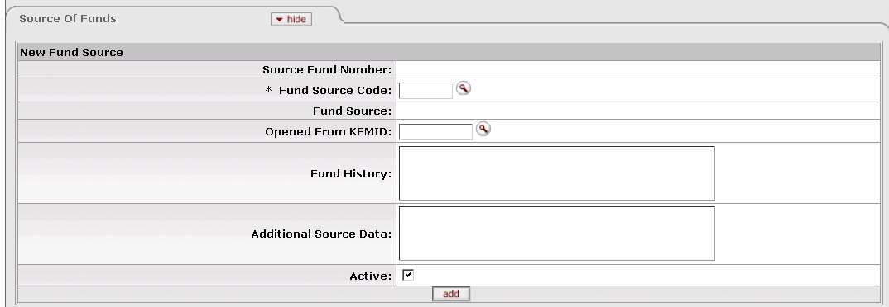

Source of Funds tab

This tab contains information about the standard sources of funding for a KEMID. These codes are used for reporting purposes only. Examples include Specific Donor(s), Multiple Donors and Pooled Funds. You must create at least one Source of Funds record for each KEMID. Multiple records are allowed.

Source of Funds tab definition

|  |  |
| --- | --- |
| Title | Description |
| Source Fund Number | Display only. A sequential, system-assigned number that uniquely identifies this source of funds. |
| Fund Source Code | Required. The applicable fund source code. Enter the code or use the lookup _searchicon.gif to find it. The code specified must exist in the system. |
| Fund Source | Display only. Your institution's description for the specified fund source code. |
| Opened from KEMID | For accounts that are opened as a result of the closing of another account, the account number of the closed account. Enter an existing KEMID or use the lookup _searchicon.gif to find it. |
| Fund History | Any other historical information regarding this account's source of funds (original endowment numbers or identifiers from previous recordkeeping systems, etc.). |
| Additional Source Data | Any additional data regarding this account's source of funds (donor IDs, campaign information, etc.). |
| Active | Indicates whether this record is viewable. Defaults to 'Yes' but may be changed. When changed to 'No', this record is not displayed on the KEMID Detail Inquiry screen.  pencil-small When this screen is in edit mode, all records (both active and inactive) are displayed and you can re-activate records if needed. |

##### Benefitting Organization Tab

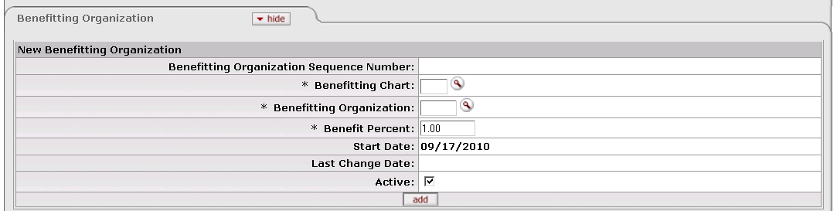

This tab contains information identifying the area(s) of the organization that benefit from the funds in this account. Each KEMID record must include at least one Benefitting Organization record. Multiple records are permitted.

Benefitting Organization tab definition

|  |  |
| --- | --- |
| Title | Description |
| Benefitting Organization Sequence Number | Display only. A sequential, system-assigned number that uniquely identifies this benefitting organization. |
| Benefitting Chart | Required. The chart code associated with the benefitting organization for endowment recordkeeping purposes. Enter an existing chart code or use the lookup _searchicon.gif to find it. |
| Benefitting Organization | Required. The organization (department) within the specified chart that is the beneficiary of this endowment account. Enter an existing organization code or use the lookup _searchicon.gif to find it. |
| Benefit Percent | Required. The percent of the endowment fund this benefitting organization will receive. Defaults to 1 (100%). You may change this entry. If this entry is less than 1, the sum of all percentages for this KEMID's benefitting organizations must equal 1. |
| Start Date | Display only. The date this organization was assigned as a beneficiary on this account. |
| Last Change Date | Display only. The date of the most recent change to this benefitting organization record. |
| Active | Indicates whether this record is viewable. Defaults to 'Yes' but may be changed. When changed to 'No', this record is not displayed on the KEMID Detail Inquiry screen.  pencil-small When this screen is in edit mode, all records (both active and inactive) are displayed and you can re-activate records if needed. |

##### General Ledger Accounts Tab

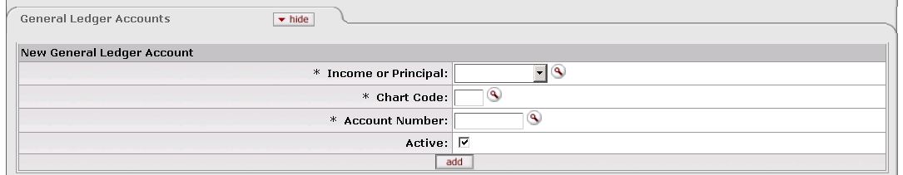

This tab specifies the General Ledger account(s) to which transaction information is to be interfaced. Each KEMID record must contain two General Ledger Account records. One specifies how principal transactions are to be applied to the GL while the other specifies how income transactions are to be applied.

General Ledger Accounts tab definition

|  |  |
| --- | --- |
| Title | Description |
| Income or Principal | Required. Indicates whether this record is for income or principal. Select the appropriate value from the list or use the lookup _searchicon.gif to find it. |
| Chart Code | Required. The General Ledger chart to which transactions are to be applied. Enter an existing chart code or use the lookup _searchicon.gif to find it.  C:\Users\jonny\Desktop\KFS 5.0.2\User Guide Images\pencil-small.gif When the parameter Accounts\_Can\_Cross\_Charts is set to 'No', the system derives the chart code from the account number entered, and an entry in this field is not required. |
| Account Number | Required. The General Ledger account number to which transactions are to be applied. Enter an existing account number or use the lookup _searchicon.gif to find it. |
| Active | Indicates whether this record is viewable. Defaults to 'Yes' but may be changed. When changed to 'No', this record is not displayed on the KEMID Detail Inquiry screen.  pencil-small When this screen is in edit mode, all records (both active and inactive) are displayed and you can re-activate records if needed. |

##### Authorizations Tab

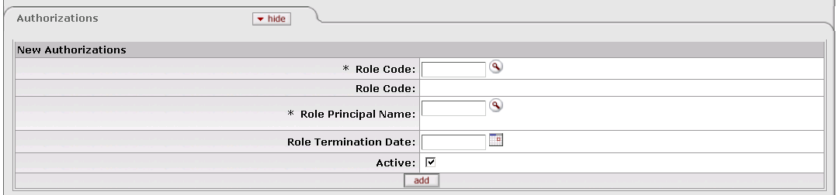

This tab contains information about the role(s) that must authorize transactions affecting this KEMID. If your institution requires that authorization by role is required, each KEMID record must have at least one authorization record associated with it. You may associate multiple roles with the KEMID in this tab.

Authorizations tab definition

|  |  |
| --- | --- |
| Title | Description |
| Role Code | Required. The ID code for a role that must authorize transactions for this KEMID. Enter a valid role code or use the lookup _searchicon.gif to find it. |
| Role Code | Display only. The description or name for the specified role code. |
| Role Principal Name | Required. The user name of the individual who is responsible for authorizations. |
| Role Termination Date | The date (if any) the role is due to terminate for the purpose of authorizations. Enter a date or select it from the calendar _cal. |
| Active | Indicates whether this record is viewable. Defaults to 'Yes' but may be changed. When changed to 'No', this record is not displayed on the KEMID Detail Inquiry screen.  pencil-small When this screen is in edit mode, all records (both active and inactive) are displayed and you can re-activate records if needed. |

##### Payout Instructions Tab

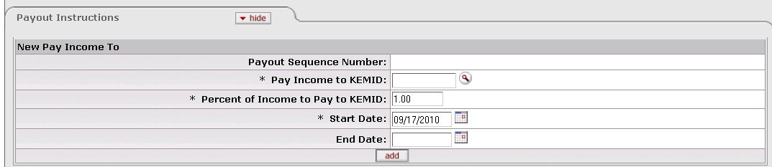

This tab contains information that controls the payout of pooled fund income. The default is to pay out 100% to the income of the KEMID, but all or part of the income received from the pooled funds owned by the KEMID may be automatically transferred to one or more KEMIDs as a result of the instructions in this tab. Each KEMID must have at least one set of payout instructions. Multiple sets of instructions may be added.

Payout Instructions tab definition

|  |  |
| --- | --- |
| Title | Description |
| Payout Sequence Number | Display only. The system-assigned sequence number for this record. |
| Pay Income to KEMID | Required. The KEMID to which the pooled fund income is to be paid. Defaults to the KEMID to which the record is attached. If desired, enter another existing KEMID or use the lookup _searchicon.gif to find it. |
| Percent of Income to Pay to KEMID | Required. The percentage of the income that is to be paid to the specified KEMID. Defaults to '1**'** (100%) but may be changed.  If you add more than one set of payout instructions, the sum of all percents must equal '1'. |
| Start Date | Required. The first date on which these instructions apply. Enter the date or select it from the calendarcal. The date specified cannot be changed after the start date has been reached. |
| End Date | The last date on which these instructions apply. Enter the date or select it from the calendar cal. You cannot view or edit the record after the end date has been reached. |

##### Use Criteria Tab

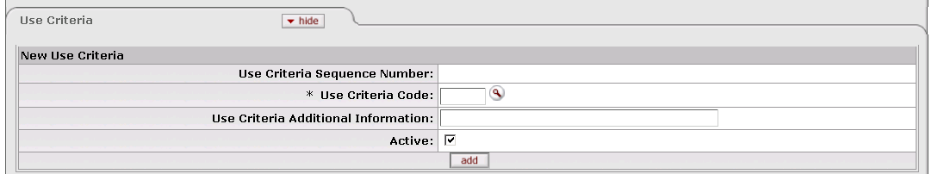

This tab contains codes that govern specific restrictions that donors place on spendable funds and/or earnings of a gift. For example, the criteria for a scholarship selection and distribution might be limited by gender or county. Having this information readily available can expedite verification of compliance with donor intent.

Use of this tab is not required for any KEMID record. If you choose to use the tab, you may associate one or more sets of use criteria with the KEMID.

Use Criteria tab definition

|  |  |
| --- | --- |
| Title | Description |
| Use Criteria Sequence Number | Display only. The system-assigned sequence number for this record. |
| Use Criteria Code | Required when adding a record to associate this KEMID with a set of use criteria; otherwise, display only. A code used by your institution to restrict the use of funds and/or earnings from a gift. Enter an existing code or use the lookup _searchicon.gif to find it. |
| Use Criteria Additional Information | Optional. Any additional detail that helps to further define the qualifying criteria in this record. |
| Active | Indicates whether this record is viewable. Defaults to 'Yes' but may be changed. When changed to 'No', this record is not displayed on the KEMID Detail Inquiry screen.  pencil-small When this screen is in edit mode, all records (both active and inactive) are displayed and you can re-activate records if needed. |

##### Special Instructions Tab

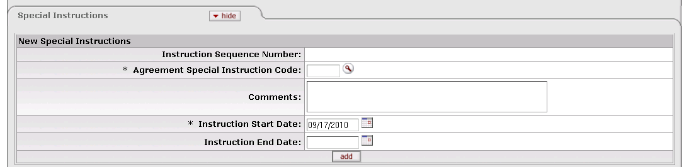

This tab contains information regarding any unique, special instructions given by donors regarding the disposition of the earnings of the funds. For example, you institution might use this tab to record instructions related to reinvestment earnings or to transfer earnings another account.

Use of this tab is not required for any KEMID record. If you choose to use the tab, you may associate one or more sets of special instructions with the KEMID. The instructions in the tab are used for information and reporting only.

Special Instructions tab definition

|  |  |
| --- | --- |
| Title | Description |
| Instruction Sequence Number | Display only. The system-assigned sequence number for this record. |
| Agreement Special Instruction Code | Required when adding a record to associate this KEMID with a set of special instructions; otherwise, display only. A code used by your institution to identify this set of special instructions. Enter an existing code or use the lookup _searchicon.gif to find it. |
| Comments | Optional. Any additional detail that helps to clarify the instructions in this record. |
| Instruction Start Date | Required. The date these instructions are to take effect. The default entry is today's date, but you may enter another date or select it from the calendar cal |
| Instruction End Date | The last date on which these instructions are to be available in the system. You can no longer view or change a record after this date has passed. Enter the date or select it from the calendar cal. |

##### Fees Tab

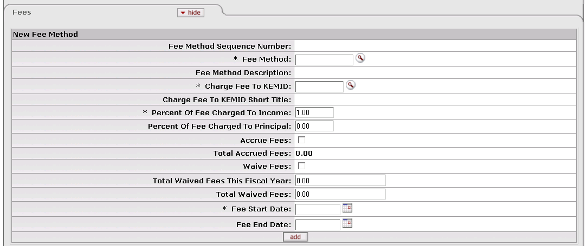

This tab contains information that is used by the system to assess fees against KEMIDs. These fees are calculated and charged to KEMIDs through an overnight batch process. Use of this tab is not required for any KEMID record. If you choose to use the tab, you may associate one or more fee methods with the KEMID.

Fees tab definition

|  |  |
| --- | --- |
| Title | Description |
| Fee Method Sequence Number | Display only. The system-assigned sequence number for this record. |
| Fee Method | Required when adding a record to associate this KEMID with a fee method; otherwise, display only. The code used by your institution to identify a particular set of parameters for calculating fees to be assessed against KEMIDs. Enter an existing fee method code or use the lookup _searchicon.gif to find it. |
| Fee Method Description | Display only. Your institution's description for this fee method. |
| Charge Fee to KEMID | The KEMID to which fees will be charged. Defaults to the KEMID for the record, but you may enter another existing KEMID or use the lookup _searchicon.gif to find it. |
| Charge Fee to KEMID Short Title | Display only. The KEMID's abbreviated title for internal reporting use. |
| Percent Of Fee Charged To Income | Required. The percent of the fee to be calculated on counts or values related to the income of the KEMID activity and/or holdings. Defaults to '1.00' (100%). You may change this value. The value entered must be a fixed point number, with three total digits including two digits to the right of the decimal point. |
| Percent Of Fee Charged to Principal | Defaults to 0.00 (0%). If only a portion of the fees are to be assessed against the income funds, the percent of the fee to be calculated on counts or values related to the principal of the KEMID activity and/or holdings. You may change this value, but it cannot exceed 0.00 if the **Restriction Code** value is 'NA' (Not Applicable) for the KEMID type code. The value entered must be a fixed point number, with three total digits including two digits to the right of the decimal point. |
| Accrue Fees | Indicates whether or not to accrue the fees charged to the account (Y/N). Defaults to 'No.' |
| Total Accrued Fees | The total of all fees calculated by this method that have accrued to date. Defaults to zero, is system generated, and may be changed in edit mode only.  exclaim.gif When the fee end date is reached, if there is a balance in the total accrued fees, the system adds that value to the total waived fees this fiscal year and changes the **Total Accrued Fees** value to zero. |
| Waive Fees | Indicates whether or not to waive the fees charged to the KEMID (Y/N). Defaults to 'No.' |
| Total Waived Fees This Fiscal Year | Display only. The total of the waived fees that could have been charged to the account for the current fiscal year. Defaults to zero, is system generated, and cannot be changed.  exclaim.gif When the fee end date is reached, if there is a balance in the total accrued fees, the system adds that value to the total waived fees this fiscal year and changes the **Total Accrued Fees** value to zero. |
| Total Waived Fees | Display only. The total of the waived fees calculated by this method that could have been charged to the account since the fee start date. Defaults to zero, is system generated, and cannot be changed. |
| Fee Start Date | Required. The first date on which this fee is to be assessed. Defaults to the next processing date. May be changed only when you are adding a new record. Enter the date or select it from the calendar cal. If edited, this value must be valid based on the fee frequency. |
| Fee End Date | The last date on which this fee is to be assessed. Enter the date or select it from the calendar cal. When the fee end date is reached, if there is a balance in the total accrued fees, the system adds that value to the total waived fees this fiscal year and changes the **Total Accrued Fees** value to zero. |

##### Report Groups Tab

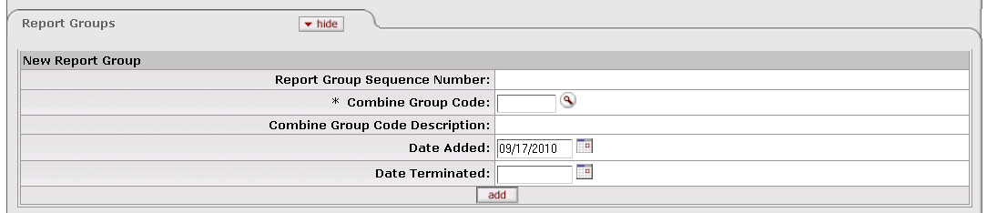

This tab lists the report groups for consolidated reporting to which the KEMID belongs. It contains coding that allows your institution to combine KEMIDs for reporting purposes. For example, you may need to group all KEMIDs that support a Life Sciences initiative. Use of this tab is not required for any KEMID record. If you choose to use the tab, you may associate one or more report groups with the KEMID.

Report Groups tab definition

|  |  |
| --- | --- |
| Title | Description |
| Report Group Sequence Number | Display only. The system-assigned sequence number for this record. |
| Combine Group Code | Required when adding a record to associate this KEMID with a reporting group; otherwise, display only. Enter an existing code or use the lookup _searchicon.gif to find it. |
| Combine Group Code Description | Display only. Your institution's description of the combine group code specified. |
| Date Added | The first date on which the KEMID is to be included in this report group. Defaults to the current date, but you may enter another date or select it from the calendar cal. |
| Date Terminated | The last date on which this KEMID is to be included in this report group. Enter the date or select it from the calendar cal. After this date is reached, the record is no longer available for viewing or editing. |

##### Donor Statements Tab

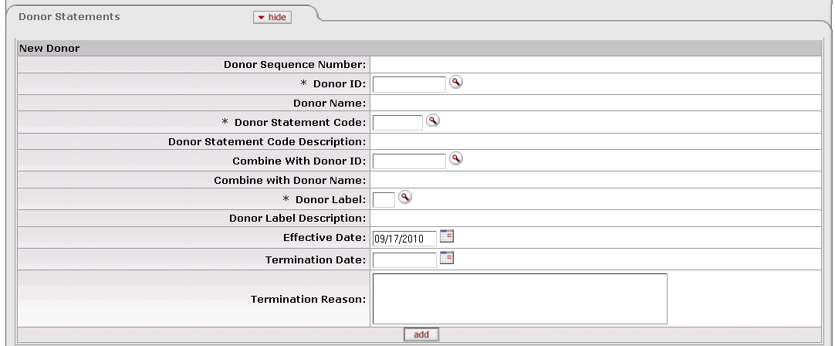

This tab identifies the donors who are to receive annual statements for the KEMID. The information is used for the purpose of creating the periodic or annual donor statements.

Use of this tab is not required for any KEMID record. If you choose to use it, you may add one or more Donor Statement records to a KEMID.

Donor Statements tab definition

|  |  |
| --- | --- |
| Title | Description |
| Donor Sequence Number | Display only. The system-assigned sequence number for this record. |
| Donor ID | Required. The unique identifier for this donor. Enter an existing ID or use the lookup _searchicon.gif to find it. |
| Donor Name | Display only. Your institution's name of record for the donor. |
| Donor Statement Code | Required. Your institution's code that identifies the type of statement the donor wants to receive. Enter an existing code or use the lookup _searchicon.gif to find it. |
| Donor Statement Code Description | Display only. Your institution's description of the code specified. |
| Combine With Donor ID | If statements are to be sent two donors (such as a husband and wife) jointly, the ID of the other donor to whom statements are to be addressed. Enter an existing donor ID or use the lookup _searchicon.gif to find it. The value entered cannot be the same as the value in **Donor ID**. |
| Combine with Donor Name | Display only. Your institution's name of record for the donor specified in the **Combine With Donor ID** field. |
| Donor Label | Required. Your institution's code identifying the appropriate prefix or prefixes for the donor's mailing label. Enter an existing label code or use the lookup _searchicon.gif to find it. |
| Donor Label Description | Display only. Your institution's description of the label specified. |
| Effective Date | The date on which this record is to take effect. Defaults to the current date but you may enter another date or select it from the calendar cal. |
| Termination Date | The last date on which this record is to be in effect. Enter the date or select it from the calendar cal. After this date is reached, the record is available for viewing but cannot be changed. |
| Termination Reason | The reason why the donor statement is no longer being sent. |

##### Endowment Corpus Values Tab

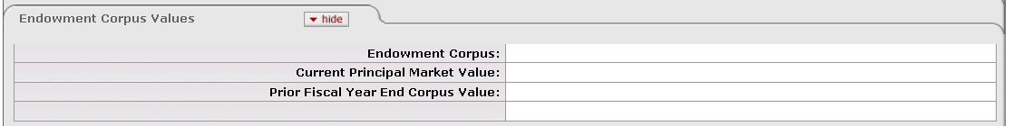

 This tab is displayed only in the KEMID inquiry view. It is not displayed in create or edit mode because the values are system generate, they are for information only, and they are not editable.

This tab displays the corpus value and market value data for a true endowment.

Endowment Corpus Values tab definition

|  |  |
| --- | --- |
| Title | Description |
| Endowment Corpus | Display only. The value of an endowment. This value changes as a result of endowment transactions. |
| Current Principal Market Value | Display only. The current market value of the endowment's principal. |
| Prior Fiscal Year End Corpus Value | Display only. The market value of the endowment's principal for the previous fiscal year. |

##### Combine Donor Statements Tab

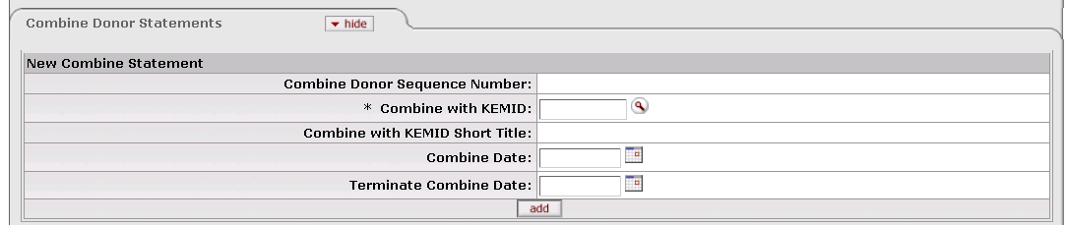

This tab specifies any KEMIDs whose statements are to be combined with statements for the current KEMID. Use of this tab is not required for any KEMID record. If you choose to use the tab, you may add one or more Combine Donor Statements records to a KEMID.

Combine Donor Statements tab definition

|  |  |
| --- | --- |
| Title | Description |
| Combine Donor Sequence Number | Display only. The system-assigned sequence number for this record. |
| Combine with KEMID | Required. The KEMID whose statements are to be combined with statements for this KEMID. Enter an existing KEMID or use the lookup _searchicon.gif to find it. |
| Combine with KEMID Short Title | Display only. The common name of the specified KEMID. |
| Combine Date | The first date on which statements are to be combined. Defaults to the current date but you may enter another date or select it from the calendar cal. |
| Terminate Combine Date | The last date on which statements are to be combined. Enter the date or select it from the calendar cal. After this date is reached, this record is no longer available for viewing or editing. |

#### Process Overview

##### Business Rules

When you open a KEMID e-doc, only the following tabs are expanded (all others are closed):

* KEMID (Main/top tab)
* Agreement
* Source of Funds
* Benefitting Organization
* General Ledger Accounts
* Authorizations
* Payout Instructions

The following business rules pertain to the **KEMID** tab:

* All of the following values in fields of the **KEMID** tab must be valid values in the system:
* **Type**
* **Purpose**
* **Income CAE Code**
* **Principal CAE Code**
* **Responsible Department**
* **Transaction Restriction**
* **Cash Sweep Model**
* **Income Automatic Investment Model**
* **Closed Indicator**
* Only one record may exist for each KEMID.
* When you initiate a KEMID e-doc, the open date defaults to the current date and cannot be changed.
* When you initiate a KEMID e-doc, the established date defaults to the current date, but you may change it when creating a record.
* When you enter a KEMID type in a new KEMID record, the system updates the following fields with the appropriate default values from the Type record, but you may change them:
* **Cash Sweep Model**
* **Income Automatic Investment Model**
* **Principal Automatic Investment Model**
* When you initiate a KEMID e-doc, the transaction restriction code defaults to the associated restriction code in your institution's PEND (Pending Completion) Agreement Status Code record.
* The **Dormant** and **Closed Indicator** fields default to 'No' (that is, the boxes are unchecked) when a KEMID is created. You may change them by editing the e-doc.
* When the **Closed Indicator** value is changed to 'Yes,' you must enter a valid close code.
* You cannot mark a record as closed if the KEMID has open current cash records (that is, records with values greater or less than zero).
* You cannot mark a record as closed if this KEMID has holding tax lot records with values greater or less than zero in the **Holding Units**, **Holding Cost**, and/or **Accrued Income Due** field.

The following business rules apply to the **Agreement** tab:

* At least one active Agreement record must exist for each KEMID.
* When you add an Agreement record, the system automatically updates the **Agreement Number** field with the next sequential record number. You cannot change this entry.
* When you add an Agreement record, the **Agreement Status Code** field defaults to 'PEND' (Pending Completion). You may change this entry.
* When you add an Agreement record, the **Agreement Status Date** field defaults to the current date. You may change this entry.
* When you add an Agreement record, the **Active** indicator defaults to 'Yes' (that is, the box is checked) but may be changed.
* Agreement records cannot be copied. When you copy a KEMID, you must add at least one Agreement record to the new KEMID.
* Both the **Agreement Type Code** and **Agreement Status Code** values must exist.
* If you change the **Agreement Status Code** value, the default transaction restriction code will be displayed if the **Use Transaction Restriction from Agreement** box is set to 'Yes' (that is, if the box is checked).
* If a KEMID has multiple active agreements, only one may have the **Use Transaction Restriction from Agreement** box set to 'Yes.' It is not necessary, however, to have a box set to 'Yes.'
* If you change the **Agreement Status Code** value, the **Agreement Status Date** value is automatically updated to reflect the current date.
* When the**Transaction Restriction Code** field is to be updated by the system, you may edit the value in the KEMID record only if the **Use Transaction Restriction from Agreement** box is set to 'No' (that is, if the box is unchecked).
* When the **Active** indicator is changed to 'No,' the record is no longer viewable via the Detail Inquiry screen. When the e-doc is in edit mode, all records (both active and inactive) are displayed and you may re-activate records if needed.
* The default value for the **Use Transaction Restriction from Agreement** box is 'No.'

The following business rules apply to the **Source of Funds** tab:

* At least one active Source of Fundsrecord must exist for each KEMID.
* When you add a Source of Funds record, the system automatically updates the **Fund Source Number** field with the next sequential record number. You cannot change this entry.
* When you add a Source of Funds record, the **Active** indicator defaults to 'Yes' (that is, the box is checked). You may change this entry.
* The fund source code you specify must exist in the system.
* The **Opened From KEMID** value you specify must exist in the system.
* When the **Active**indicatoris changed to 'No' (that is, the box is unchecked), the record is no longer viewable via the Detail Inquiry screen. When the e-doc is in edit mode, all records (both active and inactive) are displayed and you may re-activate records if needed.
* Fund source records cannot be copied. When you copy an existing KEMID record, you must add at least one Source of Funds record to the new KEMID.

The following business rules apply to the **Benefitting Organization** tab:

* At least one active Benefitting Organization record must exist for each KEMID.
* For each Benefitting Organization record you add, the system automatically updates the **Benefitting Organization Sequence Number** field with the next sequential record number. You cannot change this entry
* For each Benefitting Organization record you add, the **Benefit Percent** field defaults to '1' (100%). You may change this entry.
* For each Benefitting Organization record you add, the **Active** indicator defaults to 'Yes' (that is, the box is checked). You may change this entry.
* Both the benefitting chart and the benefitting organization must exist in the system.
* When the **Active** field is changed to 'No' (that is, the box is unchecked), the record is no longer viewable via the Detail Inquiry screen. In the edit function, all records (both active and inactive) are displayed and you may re-activate records if needed.
* Benefitting Organization records cannot be copied. When you copy an existing KEMID record, you must add at least one Benefitting Organization record to the new KEMID.
* The total of benefit percent for all records where the **Active** indicator is equal to 'Yes' must be 1(100%).
* The system automatically enters the current date as the start date when you initiate the record. You cannot change this date.
* The system automatically enters the current date as the last change date when you edit the record. You cannot change this date.

The following business rules apply to the **General Ledger Accounts** tab:

* One and only one active General Ledger income accountmust exist for each KEMID.
* One and only one active General Ledger principal account must exist for each KEMID where the principal restriction code for the KEMID is not 'NA' (Not Applicable).
* Both the chart code specified and the account number specified must exist in your institution's chart of accounts.
* When the **Active** indicator is changed to 'No' (that is, the box is unchecked), the record is no longer viewable via the Detail Inquiry screen. When the e-doc is in edit mode, all records (both active and inactive) are displayed and you can re-activate records if needed.
* General Ledger accounts cannot be copied. When you copy an existing KEMID record, you must associate a General Ledger account with the new KEMID.

These rules pertain to the **Authorizations** tab:

* If your institution has set the parameter ROLE\_REQUIRED\_IND to 'Yes,' at least one active Authorizations record must be associated with each KEMID record. If this value is set to 'No,' Authorizations records are not required.
* Each role code you specify must exist in your system's KFS-ENDOW namespace.
* Each role principal name you specify must exist in the system. After you enter a name, the system displays this user's preferred name in addition to the principal name.
* When an Authorizations record is marked as inactive, the system enters the current date into the **Role Termination Date** field.
* Authorizations records cannot be copied. When you copy an existing KEMID record, you must associate Authorizations record(s) with the new KEMID as needed.
* When the **Active** field is changed to 'No' (that is, when the box is unchecked), the record is no longer viewable via the Detail Inquiry screen. In the edit function, all records (both active and inactive) are displayed and you may re-activate records if needed.

These rules pertain to the **Payout Instructions** tab:

* At least one Payout Instructions record must exist for each KEMID.
* For each set of payout instructions you add, the system automatically updates the **Pay Income to KEMID** field with the KEMID. This field cannot be changed.
* For each set of payout instructions you add, the system automatically updates the **Payout Sequence Number** field with the next sequential record number. This field cannot be changed.
* The KEMID specified in the **Pay Income to KEMID** field must exist in the system.
* For each set of payout instructions you add, the **Percent of Income to Pay to KEMID** value defaults to '1' (100%).
* The total percent of income of all active instruction records must equal '1' (100%).
* After the end date has passed, you can no longer view or edit the record.
* For each set of payout instructions you add, the system inserts the current date into the **Start Date** field. You may change the date before submitting the document.
* The value in the **Start Date** field cannot be changed after this date has been reached.
* Payout Instruction records cannot be copied. When you copy an existing KEMID record, you must associate at least one Payout Instruction record with the new KEMID.

These rules pertain to the **Use Criteria** tab:

* Entering use criteria information is optional. Use Criteria records are not required for a KEMID.
* For each set of use criteria you add, the system automatically updates the **Use Criteria Sequence Number** field with the next sequential record number. You cannot change this value.
* Use Criteria records cannot be copied. When you copy an existing KEMID record, you must associate appropriate Use Criteria records with the new KEMID as needed.
* The use criteria code you specify must exist in the system.
* For each set of use criteria you add, the **Active** indicator defaults to 'Yes' (that is, the box is checked). You may change this entry.
* When the **Active** indicator is changed to 'No' (that is, the box is unchecked), the record is no longer viewable via the Detail Inquiry screen. When the e-doc is in edit mode, all records (both active and inactive) are displayed and you may re-activate records if needed.

These rules pertain to the **Special Instructions** tab:

* Entering special instructions is optional. Special Instructions records are not required for a KEMID.
* For each set of use criteria you add, the system automatically updates the **Instructions Sequence Number** field with the next sequential record number. You cannot change this value.
* Special Instructions records cannot be copied. When you copy an existing KEMID record, you must associate appropriate Special Instructions records with the new KEMID as needed.
* The agreement special instructions code you specify must exist in the system.
* For each set of use criteria you add, the system inserts the current date into the **Instruction Start Date** field. You may change this value.
* You can no longer view or change a record after the instruction end date has passed.

These rules pertain to the **Fees** tab:

* Entering fees is optional. Fees records are not required for a KEMID.
* For each fee you add, the system automatically updates the **Fee Method Sequence Number** field with the next sequential record number. You cannot change this value.
* Fee records cannot be copied. When you copy an existing KEMID record, you must associate appropriate Fee records with the new KEMID as needed.
* When you enter a KEMID type in a new KEMID record, the system looks at the **Type Code** value and creates the appropriate Fee records automatically.
* If you update the Type Code record that contains the default type fee methods, there is no change in the **Fees** tab. To update the Fee records in this tab, you must go to the **Fees** tab to add a new fee or terminate the existing fee.
* The fee method specified must exist in the system***.***
* For each fee you add, the default value for the **Charge Fee to KEMID** field will be the current KEMID.
* For each fee you add, the default value for **Percent Of Fee Charged To Income** is set at '1' (100%). You may change this value.
* The total of**Percent Of Fee Charged To Income** plus**Percent Of Fee Charged To Principal** cannot exceed '1' (100%).
* **Percent Of Fee Charged To Principal** defaults to zero (0.00%) for all new records. The **Percent Of Fee Charged To Principal** cannot exceed zero if the **Restriction Code** value is '**NA'** (Not Applicable) for the KEMID type code.
* The **Accrue Fees** and **Waive Fees** values default to 'No' (that is, they are unchecked).
* The **Total Waived Fees This Fiscal Year** and **Total Waived Fees** values default to zero, are system generated, and cannot be changed.
* The **Total Accrued Fees** value default to zeros. The value is updated by the system. You may change it in edit mode only.
* The system automatically enters the fee start date. You may change this value only when you create a new record.
* The default value for the **Fee Start Date** field is the fee next processing date for the fee method. When edited, this date must be valid based on the fee frequency.
* If thefee end date has not yet arrived, the fee record is available for viewing but you cannot edit it.
* When the fee end date is reached, if there is a balance in the total accrued fees, the system adds that value to the total waived fees this fiscal year and changes the **Total Accrued Fees** value to zero.

The following business rules apply to the **Report Groups** tab:

* Entering report groups is optional.
* Report Group records cannot be copied. When you copy an existing KEMID record, you must associate appropriate Report Group records with the new KEMID as needed.
* The combine group code specified must exist in the system.
* For each report group you add, the system inserts the current date into the **Date Added** field.
* After the specified date terminated is reached, the record is no longer available for viewing or editing.

The following business rules apply to the **Donor Statements** tab:

* Entering donor statement information is optional. Donor Statement records are not required for a KEMID.
* Donor Statement records cannot be copied. When you copy an existing KEMID record, you must associate appropriate Donor Statement records with the new KEMID as needed.
* Values for the following fields must already exist in the system in order to be used in the record: **Donor ID**, **Donor Statement Code**, and **Combine With Donor ID**.
* The value in the **Combine With Donor ID** field cannot be the same as the value in **Donor ID**.
* For each Donor Statement record you add, the system inserts the current date in the **Effective Date** field.
* If you enter a termination date, you must enter a termination reason.
* After the termination date is reached, the record is available for viewing but cannot be changed.

The following business rules apply to the **Endowment Corpus Values** tab:

* Records may be viewed but may not be created or edited by users.
* Records are generated by the system as part of a nightly batch process.
* Corpus Values records are associated with permanently endowed KEMIDs only.

These rules apply to the **Combine** **Donor Statements** tab:

* Entering combine donor statement information is optional. This information is not required for a KEMID.
* For each Combine Donor Statement record you add, the system automatically updates the **Combine Donor Sequence Number** field with the next sequential record number. You cannot change this value.
* Combine Donor Statement records cannot be copied. When you copy an existing KEMID record, you must associate appropriate Combine Donor Statement records with the new KEMID as needed.
* The value in the **Combine with KEMID** field must exist in the system.
* For each Combine Donor Statement record you add, the system inserts the current date into the **Combine Date** field.
* When the terminate combine date has been reached, the record is no longer available for viewing or editing.

##### Routing

The figure below shows the standard routing for this e-doc. Your institution's routing may vary.



#### Example

A donor, Mr. Miyagi, has recently contributed $100,000 to set up the Miyagi Scholarship Fund. Your institution creates a KEMID record to specify all appropriate information for this new endowment.

### Recurring Cash Transfer

 > > >  > 

The Recurring Cash Transfere-doc allows you to schedule recurring cash transfers between KEMIDs or from a KEMID to one or more GL accounts. Each transfer you set up will occur via a batch process on a regular basis according to the specifications you provide. The recurring batch process automatically generates the appropriate cash transfer or Endowment to General Ledger cash transfer transactions.

When you select **Recurring Cash Transfer** from the menu, the system displays the Recurring Cash Transfer Lookup screen.

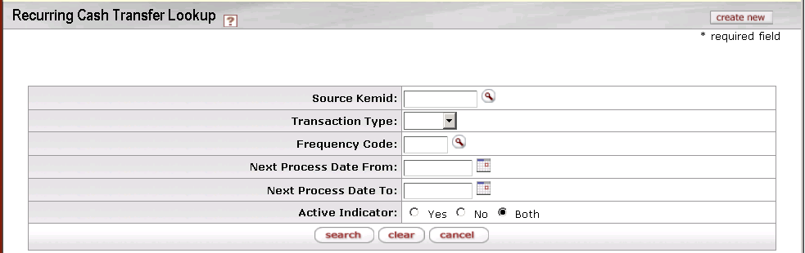

On this screen, you have two options:

* To set up a new recurring cash transfer, click the **create new** button in the upper right corner of the screen. The system displays the Recurring Cash Maintenance Document screen in create mode. Complete the fields as indicated in Document Layout below.
* To display information for one or more existing recurring cash transfers, enter search criteria in the fields on this screen as indicated in the table below and click **search**.

Recurring Cash Transfer Lookup definition

|  |  |
| --- | --- |
| Title | Description |
| Source Kemid | The KEMID from which the transfer of funds is made. |
| Transaction Type | The type of recurring transaction—either ECT (Endowment Cash Transfer) or EGLT (Endowment to General Ledger Transfer). Select the appropriate type from the list. |
| Frequency Code | The frequency with which the transaction occurs. Enter a frequency code or use the lookup _searchicon to find it. |
| Next Processing Date From | For searches based on when the next transfer is scheduled to occur, indicates the earliest date in a range of dates. |
| Next Processing Date To | For searches based on when the next transfer is scheduled to occur, indicates the latest date in a range of dates. |
| Active Indicator | The status (active, inactive, or both) of the desired record(s). |

After you enter search criteria and click **search**, the system displays a list of matching records at the bottom of the screen.

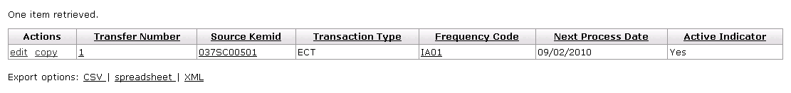

Recurring Cash Transfer Lookup search results definition

|  |  |
| --- | --- |
| Title | Description |
| Transfer Number | The unique number that identifies a recurring cash transfer. |
| Source KEMID | The KEMID from which money is to be transferred. |
| Transaction Type | The type of e-doc to be created by a recurring transfer. Select the document type from the list:  'ECT' Endowment Cash Transfer  'EGLT' Endowment to GL Transfer |
| Frequency Code | A code specifying the frequency of a recurring transfer. |
| Next Process Date | The next date on which a recurring transfer is to occur. |
| Active Indicator | Indicates whether a recurring cash transfer is active or not. |

To edit or copy one of these records, click the or link in the **Actions** column.

From the results table, you may drill down into detail for a recurring cash transfer. To do so, click an underlined transfer number. The system displays the Recurring Cash Transfer Inquiry screen.

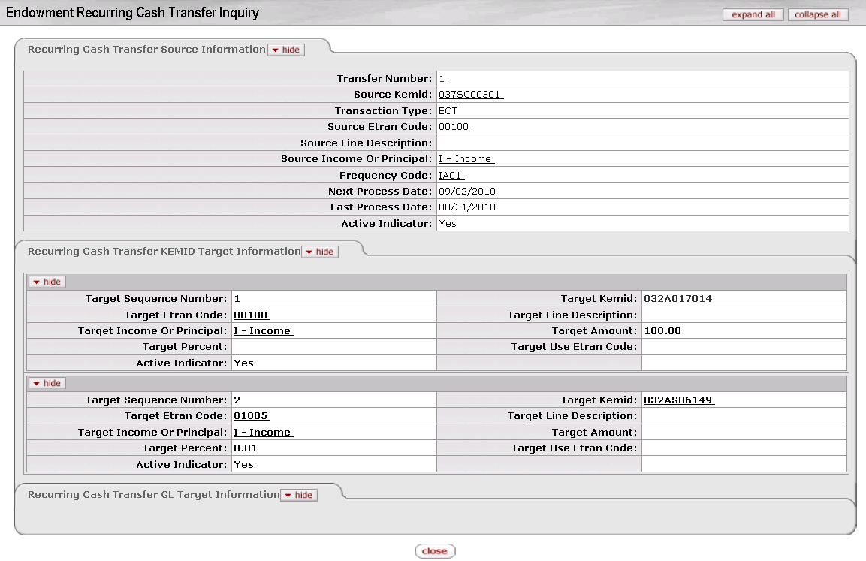

 For more information about the fields of the lookup screen, see Edit Recurring Cash Transfer Tab|topic=Edit Recurring Cash Transfer Tab below.

#### Document Layout

If you click the **create new** button on the Recurring Cash Transfer Lookup screen, the system displays the Recurring Cash Transfer screen in create mode. If you search for recurring cash transfers on the lookup screen and then click on the **edit** link for a recurring cash transfer in the search results, the system displays the Recurring Cash Transfer screen in edit mode (shown below). In this mode, additional fields are displayed so you can change the valuation for this security.

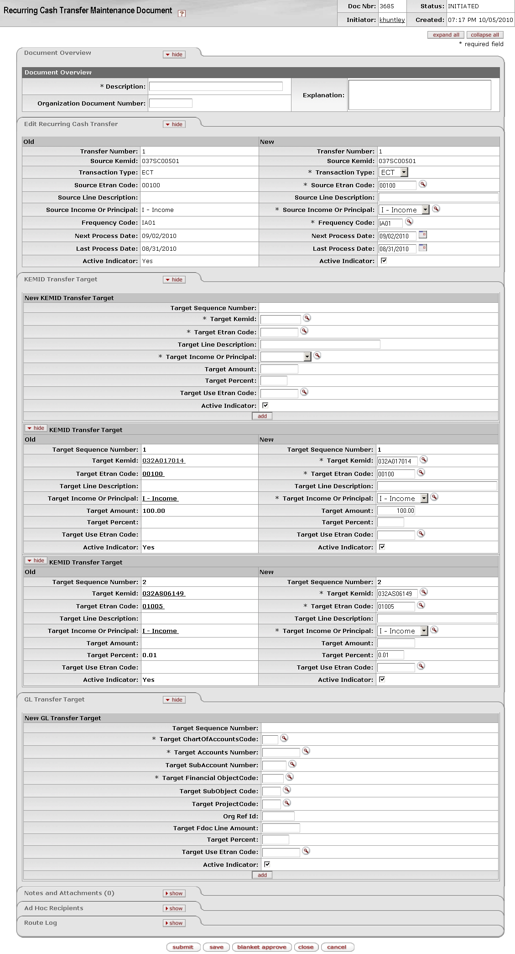

Recurring Cash Transfer screen

The Recurring Cash Transfer document contains three unique tabs— **Edit Recurring Cash Transfer**, **KEMID Transfer Target**, and **GL Transfer Target**—in addition to the standard tabs.

 For more information about the standard tabs, see Standard Tabs|document=WordDocuments\KFS 5\_2 Overview.docx;topic=Standard Tabs“Standard Tabs” in the KFS Overview and Introduction to the User Interface.

##### Edit Recurring Cash Transfer Tab

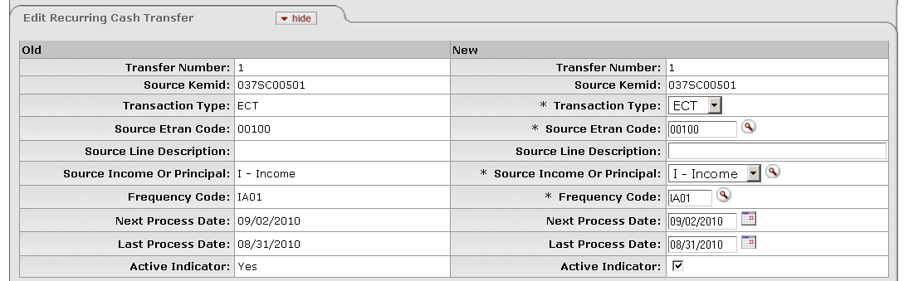

This tab contains essential information about the recurring cash transfer.

Edit Recurring Cash Transfer tab definition

|  |  |
| --- | --- |
| Title | Description |
| Transfer Number | Display only. A system-assigned unique number that identifies this recurring cash transfer. |
| Source KEMID | Required. The KEMID from which money is to be transferred. Enter an existing valid KEMID or use the lookup _searchicon.gif to find it. The KEMID must not be closed. |
| Transaction Type | Required when initiating the document. Display only when the e-doc is in edit mode. The type of e-doc to be created by this recurring transfer. Select the document type from the list. The choices are:  'ECT' Endowment Cash Transfer  'EGLT' Endowment to GL Transfer  If you specify 'ECT', entries in the **Edit KEMID Transfer Target** tab are required and entries in the **General Ledger Transfer Target** tab are ignored.  If you specify 'EGLT', entries in the **General Ledger Transfer Target** tab are required and entries in the **Edit KEMID Transfer Target** tab are ignored. |
| Source Etran Code | Required. Identifies the type of processing required on the 'From' side of this recurring transaction. The Etran code you specify must have an Etran Type Code of 'I' (income). The Etran code must also have an appropriately identified General Ledger object code record that matches the chart for the KEMID-associated General Ledger account.  Enter an existing Etran code or use the lookup _searchicon.gif to find it. |
| Source Line Description | A description of this recurring transfer for the 'From' side of this recurring transaction. |
| Source Income or Principal | Determines whether the cash is transferred from this KEMID's income or principal. |
| Frequency Code | Required. Determines the frequency of the recurring transfer. Enter an existing frequency code or use the lookup _searchicon.gif to find it. |
| Next Process Date | The next date on which this recurring transfer is to occur. The date you enter must be valid for the frequency specified. Enter a date or select it from the calendar cal.  If you do not enter a value in this field, when you save or submit the document the system automatically calculates and enters the next expected date for processing. |
| Last Process Date | The date on which this recurring transfer most recently occurred. When editing an existing recurring transfer, the system enters a date in this field. For a new transfer, you may enter a date that is valid for the frequency specified or select it from the calendar cal. If you do not enter a date, when you save or submit the document the system automatically calculates and enters the most recent date on which processing should have occurred. |
| Active Indicator | Indicates whether this recurring cash transfer is active or not. Select the check box if this recurring transfer is active in the system. Clear the check box if it is inactive.  When you deactivate the source record, the system automatically deactivates all target records. |

##### **KEMID Transfer** Target Tab

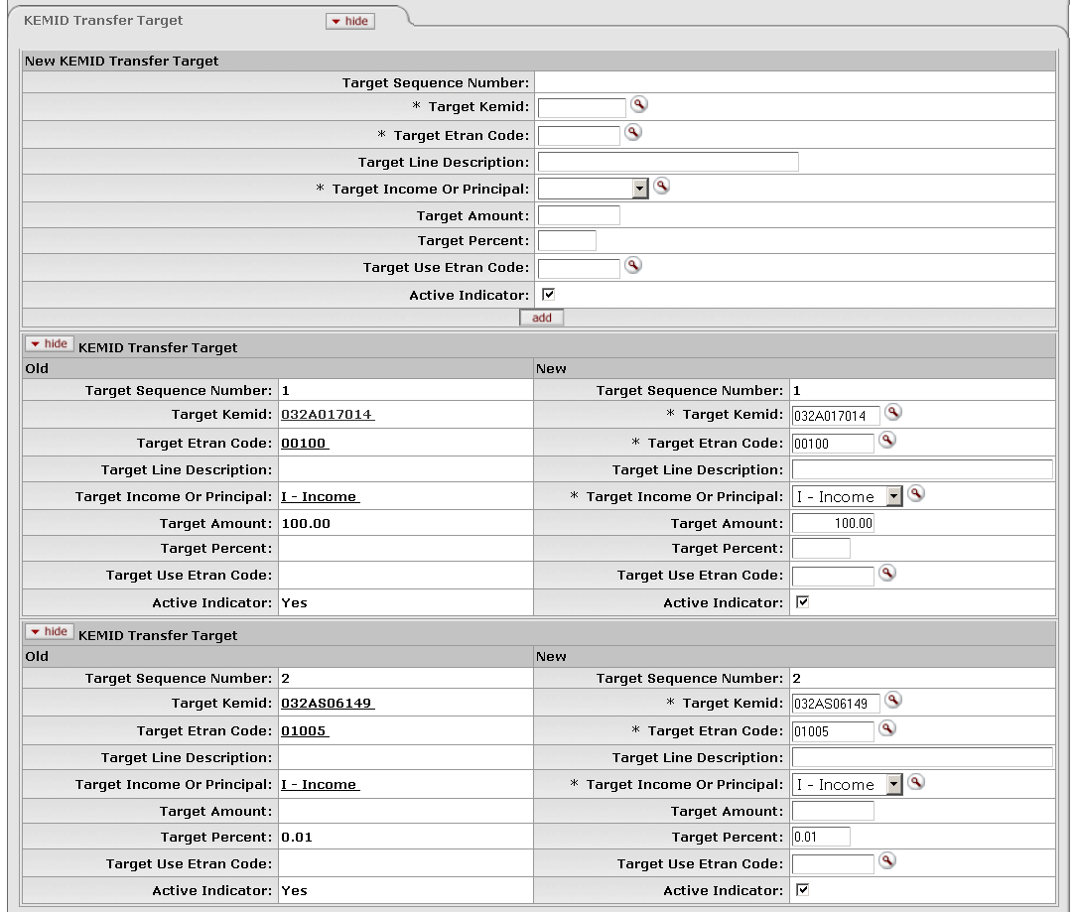

KEMID Transfer Target tab

For recurring cash transfers to KEMID(s) (that is, transfers for which **Transaction Document Type** = 'ECT)', this tab contains essential information about the KEMID(s) to which the recurring transfer is to be made.

 For a cash transfer to a GL account, do not enter information into this tab. Instead, enter information into the **GL Transfer Target** tab.

KEMID Transfer Target tab definition

|  |  |
| --- | --- |
| Title | Description |
| Target Sequence Number | Display only. The order in which the transaction for this KEMID will be processed. This number is sequential and is automatically assigned by the system. |
| Target Kemid | Required for ECT transactions. The KEMID to which money is to be transferred. Enter an existing valid KEMID or use the lookup _searchicon.gif to find it. The KEMID must not be closed. |
| Target Etran Code | Required for ECT transactions. Identifies the type of processing required on the 'To' side of this recurring transaction. Enter an existing Etran code or use the lookup _searchicon.gif to find it.  The Etran code you specify must have an Etran Type Code equal to 'I' (Income) or 'E' (Expense). The Etran code must also have an appropriately identified General Ledger object code record that matches the chart for the KEMID-associated general ledger account. |
| Target Line Description | A description of this recurring transfer for the 'To' side of this recurring transaction. |
| Target Income or Principal | Required for ECT transactions. Determines whether the cash is transferred to this KEMID's income or principal. |
| Target Amount | The amount of cash to be transferred to this KEMID.  pencil-small.gif If you enter an amount in this field, you cannot enter information in the **Target Percent** or **Use Etran Code** field for the record. |
| Target Percent | The percentage of the overall amount of cash to be transferred to this KEMID.  pencil-small.gif The total percent of all target KEMID records cannot exceed 100%.  pencil-small.gif If you enter both a target percent and a **Use Etran Code** value, the total for all records with the specified Etran code cannot exceed 100%.  pencil-small.gif If you enter a percent here, no entry is permitted in the **Target Amount** field. |
| Target Use Etran Code | The Etran code (if any) associated with the desired transaction processing. |
| Active Indicator | Indicates whether this KEMID transfer target is active or not. Select the check box if this target is active in the system. Clear the check box if it is inactive.  At least one KEMID record must be active for the recurring ECT to be active. |

Click the  button to add a new record for this target KEMID.

##### GL Transfer Target Tab

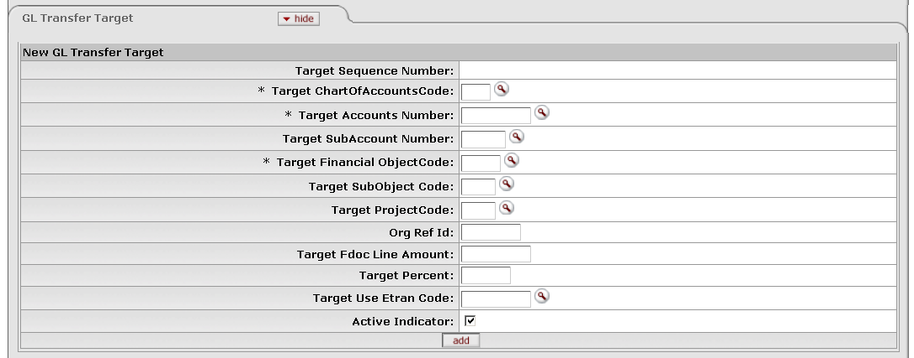

GL Transfer Target tab (create mode)

For recurring Endowment to General Ledger Transfer of Funds e-docs (that is, transfers for which **Transaction Document Type** = 'EGLT'), this tab contains essential information about the General Ledger account(s) to which a recurring transfer is to be made.

 For a cash transfer to a KEMID, do not enter information into this tab. Instead, enter information into the **KEMID Transfer Target** tab.

****GL**** Transfer tab definition

|  |  |
| --- | --- |
| Title | Description |
| Target Sequence Number | Display only. The order in which the transaction for this GL account will be processed. This number is sequential and is automatically assigned by the system. |
| Target ChartOfAccounts Code | Required for EGLT transactions. The chart to which money is to be transferred. Enter an existing account number or use the lookup _searchicon.gif to find it. The chart specified must not be closed.  C:\Users\jonny\Desktop\KFS 5.0.2\User Guide Images\pencil-small.gif When the parameter Accounts\_Can\_Cross\_Charts is set to 'No', the system derives the chart code from the account number entered, and an entry in this field is not required. |
| Target Account Number | Required for EGLT transactions. The account to which money is to be transferred. Enter an existing account number or use the lookup _searchicon.gif to find it. The account specified must not be closed. |
| Target SubAccount Number | The sub-account to which money is to be transferred. Enter an existing sub-account or use the lookup _searchicon.gif to find it. The sub-account specified must exist in the system, must be active, and must be associated with the specified account and chart in combination. |
| Target Financial ObjectCode | Required for EGLT transactions. The object code to which money is to be transferred. Enter an existing object code or use the lookup _searchicon.gif to find it. The object code specified must have a Type of 'I' (Income) or 'E' (Expense), and it must exist in the system, must be active, and must be associated with the fiscal year and account's chart. |
| Target SubObject Code | The sub-object code to which money is to be transferred. Enter an existing sub-object code or use the lookup _searchicon.gif to find it. The sub-object code specified must exist in the system, must be active, and must be associated with the specified object code, account, chart, and fiscal year in combination. |
| Target Project Code | The project to which money is to be transferred. Enter an existing project code or use the lookup _searchicon.gif to find it. The project specified must exist in the system and must be active. |
| Org Ref Id | The associated organizational reference number, if any. |
| Target Fdoc Line Amount | The amount of cash to be transferred to this account.  pencil-small.gif If you enter an amount in this field, you cannot enter information in the **Target Percent** or **Use Etran Code** field for the record. |
| Target Percent | The percentage of the overall amount of cash to be transferred to this account.  pencil-small.gif The total percent of all target GL account records cannot exceed 100%.  pencil-small.gif The total percent of all target KEMID records cannot exceed 100%.  pencil-small.gif If you enter both a target percent and a **Use Etran Code** value, the total for all records with the specified Etran code cannot exceed 100%. |
| Target Line Etran Code | The Etran code (if any) associated with the desired transaction processing. |
| Active Indicator | Indicates whether this KEMID transfer target is active or not. Select the check box to activate the record in the system. (The box is checked by default when the e-doc is initiated.) Clear the check box to deactivate it.  At least one account must be active in order for the recurring EGLT transaction to be active. |

Click the  button to add the record for this account.

#### Process Overview

##### Business Rules

The following business rules apply to recurring cash transfer transactions.

For the **Edit Recurring Cash Transfer** tab and its fields:

* ***The*** KEMID must exist and must not be closed.
* Only two transaction document types are allowed—Endowment Cash Transfer (ECT) and Endowment to General Ledger Cash Transfer (EGLT).
* If the transaction document type is ECT, there can be associated target records only in the **KEMID Transfer Target** tab***.*** There must be at least one active record for an active recurring transfer.
* If the transaction document type is EGLT, there can be associated target records only in the **GL Transfer Target** tab***.*** There must be at least one active record for an active recurring transfer.
* The Etran code used in the **Source Etran Code** field must have an Etran type code of 'I' (Income) or 'E' (Expense).
* The Etran code used must have an appropriately identified General Ledger object code record—one that matches the chart for the KEMID-associated General Ledger account.
* If the source is income, the chart must match the chart of the active KEMID-GL Link record for income.
* If the source is principal, the chart must match the chart of the active KEMID-GL Link record for principal.
* The frequency code you specify must exist in the system.
* If you specify a date in the **Next Process Date** field, it must be a valid date for the frequency entered.
* If you do not enter a value in the **Next Process Date** field, when you save or submit the document the system automatically calculates and enters the next expected date for processing.
* If you specify a date in the **Last Process Date** field, it must be a valid date for the frequency entered.
* If you do not enter a value in the **Last Process Date** field, when you save or submit the document the system automatically calculates and enters the most recent date on which processing should have occurred.
* If you deactivate a source record, the system automatically deactivates all target records.
* When you copy a recurring cash transfer, only the source data is copied. You must enter all target information.
* You cannot change the transaction document type when editing a record.

For the **Edit KEMID Transfer Target** tab and its fields:

* You may enter multiple KEMID targets for a transfer.
* The transfer number will be the same as the number for the associated Cash Transfer record.
* The sequence number for each KEMID target is assigned by the system sequentially.
* Each KEMID specified must exist in the system and must not be closed.
* The target Etran code you specify must have an Etran type code of 'I' (Income) or 'E' (Expense).
* The target Etran code you specify must have an appropriately identified General Ledger object code record—one that matches the chart for the KEMID-associated General Ledger account.
* If the target is income, the chart must match the chart of the active KEMID-GL Link record for income.
* If the target is principal, the chart must match the chart of the active KEMID-GL Link record for principal.
* If you enter a value in the **Target Amount** field, you cannot enter data into the **Target Percent** or **Use Etran Code** fields for this KEMID target.
* If you enter a value in the **Target Percent** field, the total for all active target KEMID target records cannot exceed 100%.
* If you enter values in both the **Target Percent** and **Use Etran Code** fields, the total for all active KEMID target records with this **Use Etran Code** value cannot exceed 100%.

For the **General Ledger Transfer Target** tab and its fields:

* You may enter multiple GL account targets for a transfer.
* The transfer number will be the same as the number for the associated Cash Transfer record.
* The sequence number for each GL account target is assigned by the system sequentially.
* Each chart specified must exist in the system and must not be closed.
* Each account specified must exist in the system and must not be closed.
* Each object code specified must have a type code equal to 'I' (Income) or 'E' (Expense).
* If you specify a sub-account, it must exist in the system, must be active, and must be associated with the account and chart in combination.
* Each object code specified must exist in the system, must be active, and must be associated with the fiscal year and account's chart.
* If you specify a sub-object code, it must exist in the system, must be active, and must be associated with the object code, account, chart, and fiscal year in combination.
* If you specify a project code, it must exist in the system and must be active.
* If you enter a value in the **Target Amount** field, you cannot enter data into the **Target Percent** or **Use Etran Code** fields for this GL account target.
* If you enter a value in the **Target Percent** field, the total for all active target GL account target records cannot exceed 100%.
* If you enter values in both the **Target Percent** and **Use Etran Code** fields, the total for all active GL account target records with this **Use Etran Code** value cannot exceed 100%.

##### Routing

The figure below shows the standard routing for this e-doc. Your institution's routing may vary.



#### Example

A donor establishes a named endowment and would like it to support both the Chemistry and Biology departments. To accomplish the donor's wishes, the school would like to transfer 50% of the annual income produced by the endowment to the Chemistry Department's General Ledger account and 50% to the Biology Department's General Ledger account. A recurring cash transfer is created for the KEMID representing the named endowment. The recurring transfer has a document type of EGLT, has two entries in the General Ledger Transfer Target section—one for Chemistry and one for Biology—and each entry has a target percent of 50%.

### Security

 > > > > 

The Security Maintenance Documentscreen allows you to retrieve, create, and edit security records.

When you select **Security** from the menu, the system displays the Security Lookup screen.

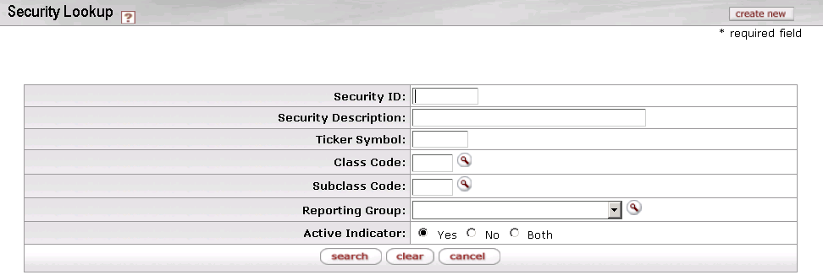

On this screen, you have two options:

* To set up a new security, click the **create new** button in the upper right corner of the screen. The system displays the Security Maintenance Document screen in create mode. Complete the fields as indicated under Document Layout below.
* To display information for one or more existing securities, enter search criteria in the fields on this screen as explained in the table below and click **search**.

Security Lookup definition

|  |  |
| --- | --- |
| Title | Description |
| Security ID | The ID number for the security(ies). |
| Security Description | The text description for the security(ies). |
| Ticker Symbol | The ticker symbol for the security(ies). |
| Class Code | The class code associated with the desired security(ies). |
| Subclass Code | The subclass code associated with the desired security(ies). |
| Reporting Group | The reporting group for the desired security(ies). |
| Active Indicator | The status (active, inactive, or both) of the desired record(s). |

* After you enter search criteria and click **search**, the system displays a list of matching records at the bottom of the screen.

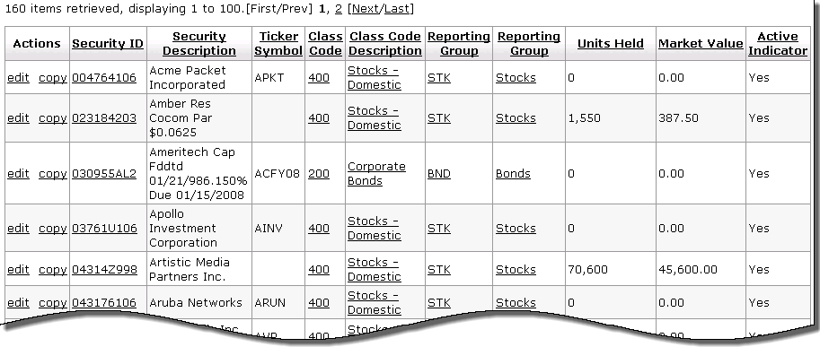

Edit Security tab definition

|  |  |
| --- | --- |
| Title | Description |
| Security ID | A code that uniquely identifies a security. |
| Security Description | The description of a security. |
| Ticker Symbol | The ticker symbol (if any) for a security. |
| Class Code | The group of securities to which a security belongs. |
| Class Code Description | The description of the group of securities to which a security belongs. |
| Reporting Group | The code and description of the reporting group to which a security belongs. |
| Units Held | The total number of units of the security held by the organization. |
| Market Value | The value that your institution or the holder of a security might expect to receive if the security were sold. |
| Active Indicator | Indicates whether this security is active or not. |

To edit or copy one of these records, click the or link in the **Actions** column.

From the results table, you may drill down into detail for a security. To do so, click an underlined security ID. The system displays the Security Inquiry screen.

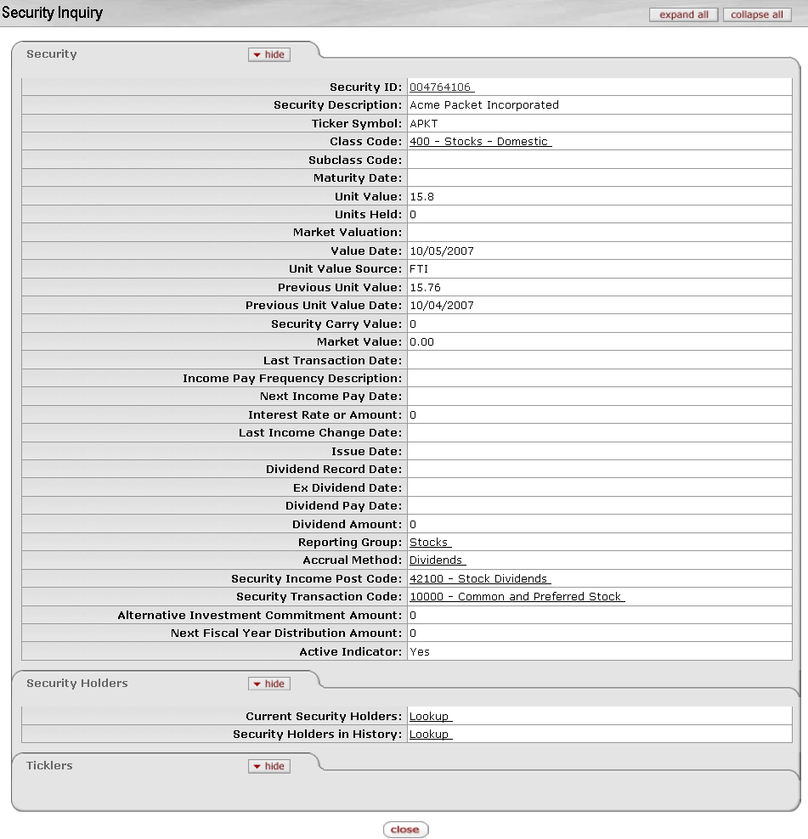

 For more information about the fields of the lookup screen, see Edit Security Tab|topic=Edit Security Tab below.

 From the **Security Holders** tab near the bottom of the lookup screen, you may link to the information on the current and historical holders of this security by clicking the appropriate **Lookup** link.

 From the **Ticklers** tab near the bottom of the lookup screen, you may link to information on ticklers for this security by clicking on the **Lookup** link.

#### Document Layout

If you click the **create new** button on the Security Lookup screen, the system displays the Security Maintenance Document screen in create mode. If you search for securities on the lookup screen and then click on the **edit** link of a security in the search results, the system displays the Security Maintenance Document in edit mode. In this mode, additional fields are displayed so you can change the valuation for this security. The example below shows the e-doc in edit mode.

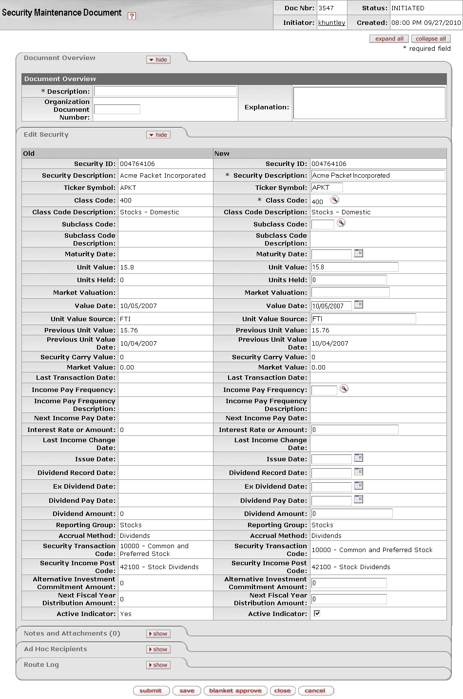

The Security document contains one unique tab— **Edit Security**—in addition to the standard tabs.

 For more information about the standard tabs, see Standard Tabs|document=WordDocuments\KFS 5\_2 Overview.docx;topic=Standard Tabs“Standard Tabs” in the KFS Overview and Introduction to the User Interface.

##### Edit Security Tab

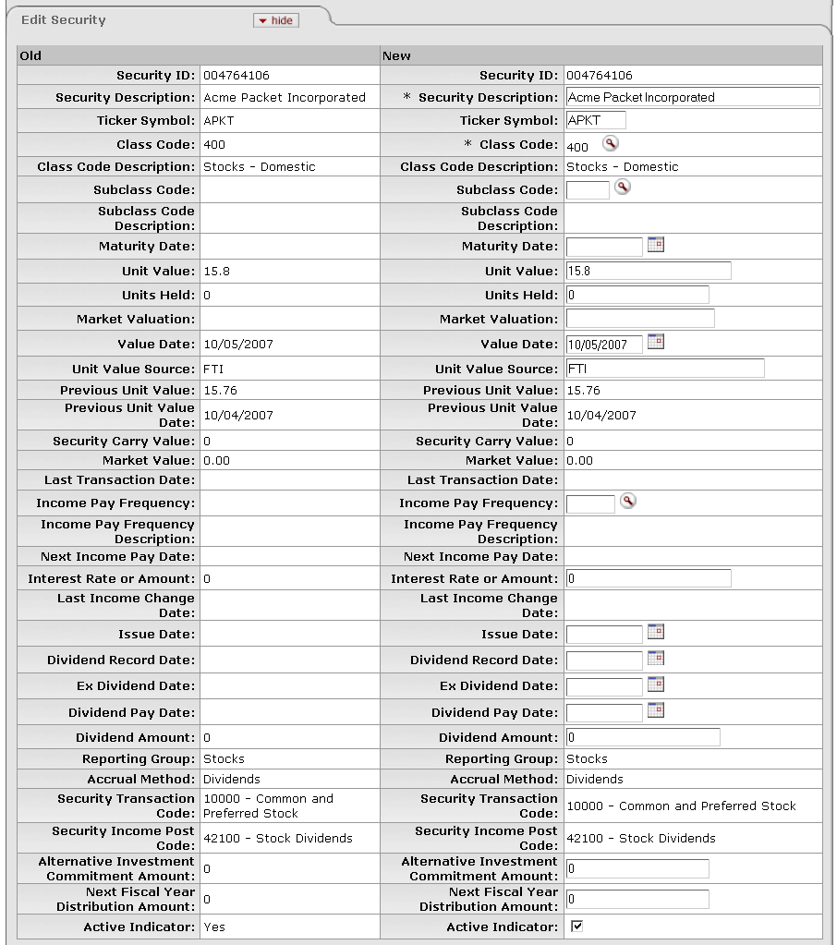

This tab (shown above in edit mode) contains essential information about the security.

 In document create mode, the screen contains a subset of the fields displayed above. It does not contain fields (shown above) used to calculate the value of the security.

Edit Security tab definition

|  |  |
| --- | --- |
| Title | Description |
| Security ID | Required when initiating a document; otherwise, display only. Uniquely identifies this security. The Security ID is nine alpha or numeric characters and is often the CUSIP number. When you create a new security record, enter only the first eight digits. The system calculates the ninth character and displays a message confirming the value. |
| Security Description | Required. Provides a description of this security. |
| Ticker Symbol | Indicates the ticker symbol (if any) for the security. |
| Class Code | Required. Identifies the group of securities to which this security belongs. Enter an existing code or use the lookup _searchicon.gif to find it. |
| Class Code Description | Display only. Provides a description of the group of securities to which this security belongs. Derived from the class code of the security. |
| Subclass Code | Identifies the subgroup of securities to which this security belongs. Enter an existing code or use the lookup _searchicon.gif to find it. |
| Subclass Code Description | Display only. Provides a description of the group of securities to which this security belongs. |
| Maturity Date | Required if the security class code for the new security record has a **Security Accrual Method** entry of '3', '6', B', 'M' or 'T. Indicates the date (if any) on which this security will mature. Enter a date or select it from the calendar cal. |
| Unit Value | Required if the security class code has a valuation method of 'U' (Unit Value). No entry permitted if the class code for the security has a valuation method of 'M' (Market Value). If the security has a class code type of 'P' (Pooled Funds), you cannot change this entry on the e-doc.  Indicates the calculated per share value for units of the security. The system displays this field only when in edit or inquiry mode.  When a new security is created the system automatically sets the unit value at '1' except for liabilities, for which the value defaults to '-1'. The unit value must always be greater than or equal to zero except for liabilities, which are always '-1'.  If the class code for the security has a valuation method of 'M' (Market Value), the system calculates the new unit value with the formula: Market Valuation divided by Units Held = the new Unit Value. |
| Units Held | Indicates the total number of units of the security held by the organization. The system changes the entry as a result of transaction processing during the Post E-Doc batch process. The number of decimal places is defined by your institution, up to five decimal positions, to allow for fractional shares.  The system displays this field only when the screen is in edit mode. |
| Market Valuation | Required if the class code for the security has a valuation method of 'M' (Market Value). No entry is permitted if the class code for the security has a valuation method of 'U' (Unit Value).  Market valuation is a stated value as of the stated value date. The system displays this field only when in edit or inquiry mode. |
| Value Date | Indicates the date on which the market valuation was last determined. Enter the date or select it from the calendar cal. If the security has a class code type of 'P' (Pooled Funds), you cannot change this entry on this e-doc.  The system displays this field only when the screen is in edit mode. |
| Unit Value Source | Identifies the person or other source that last entered the unit value or market valuation. If the change is a result of input from a pricing file from an outside source, the file update program populates this field automatically.  The system displays this field only when the screen is in edit mode. |
| Previous Unit Value | Display only. Indicates the unit value of the security before it was last changed. Based on the previous entry in the **Unit Value** field.  The system displays this field only when the screen is in edit mode. |
| Previous Unit Value Date | Display only. Indicates the date on which the unit value was last changed. Based on the previous value in the **Value** **Date** field.  The system displays this field only when the screen is in edit mode. |
| Security Carry Value | Display only. Indicates the total original cost for the security held by the organization. This value is automatically changed during transaction processing in the Post E-Doc batch process. The number is restricted to two decimal places. When a transaction generates a change to the carry value, the change reflects the exact amount of the carry value of the transaction as calculated and rounded according to standard rounding rules.  The system displays this field only when the screen is in edit mode. |
| Market Value | Display only. The value that your institution or the holder of the security might expect to receive if the security were sold. This is a calculated number based upon the best information available regarding the market value per share or unit held. |
| Last Transaction Date | Display only. Indicates the date on which the most recent transaction for this security took place. The system changes the entry each time the number of units and/or carry value is changed as a result of transaction processing. The date reflects the process date in the System Values table at the time the transaction was posted during the Post E-Doc batch process.  The system displays this field only when the screen is in edit mode. |
| Income Pay Frequency | Required if the security class code for the new security record has a **Security Accrual Method** entry of '3', '6', B', 'M' or 'T. Indicates the system code associated with the frequency of income payments for this security. Enter the frequency code or use the lookup _searchicon.gif to find it. |
| Income Pay Frequency Description | Display only. Provides a description of the income pay frequency. |
| Next Income Pay Date | Display only. Indicates the date on which income will next be paid. Calculation is based upon the process date in the System Values table and the security income pay frequency code selected for the payment. Updated as a result of the Roll Frequency Dates nightly batch process. |
| Interest Rate or Amount | Required if the security class code for the new security record has a **Security Accrual Method** entry of '3', '6', B', 'M' or 'T'. If the security has a class code type of 'P' (Pooled Funds), no change is allowed on this e-doc.  Indicates the current rate or amount of interest.  If the security has a class code type of 'P' (Pooled Funds), the system automatically updates this value when the distribution amount in the pooled fund value is updated. The value is calculated by multiplying the amount of the distribution by the number of times per year that the institution will distribute income to the account holders. |
| Last Income Change Date | Display only. Indicates the date on which income was last paid.  The system displays this field only when the screen is in edit mode. |
| Issue Date | Required if the security class code for the new security record has a **Security Accrual Method** entry of '3', '6', B', 'M' or 'T. Indicates the original date of issue of the security. Enter the date or select it from the calendar cal. |
| Dividend Record Date | Indicates the date on which one must hold shares of a stock to be entitled to the dividend. Enter the date or select it from the calendar cal.  The system displays this field only when the screen is in edit mode. |
| Ex Dividend Date | Indicates the last date one may purchase shares of a stock and be entitled to the dividend (to allow time for trade settlement). Enter the date or select it from the calendar cal.  The system displays this field only when the screen is in edit mode. |
| Dividend Pay Date | Indicates the date the dividend will actually be paid. The system displays this field only when the screen is in edit mode. Enter the date or select it from the calendar cal. |
| Dividend Amount | Indicates the dividend amount paid per share When you change this value, the system multiplies the changed value by 4, enters the result rounded to five decimals in the **Interest Rate or Amount** field, and changes the **Last Income Change Date** entry to reflect the current process date.  The system displays this field only when the screen is in edit mode. |
| Reporting Group | Display only. Indicates the reporting group to which the security belongs. Derived from the class code of the security. |
| Accrual Method | Display only. Indicates the accrual method used for this security. Derived from the class code of the security. |
| Security Transaction Code | Display only. Indicates the security transaction code assigned to this security. Derived from the class code of the security. |
| Security Income Post Code | Display only. Indicates the General Ledger code used to record income (dividend or interest). Derived from the class code of the security. |
| Alternative Investment Commitment Amount | Required if the class code entered has a class code type of 'Alternative Investment.' Indicates the dollar amount committed to this specific alternative investment over time. |
| Next Fiscal Year Distribution Amount | Indicates the estimated distribution over the next fiscal year. Entry is allowed only for securities with a class code type of 'P' (Pooled Funds). Automatically updated to zero at fiscal year end.  The system displays this field only when the screen is in edit mode. |
| Active Indicator | Indicates whether this security is active or not. Select the check box if the security is active in the system. Clear the check box if it is inactive. |

#### Process Overview

##### Business Rules

* All rules for valuation affect the edit screen only. When a new security is created, the unit value is automatically set at 1. Typically a marketable security will have its unit value updated as a part of a nightly process which pulls information from an outside pricing source. For those securities that are valued through the current market value (alternative investments), that information is only available periodically and, at the onset, is equal to the carry value. Therefore, updating the unit or market valuation is accessible only through the edit screen.
* Rules regarding income rates affect the calculations for anticipated income.

The following business rules apply to security transactions:

* The Security ID is nine alpha or numeric characters. When you create a new security record, enter only the first eight digits. The system calculates the ninth and displays a message confirming the value.
* When editing a security, you may change the class code.
* If the security class code for the new security record has a **Security Accrual Method** value of '3', '6', B', 'M' or 'T', you must enter data into these fields:
* **Issue Date**
* **Maturity Date**
* **Interest Rate or Amount**
* **Income Pay Frequency**
* If the class code for a security has a class code type of 'Alternative Investment', an entry in the **Commitment Amount** field is required.
* If the class code for a security has a class code type of 'P' (Pooled Funds), you cannot change the unit value and value date on this e-doc. This restriction ensures that the unit value in the Security record matches the unit value stored in the corresponding Pooled Fund Value record with the latest value effective date.
* If the security has a class code type of 'P' (Pooled Funds), you cannot change the value in the **Interest Rate or Amount** field on this e-doc. The system automatically updates this value when the distribution amount in the pooled fund value is updated. The value is calculated as follows: the amount of the distribution is multiplied by the number of times per year that the institution will distribute income to the account holders.
* If the class code for the security has a valuation method of 'U' (Unit Value), you must enter a value in the **Unit Value** field but no entry is allowed in the **Market Valuation** field.
* If the class code for the security has a valuation method of 'M' (Market Value), you must enter a value in the **Market Valuation** field but no **Unit Value** entry is allowed.
* The default unit value for a new security is 1 except for liabilities, which default to negative 1 (-1).
* The unit value must always be greater than or equal to zero except for liabilities, which are always -1.
* After you change the **Unit Value** entry and the change is accepted by the system, the system automatically moves the old date from the **Value** **Date** field to the **Previous Unit Value** **Date** field.
* After the **Unit Value** field is changed and the change is accepted by the system, the system automatically moves the old value from the **Unit Value** field to the **Previous** **Unit Value** field.
* In the **Unit Value Source** field, the system displays the name of the source of the most recent change to the **Unit Value** or **Market Valuation** field. This information must be inserted manually: it is not system generated. If the change is a result of input from a pricing file from an outside source, however, the file update program populates this field automatically.
* Calculation of the next income pay date is based upon the process date in the System Values table and the security income pay frequency code selected for the payment. This calculation is updated as a result of the Roll Frequency Dates batch process.
* **Units Held** represents the total units of the security held by the organization. The system changes the entry as a result of transaction processing that occurs during the Post E-Docs batch process. The units held number is defined by your institution. This number may reflect up to five decimal positions to allow for fractional shares.
* The security carry value is automatically changed during transaction processing in the Post E-Docs batch process.
* The entry in the **Security Carry Value** field is restricted to two decimal places and is stored as such. When a transaction generates a change to the field, the change reflects the exact amount of the carry value of the transaction as calculated and rounded according to standard KEM rules.
* The system changes the entry in the **Last Transaction Date** field each time the number of units and/or carry value is modified as a result of transaction processing. The date always reflects the process date in the System Values table at the time the transaction was posted during the Post E-Docs batch process.
* When you change the dividend amount, the system multiplies the changed value by 4, enters the result rounded to five decimals into the **Interest Rate or Amount** field, and changes the **Last Income Change Date** entry to reflect the current process date.
* The system derives the **Reporting Group** entry from the class code of the security.
* The **Accrual Method** entry is derived from the class code of the security.
* Valuation:
* If the security class code has a valuation method of 'U' (Units), you must enter a unit value. An overnight batch process updates the market value based upon this new value.
* If the security class code has a valuation method of 'M' (Market), you must enter a market valuation for the security. The system then calculates the new unit value with this formula: Market Valuation divided by Units Held = new Unit Value.
* Entry in the **Next Fiscal Year Distribution Amount** field is valid only for securities with a Class Code Type of 'P' (Pooled Funds).
* As a part of the KEM Batch Update Holding History process, the field **Next Fiscal Year Distribution Amount** is automatically updated to zero at fiscal year end.
* For the Security Detail Inquiry screen and for the Security Maintenance Document screen in edit mode, the value in the **Market Value** field equals the sum of the holding market value for all records for the security.

##### Routing

The figure below shows the standard routing for this e-doc. Your institution's routing may vary.



#### Example

An institution has acquired a security through a gift. The institution has never held this security before, so a user needs to initiate a Security e-doc to record essential information about it in the system.

### Tickler

 > > > >

The Tickler e-doc allows you to create and manage ticklers (electronic reminders) to be sent to individuals and/or groups who need to take various endowment-related actions on specific dates or at regular intervals.

When you select **Tickler** from the menu, the system displays the Tickler Lookup screen.

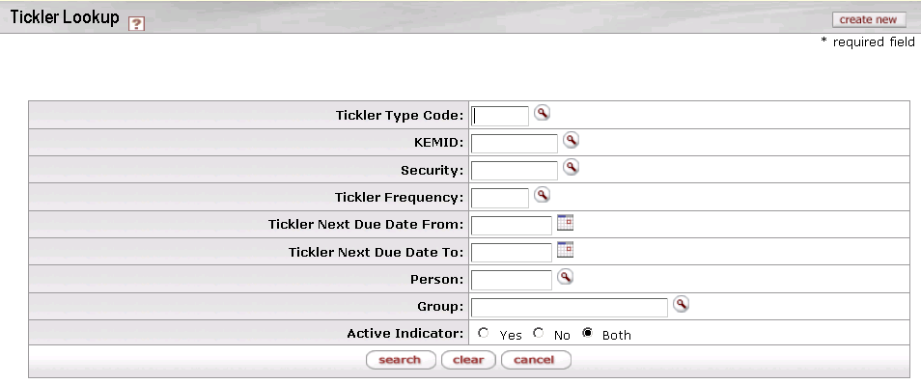

On this screen, you have two options:

* To set up a new tickler, click the **create new** button in the upper right corner of the screen. The system displays the Tickler Maintenance Document screen in create mode. Complete the fields as indicated under “Document Layout” below.
* To display information for one or more existing ticklers, enter search criteria in the fields on this screen as explained in the table below and click **search**.

Tickler Lookup definition

|  |  |
| --- | --- |
| Title | Description |
| Tickler Type Code | The type of tickler(s) you want to work with. |
| KEMID | The KEMID associated with the tickler(s) you want to work with. |
| Security | The security associated with the tickler(s) you want to work with. |
| Tickler Frequency | Frequency associated with the tickler(s) you want to work with. |
| Tickler Next Due Date From | The first date in a range of next due dates for the tickler(s) you want to work with. |
| Tickler Next Due Date To | The last date in a range of next due dates for the tickler(s) you want to work with. |
| Person | Recipient person associated with the tickler(s) you want to work with. |
| Group | Recipient group associated with the tickler(s) you want to work with. |
| Active Indicator | Status (active, inactive, or both) of the tickler(s) you want to work with. |

* After you enter search criteria and click **search**, the system displays a list of matching records at the bottom of the screen.

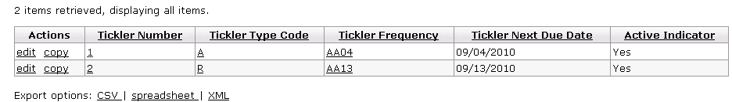

Tickler tab definition

|  |  |
| --- | --- |
| Title | Description |
| Tickler Number | The number that uniquely identifies a tickler. |
| Tickler Type Code | The code identifying a reason a person or department wants or needs to be notified of an upcoming event or action to be taken. |
| Tickler Frequency | The code identifying how often a tickler is to be sent. |
| Tickler Next Due Date | The specific date on which the next tickler is to be sent. |
| Active Indicator | Indicates whether a tickler is active or not. |

To edit or copy one of these records, click the or link in the **Actions** column.

From the results table, you may drill down into detail for a tickler. To do so, click an underlined tickler number. The system displays the Tickler Inquiry screen.

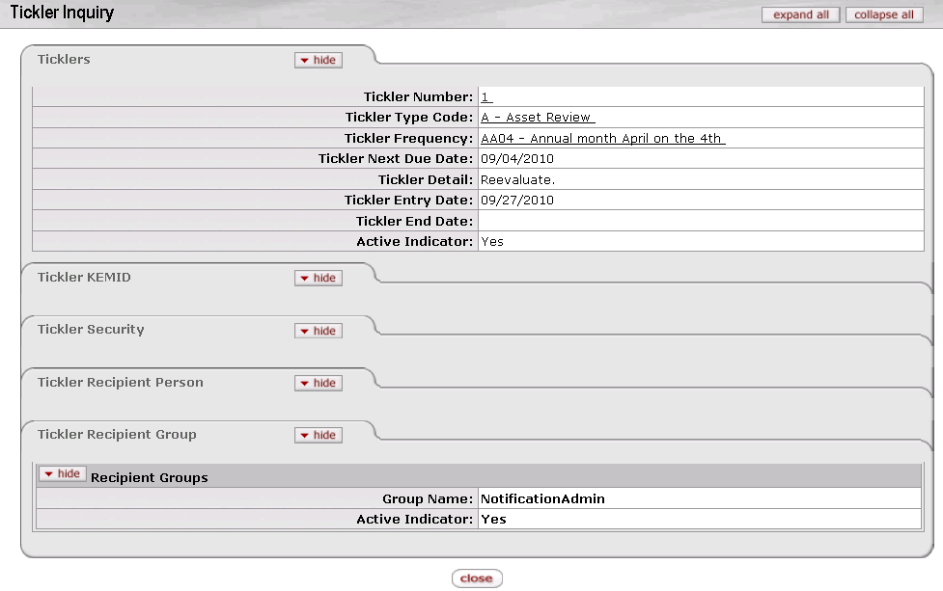

#### Document Layout

When you click **create new** in the top right corner of the Tickler Lookup screen or click the **edit** link for any row in the search results display, the system displays the Tickler Maintenance Document screen. If you are creating a new tickler, the screen is displayed in create mode (as shown below). If you are editing an existing tickler, the screen is displayed in edit mode.

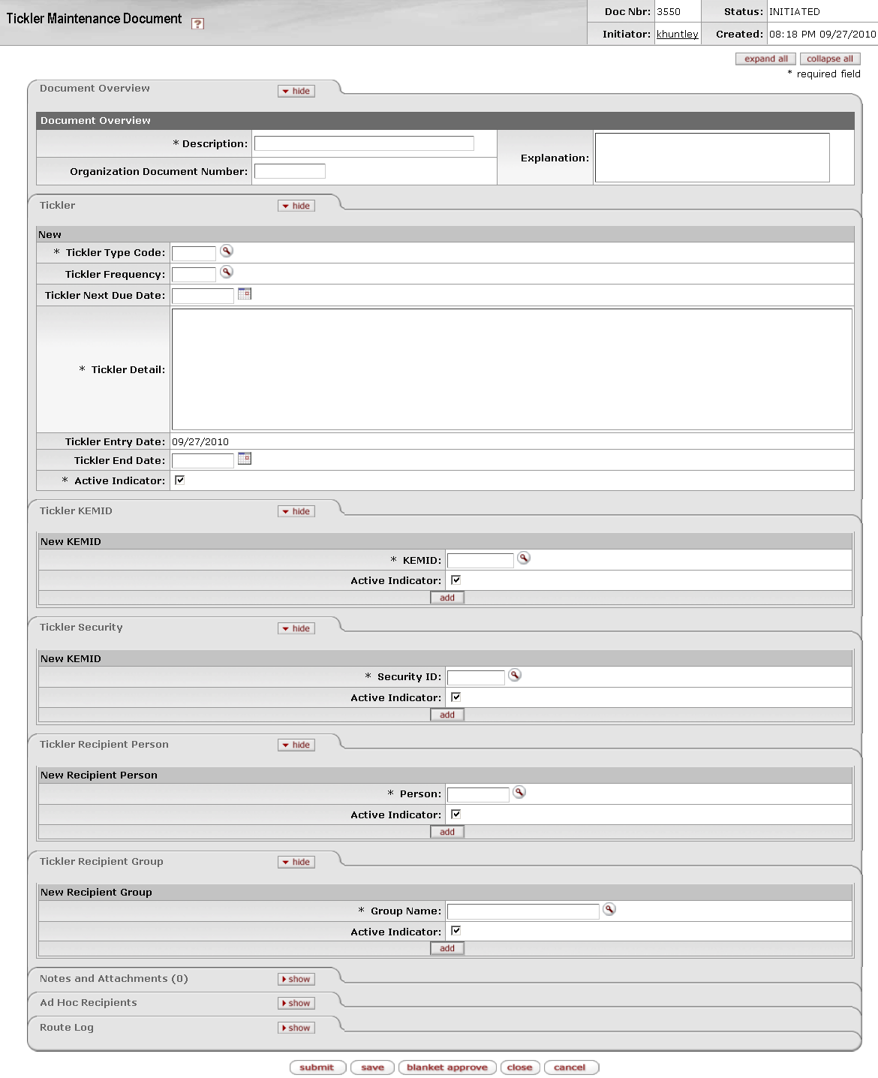

The Tickler document contains five unique tabs— **Tickler**, **Tickler KEMID**, **Tickler Security**, **Tickler Recipient Person, and Tickler Recipient Group**—in addition to the standard tabs.

 For more information about the standard tabs, see Standard Tabs|document=WordDocuments\KFS 5\_2 Overview.docx;topic=Standard Tabs“Standard Tabs” in the KFS Overview and Introduction to the User Interface.

##### Tickler Tab

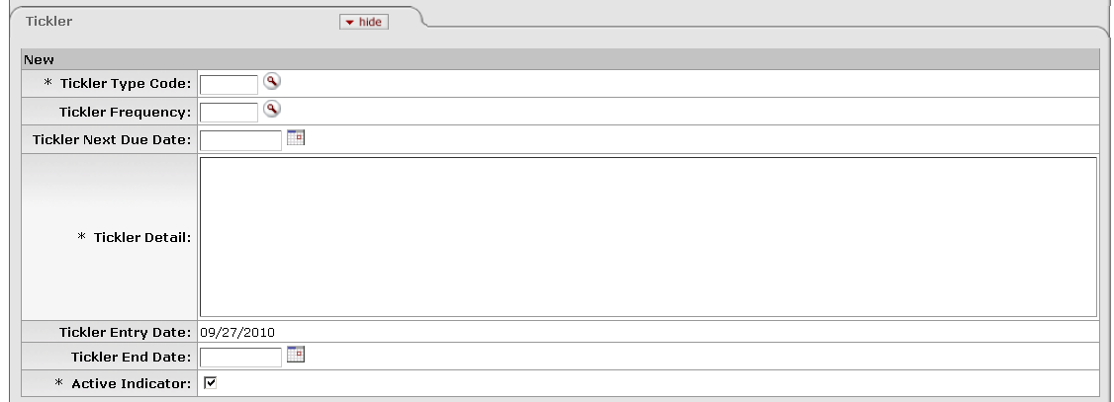

This tab contains basic information for the tickler, such as the reason for it, the text of the message, and the frequency or dates for its transmission.

Tickler tab definition

|  |  |
| --- | --- |
| Title | Description |
| Tickler Type Code | Required. Indicates the reason a person or department wants or needs to be notified of an upcoming event or action to be taken. These reasons are defined by your institution through Tickler Type Code maintenance e-docs. Different type codes might indicate 'Investment Review', 'Spending Review', or Income Reinvestment.' Enter an existing code or use the lookup _searchicon.gif to find it. |
| Tickler Frequency | Indicates how often you want the tickler to be sent. Enter an existing frequency code or use the lookup _searchicon.gif to find it. You must enter either a **Tickler** **Frequency** value or a **Tickler Next Due Date** value, but you may not enter both. If you do not enter a **Tickler** **Frequency** value, the system assumes that this is a one-time reminder so you must enter **Tickler Next Due Date** value. |
| Tickler Next Due Date | Indicates a specific date on which the next tickler is to be sent. Enter the date or select it from the calendar cal. You must enter either a **Tickler** **Frequency** value or a **Tickler Next Due Date** value, but you may not enter both. If you do not enter a **Tickler** **Frequency** value, the system assumes that this is a one-time reminder so you must enter **Tickler Next Due Date** value. |
| Tickler Detail | Required. The text of the tickler message. |
| Tickler Entry Date | Display only. When you create a tickler, the system automatically enters the current date in this field. |
| Tickler End Date | The date the tickler expires. Enter the date or select it from the calendar cal. If you mark a tickler as inactive, the system automatically populates the **Tickler End Date** based on the current date. |
| Active Indicator | Required. Indicates whether this tickler is active or not. Check the box to activate the tickler. Clear the box to deactivate it. If you mark a tickler as inactive, the system automatically populates the **Tickler End Date** based on the current date. |

##### Tickler KEMID Tab

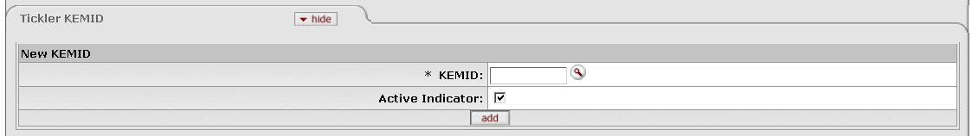

This tab indicates the KEMIDs (if any) to which the tickler applies. You may add multiple KEMIDs to each Tickler record.

Tickler KEMID tab definition

|  |  |
| --- | --- |
| Title | Description |
| KEMID | Required if the tickler is to be linked to a KEMID. The KEMID to which the tickler applies. Enter an existing KEMID or use the lookup _searchicon.gif to find it. |
| Active Indicator | Check the box to activate the association of the KEMID with this tickler. Clear the box to deactivate it. |

##### Tickler Security Tab

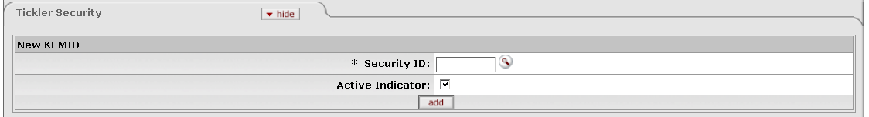

This tab indicates the securities (if any) to which the tickler applies. You may add multiple securities in this tab.

Tickler Security tab definition

|  |  |
| --- | --- |
| Title | Description |
| Security ID | Required if the tickler is to be linked to a security. The security to which the tickler applies. Enter an existing ID or use the lookup _searchicon.gif to find it. |
| Active Indicator | Check the box to activate the association of the security with this tickler. Clear the box to deactivate it. |

##### Tickler Recipient Person Tab

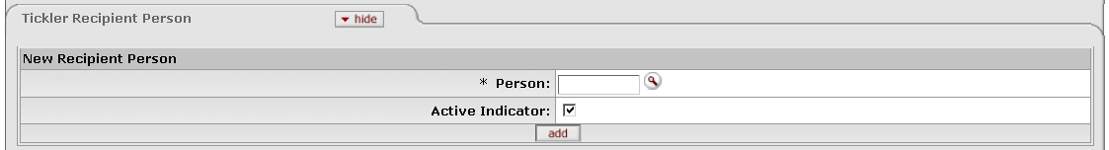

This tab identifies individual users who are to receive the tickler. You may specify multiple users in this tab.

Tickler Recipient Person tab definition

|  |  |
| --- | --- |
| Title | Description |
| Person | Required if the reminder is to be sent to a particular person. The principal name (user ID) for a person who is to receive this tickler. Enter an existing principal ID or use the lookup _searchicon.gif to find it. |
| Active Indicator | Check the box to activate the association of the user with this tickler. Clear the box to deactivate it. |

##### Tickler Recipient Group Tab

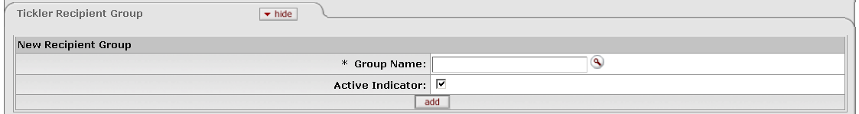

This tab identifies groups of users who are to receive the tickler. You may specify multiple groups in this tab.

Tickler Recipient Group tab definition

|  |  |
| --- | --- |
| Title | Description |
| Group Name | Required if the reminder is to be sent to a particular group of people. Enter an existing group name or use the lookup _searchicon.gif to find it. |
| Active Indicator | Check the box to activate the association of the group with this tickler. Clear the box to deactivate it. |

#### Process Overview

##### Business Rules

The following business rules apply to tickler transactions:

* When you add a Tickler record, the system automatically updates the **Tickler Number** field with the next sequential record number. You cannot change this entry and it is not displayed on the screen, but you may use it to generate a custom ticklers report.
* The **Tickler** **Type Code** and **Tickler** **Frequency** values must already be defined in the system.
* You must enter either a **Tickler** **Frequency** value or a **Tickler Next Due Date** value, but you may not enter both.
* If you do not enter a **Tickler** **Frequency** value, the system assumes that this is a one-time reminder so you must enter **Tickler Next Due Date** value.
* If you enter a **Tickler** **Frequency** value when creating, copying, or editing this e-doc, the system automatically updates the **Tickler Next Due Date** value according to the frequency if a frequency was specified.
* When you create a tickler, the system automatically enters the current date in the **Tickler Entry Date** field. You cannot change this entry.
* **Tickler End Date** is not a required field.
* If you mark a tickler as inactive, the system automatically populates the **Tickler End Date** based on the current date.
* This e-doc does not require entries in the **Tickler KEMID** or **Tickler Security** tabs, but each e-doc may have one or more entries in these tabs.
* Any KEMID, security ID, group name, and/or recipient person specified must already be defined in the system.
* Each active tickler must reference at least one active recipient person or group.
* Each active tickler may reference multiple recipient persons and/or groups***.***
* If you mark a tickler as inactive, the system automatically marks all associated info in the **Tickler KEMID**, **Tickler Security**, **Tickler Recipient Person**, and **Tickler Recipient Group** tabs as inactive.
* When the system displays results in the Ticker Lookup screen, the active indicator selection applies only to the tickler record, not to the information in the tabs for KEMID, security, person, and group. If you enter a KEMID, security or recipient person or group as a search criterion for the tickler, the system does not check the active indicator on these tabs.
* When the **Active** indicator is changed to 'No' for a KEMID, security, person or group, you may still view the record via the detail inquiry function. In edit mode, the system displays all records (both active and inactive) so you can re-activate records as needed. In both cases, you may hide all inactive records in the tab if you wish.
* You cannot copy the information in the **Tickler KEMID**, **Tickler Security**, **Tickler Recipient Person**, and **Tickler Recipient Group** tabs. When you create a new tickler by copying an existing Tickler record, you must add the information in these tabs.
* If you re-activate a Tickler record, the system revalidates the data for it and reports any errors so you may correct them. Whenever a tickler is re-activated, the system checks to ensure that the **Tickler End Date** value is greater than the current date.

##### Routing

The figure below shows the standard routing for this e-doc. Your institution's routing may vary.



#### Example

A donor establishes an endowment and instructs that the funds generated from it are not to be used until the market value reaches a specific level. The institution sets up an annual tickler to monitor the market value of the KEMID. Additionally, all income paid must be reinvested in principal until the endowment reaches a certain market value, so another annual tickler is set up to monitor the market value for this purpose.

## Balance Inquiries

 > > 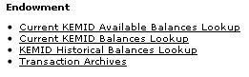

The **Balance Inquiries** menu group on the **Main Menu** tab provides access to four Endowment balance inquiries. These inquiries allow you to view the current and historical balances of an individual KEMID. The initial lookup provides high-level balance information. You may then drill down to greater detail for selected information, including detail for a specific tax lot.

The following table summarizes the purpose of each inquiry.

Endowment balance inquiries available from the Main Menu, Balance Inquiries submenu

|  |  |
| --- | --- |
| Inquiry Title | Description |
| Current KEMID Available Balances Lookup | Allows you to view summary information for available cash (for income, principal, and a total of the two) for any KEMID. You may also drill down into the details of the information shown. |
| Current KEMID Balances Lookup | Allows you to view the current market value of any KEMID in terms of its income, principal, and total value along with estimates of future income. From the results screen, you may drill down into many levels of detail for the KEMID and its balances, value, and holdings. At the holding lot level, you may edit the tax lot calculation for a specific holding lot. |
| KEMID Historical Balances Lookup | Allows you to view the total market values for cash, assets and liabilities held by a KEMID as of a specific month end. The results show the totals grouped by income and principal and a total of the two. You may drill down to the level of individual securities and tax lots. |
| Transaction Archives | Allows you to research transaction activity by accessing selected transactions that have been archived. |

### Making a Balance Inquiry

To access any of the balance inquiries and perform a search, follow these steps:

1. Select the desired inquiry from the **Endowment** submenu group in the **Balance Inquiries** menu group on the **Main Menu** tab.

The system displays the requested lookup screen. This screen may display default values, any of which may be changed.

1. Enter values in all required fields (fields preceded by an asterisk). Narrow the search as desired by including additional criteria.
2. Click  when you are ready to retrieve the balances.
3. Drill down to the desired level of detail by clicking any of the underlined links in the search results.

### Current KEMID Available Balances Lookup

 > >  >  > 

This inquiry allows you to view available cash (for income, principal, and a total of the two) for any KEMID(s). From the results screen, you may drill down into a detailed KEMID inquiry screen, from which you may view information about the KEMID (including information regarding the KEMID's current available funds, current balances, historical balances, ticklers, and recurring transfer transactions). From that screen, you may drill down into further detail.

#### Lookup Criteria

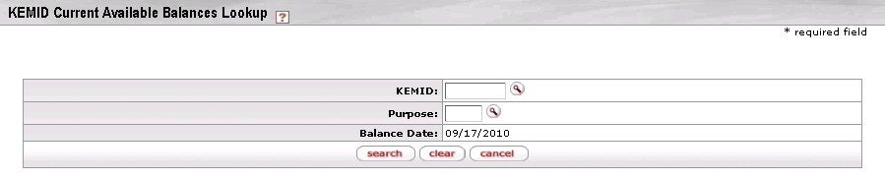

Current KEMID Available Balances Lookup inquiry screen

|  |  |
| --- | --- |
| Title | Description |
| KEMID | Optional. Enter the KEMID for which you want information or search for it from the lookup searchicon. |
| Purpose | Optional. Enter the KEMID purpose for which you want information or search for it from the lookup searchicon. |
| Balance Date | Display only. The most recent balance date. |

Click  when you have entered all necessary criteria and are ready to retrieve the balances.

#### Search Results

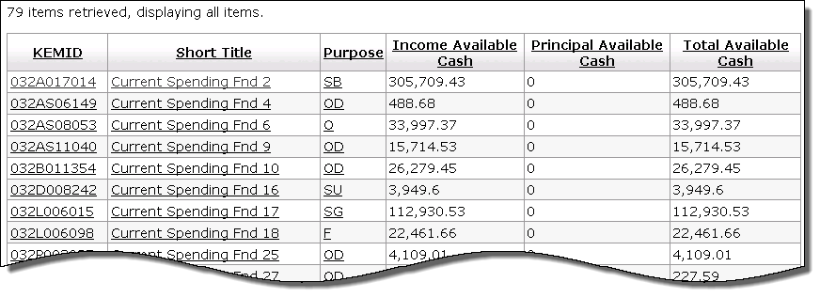

Current KEMID Available Balances Lookup results definition

|  |  |
| --- | --- |
| Title | Description |
| KEMID | Identifies a specific set of funds held by your institution as an endowment or a specific set of funds functioning as an endowment. Click on an underlined KEMID to display the details of a KEMID record. |
| Short Title | The descriptive name of this KEMID. Click on an underlined short title to display the details of a KEMID record. |
| Purpose | The purpose for which the KEMID has been established. Click on an underlined purpose value to display information about it. |
| Income Available Cash | The amount of income available as cash for expenditure by the benefitting organization. This value is the sum of  current income cash  plus the market value of all cash equivalents tax lots for income  plus the market value of all pooled investment tax lots records for income times the value in the institutional parameter for the available cash calculation (which accounts for only a percentage of the market value allowing for pricing changes) |
| Principal Available Cash | The amount of principal available as cash for expenditure by the benefitting organization.  If the KEMID has a type code with a permanent restriction, this value is always zero.  Otherwise, this value is the sum of  current principal cash  plus the market value of all cash equivalents tax lots for principal  plus the market value of all pooled investment tax lots records for principal times the value in the institutional parameter for the available cash calculation (which accounts for only a percentage of the market value allowing for pricing changes) |
| Total Available Cash | The total amount of available cash (available income cash plus available principal cash) for this KEMID. |

##### Drilldown into KEMID Inquiry Screen

When you click the underlined KEMID, short title, or closed indicator in the row for a KEMID in the lookup results, the system displays the KEMID Inquiry screen for the KEMID. This display (shown below in three parts) contains extensive detail for the KEMID and many options for drilling down further in key areas.

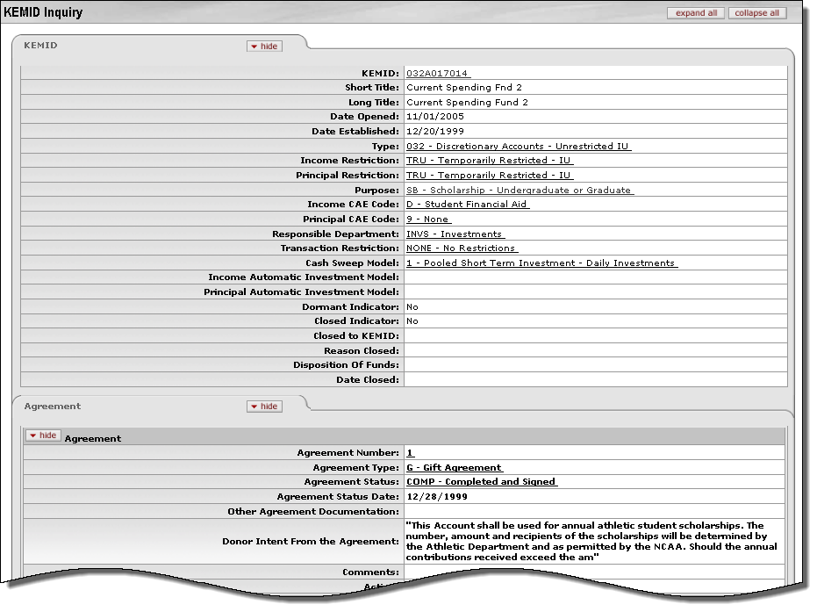

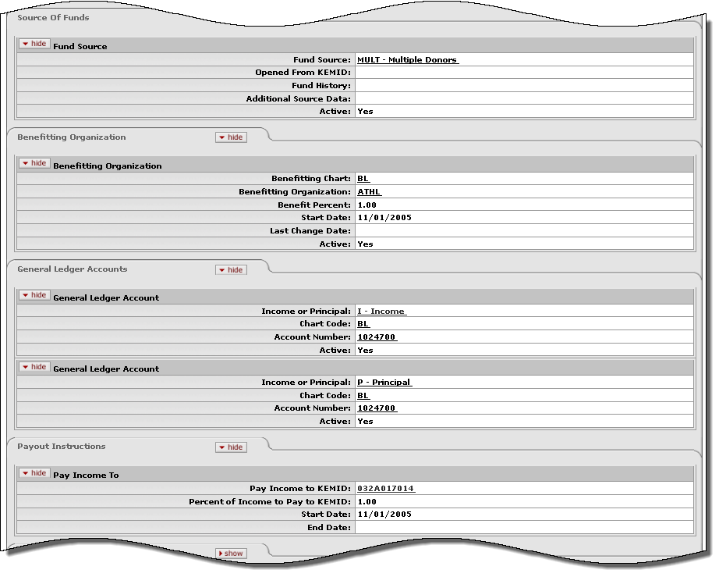

In the portions of the screen shown above, you may access additional detail by clicking on any underlined field value. For example, to display information for the KEMID's income account, scroll down to the **General Ledger Accounts** tab and click on the underlined account number in the **Income** section.

Continuing down the screen, the lower portion of the display (shown below) contains **Lookup** links to the system's standard lookups for current available funds, current balances, and historical balances (all of which are also available from the **Balance Inquiries** submenu on the **Main Menu** tab). This portion of the screen also provides **Lookup** links to ticklers and recurring transfer transactions for the KEMID.

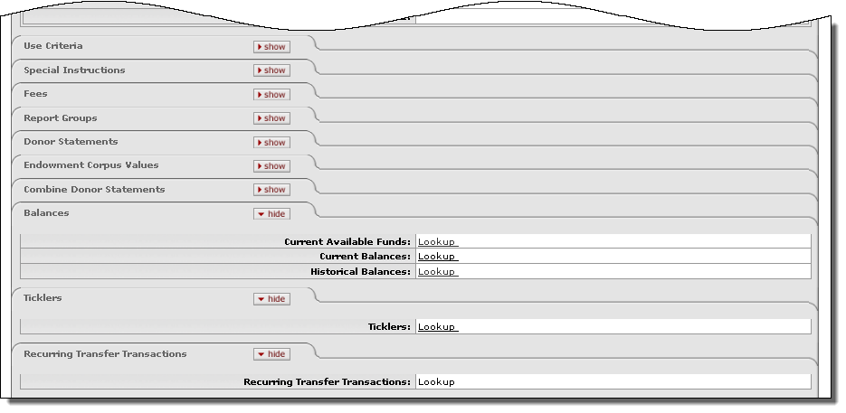

 For more information about the fields on this screen, see KEMID|document=WordDocuments\KFS 5\_2 KEM.docx;topic=KEMID.

### Current KEMID Balances Lookup

 > >  >  > 

This inquiry allows you to view the current market value of any KEMID in terms of its income, principal, and total value along with estimates of future income for the next twelve months, the remainder of the current fiscal year, and the next fiscal year. From the results screen, you may drill down into a detailed KEMID inquiry screen, from which you may view and drill down further into the details of the KEMID record and access current available funds, current balances, historical balances, ticklers, and recurring transfer transactions for the KEMID. You may also drill down into detail for the KEMID's market value to see detail for individual securities and holding lots. At the holding lot level, you may edit the tax lot calculation for a specific holding lot.

#### Lookup Criteria

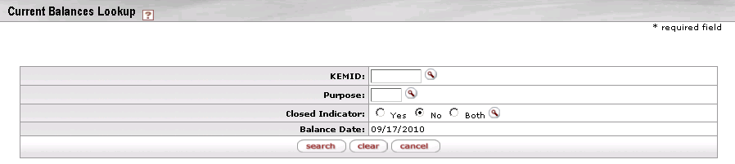

Current KEMID Balances Lookup inquiry screen

|  |  |
| --- | --- |
| Title | Description |
| KEMID | Optional. Enter the KEMID for which you want information or search for it from the lookup searchicon. |
| Purpose | Optional. Enter the KEMID purpose for which you want information or search for it from the lookup searchicon. |
| Closed Indicator | Optional. A KEMID may be closed only if the cash balances are zero, all holdings are zero, and the accrual amounts in the holding records are zero for all securities held by the KEMID.  By default, the system searches for open KEMIDs only, but you may click the appropriate button to specify any of the following:  Yes = Search only for closed KEMIDs  No = Search only for open KEMIDs  Both = Search for both open and closed KEMIDs |
| Balance Date | Display only. The most recent balance date. |

Click  when you have entered all necessary criteria and are ready to retrieve the balances.

#### Search Results

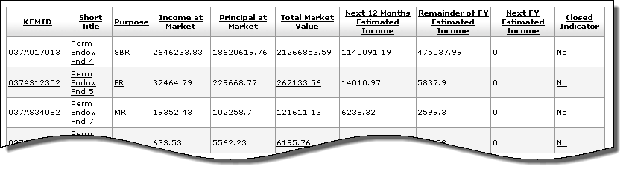

Current KEMID Balances Lookup results definition

|  |  |
| --- | --- |
| Title | Description |
| KEMID | Identifies a specific set of funds held by your institution as an endowment or a specific set of funds functioning as an endowment. To view more detail about a KEMID, click the underlined link. |
| Short Title | The descriptive name of this KEMID. To view more detail about a KEMID, click the underlined short title. |
| Purpose | The purpose for which this KEMID has been established. To view more detail about a purpose, click the underlined link. |
| Income at Market | The market value of the KEMID's current income holdings. This value is the total of:  current income cash for the KEMID.  plus the total market value of all current tax lot balance records held as income by the KEMID |
| Principal at Market | The market value of the KEMID's current principal holdings. This value is the total of:  current principal cash for the KEMID  plus the total market value of all current tax lot balance records held as principal by the KEMID. |
| Total Market Value | The market value of the KEMID's current total (income at market plus principal at market) balance. To view more detail about the KEMID's total market value, click the underlined link. |
| Next 12 Months Estimated Income | The estimated income for this KEMID in the next twelve months. This calculation represents what an endowment might realize should there be no changes in the number of units held and no change in the payout rate.  This estimate is the result of the number of units in the holding lot times the rate for the security. |
| Remainder of FY Estimated Income | The estimated income for this KEMID for the rest of the current fiscal year. This calculation represents what an endowment might realize should there be no changes in the number of units held and no change in the payout rate.  This estimate is displayed only for current holdings at the tax lot level. The calculation takes into account the frequency of the payments for the security and the next payment date—factors that are tied to the type of security. Consequently, the calculation varies based on the class code type of the security.  C:\Documents and Settings\jbrown\Desktop\KFS 4.0\User Guide Images\User Guide Icons\go-arrow-red.gif For more information on the calculations for each class code type, see [KFS 4.0 Endowment System Calculations](https://wiki.kuali.org/download/attachments/307464563/KEM+System+Calculations.docx?version=1&modificationDate=1289344047000).  Some securities do not have an estimated income because the expected payout is not known (e.g., alternative investments, real estate, receivables, liabilities, etc). If the calculation cannot be made because the rate is zero, the estimated income is zero. |
| Next FY Estimated Income | The estimated income for this KEMID in the next fiscal year. This calculation represents what an endowment might realize should there be no changes in the number of units held and no change in the payout rate.  This estimate is the result of the next fiscal year distribution amount times the number of holding units.  pencil-small This value is typically visible only for a short period of time (the length of which is determined by your institution as the new fiscal year approaches). |
| Closed Indicator | Status indicator:  No = KEMID is open.  Yes = KEMID is closed.  A KEMID may be closed only if the cash balances are zero, all holdings are zero, and the accrual amounts in the holding records are zero for all securities held by the KEMID. |

##### Drilldown into KEMID Detail

From the Current KEMID Balances Lookup results, you may display information about any of the KEMIDs displayed. To do so, click the underlined KEMID or its short title. The system displays the KEMID Inquiry screen with information for the KEMID you selected.

 For more information about the KEMID Inquiry Screen, see Drilldown into KEMID Inquiry Screen|topic=Drilldown into KEMID Inquiry Screen.

##### Drilldown into KEMID Total Market Value Detail

From the Current KEMID Balances Lookup results, you may display information about the total market value of the underlying assets for any of the KEMIDs displayed. To do so, click the underlined **Total Market Value** link for the KEMID. The system displays the KEMID Current Balances Detail Lookup screen with results.

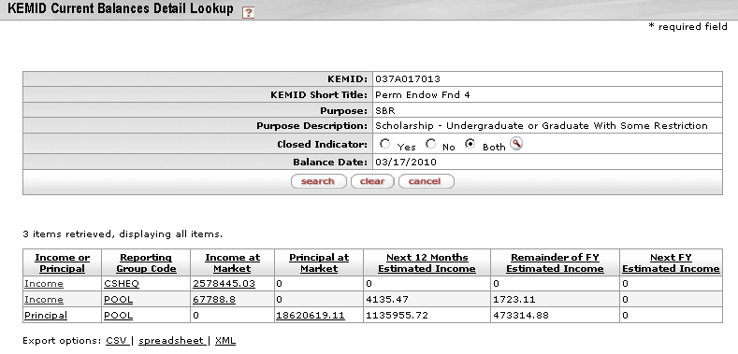

In the upper half of the screen, the search fields are pre-filled with data for the KEMID whose **Total Market Value** link you chose. In the lower part of the screen is the search results table. Each row of the table displays current balance information for a group of income or principal holdings.

KEMID Current Balances Detail Lookup results definition

|  |  |
| --- | --- |
| Title | Description |
| Income or Principal | The nature of this reporting group—income or principal. |
| Reporting Group Code | The reporting group to which one or more holdings belong for the purpose of reporting income or principal. Derived from the class code of the security(ies) represented.  To view more detail about a reporting group code, click its underlined link. |
| Income at Market | The market value of the group's current income balance. For a principal holding group, this value is always zero. For an income holding group, this value is the total of all securities held by the KEMID and classified as belonging to the group.  To view more detail about this value, click the underlined link. |
| Principal at Market | The market value of the group's current principal balance. For an income holding group, this value is always zero. For a principal holding group, this value is the total of all securities held by the KEMID and classified as belonging to the group.  To view more detail about this value, click the underlined link. |
| Next 12 Months Estimated Income | The estimated income for the next twelve months for all securities held by the KEMID and classified as belonging to the group. This calculation represents what an endowment might realize should there be no changes in the number of units held and no change in the payout rate.  This estimate is the result of the number of units in the holding lot times the rate for the security. |
| Remainder of FY Estimated Income | The estimated income for the rest of the current fiscal year for all securities held by the KEMID and classified as belonging to the group. This calculation represents what an endowment might realize should there be no changes in the number of units held and no change in the payout rate.  This estimate is displayed only for current holdings at the tax lot level. The calculation takes into account the frequency of the payments for the security and the next payment date—factors that are tied to the type of security. Consequently, the calculation varies based on the class code type of the security.  C:\Documents and Settings\jbrown\Desktop\KFS 4.0\User Guide Images\User Guide Icons\go-arrow-red.gif For more information on the calculations for each class code type, see [KFS 4.0 Endowment System Calculations](https://wiki.kuali.org/download/attachments/307464563/KEM+System+Calculations.docx?version=1&modificationDate=1289344047000).  Some securities do not have an estimated income because the expected payout is not known (e.g., alternative investments, real estate, receivables, liabilities, etc). If the calculation cannot be made because the rate is zero, the estimated income is zero. |
| Next FY Estimated Income | The estimated income for all holdings in the reporting group for the next fiscal year. This calculation represents what an endowment might realize should there be no changes in the number of units held and no change in the payout rate.  This estimate is the result of the next fiscal year distribution amount (if a value has been placed in that field for the security record) times the number of holding units. At the end of the fiscal year this value is returned to zero until a user enters another value. |

##### Drilldown into KEMID Current Reporting Group Detail

From the results table for the KEMID Current Balances Detail Lookup screen, you may drill down into a list of individual securities within any reporting group for income or principal. To do so, click the underlined link for **Income at Market** or **Principal at Market** for the desired component. The system displays the information in the results portion of the KEMID Current Reporting Group Lookup screen with results.

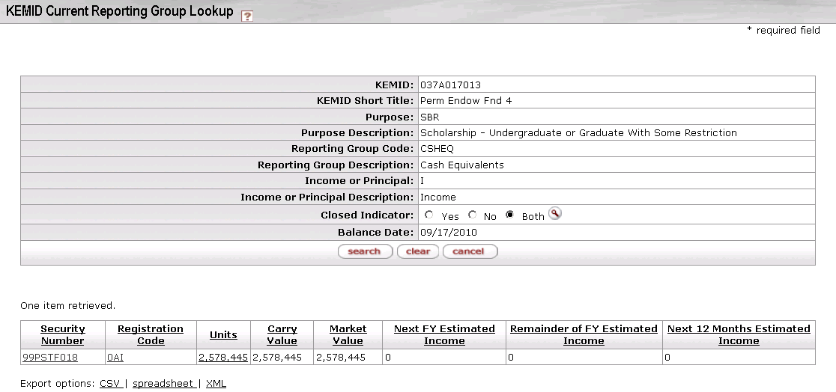

The search fields are pre-filled with data for the KEMID and income or principal reporting group whose **Income at Market** or **Principal at Market** link you chose. Each row of the results table displays information for a security and registration code combination within the reporting group.

KEMID Current Reporting Group Lookup results definition

|  |  |
| --- | --- |
| Title | Description |
| Security Number | The ID number for a specific security held by this KEMID. To view more detail about a security, click the underlined link. |
| Registration Code | An indication of where (for example, at a bank, at a broker, or somewhere in the institution) this security is held in custody for the institution. To view more detail about a registration code, click the underlined link. |
| Units | The number of units of this security associated with this registration code. To view more detail, click the underlined link. |
| Carry Value | The carry value of this holding. |
| Market Value | The market value of this holding. |
| Next FY Estimated Income | The estimated income for this holding in the next fiscal year. This calculation represents what an endowment might realize should there be no changes in the number of units held and no change in the payout rate.  This estimate is the result of the next fiscal year distribution amount times the number of holding units. |
| Remainder of FY Estimated Income | The estimated income for this holding in the rest of the current fiscal year. This calculation represents what an endowment might realize should there be no changes in the number of units held and no change in the payout rate.  This estimate is displayed only for current holdings at the tax lot level. The calculation takes into account the frequency of the payments for the security and the next payment date—factors that are tied to the type of security. Consequently, the calculation varies based on the class code type of the security.  C:\Documents and Settings\jbrown\Desktop\KFS 4.0\User Guide Images\User Guide Icons\go-arrow-red.gif For more information on the calculations for each class code type, see [KFS 4.0 Endowment System Calculations](https://wiki.kuali.org/download/attachments/307464563/KEM+System+Calculations.docx?version=1&modificationDate=1289344047000).  Some securities do not have an estimated income because the expected payout is not known (e.g., alternative investments, real estate, receivables, liabilities, etc). If the calculation cannot be made because the rate is zero, the estimated income is zero. |
| Next 12 Months Estimated Income | The estimated income for this holding in the next twelve months. This calculation represents what an endowment might realize should there be no changes in the number of units held and no change in the payout rate. |

##### Drilldown into KEMID Security Detail

From the results table for the KEMID Current Reporting Group Lookup screen, you may drill down into detail for any security/registration code combination. To do so, click an underlined **Security Number** link. The system displays the Security Lookup screen with data for the security you chose.

 For information on the Security Lookup screen, see Security|document=WordDocuments\KFS 5\_2 KEM.docx;topic=Security.

##### Drilldown into KEMID Tax Lot Detail

From the results table for the KEMID Current Reporting Group Lookup screen, you may drill down further to view the detail of a specific security held at a specific location (registration code) and to view the holding and tax lots. To do so, click the underlined link for **Units**. The system displays the KEMID Current Tax Lots Lookup screen with results.

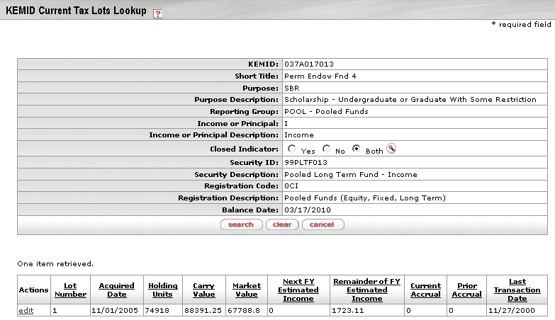

The search fields are pre-filled with data for the KEMID, reporting group, and security and registration code combination whose **Units** link you chose. Each row of the results table displays information for a single tax lot.

KEMID Current Tax Lots Lookup results definition

|  |  |
| --- | --- |
| Title | Description |
| Actions | Click the **edit** link to edit the accrued income due. This edit is necessary only if the KEMID is to be closed and still has accrued income due. |
| Lot Number | The ID number for this tax lot. |
| Acquired Date | The date this lot was acquired. |
| Holding Units | The number of units in this tax lot. |
| Carry Value | The carry value of this tax lot. |
| Market Value | The market value of this tax lot. |
| Next FY Estimated Income | The estimated income for this tax lot in the next fiscal year. This calculation represents what an endowment might realize should there be no changes in the number of units held and no change in the payout rate.  This estimate is the result of the next fiscal year distribution amount times the number of holding units. |
| Remainder of FY Estimated Income | The estimated income for this tax lot in the rest of the current fiscal year. This calculation represents what an endowment might realize should there be no changes in the number of units held and no change in the payout rate.  This estimate is displayed only for current holdings at the tax lot level. The calculation takes into account the frequency of the payments for the security and the next payment date—factors that are tied to the type of security. Consequently, the calculation varies based on the class code type of the security.  C:\Documents and Settings\jbrown\Desktop\KFS 4.0\User Guide Images\User Guide Icons\go-arrow-red.gif For more information on the calculations for each class code type, see [KFS 4.0 Endowment System Calculations](https://wiki.kuali.org/download/attachments/307464563/KEM+System+Calculations.docx?version=1&modificationDate=1289344047000).  Some securities do not have an estimated income because the expected payout is not known (e.g., alternative investments, real estate, receivables, liabilities, etc). If the calculation cannot be made because the rate is zero, the estimated income is zero. |
| Current Accrual | The current accrued value of the lot. |
| Prior Accrual | The prior accrued value of the lot. |
| Last Transaction Date | The date of the last transaction for this lot. |

##### Holding Tax Lot Maintenance Document

From the results table for the KEMID Current Tax Lots Lookup screen, you may access the Holding Tax Lot Maintenance Document. In this document you may view details of a tax lot and, if desired, change the current and prior accrual values.

To access the maintenance e-doc for a tax lot, click the **edit** link in the **Actions** column for the lot. The system displays the Holding Tax Lot Maintenance Document.

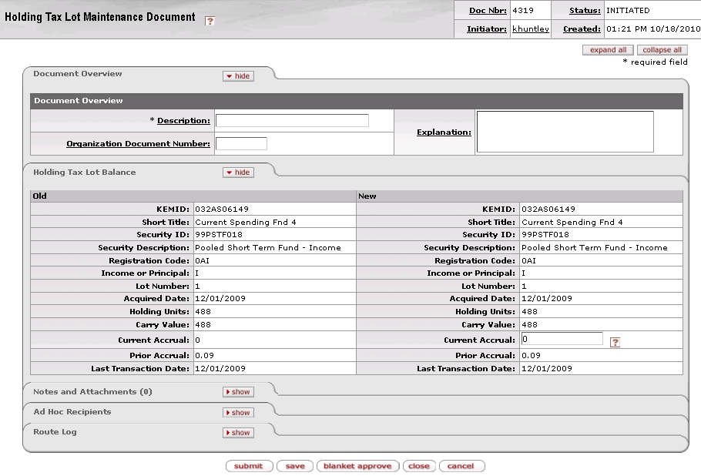

The Holding Tax Lot Maintenance Document contains one unique tab—**Holding Tax Lot Balance**—in addition to the standard tabs.

 For more information about the standard tabs, see Standard Tabs|document=WordDocuments\KFS 5\_2 Overview.docx;topic=Standard Tabs“Standard Tabs” in the KFS Overview and Introduction to the User Interface.

This tab contains detail about the tax lot. All fields are display only, except for **Current Accrual** and **Foreign Tax Withheld**, both of which you may change in order to change the calculations for the tax lot.

Holding Tax Lot Balance tab definition

|  |  |
| --- | --- |
| Title | Description |
| KEMID | Display only. The KEMID holding this lot. |
| Short Title | Display only. The descriptive title for this KEMID. |
| Security ID | Display only. The security in the tax lot. |
| Security Description | Display only. The descriptive title for this security. |
| Registration Code | Display only. The registration code for this security. |
| Income or Principal | Display only. Indicator (I or P) for income or principal. |
| Lot Number | Display only. The lot number. |
| Acquired Date | Display only. The date this lot was acquired. |
| Holding Units | Display only. The number of units in the lot. |
| Carry Value | Display only. The carry value of the lot. |
| Current Accrual | The current accrued value of the lot. You may change this value in order to change calculations for this tax lot. |
| Prior Accrual | Display only. The prior accrued value of the lot. |
| Last Transaction Date | Display only. The date of the last transaction for this lot. |

### KEMID Historical Balances Lookup

 > >  >  > 

This inquiry allows you to view the same types of information you access via the current balance inquiry but, in this case, you are accessing historical values as of a previous month end. The information available through this inquiry includes the total market values for cash, assets, and liabilities held by the KEMID as of the specified month end. The results show the totals grouped by values held as income and principal along with a total for the entire KEMID. You may drill down into the results to view more detail for individual securities and tax lots.

#### Lookup Criteria

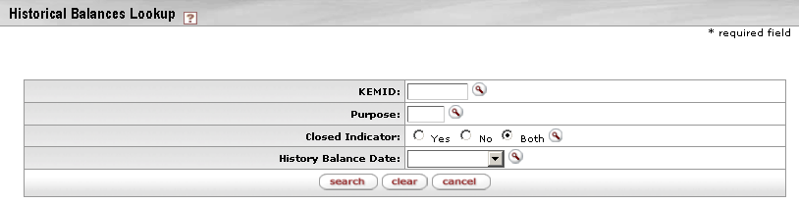

KEMID Historical Balances Lookup inquiry

|  |  |
| --- | --- |
| Title | Description |
| KEMID | Optional. Enter the KEMID for which you want information or search for it from the lookup searchicon. |
| Purpose | Optional. Enter the KEMID purpose for which you want information or search for it from the lookup searchicon. |
| Closed Indicator | Optional. A KEMID may be closed only if the cash balances are zero, all holdings are zero, and the accrual amounts in the holding records are zero for all securities held by the KEMID.  By default, the system searches for open KEMIDs only, but you may click the appropriate button to specify any of the following:  Yes = Search only for closed KEMIDs  No = Search only for open KEMIDs  Both = Search for open and closed KEMIDs |
| History Balance Date | Optional. Defaults to the most recent month end value. Select a desired balance date from the list. |

Click  when you have entered all necessary criteria and are ready to retrieve the balances.

#### Search Results

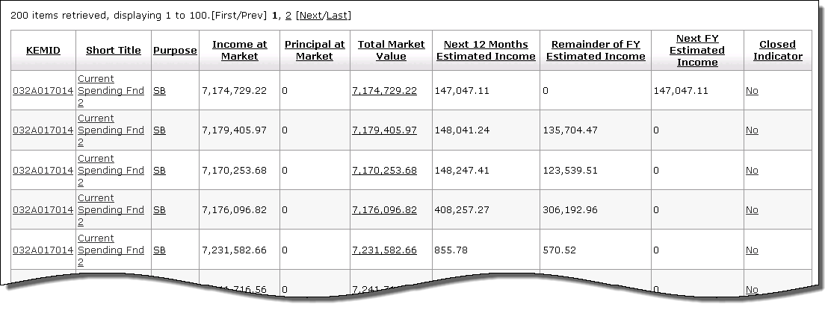

KEMID Historical Balances Lookup results definition

|  |  |
| --- | --- |
| Title | Description |
| KEMID | Identifies a specific set of funds held by your institution as an endowment or a specific set of funds functioning as an endowment. To view more detail about a KEMID, click the underlined link. |
| Short Title | The descriptive name of this KEMID. To view more detail about a KEMID, click the underlined link for its title. |
| Purpose | The purpose for which the KEMID has been established. To view more detail about a purpose code, click the underlined link. |
| Income at Market | The market value of the KEMID's current income balance. |
| Principal at Market | The market value of the KEMID's current principal balance. |
| Total Market Value | The market value of the KEMID's current total (income at market plus principal at market) balance. |
| Next 12 Months Estimated Income | The estimated income for this KEMID in the next twelve months. |
| Remainder of FY Estimated Income | The estimated income for this KEMID in the rest of the current fiscal year. |
| Next FY Estimated Income | The estimated income for this KEMID in the next fiscal year. |
| Closed Indicator | Status indicator:  No = KEMID is open.  Yes = KEMID is closed.  A KEMID may be closed only if the cash balances are zero, all holdings are zero, and the accrual amounts in the holding records are zero for all securities held by the KEMID. |

##### Drilldown into KEMID Detail

From the Historical Balances Lookup results, you may display information about any of the KEMIDs displayed. To do so, click the underlined KEMID or its short title. The system displays the KEMID Inquiry screen with information for the KEMID you selected.

 For more information about the KEMID Inquiry Screen and further drilldowns from it, see Drilldown into KEMID Inquiry Screen|topic=Drilldown into KEMID Inquiry Screen.

##### Drilldown into KEMID Historical Balances Detail

From the Historical Balances Lookup results, you may display information about the total market value of the underlying assets for any of the KEMIDs displayed. To do so, click the underlined **Total Market Value** link for the KEMID. The system displays the KEMID Historical Balances Detail Lookup screen with results.

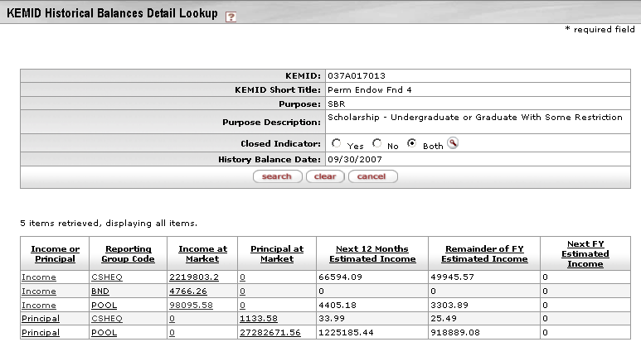

In the upper part of the screen, the search fields are pre-filled the selected month-end date and data for the KEMID whose **Total Market Value** link you chose. In the lower part of the screen is the search results table. Each row of the table displays historical balance information for a group of income or principal holdings.

KEMID Historical Balances Detail Lookup results definition

|  |  |
| --- | --- |
| Title | Description |
| Income or Principal | The nature of this reporting group—income or principal. |
| Reporting Group Code | The reporting group to which one or more holdings belong for the purpose of reporting income or principal. Derived from the class code of the security(ies) represented. To view more detail about the reporting group code, click the underlined link. |
| Income at Market | The market value of the group's historical income balance. For a principal holding group, this value is always zero. For an income holding group, this value is the total of income cash for the month-end date plus the total holding market value of all income records for the month-end date.  To view more detail about this value, click the underlined link. |
| Principal at Market | The market value of the group's historical principal balance. For an income holding group, this value is always zero. For a principal holding group, this value is the total of principal cash for the month-end date plus the total holding market value of all principal records for the month-end date.  To view more detail about this value, click the underlined link. |
| Next 12 Months Estimated Income | The estimated income for all holdings in the reporting group for the next twelve months. This calculation represents what this endowment might realize should there be no changes in the number of units held and no change in the payout rate.  This estimate is the result of the number of units in the holding lot times the rate for the security. |
| Remainder of FY Estimated Income | The estimated income for the rest of the current fiscal year for all securities held by the KEMID and classified as belonging to the group. This calculation represents what an endowment might realize should there be no changes in the number of units held and no change in the payout rate.  This estimate is displayed only for current holdings at the tax lot level. The calculation takes into account the frequency of the payments for the security and the next payment date—factors that are tied to the type of security. Consequently, the calculation varies based on the class code type of the security.  C:\Documents and Settings\jbrown\Desktop\KFS 4.0\User Guide Images\User Guide Icons\go-arrow-red.gif For more information on the calculations for each class code type, see [KFS 4.0 Endowment System Calculations](https://wiki.kuali.org/download/attachments/307464563/KEM+System+Calculations.docx?version=1&modificationDate=1289344047000).  Some securities do not have an estimated income because the expected payout is not known (e.g., alternative investments, real estate, receivables, liabilities, etc). If the calculation cannot be made because the rate is zero, the estimated income is zero. |
| Next FY Estimated Income | The estimated income for all holdings in the reporting group for the next fiscal year. This calculation represents what an endowment might realize should there be no change in the number of units held and no change in the payout rate.  This estimate is the result of the next fiscal year distribution amount (if a value has been placed in that field for the security record) times the number of holding units. At the end of the fiscal year this value is returned to zero until a user enters another value. |

##### Drilldown into KEMID Historical Reporting Group Detail

From the results table for the KEMID Historical Balances Detail Lookup screen, you may drill down into a list of individual securities within any reporting group for income or principal. To do so, click the underlined link for **Income at Market** or **Principal at Market** for the desired component. The system displays the information in the results portion of the KEMID Historical Reporting Group Lookup screen with results.

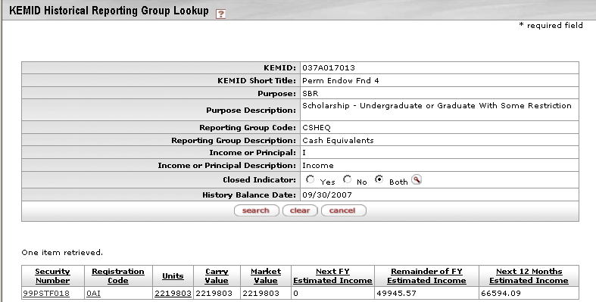

The search fields are pre-filled with the month-end date, data for the KEMID, and the income or principal reporting group whose **Income at Market** or **Principal at Market** link you chose. Each row of the results table displays information for a security and registration code combination within the reporting group.

KEMID Historical Reporting Group Lookup results definition

|  |  |
| --- | --- |
| Title | Description |
| Security Number | The ID number for a specific security held by this KEMID. To view more detail about a security, click the underlined link. |
| Registration Code | An indication of where (for example, at a bank, at a broker, or somewhere in the institution) this security is held in custody for the institution. To view more detail about a registration code, click the underlined link. |
| Units | The number of units of this security associated with this registration code. To view more detail, click the underlined link. |
| Carry Value | The carry value of this KEMID holding as of the month-end date. |
| Market Value | The market value of this KEMID holding as of the month-end date. |
| Next FY Estimated Income | The estimated income for this KEMID holding in the next fiscal year. This calculation represents what an endowment might realize should there be no changes in the number of units held and no change in the payout rate that has been determined for the next year.  This estimate is the result of the next fiscal year distribution amount times the number of holding units. |
| Remainder of FY Estimated Income | The estimated income for this KEMID holding in the rest of the current fiscal year. This calculation represents what an endowment might realize should there be no changes in the number of units held and no change in the payout rate.  This estimate is displayed only for current holdings at the tax lot level. The calculation takes into account the frequency of the payments for the security and the next payment date—factors that are tied to the type of security. Consequently, the calculation varies based on the class code type of the security.  C:\Documents and Settings\jbrown\Desktop\KFS 4.0\User Guide Images\User Guide Icons\go-arrow-red.gif For more information on the calculations for each class code type, see [KFS 4.0 Endowment System Calculations](https://wiki.kuali.org/download/attachments/307464563/KEM+System+Calculations.docx?version=1&modificationDate=1289344047000).  Some securities do not have an estimated income because the expected payout is not known (e.g., alternative investments, real estate, receivables, liabilities, etc). If the calculation cannot be made because the rate is zero, the estimated income is zero. |
| Next 12 Months Estimated Income | The estimated income for this KEMID holding in the next twelve months. This calculation represents what an endowment might realize should there be no changes in the number of units held and no change in the current known distribution rate. |

##### Drilldown into KEMID Security Detail

From the results table for the KEMID Historical Reporting Group Lookup screen, you may drill down into detail for any security/registration code combination. To do so, click an underlined **Security Number** link. The system displays the Security Lookup screen with data for the security you chose.

 For information on the Security Lookup screen, see Security|document=WordDocuments\KFS 5\_2 KEM.docx;topic=Security.

##### Drilldown into KEMID Tax Lot Detail

From the results table for the KEMID Historical Reporting Group Lookup screen, you may drill down further to view the detail of a specific security held at a specific location (registration code) and the holding and tax lots as of the selected month end. To do so, click the underlined link for **Units**. The system displays the KEMID Historical Tax Lots Lookup screen with results.

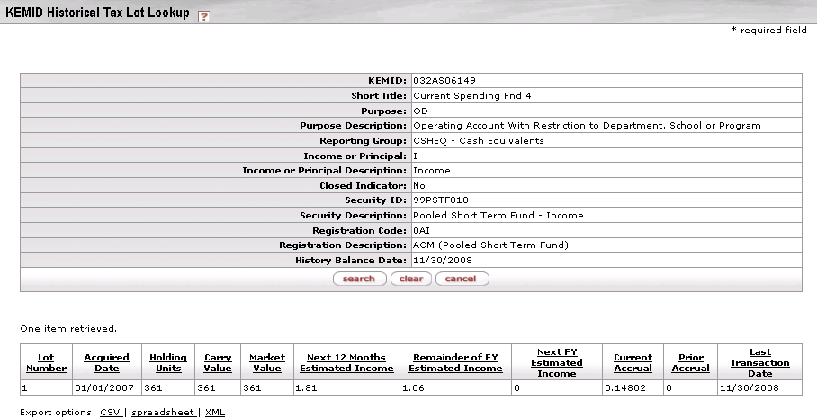

The search fields are pre-filled with the security ID and balance date for the month-end date/KEMID/reporting group/security/registration code combination whose **Units** link you chose. Each row of the results table displays information for a tax lot held for that security number and registration code as of the selected month end.

KEMID Historical Tax Lots Lookup results definition

|  |  |
| --- | --- |
| Title | Description |
| Lot Number | The ID number for this tax lot. |
| Acquired Date | The date this lot was acquired. |
| Holding Units | The number of units in this tax lot as of the month-end date. |
| Carry Value | The carry value of this tax lot as of the month-end date. |
| Market Value | The market value of this tax lot as of the month-end date. |
| Next 12 Months Estimated Income | The estimated income for this tax lot in the next twelve months. This calculation represents what an endowment might realize should there be no changes in the number of units held and no change in the payout rate. |
| Remainder of FY Estimated Income | The estimated income for this tax lot in the rest of the current fiscal year. This calculation represents what an endowment might realize should there be no changes in the number of units held and no change in the payout rate.  This estimate is displayed only for current holdings at the tax lot level. The calculation takes into account the frequency of the payments for the security and the next payment date—factors that are tied to the type of security. Consequently, the calculation varies based on the class code type of the security.  C:\Documents and Settings\jbrown\Desktop\KFS 4.0\User Guide Images\User Guide Icons\go-arrow-red.gif For more information on the calculations for each class code type, see [KFS 4.0 Endowment System Calculations](https://wiki.kuali.org/download/attachments/307464563/KEM+System+Calculations.docx?version=1&modificationDate=1289344047000).  Some securities do not have an estimated income because the expected payout is not known (e.g., alternative investments, real estate, receivables, liabilities, etc). If the calculation cannot be made because the rate is zero, the estimated income is zero. |
| Next FY Estimated Income | The estimated income for this tax lot in the next fiscal year. This calculation represents what an endowment might realize should there be no changes in the number of units held and no change in the payout rate.  This estimate is the result of the next fiscal year distribution amount (if a value has been placed in that field for the security record) times the number of holding units. At the end of the fiscal year this value is returned to zero until a user enters another value. |
| Current Accrual | The accrued value of the lot as of the month-end date. | |
| Prior Accrual | The prior accrued value of the lot. | |
| Foreign Tax Withheld | The amount withheld for foreign taxes. | |
| Last Transaction Date | The date of the last transaction for this lot. | |

### Transaction Archives

 > >  >  > 

This inquiry allows you to research transaction activity by accessing selected transac­tions that have been archived. From the results, you may drill down into the details of any given transaction.

#### Lookup Criteria

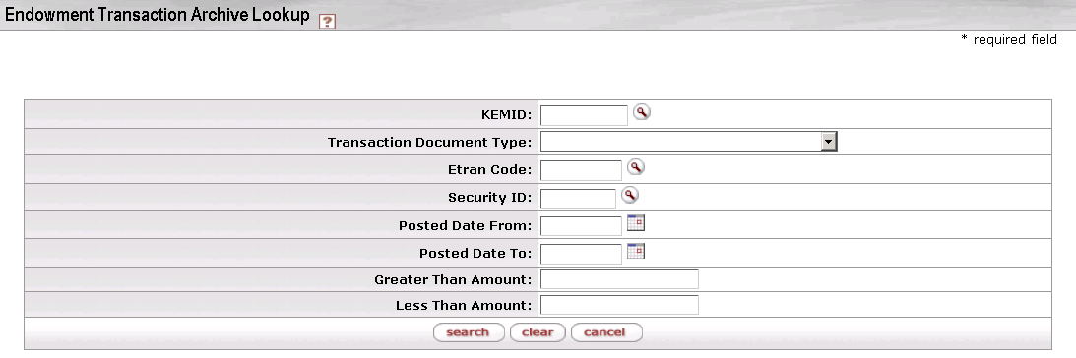

Transaction Archive inquiry screen

|  |  |
| --- | --- |
| Title | Description |
| KEMID | Optional. To search for transactions involving a specific KEMID, enter the KEMID or search for it from the lookup searchicon. |
| Transaction Document Type | Optional. To search for transactions involving a specific type, select the type of transaction from the list. |
| Etran Code | Optional. To search for transactions involving a specific Etran code, enter the code or search for it from the lookup searchicon. |
| Security ID | Optional. To search for transactions involving a particular security, specify the security ID or search for it from the lookup searchicon. |
| Posted Date From | Optional. To search for transactions posted within a range of dates, enter the first posting date for which you want to view transactions or select it from the calendar C:\Documents and Settings\jbrown\Desktop\KFS 4.0\User Guide Images\User Guide Icons\_cal.gif. |
| Posted Date To | Optional. To search for transactions posted within a range of dates, enter the last posting date for which you want to view transactions or select it from the calendar C:\Documents and Settings\jbrown\Desktop\KFS 4.0\User Guide Images\User Guide Icons\_cal.gif. |
| Greater Than Amount | Optional. To view transactions within a range of amounts, enter the lowest amount in the range. |
| Less Than Amount | Optional. To view transactions within a range of amounts, enter the highest amount in the range. |

Click  when you have entered all necessary criteria and are ready to retrieve the balances.

#### Search Results

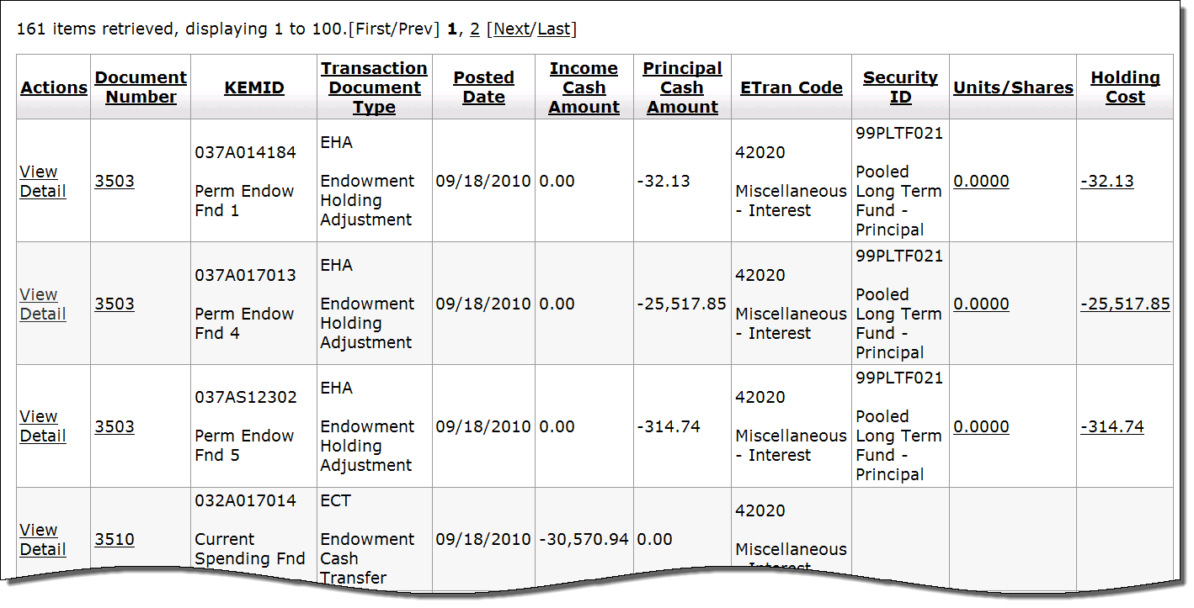

Transaction Archives results definition

|  |  |
| --- | --- |
| Title | Description |
| Actions | To view further detail for the transaction in this row, click **View Detail**. |
| Document Number | The system-assigned ID number for this transactional e-doc. |
| KEMID | Identifies a specific set of funds held by your institution as an endowment or a specific set of funds functioning as an endowment. |
| Transaction Document Type | The type of e-doc. |
| Posted Date | The date this transaction was posted. |
| Income Cash Amount | The cash income amount of the transaction. |
| Principal Cash Amount | The principal cash amount of the transaction. |
| ETran Code | The Etran code of this transaction. |
| Security ID | The ID number of the security affected by this transaction. |
| Units/Shares | The number of units or shares affected by the transaction. |
| Holding Cost | The holding cost of the transaction. |

##### Drilldown to Endowment Transaction Archives

From the lookup results, you may display further detail about a transaction by clicking **View Detail** in the **Actions** column. The subsequent display (shown below in three parts) contains extensive detail for the KEMID.

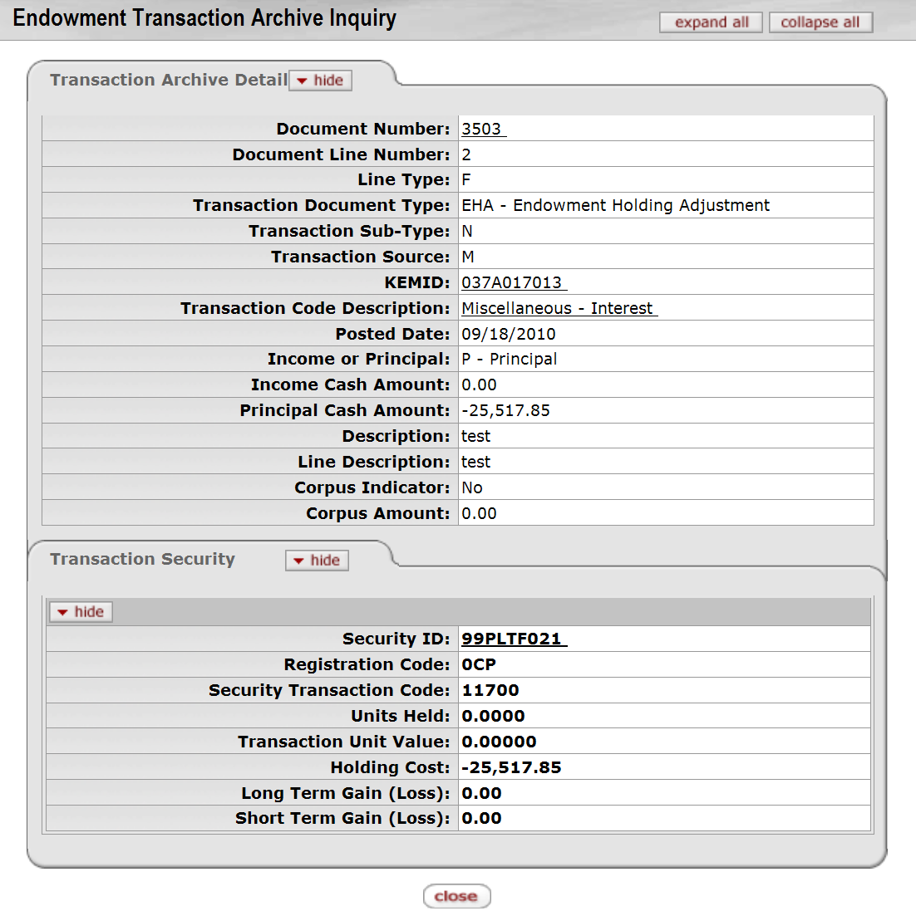

 For more information about the fields on this screen, see the help documentation on the particular type of transactional e-doc you are viewing.

## Endowment Reports

 >  >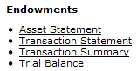

On the **Main Menu** tab, the **Reports** submenu provides options that allow users to four standard endowment reports.

KEM reports available from the Main Menu, Reports submenu

|  |  |
| --- | --- |
| Report Type | Description |
| Asset Statement | Reflects the value of assets and liabilities for a KEMID or group of KEMIDs as of a month end. |
| Transaction Statement | Reflects cash-based activity for a KEMID or group of KEMIDs for the period from the beginning of a month through the end of the same or another month. |
| Transaction Summary | Shows how a KEMID or group of KEMIDs has changed in market value over the period from the beginning of a month through the end of the same or another month by showing the beginning market value, selected cash and non-cash activity, the change in market value, and the ending market value. |
| Trial Balance|document=WordDocuments\KFS 5\_2 KEM.docx;topic=Trial Balance (endowments) | Lists all values for a KEMID or group of KEMIDs and provides totals. |

### Asset Statement

 >  >>  > 

The Asset Statement Generation screen allows you to create asset statements for a KEMID or a group of KEMIDs. Each statement indicates the value of assets and liabilities for the KEMID(s) as of a specified month end.

#### Lookup Criteria

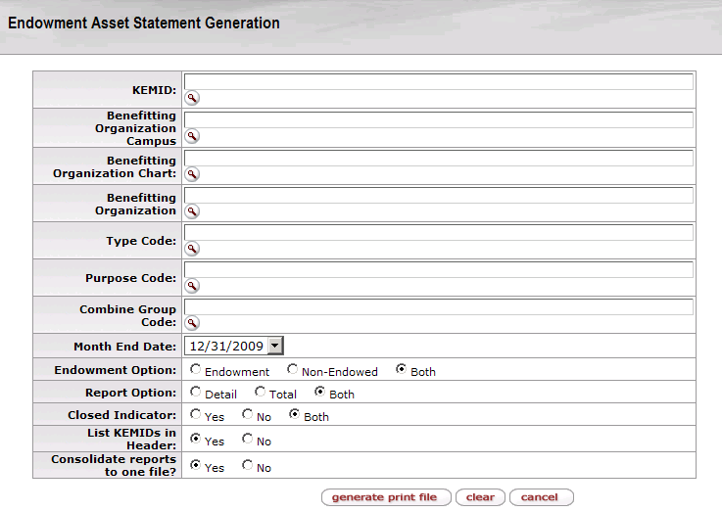

If and only if you do not specify a particular KEMID for which to generate a report, you may use any combination of other record-selection criteria to generate a report for a group of KEMIDs.

Asset Statement Generation screen definition

|  |  |
| --- | --- |
| Field | Description |
| KEMID | The KEMID for which the report is to be generated.  exclaim.gif You may not specify this criterion in combination with any other record selection criteria. |
| Benefitting Organization Campus | The campus code of the benefitting organization on records to be included in the report. The system will select all KEMID records in which the Campus Code selected matches the Campus Code for one or more of the active Benefitting Organization records. |
| Benefitting Organization Chart | The chart code of the benefitting organization on records to be included in the report. The system will select all KEMID records in which the Chart Code selected matches the Chart Code for one or more of the active Benefitting Organization records. |
| Benefitting Organization | The benefitting organization specified on records to be included in the report. The system will select all KEMID records in which the Organization Code selected matches the Organization Code for one or more of the active Benefitting Organization records. |
| Type Code | The specific type code on records to be included in the report. The system will select all KEMID records in which the Type Code selected matches the Type Code for the KEMID record. |
| Purpose Code | The specific purpose code on records to be included in the report. The system will select all KEMID records in which the Purpose Code selected matches the Purpose Code for the KEMID record. |
| Combine Group Code | The specific combine group code on records to be included in the report. The system will select all KEMID records in which the Combine Group Code selected matches the Combine Group Code for the KEMID record. |
| Month End Date | The month-end date for which the report is to be generated. |
| Endowment Option | The Endowment Option setting (endowed, non-endowed, or both) on records to be included in the report |
| Report Option | The type of report to be generated (detail report, total report, or both). |
| Closed Indicator | The Closed Indicator setting (yes, no, or both) on records to be included in the report. |
| List KEMIDs in Header | Setting that controls whether to include or exclude a list of the KEMID(s) in the report at the bottom of the report header page. |

Click  to generate a .pdf file for the report.

#### Results

After you enter lookup information, the system generates the asset statement as a .pdf file. In this report:

* Anticipated income for the KEMID is shown where available for each income-earning asset.
* Values for the securities reflect holding totals, not individual tax lot amounts.

Statements differ for endowed and non-endowed KEMIDs. The endowed asset statement (shown below) distinguishes between income and principal assets or holdings. Cash and securities held in Income are listed under Expendable Funds, while cash and securities held in Principal are listed under Endowment Funds.

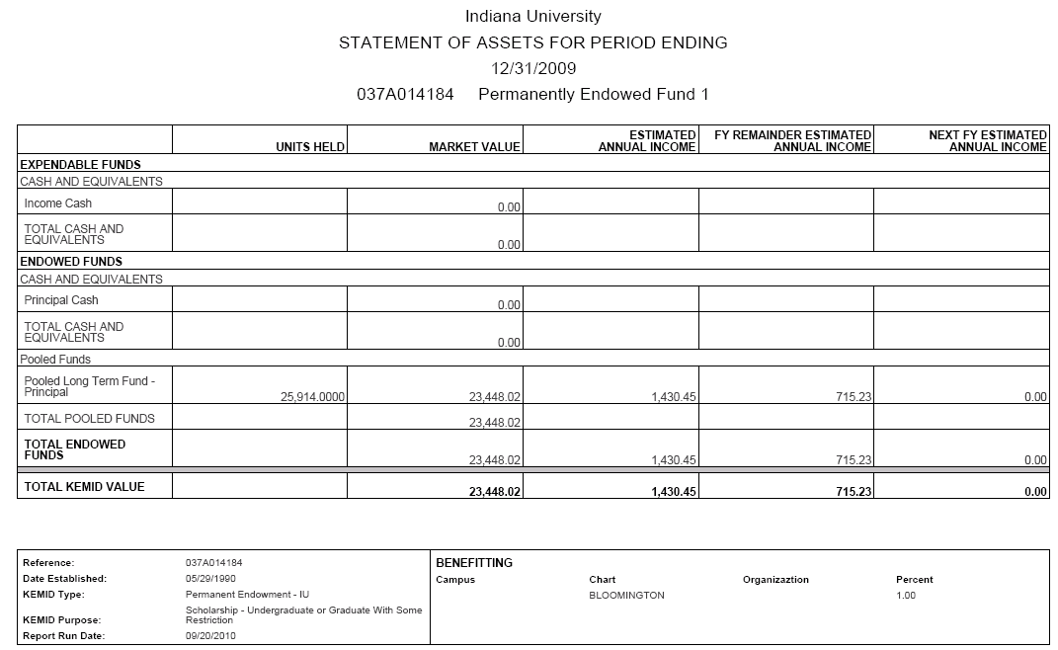

The non-endowed asset statement report (shown below) does not distinguish between income and principal assets or holdings: All assets or holdings are combined, with the exception of the cash, which is listed separately.

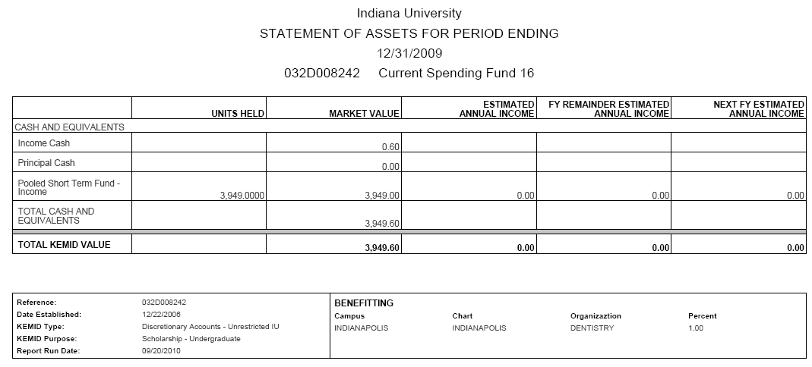

Additionally, the report (whether for endowed or non-endowed KEMIDs) differs depending on whether you select **Detail**, **Total** or **Both**.

* If you request a detail report, the output includes a separate page or pages for each KEMID.
* If you request a total report, the output is a single total report incorporating the data from all selected KEMIDs.
* If you request both, the system generates two separate .pdf files, one for the detail reports and one for the totals.

### Transaction Statement

 >  >>  > 

The Transaction Statement Generation screen allows you to generate transaction statements that reflect cash-based activity for a KEMID or group of KEMIDs from the beginning of a month through the end of the same or another month.

 This screen generates the detail view for each individual KEMID. It does not provide a total view for all KEMIDS in a group.

#### Lookup Criteria

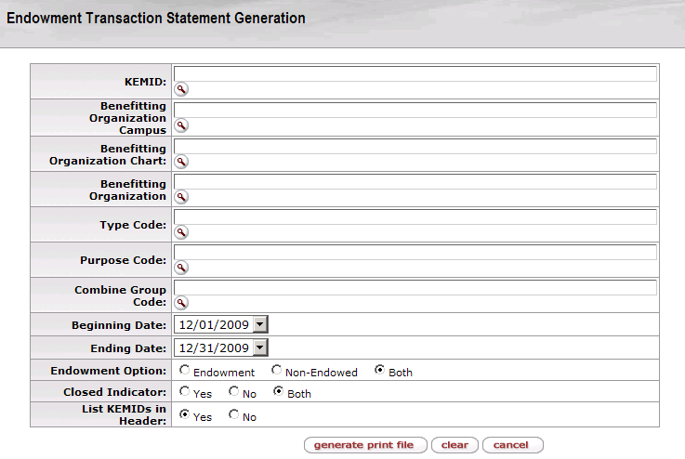

If and only if you do not specify a particular KEMID for which to generate a report, you may use any combination of other record-selection criteria to generate a report for a group of KEMIDs.

Transaction Statement Generation screen definition

|  |  |
| --- | --- |
| Field | Description |
| KEMID | The KEMID for which the report is to be generated.  exclaim.gif You may not specify this criterion in combination with any other record selection criteria. |
| Benefitting Organization Campus | The campus code of the benefitting organization on records to be included in the report. The system will select all KEMID records in which the Campus Code selected matches the Campus Code for one or more of the active Benefitting Organization records. |
| Benefitting Organization Chart | The chart code of the benefitting organization on records to be included in the report. The system will select all KEMID records in which the Chart Code selected matches the Chart Code for one or more of the active Benefitting Organization records. |
| Benefitting Organization | The benefitting organization specified on records to be included in the report. The system will select all KEMID records in which the Organization Code selected matches the Organization Code for one or more of the active Benefitting Organization records. |
| Type Code | The specific type code on records to be included in the report. The system will select all KEMID records in which the Type Code selected matches the Type Code for the KEMID record. |
| Purpose Code | The specific purpose code on records to be included in the report. The system will select all KEMID records in which the Purpose Code selected matches the Purpose Code for the KEMID record. |
| Combine Group Code | The specific combine group code on records to be included in the report. The system will select all KEMID records in which the Combine Group Code selected matches the Combine Group Code for the KEMID record. |
| Beginning Date | Required. The beginning date—which must be the first day of a month—for which data will be collected for the report. |
| Ending Date | The last date—which must be a month-end date—for which data will be collected for the report. |
| Endowment Option | The Endowment Option setting (endowed, non-endowed, or both) on records to be included in the report |
| Closed Indicator | The Closed Indicator setting (yes, no, or both) on records to be included in the report. |

Click  to generate a .pdf file for the report.

#### Results

After you enter lookup information, the system generates the transaction statement as a .pdf file. The report is the same for true endowments and non-endowments.

In this report, if no beginning cash record is found for the KEMID, but a record for the ending cash is found for it, the beginning cash is zero. If a beginning cash record is found for the KEMID but no ending cash record is found, the ending cash is reported as zero.

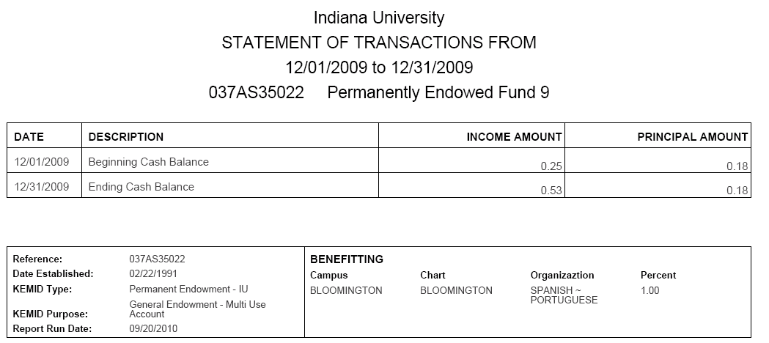

### Transaction Summary

 >  >>  > 

The Transaction Summary Report screen allows you to generate reports showing how a KEMID or group of KEMIDs has changed in market value over a period of time (from the beginning of a month through the end of the same or another month). Each report shows the beginning market value, selected cash and non-cash activity over the period, the change in market value (growth or reduction), and the ending market value. The change in market value represents both realized and unrealized gains and losses to the KEMID(s).

#### Lookup Criteria

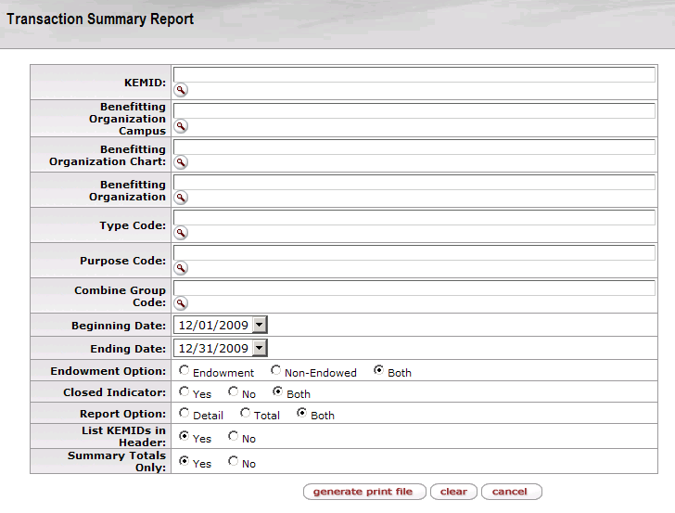

If and only if you do not specify a particular KEMID for which to generate a report, you may use any combination of other record-selection criteria to generate a report for a group of KEMIDs.

Transaction Summary Generation screen definition

|  |  |
| --- | --- |
| Field | Description |
| KEMID | The KEMID for which the report is to be generated.  exclaim.gif You may not specify this criterion in combination with any other record selection criteria. |
| Benefitting Organization Campus | The campus code of the benefitting organization on records to be included in the report. The system will select all KEMID records in which the Campus Code selected matches the Campus Code for one or more of the active Benefitting Organization records. |
| Benefitting Organization Chart | The chart code of the benefitting organization on records to be included in the report. The system will select all KEMID records in which the Chart Code selected matches the Chart Code for one or more of the active Benefitting Organization records. |
| Benefitting Organization | The benefitting organization specified on records to be included in the report. The system will select all KEMID records in which the Organization Code selected matches the Organization Code for one or more of the active Benefitting Organization records. |
| Type Code | The specific type code on records to be included in the report. The system will select all KEMID records in which the Type Code selected matches the Type Code for the KEMID record. |
| Purpose Code | The specific purpose code on records to be included in the report. The system will select all KEMID records in which the Purpose Code selected matches the Purpose Code for the KEMID record. |
| Combine Group Code | The specific combine group code on records to be included in the report. The system will select all KEMID records in which the Combine Group Code selected matches the Combine Group Code for the KEMID record. |
| Beginning Date | Required. The beginning date—which must be the first day of a month—for which data will be collected for the report. |
| Ending Date | The last date—which must be a month-end date—for which data will be collected for the report. |
| Endowment Option | The Endowment Option setting (endowed, non-endowed, or both) on records to be included in the report |
| Report Option | The type of report to be generated (detail report, total report, or both). |
| Closed Indicator | The Closed Indicator setting (yes, no, or both) on records to be included in the report. |
| List KEMIDs in Header | Setting that controls whether to include or exclude a list of the KEMID(s) in the report at the bottom of the report header page. |
| List KEMIDs in Header | Setting that controls whether to include or exclude a list of the KEMID(s) in the report at the bottom of the report header page. |

Click  to generate a .pdf file for the report.

#### Results

After you enter lookup information, the system generates the transaction summary as a .pdf file.

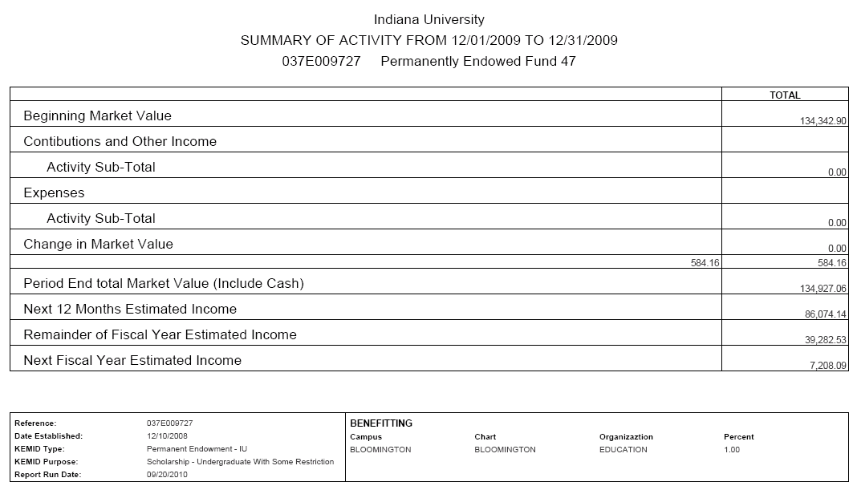

The report is the same for true endowments and non-endowments, but it differs depending on whether you select **Detail**, **Total**, or **Both**.

* If you request a detail report, the output includes a separate page or pages for each KEMID.
* If you request a total report, the output is a single total report incorporating the data from all selected KEMIDs. This report contains only a Totals column; it does not contain columns of data headed Income and Principal.
* If you request both, the system generates two separate .pdf files, one for the detail reports and one for the totals.

In this report, if no beginning cash record is found for the KEMID, but a record for the ending cash is found for it, the beginning cash is zero. If a beginning cash record is found for the KEMID but no ending cash record is found, the ending cash is reported as zero.

### Trial Balance (endowments)

 >  >> > 

The Trial Balance Generation screen allows you to generate reports listing all values for an open KEMID or group of open KEMIDs for the current date. Each report also provides totals.

#### Lookup Criteria

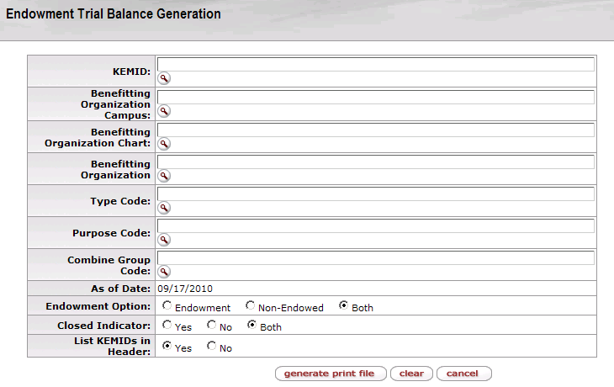

If and only if you do not specify a particular KEMID for which to generate a report, you may use any combination of other record-selection criteria to generate a report for a group of KEMIDs.

Trial Balance Generation screen definition

|  |  |
| --- | --- |
| Field | Description |
| KEMID | The KEMID for which the report is to be generated.  exclaim.gif You may not specify this criterion in combination with any other record selection criteria. |
| Benefitting Organization Campus | The campus code of the benefitting organization on records to be included in the report. The system will select all KEMID records in which the Campus Code selected matches the Campus Code for one or more of the active Benefitting Organization records. |
| Benefitting Organization Chart | The chart code of the benefitting organization on records to be included in the report. The system will select all KEMID records in which the Chart Code selected matches the Chart Code for one or more of the active Benefitting Organization records. |
| Benefitting Organization | The benefitting organization specified on records to be included in the report. The system will select all KEMID records in which the Organization Code selected matches the Organization Code for one or more of the active Benefitting Organization records. |
| Type Code | The specific type code on records to be included in the report. The system will select all KEMID records in which the Type Code selected matches the Type Code for the KEMID record. |
| Purpose Code | The specific purpose code on records to be included in the report. The system will select all KEMID records in which the Purpose Code selected matches the Purpose Code for the KEMID record. |
| Combine Group Code | The specific combine group code on records to be included in the report. The system will select all KEMID records in which the Combine Group Code selected matches the Combine Group Code for the KEMID record. |
| As of Date | Display only. Always today's date. This report shows current value only. |
| Endowment Option | The Endowment Option setting (endowed, non-endowed, or both) on records to be included in the report |

Click  to generate a .pdf file for the report.

#### Results

After you enter lookup information, the system generates the trial balance report as a .pdf file.

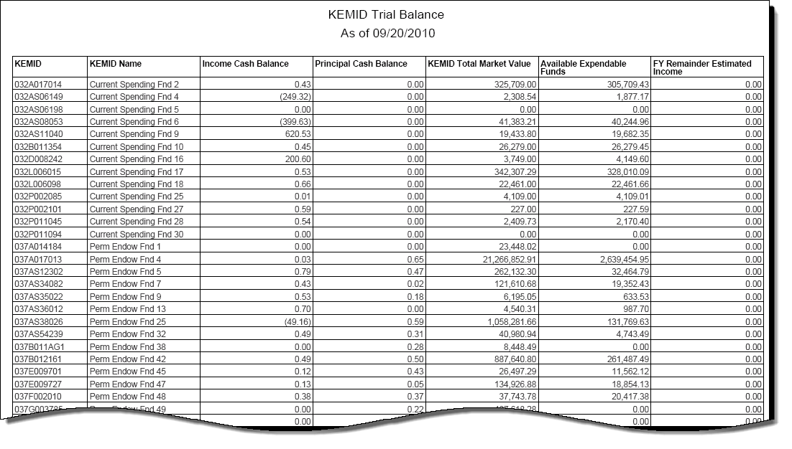

## Attribute Maintenance E-Docs

 **> 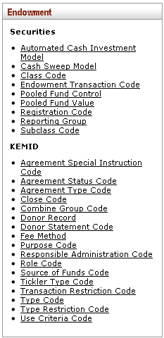**

Endowment documents on the **Maintenance** menu tab allow you to maintain valid values for the various security and KEMID attributes needed to support the Endowment module. Within the Endowment submenu these e-docs are organized into two groups, Securities and KEMID.

### Securities Submenu Group

 **>  > 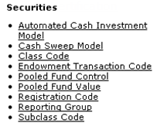**

The Securities submenu group contains e-docs that allow you to maintain basic attributes used in your institution's Security records.

Endowments submenu, Securities group

|  |  |
| --- | --- |
| Document | Description |
| Automated Cash Investment Model | Allows you to create different sets of criteria for the system's periodic review of any uninvested cash and/or negative cash balance for each KEMID that uses this model. |
| Cash Sweep Model | Provides criteria for periodically sweeping uninvested cash into short-term investment vehicles. |
| Class Code | Identifies different types of securities. Types often include alternative investment, bond, cash equivalents, liability, pooled investment, stock, etc. |
| Endowment Transaction Code | Identifies user-defined codes that the system uses when processing transaction activity that updates KEM records. |
| Pooled Fund Control | Identifies pooled funds for internal investment by your institution's endowments. |
| Pooled Fund Value | Allows the storage of historical unit values and distribution amounts for your institution's pooled funds. |
| Registration Code | Identifies the custodial institutions holding your institution's securities. |
| Reporting Group | Defines how securities are grouped and ordered in the pre-defined and user-defined reports of securities and holdings. |
| Subclass Code | Further identifies the type of security that is represented by a record. |

#### Automated Cash Investment Model

 **> ** **> ** **> 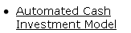**

The Automated Cash Investment Model Maintenance document is used to manage your institution's automated cash investment (ACI) models. Each ACI model provides criteria for the system to periodically review the uninvested cash or negative cash balance for all KEMIDs associated with this model. As a result of each review, the system automatically invests excess cash and cash equivalents as specified by the mix of investments your institution has defined in the model. If the account cash balance is negative, the system generates sale transactions as needed to meet the investment criteria.

#### Document Layout

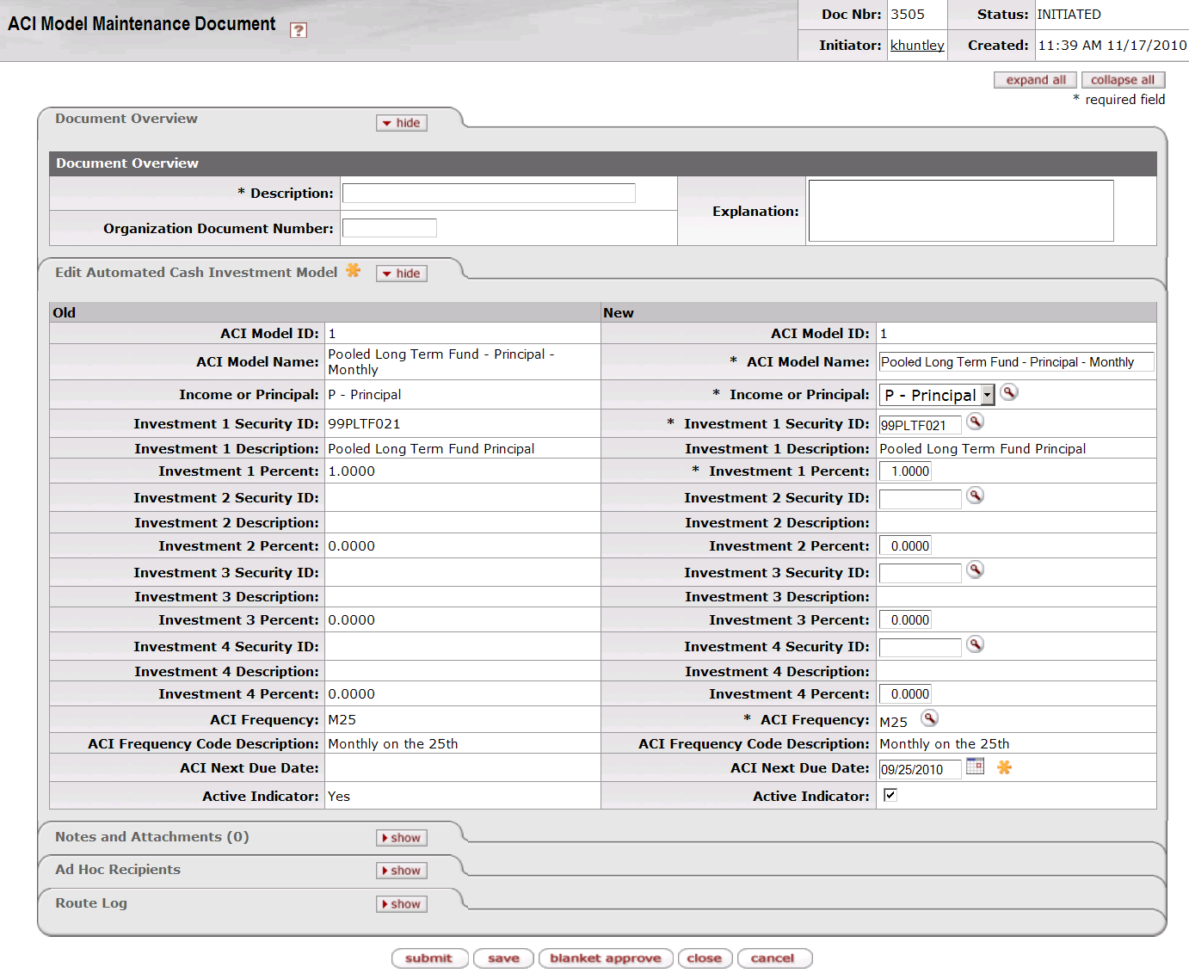

The Automated Cash Investment Model Maintenance document includes the **Edit** **Automated Cash Investment Model** tab. The system automatically enters data into both the **Old** and **New** sections in this tab. Selected data fields are available for editing.

Edit Automated Cash Investment Model tab definition

|  |  |
| --- | --- |
| Title | Description |
| ACI Model ID | Display only. The system-assigned identifier for this automated cash investment model. |
| ACI Model Name | Required. The name of this investment model as determined by your institution. |
| Income or Principal | Required. Indicates whether this model generates activity in income or principal. Enter the appropriate value or use the lookup _searchicon.gif to find it. |
| Investment 1 Security ID | Required. The security ID of the first security that is to be considered for automatic purchase or sale transactions. Enter the appropriate security ID or use the lookup _searchicon.gif to find it. |
| Investment 1 Description | Display only. Your institution's description of the first investment security to be considered. |
| Investment 1 Percent | The percent of available cash that is to be used to purchase the first security and/or the percentage of the cash requirement that is be met through the sale of the first security. Enter the percentage with up to four decimal places. |
| Investment 2 Security ID | The security ID of the second security that is to be considered for automatic purchase or sale transactions. Enter the appropriate security ID or use the lookup _searchicon.gif to find it. |
| Investment 2 Description | Display only. Your institution's description of the second investment security to be considered. |
| Investment 2 Percent | The percent of available cash that is to be used to purchase the second security and/or the percentage of the cash requirement that is be met through the sale of the second security. Enter the percentage with up to four decimal places. |
| Investment 3 Security ID | The security ID of the third security that is to be considered for automatic purchase or sale transactions. Enter the appropriate security ID or use the lookup _searchicon.gif to find it. |
| Investment 3 Description | Display only. Your institution's description of the third investment security to be considered. |
| Investment 3 Percent | The percent of available cash that is to be used to purchase the third security and/or the percentage of the cash requirement that is be met through the sale of the third security. Enter the percentage with up to four decimal places. |
| Investment 4 Security ID | The security ID of the fourth security that is to be considered for automatic purchase or sale transactions. Enter the appropriate security ID or use the lookup _searchicon.gif to find it. |
| Investment 4 Description | Display only. Your institution's description of the fourth investment security to be considered. |
| Investment 4 Percent | The percent of available cash that is to be used to purchase the fourth security and/or the percentage of the cash requirement that is be met through the sale of the fourth security. Enter the percentage with up to four decimal places. |
| ACI Frequency | Required. A code representing the regularly scheduled date on which activity for this model is to take place. Enter the appropriate code or use the lookup _searchicon.gif to find it. |
| ACI Frequency Code Description | Display only. The description of the ACI frequency code. |
| ACI Next Due Date | The date the next automatic cash investment is to occur. Initially filled in by the system based on the frequency code. Change the date by entering another date or selecting it from the calendar _cal.gif. |
| Active Indicator | Indicates whether this automated cash investment model is active or inactive. Remove the check mark to deactivate this model. |

#### Cash Sweep Model

 **> ** **> ** **> **

The Cash Sweep Model Maintenance document is used to manage your institution's specifications for periodically and automatically sweeping uninvested cash into short-term investment vehicles. Each KEMID may be associated with only one cash sweep model. Each model controls separate investments of income and principal. If a KEMID's cash balance is negative when the automated process is run, your institution's business rules may allow for the sale of investments to cover the negative balance.

##### Document Layout

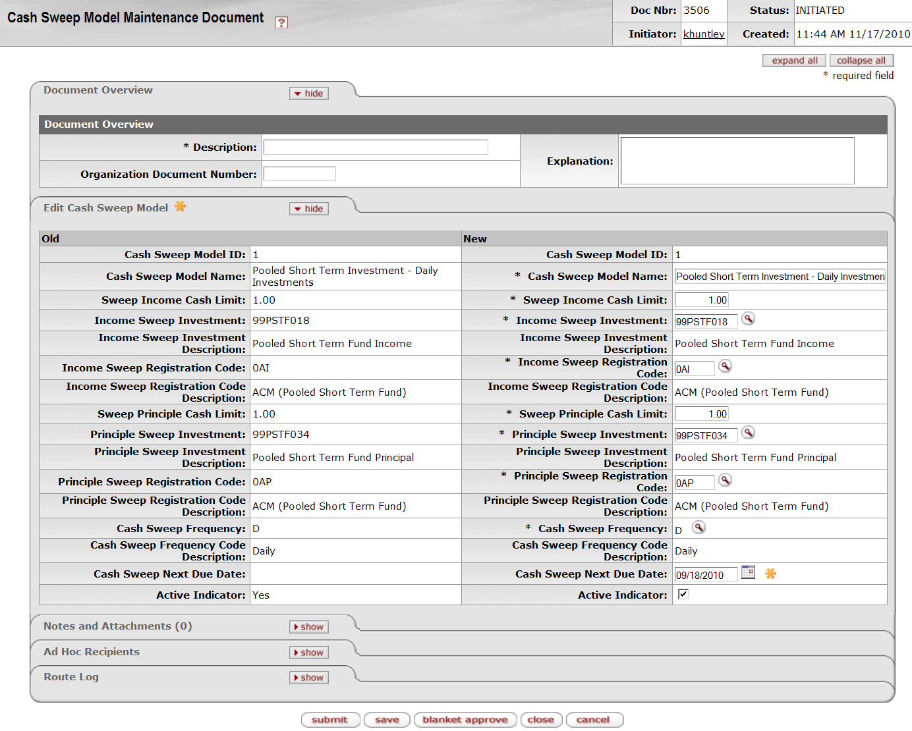

The Cash Sweep Model Maintenance document includes the **Edit** **Cash Sweep Model** tab. The system automatically enters data into both the **Old** and **New** sections in this tab. Selected data fields are available for editing.

Edit Cash Sweep Model tab definition

|  |  |
| --- | --- |
| Title | Description |
| Cash Sweep Model ID | Required when initiating a document; otherwise, display only. The unique identifier for this cash sweep model. |
| Cash Sweep Model Name | Required. Your institution's name for this cash sweep model. |
| Sweep Income Cash Limit | Required. The smallest amount of uninvested income cash your institution wants to hold in KEMIDs that use this model. |
| Income Sweep Investment | Required. The security ID of the security that is to be used for the sweep investment of income cash. Enter the appropriate security ID or use the lookup _searchicon.gif to find it. |
| Income Sweep Investment Description | Display only. Your institution's description of the income sweep investment. |
| Income Sweep Registration Code | Required. The registration code for the KEMID income sweep investment security holdings. Enter the appropriate code or use the lookup _searchicon.gif to find it. |
| Income Sweep Registration Code Description | Display only. Your institution's description for the income sweep registration code. |
| Sweep Principal Cash Limit | Required. The least amount of uninvested principal cash that your institution wants to hold in the KEMID. |
| Principal Sweep Investment | Required. The security ID of the security that is to be used for the sweep investment of principal cash. Enter the appropriate security ID or use the lookup _searchicon.gif to find it. |
| Principal Sweep Investment Description | Display only. Your institution's description of the principal sweep investment. |
| Principal Sweep Registration Code | Required. The registration code for the KEMID principal sweep investment security holdings. |
| Principal Sweep Registration Code Description | Display only. Your institution's description of the principal sweep registration code. |
| Cash Sweep Frequency | Required. A code identifying the regularly scheduled date on which activity for this model is to take place. Enter the appropriate code or use the lookup _searchicon.gif to find it. |
| Cash Sweep Frequency Description | Display only. Your institution's description of the cash sweep frequency. |
| Cash Sweep Next Due Date | The date the next cash sweep is to occur. Initially filled in by the system based on the frequency code. Change the date by entering another date or selecting it from the calendar _cal.gif. |
| Active Indicator | Indicates whether this cash sweep model is active or inactive. Remove the check mark to deactivate this cash sweep model. |

#### Class Code

 **> ** **> ** **> 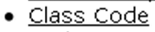**

The Class Code Maintenance document is used to specify different categories of securities. The use of class codes allows your institution to establish security categories with as much or little detail as needed. For example, class codes 400-499 might represent stocks and 410 might represent bank stocks.

Each Class Code record associates its class code with a class code type (stocks, bonds, etc.) that determines the business rules and market value calculations the system is to apply to transactions involving securities with this class code. Each Class Code record also specifies an accrual method. The system uses this information to identify additional required fields (if any) for Security records with this class code.

##### Document Layout

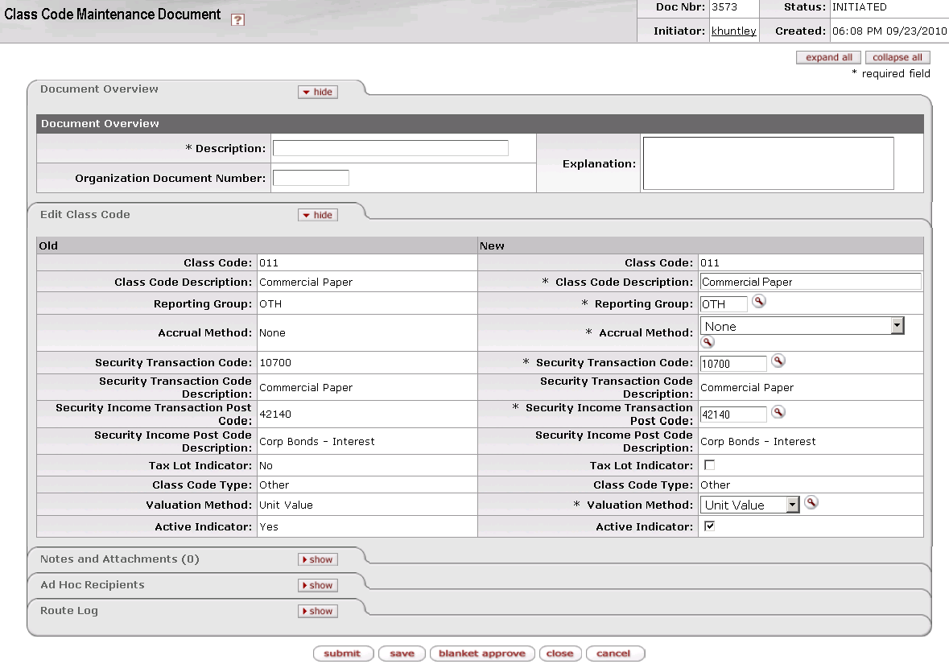

The Class Code Maintenance document includes the **Edit Class Code** tab. The system automatically enters data into both the **Old** and **New** sections in this tab. Selected data fields are available for editing.

Edit Class Code tab definition

|  |  |
| --- | --- |
| Title | Description |
| Class Code | Required when initiating a document; otherwise, display only. The unique code that identifies this class of security. |
| Class Code Description | Required. Your institution's description for this class code. |
| Reporting Group | Required. The group to which this class of securities belongs for reporting purposes. Reporting group codes are defined by your institution. Enter the appropriate code or use the lookup _searchicon.gif to find it. |
| Accrual Method | Required. When accrual processing is appropriate for individual holdings of this class of security, the method of calculating accrued income to be used. Use the lookup _searchicon.gif to find the appropriate code. |
| Security Transaction Code | Required. The asset code to be linked to the security object code on the General Ledger. This code is used on transactional e-docs that increase or decrease the holdings of this class of security. Enter the appropriate code or use the lookup _searchicon.gif to find it. |
| Security Transaction Code Description | Display only. Your institution's description of the security transaction code. |
| Security Income Transaction Post Code | Required. The code to be used to post income activity to the KEMID for this security. Enter the appropriate code or use the lookup _searchicon.gif to find it. |
| Security Income Post Code Description | Display only. Your institution's description of the security income transaction post code. |
| Tax Lot Indicator | Indicates whether each KEMID acquisition of security units (holdings) are to be maintained in separate accounting (tax) lots or consolidated into one holding. This indicator affects the way gains and losses on the sale of the security are calculated. |
| Class Code Type | Required. Identifies a group of class codes. The options are Stock, Bond, Liability, Alternative Investment, Cash Equivalent, Pooled Investment, and Other. |
| Valuation Method | Required. The method by which this type of security is valued—either by an established unit value or by an established market value at a point in time (typically used for alternative investments). Use the lookup _searchicon.gif to find the appropriate valuation method. |
| Active Indicator | Indicates whether this class code is active or inactive. Remove the check mark to deactivate a class code. |

#### Endowment Transaction Code

 **> ** **> ** **> 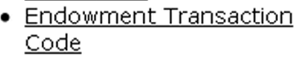**

The Endowment Transaction Code Maintenance document allows you to create and manage transaction codes (usually known as Etran codes). The system uses these codes to identify the purpose of each transaction affecting a KEMID. Like object codes, Etran codes identify categories of assets, liabilities, income, and expense. Each Etran code defined by your institution is mapped to one or more chart/object code combinations in the General Ledger. This mapping allows the system to generate appropriate General Ledger entries for your endowment transactions.

 General Ledger entries are generated by a nightly batch process.

##### Document Layout

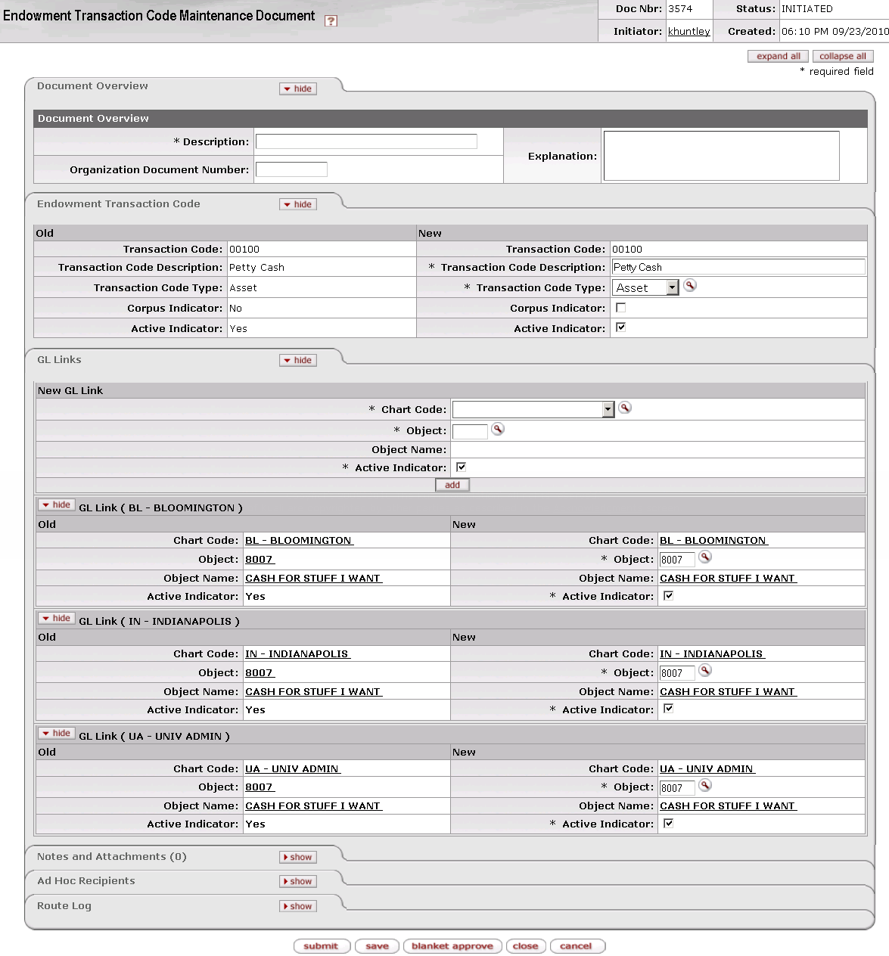

The Endowment Transaction Code Maintenance document includes the **Endowment Transaction Code** tab and the **GL Links** tab.

###### Endowment Transaction Code Tab

The system automatically enters data into both the **Old** and **New** sections in this tab. Selected data fields are available for editing.

Endowment Transaction Code tab definition

|  |  |
| --- | --- |
| Title | Description |
| Transaction Code | Required when initiating a document; otherwise, display only. Also known as Etran Code. The code that uniquely identifies system processing (including generation of appropriate General Ledger entries) required for a specific purpose. For example, your institution may set up different Etran codes to specify different handling for transactions involving petty cash, student loans, mutual funds, etc. |
| Transaction Code Description | Required. Your institution's description of this Etran code (Petty Cash, Student Loans, Mutual Funds, etc.). |
| Transaction Code Type | Required. The accounting code type associated with this Etran code. Values are 'Asset,' 'Liability,' 'Income,' and 'Expense.' Select from the list or use the lookup _searchicon.gif to find the appropriate type.  go-arrow-red Each object code specified in the **GL Links** **tab** must be of the type specified in this field. For information on the **GL Links tab**, see GL Links Tab. |
| Corpus Indicator | An indicator specifying whether transactions using this Etran code affect the total corpus balance of a true endowment. Check the box to indicate that the transactions affect corpus. |
| Active Indicator | Indicates whether this Etran code is active or inactive. Remove the check mark to deactivate this Etran code. |

###### ****GL Links**** Tab

The system automatically enters data into both the **Old** and **New** sections in this tab. Selected data fields are available for editing. Note that you may specify multiple GL links for each Etran code.

GL Links tab definition

|  |  |
| --- | --- |
| Title | Description |
| Chart Code | Required when adding a new GL link; otherwise, display only. The KFS chart code to be used for generating GL entries for transactions containing this Etran code. Select from the list or use the lookup _searchicon.gif to find the appropriate chart code.  pencil-small In any given transaction, the Etran code and KEMID specified must be associated with the same chart. |
| Object Code | Required. The General Ledger object code to be used for generating GL entries for transactions with this Etran code. Enter a valid object code or use the lookup _searchicon.gif to find it.  pencil-small The object specified here must be valid for the chart specified in the **Endowment Transaction Code** tab. The object must also be of the type specified in the **Transaction Code Type** field in the **Endowment Transaction Code** tab. For example, if the entry in the **Transaction Code Type** field is Income, the object code specified here must also be associated with the Income object code type. |
| Object Name | Display only. The descriptive name of the object code. |
| Active Indicator | Required. Indicates whether this GL link is active or inactive. Remove the check mark to deactivate this GL link for this Etran code record. |

Click  to add a GL link record to this Etran code record.

#### Pooled Fund Control

 **> ** **> ** **> 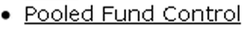**

The Pooled Fund Control Maintenance document allows you to create and change pooled funds for internal investment of endowments. For each pooled fund, you may set up specific criteria for the valuation and generation of control offsets and General Ledger values regarding daily activity. The fields in each Pooled Fund record instruct the system regarding the criteria for automated transaction generation and maintenance of the pool control record.

##### Document Layout

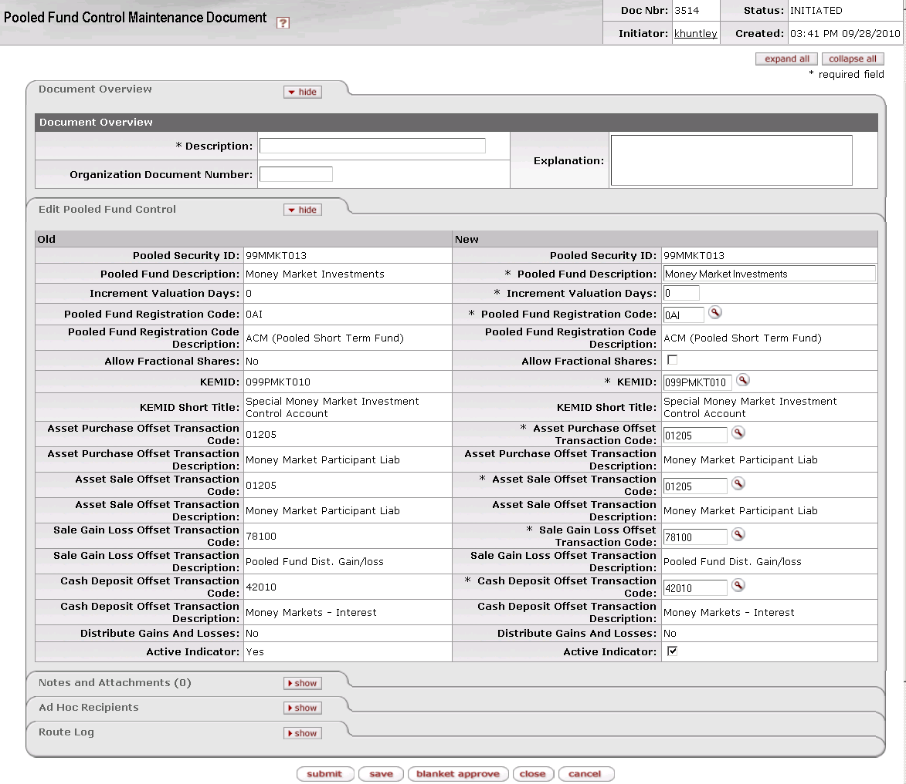

The Pooled Fund Control Maintenance document includes the **Edit** **Pooled Fund Control** tab. The system automatically enters data into both the **Old** and **New** sections in this tab. Selected data fields are available for editing.

Edit Pooled Fund Control tab definition

|  |  |
| --- | --- |
| Title | Description |
| Pooled Security ID | Required when initiating a document; otherwise, display only. The identification code for this investment pool. |
| Pooled Fund Description | Required. The name associated with the ID code. |
| Increment Valuation Days | Required. The number of days from the date of the pool valuation (see Pooled Fund Value|document=WordDocuments\KFS 5\_2 KEM.docx;topic=Pooled Fund Value) that the new value is to take effect. |
| Pooled Fund Registration Code | Required. The registration code for the pooled fund. Enter the appropriate code or use the lookup _searchicon.gif to find it. |
| Pooled Fund Registration Code Description | Display only. Your institution's description of the registration code. |
| Allow Fractional Shares | Check the box to allow fractional shares. If the box is unchecked, fractional shares are not permitted. |
| KEMID | Required. The KEMID that holds control totals of pooled fund activity (buys, sells, and distributions) and through which information can be passed to the General Ledger, typically to a control account that is not included in the balance sheet (to avoid double accounting). |
| KEMID Short Title | Display only. The descriptive name of the KEMID. |
| Asset Purchase Offset Transaction Code | Required. The Etran code to be used to record entries to the control KEMID for shares purchased by the endowments as a result of automated or manual pooled investment activity. |
| Asset Sale Offset Transaction Code | Required. The Etran code to be used to record entries to the control KEMID for the carry value of shares sold by endowments as a result of automated or manual pooled investment activity. |
| Asset Sale Offset Transaction Description | Display only. The description stored in the system for the asset sale offset transaction code entered. |
| Sale Gain Loss Offset Transaction Code | Required. The Etran code to be used to record entries to the control KEMID for realized gains or losses resulting from shares sold by endowments as a result of automated or manual pooled investment activity. |
| Sale Gain Loss Offset Transaction Description | Display only. The description stored in the system for the sale gain loss offset transaction code entered. |
| Cash Deposit Offset Transaction Code | Required. The Etran code to be used to record entries to the control KEMID for shares purchased by endowments as a result of automated or manual pooled investment activity. |
| Cash Deposit Offset Transaction Description | Display only. The description stored in the system for the cash deposit offset transaction code entered. |
| Distribute Gains And Losses | Display only. Indicates whether unrealized gains and/or losses are to be distributed through the automated process to the holders of this pooled security. |
| Active Indicator | Indicates whether this pooled fund is active or inactive. Remove the check mark to deactivate the fund. |

##### Creating a Pooled Fund

Creating a new pooled fund involves working with several different e-docs. To create a pooled fund, proceed as follows:

1. Create a Security record for the pooled security to be purchased by the endowments as part of the automated cash investment model. To create this record, use the 'create new' function after selecting **Security** from the Main menu, Lookup and Maintenance sub-menu, Endowments sub-menu group.
2. Create the pooled fund control KEMID record. This KEMID will be used as an off-balance sheet holder of the pooled securities and the liability for the shares owned by the endowments. To create this record, use the 'create new' function after selecting **KEMID** from the Main menu, Lookup and Maintenance sub-menu, Endowments sub-menu group.
3. Create the Pooled Fund Control record. Creating this record creates the pooled fund and provides the necessary defaults for the creation of transactions. To create this record, use the 'create new' function after selecting **Pooled Fund Control** from the Maintenance menu, Endowments sub-menu, Securities sub-menu group.
4. Create the automated cash investment model that will generate the automated buys and sells of the pooled securities by the endowments. To create this record, use the 'create new' function after selecting **Automated Cash Investment Model** from the Maintenance menu, Endowments sub-menu, Securities sub-menu group.
5. Establish the pooled fund value per unit as of the last day of the month. To do so, use the 'create new' function after selecting **Pooled Fund Value** from the Maintenance menu, Endowments sub-menu, Securities sub-menu group.

#### Pooled Fund Value

 **> ** **> ** **> 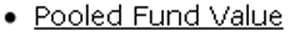**

The Pooled Fund Value e-doc allows you to store historical unit values and distribution amounts for pooled funds. Using these e-docs you may update unit values for these funds and initiate the automated generation of distributions of cash and/or gains and losses to holders of the funds. The system uses data from these e-docs to generate automated pooled fund transactions in the overnight processes.

##### Document Layout

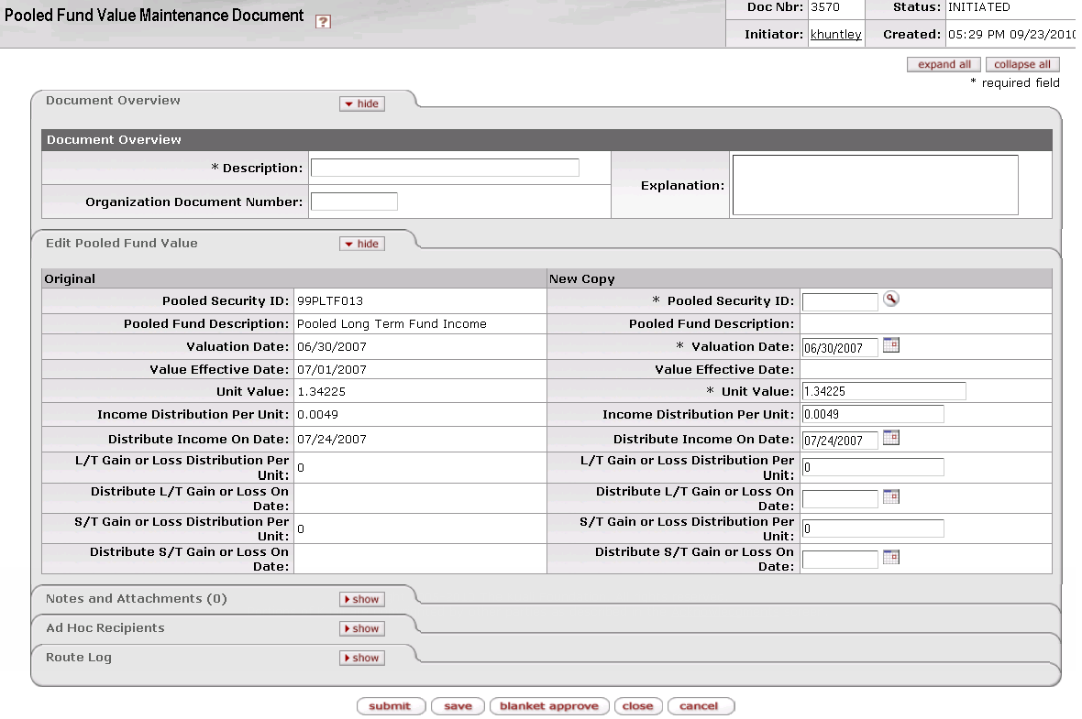

The Pooled Fund Value Maintenance document includes the **Edit Pooled Fund Value** tab. The system automatically enters data into both the **Old** and **New** sections in this tab. Selected data fields are available for editing.

Edit Pooled Fund Value tab definition

|  |  |
| --- | --- |
| Title | Description |
| Pooled Security ID | Required. Identifies an investment pool. |
| Pooled Fund Description | Display only. The name given to the investment pool. |
| Valuation Date | Required. The date of the information that serves as the basis for this valuation. |
| Value Effective Date | Display only. The system-calculated effective date of the new value. This date is based on the increment value days established in the pooled fund control record. |
| Unit Value | Required. The externally calculated value per share of the pooled fund as of the valuation date. |
| Income Distribution Per Unit | The amount of income to be automatically distributed to the KEMID for each unit (share) held. |
| Distribute Income On Date | The date on which distribution calculations will be performed and transactions generated through the batch process. |
| L/T Gain or Loss Distribution Per Unit | The amount of unrealized long-term gain or loss to be automatically distributed to the KEMID holding carry value for each unit (share) held. |
| Distribute L/T Gain or Loss On Date | The date on which the long-term gain or loss distribution calculations are to be performed and transactions generated through the batch process. |
| S/T Gain or Loss Distribution Per Unit | The amount of unrealized short-term gain or loss to be automatically distributed to the KEMID holding carry value for each unit (share) held. |
| Distribute S/T Gain or Loss On Date | The date on which the short-term gain or loss distribution calculations is to be performed and transactions generated through the batch process. |

#### Registration Code

 **> ** **> ** **> **

The Registration Code document indicates where a security is held (e.g., custodial bank). This code is used on holding tax lot records and is used to provide an accurate analysis of KEMID holdings in history. The registration code associated with each current holding record is input as a part of the security transaction that creates or updates the holding record.

##### Document Layout

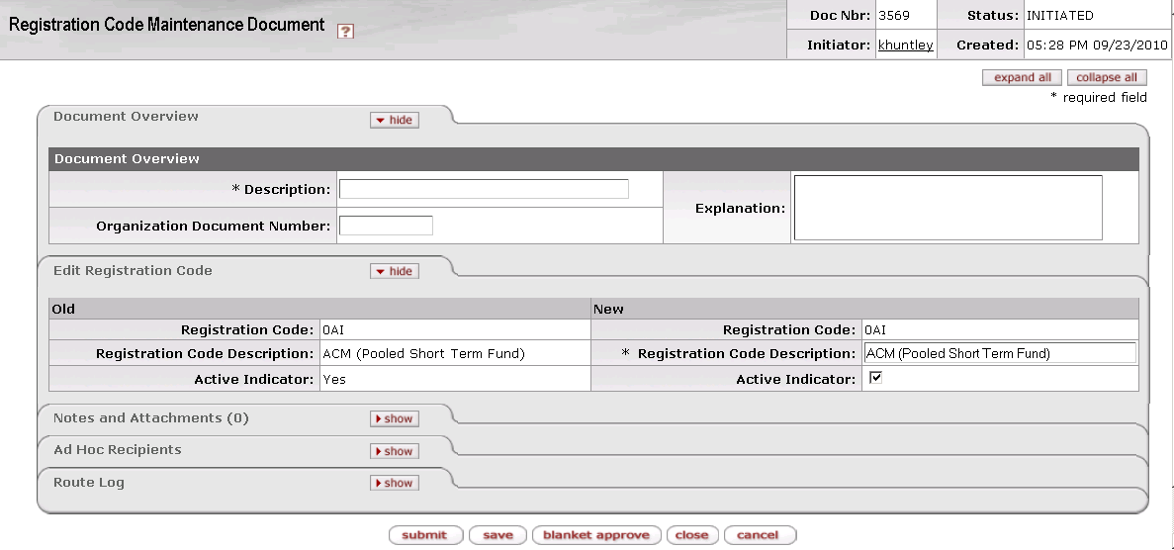

The Registration Code Maintenance document includes the **Edit Registration Code** tab. The system automatically enters data into both the **Old** and **New** sections in this tab. Selected data fields are available for editing.

Edit Registration Code tab definition

|  |  |
| --- | --- |
| Title | Description |
| Registration Code | Required when initiating a document; otherwise, display only. Indicates where a security is held in custody for the institution. The code may reference a bank, a broker or a location in your institution. |
| Registration Code Description | Required. The description of the custodial location. |
| Active Indicator | Indicates whether this registration code is active or inactive. Remove the check mark to deactivate the code. |

#### Reporting Group

 **> ** **> ** **> 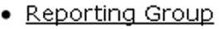**

The Security Reporting Group Maintenance document allows you to define the way securities will be listed in reports of securities and holdings. Multiple security class codes may roll up into the same reporting group.

 Care must be taken when deactivating a reporting group to ensure that historical values are not adversely affected.

##### Document Layout

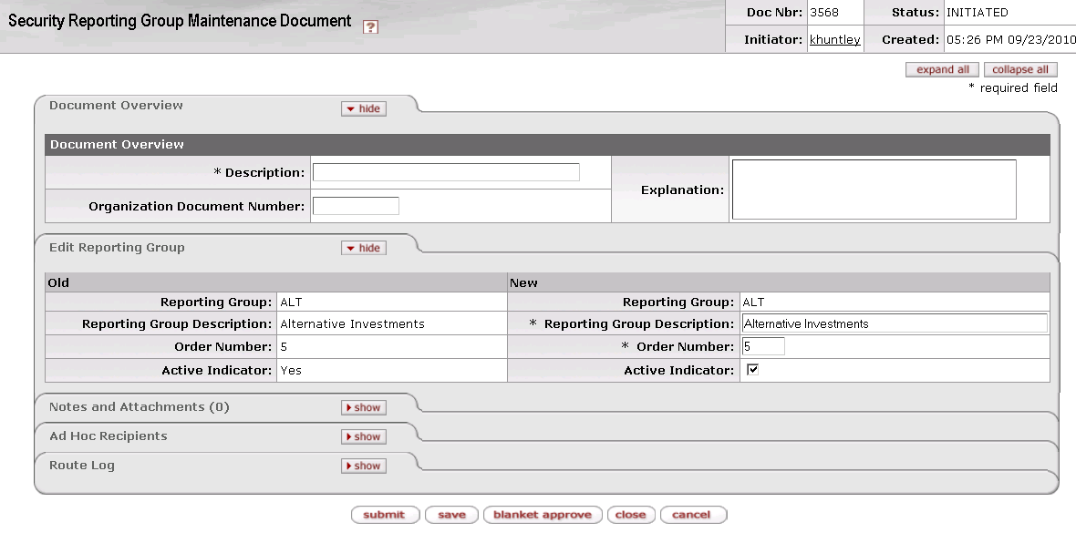

The Security Reporting Group Maintenance document includes the **Edit Reporting Group** tab. The system automatically enters data into both the **Old** and **New** sections in this tab. Selected data fields are available for editing.

Edit Reporting Group tab definition

|  |  |
| --- | --- |
| Title | Description |
| Reporting Group | Required when initiating a document; otherwise, display only. Identifies a group of securities for reporting purposes. |
| Reporting Group Description | Required. The description of the reporting group code to be used in reporting. Examples include 'Stocks,' 'Bonds,' 'Real Estate,' etc. |
| Order Number | The order in which this reporting group is to appear on reports and on balance screens. No two groups may have the same order number. |
| Active Indicator | Indicates whether this reporting group is active or inactive. Remove the check mark to deactivate the group. |

#### Subclass Code

 **> ** **> ** **> 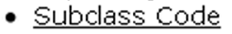**

The Subclass Code Maintenance document allows you to further identify the type of security that is represented by a record. Subclass codes enable your institution to establish codes in a different scheme for external reporting purposes with as much detail as needed. For example, a class code might represent real property and one of its subclass codes might represent mineral rights.

##### Document Layout

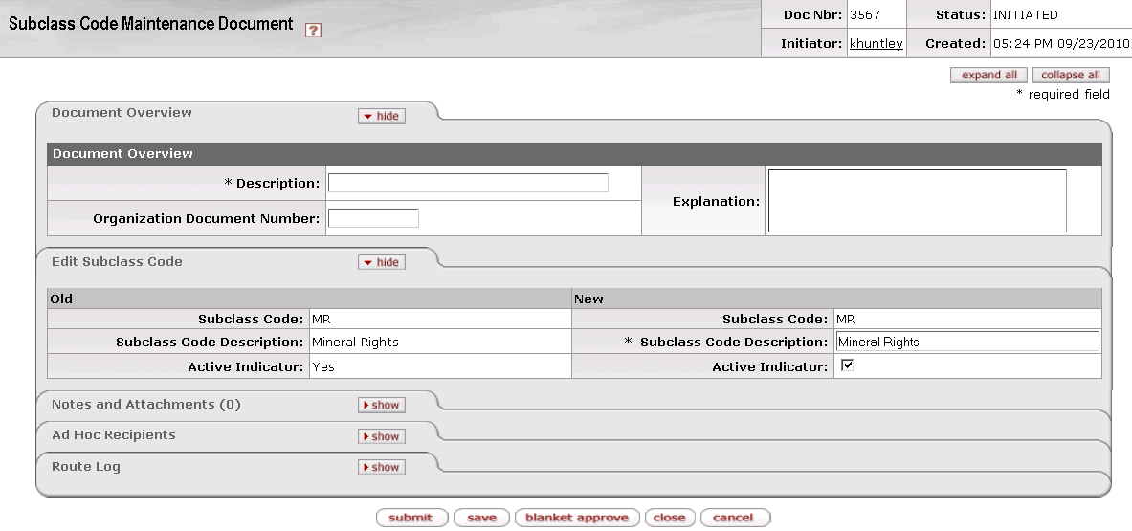

The Subclass Code Maintenance document includes the **Edit Subclass Code** tab. The system automatically enters data into both the **Old** and **New** sections in this tab. Selected data fields are available for editing.

Edit Subclass Code tab definition

|  |  |
| --- | --- |
| Title | Description |
| Subclass Code | Required when initiating a document; otherwise, display only. Identifies a subcategory within a class code for a security. This code is used for reporting purposes only. |
| Subclass Code Description | Required. The full description of the code. |
| Active Indicator | Indicates whether this subclass code is active or inactive. Remove the check mark to deactivate the code. |

### KEMID Submenu Group

 **>  > 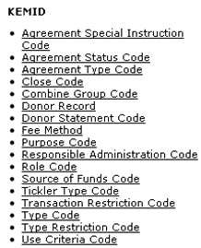**

The KEMID submenu group contains e-docs that allow you to maintain basic attributes used in your institution's KEMID records.

Endowments submenu, KEMID group

|  |  |
| --- | --- |
| Document | Description |
| Agreement Special Instruction Code | Stores donor instructions that are unique to a gift agreement. |
| Agreement Status Code | Defines your institution's unique status agreement codes for agreements governing activities of a KEMID. |
| Agreement Type Code | Defines the types of agreements that exist for the establishment and support of KEMIDs. |
| Close Code | Defines the reasons a KEMID may be closed. |
| Combine Group Code | Defines reporting group codes. |
| Donor Record | Identifies a donor record for the purpose of creating periodic or annual donor statements. |
| Donor Statement Code | Indicates the type of annual statement to provide for a given donor. |
| Fee Method | Allows you to specify sets of fee calculations to be used by the system to assess fees against KEMIDs |
| Purpose Code | Identifies an allowable use of funds; may indicate a very specific limitation or a broad range of uses depending on the donor wishes for a gift fund. |
| Responsible Administration Code | Identifies the section or department in the endowment management and accounting area of the institution that is responsible for oversight of a KEMID and its activity. |
| Source of Funds Code | Identifies a standard source of funding for KEMIDs. |
| Tickler Type Code | Defines a unique reason a person or department may wish to be notified of an upcoming event or action to be taken. |
| Transaction Restriction Code | Identifies a specific rule regarding allowable transactions for KEMIDs. |
| Type Code | Identifies a group of KEMIDs for reporting purposes. |
| Type Restriction Code | Indicates how funds are to be used according to the agreement establishing a KEMID. |
| Use Criteria Code | Identifies a specific restriction that a donor has placed on the use of the funds and or earnings of a gift. |

#### Agreement Special Instruction Code

 **> ** **> ** **> 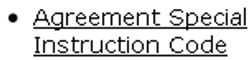 > **

The Agreement Special Instruction Code Maintenance document is used to manage donor instructions that are unique to a gift agreement. Each code defines a unique special activity that is to be undertaken by an organization to ensure compliance with the intent of the donor. For example, a special instruction code might be to indicate that the donor wishes a percentage of the earnings go to another KEMID spending account or to return earnings to principal until a certain value is reached.

Special instructions for the KEMID may be temporary, so these codes are editable. Special instructions are used only for reporting and have no business rules attached to them.

##### Document Layout

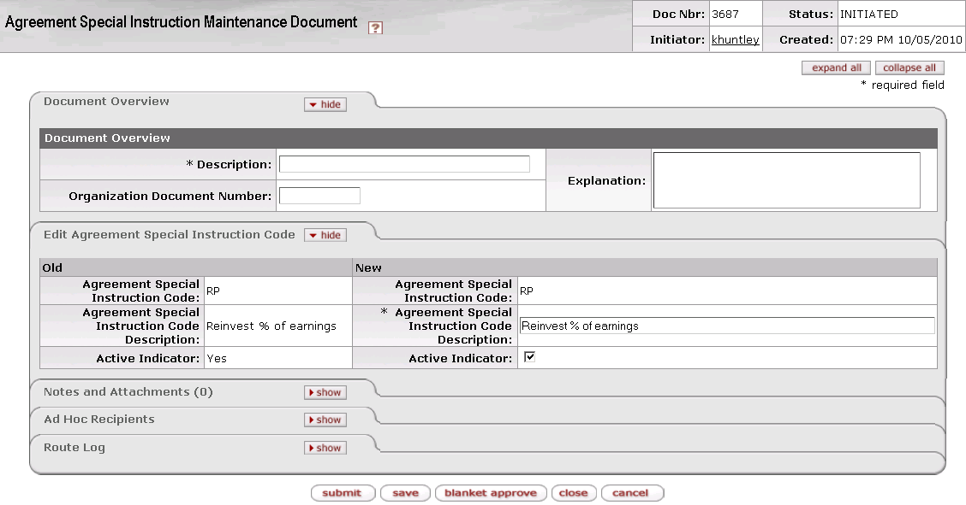

The Agreement Special Instruction Code Maintenance document includes the **Edit Agreement Special Instruction Code** tab. The system automatically enters data into both the **Old** and **New** sections in this tab. Selected data fields are available for editing.

Edit Agreement Special Instruction Code tab definition

|  |  |
| --- | --- |
| Title | Description |
| Agreement Special Instruction Code | Required when initiating a document; otherwise, display only. Identifies a set of donor instructions unique to a gift agreement. |
| Agreement Special Instruction Code Description | Required. The description for this set of agreement special instructions as defined by your institution. |
| Active Indicator | Indicates whether this agreement special instruction code is active or inactive. Remove the check mark to deactivate a code. |

#### Agreement Status Code

 **> ** **>  >  > **

The Agreement Status Code Maintenance document is used to manage KEM agreement status codes. The agreement status codes allow your institution to list unique status definitions for agreements governing a KEMID. These institutionally defined codes may be used in addition to the basic codes provided with the standard KEM model. For example, your institution's agreement status codes might include Completed and Signed, Draft, Not Applicable, and Pending Completion.

 An agreement must have a status of completed for the account to be active.

 The assignment of an agreement status code to a KEMID agreement record results in the assignment of a default transaction restriction for the affected KEMID.

##### Document Layout

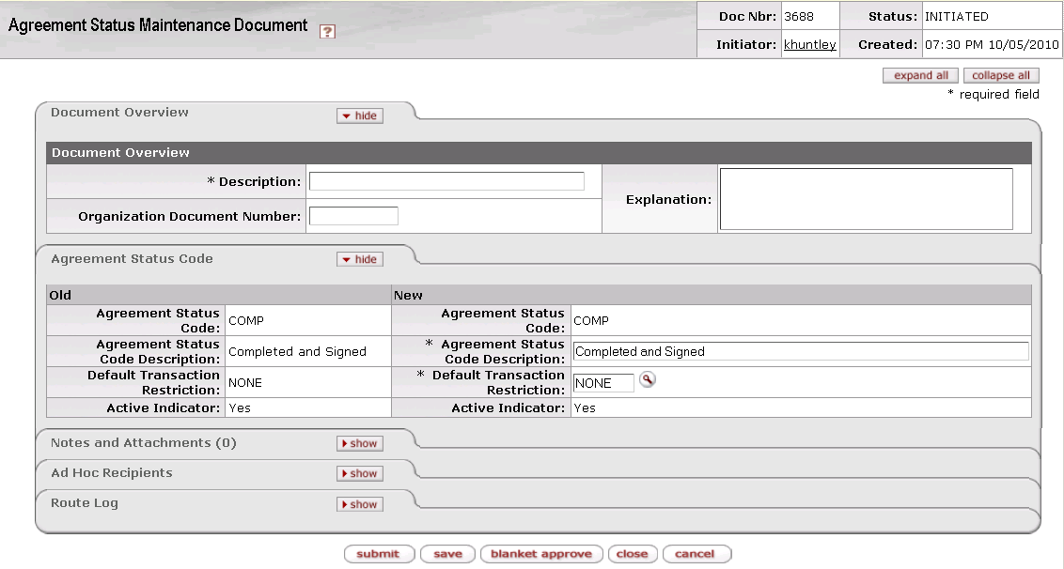

The Agreement Status Code Maintenance document includes the **Agreement Status Code** tab. The system automatically enters data into both the **Old** and **New** sections in this tab. Selected data fields are available for editing.

Edit Agreement Status Code tab definition

|  |  |
| --- | --- |
| Title | Description |
| Agreement Status Code | Required when initiating a document; otherwise, display only. Indicates the status of the most recent account agreement documentation on file. An agreement must have a status of completed for the account to be active. |
| Agreement Status Code Description | Required. An institutionally defined description for this status. |
| Default Transaction Restriction | Required. Identifies the types of transactions that may and may not be posted to an account—for example, income only, gifts only, no transactions, and no disbursement transactions. |
| Active Indicator | Indicates whether this agreement status code is active (Yes) or inactive (No). |

#### Agreement Type Code

 **> ** **>  >  > **

The Agreement Type Code Maintenance document is used to manage the types of agreements that exist for the establishment and support of KEMIDs. Typically the referenced agreement document provides all of the requirements for use of the funds in the KEMID. The document may also include expectations for investment and fund management. Examples of typical agreement types include grant, gift, pledge, and last will and testament agreement.

##### Document Layout

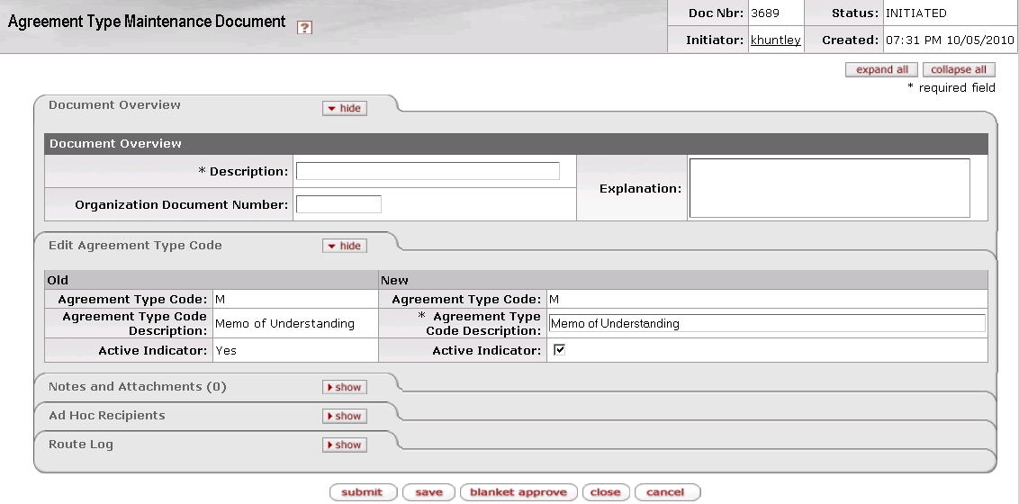

The Agreement Type Maintenance document includes the **Edit** **Agreement Type Code** tab. The system automatically enters data into both the **Old** and **New** sections in this tab. Selected data fields are available for editing.

Edit Agreement Type Code tab definition

|  |  |
| --- | --- |
| Title | Description |
| Agreement Type Code | Required when initiating a document; otherwise, display only. Identifies the type of agreement made between the donor or unit and the organization. |
| Agreement Type Code Description | Required. A description of this type of agreement. |
| Active Indicator | Indicates whether this agreement type code is active or inactive. Remove the check mark to deactivate an agreement type code. |

#### Close Code

 **> ** **> ** **>  > **

The Close Code Maintenance document is used to manage the various reasons that a KEMID may be closed. This information is used for reporting and tracking purposes and is always associated directly with a KEMID record. Possible values might include 'Not funded,' Refunded to Donor,' 'Expended,' and 'Transferred to an outside organization.'

##### Document Layout

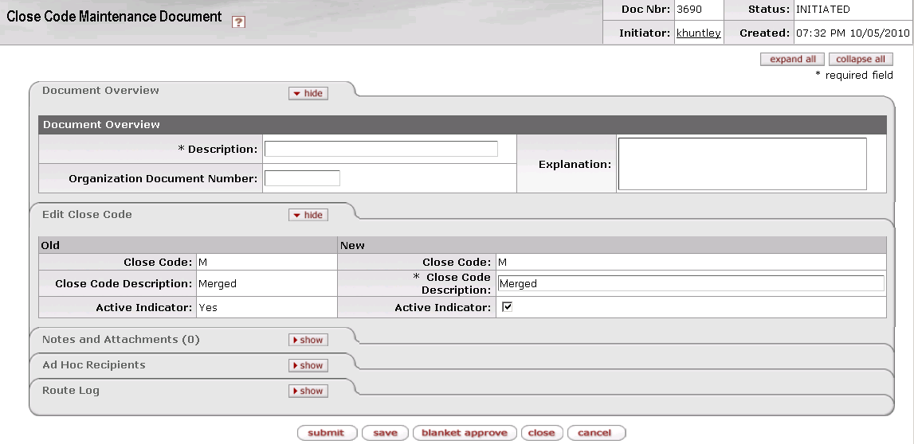

The Close Code Maintenance document includes the **Edit Close Code** tab. The system automatically enters data into both the **Old** and **New** sections in this tab. Selected data fields are available for editing.

Edit Close Code tab definition

|  |  |
| --- | --- |
| Title | Description |
| Close Code | Required when initiating a document; otherwise, display only. Identifies the reason an account may be closed. This code does not affect system processing, it is for information only. |
| Close Code Description | Required. Your institution's description of the reason associated with the close code. |
| Active Indicator | Indicates whether this close code is active or inactive. Remove the check mark to deactivate a close code. |

#### Combine Group Code

 **> ** **>  >  > **

The Combine Group Code Maintenance document is used to manage reporting group codes. Each code identifies a group of KEMIDs for reporting purposes. For example, your institution may use a combine group code to group all KEMIDs that support a Life Sciences initiative.

##### Document Layout

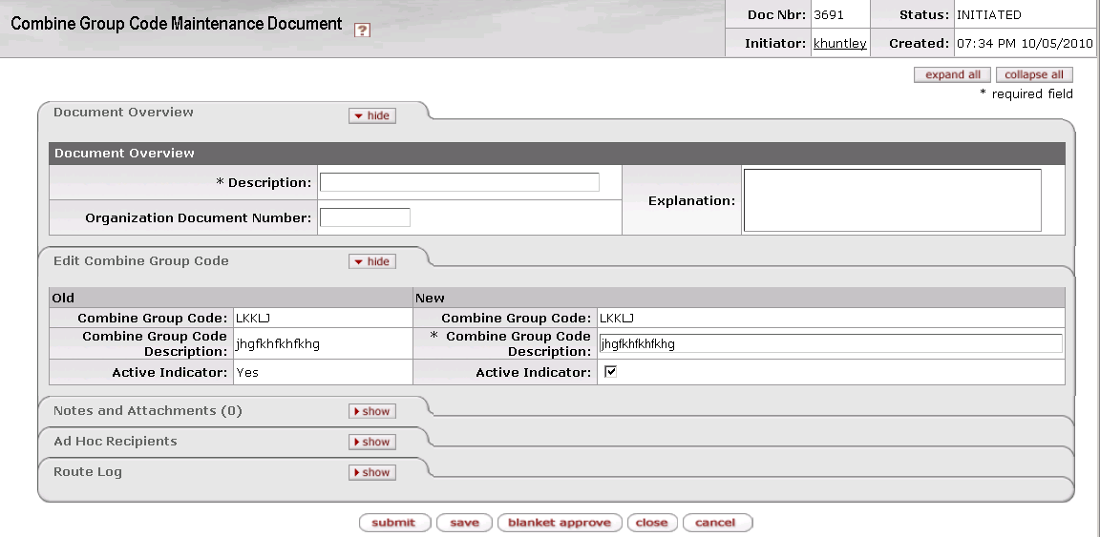

The Combine Group Code Maintenance document includes the **Edit Combine Group Code** tab. The system automatically enters data into both the **Old** and **New** sections in this tab. Selected data fields are available for editing.

Edit Combine Group Code tab definition

|  |  |
| --- | --- |
| Title | Description |
| Combine Group Code | Required when initiating a document; otherwise, display only. Identifies a group of KEMIDs for reporting purposes. |
| Combine Group Code Description | Required. A description of this group of KEMIDs. |
| Active Indicator | Indicates whether this combine group code is active or inactive. Remove the check mark to deactivate a combine group code. |

#### Donor Record

 **> ** **> ** **> 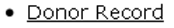**

The Donor Maintenance document allows you to manage the Endowment system's Donor records. These records exist primarily for the purpose of creating periodic or annual donor statements. The only required field in this e-doc is the donor ID, which should match the donor identification number in your institution's donor database.

 Your organization should develop a routine to update data in the Donor records from the donor database regularly.

##### Document Layout

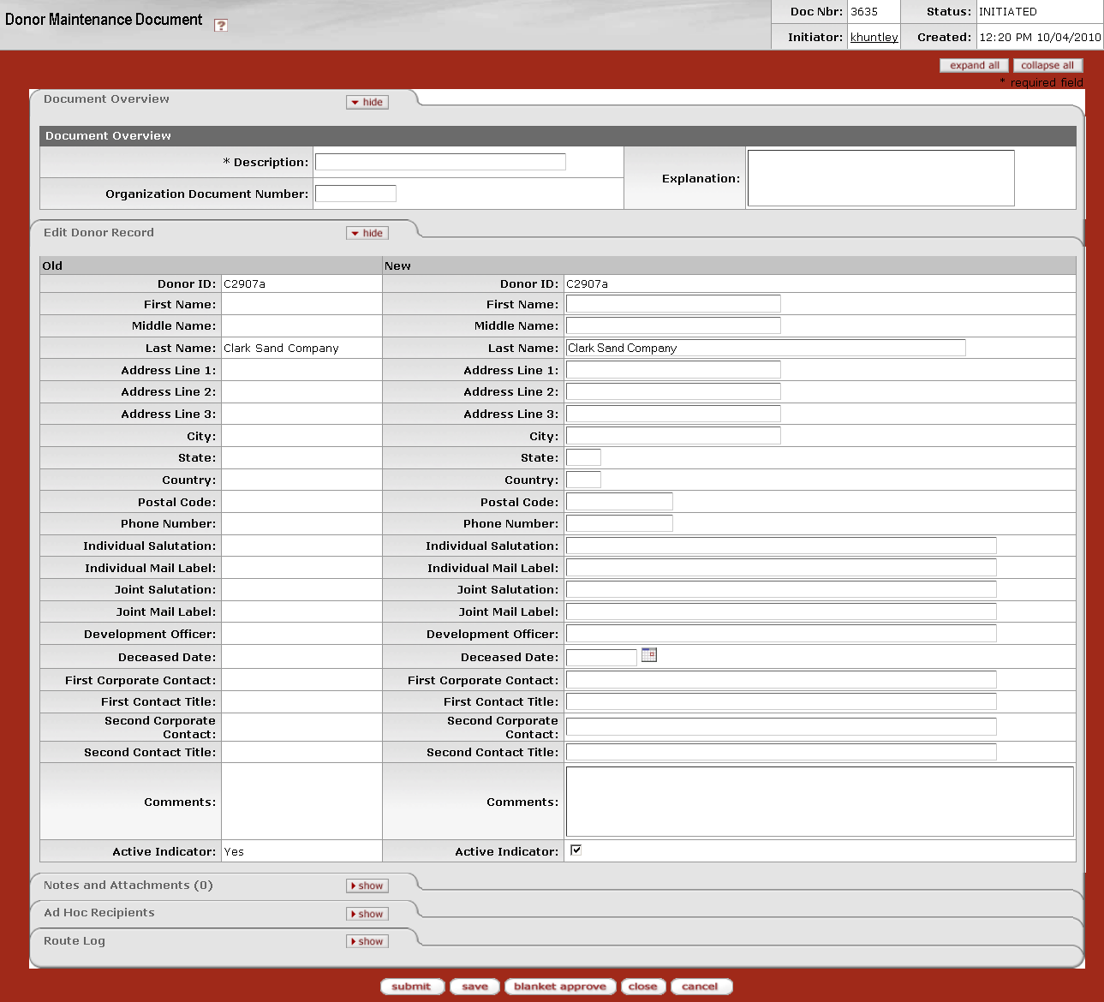

The Donor Maintenance document includes the **Edit** **Donor Record** tab. The system automatically enters data into both the **Old** and **New** sections in this tab. Selected data fields are available for editing.

Edit Donor Record tab definition

|  |  |
| --- | --- |
| Title | Description |
| Donor ID | Required when initiating a document; otherwise, display only. The code that uniquely identifies a specific donor within the KFS Endowment module. The person represented by the donor ID receives the annual donor endowment statement. |
| First Name | The first name of the donor or the donor organization name. |
| Middle Name | The middle name (or initial) of the donor. |
| Last Name | The last name of the donor. |
| Address Line 1 | The first line of the donor's address. |
| Address Line 2 | The second line of the donor's address. |
| Address Line 3 | The third line of the donor's address. |
| City | The city in which the donor resides. |
| State | The state in which the donor resides. |
| Country | The country in which the donor resides. |
| Postal Code | The zip code or postal code for the area in which the donor resides. |
| Phone Number | The donor's phone number. |
| Individual Salutation | The preferred salutation to be used for this donor when correspondence is directed to the donor as an individual. |
| Individual Mail Label | The preferred mailing label to use for this donor when correspondence is directed to the donor as an individual. |
| Joint Salutation | The preferred salutation to use for this donor when correspondence is directed to the donor jointly with another donor. |
| Joint Mail Label | The preferred mailing label to use for this donor when correspondence is directed to the donor jointly with another donor. |
| Development Officer | Your institution's primary development officer assigned to this donor. |
| Deceased Date | If the donor is deceased, the date of the donor's death. Enter a date or select it from the calendar _cal. |
| First Corporate Contact | If the donor is a corporation, the primary contact within the corporation for information regarding contributions. |
| First Contact Title | If the donor is a corporation, the title of the individual listed as the first corporate contact. |
| Second Corporate Contact | If the donor is a corporation, the secondary contact within the corporation for information regarding contributions. |
| Second Contact Title | If the donor is a corporation, the title of the individual listed as the second corporate contact. |
| Comments | Additional comments providing further direction for anyone referencing this Donor record. |
| Active Indicator | Indicates whether this Donor record is active or inactive. Remove the check mark to deactivate this Donor record. |

#### Donor Statement Code

 **> ** **>  > **

The Donor Statement Code Maintenance document allows you to manage the reference code for the type of annual statement to provide for a given donor. This code is used for the generation of reports and annual donor statements only.

##### Document Layout

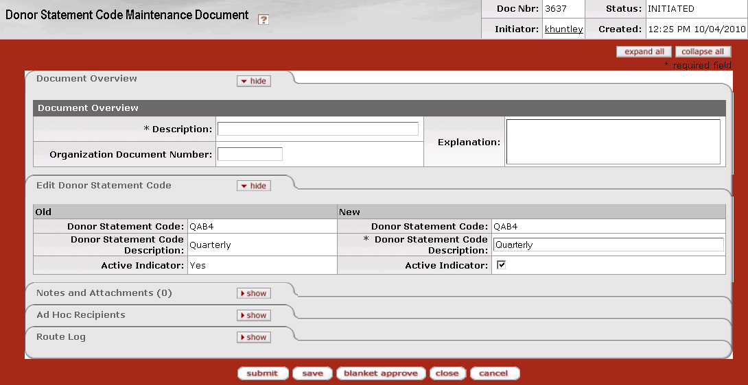

The Donor Statement Code Maintenance document includes the **Edit Donor Statement Code** tab. The system automatically enters data into both the **Old** and **New** sections in this tab. Selected data fields are available for editing.

Edit Donor Statement Code tab definition

|  |  |
| --- | --- |
| Title | Description |
| Donor Statement Code | Required when initiating a document; otherwise, display only. A code indicating the type of statement donors want to receive. |
| Donor Statement Code Description | Required. Your institution's description of this donor statement code. |
| Active Indicator | Indicates whether this donor statement code is active or inactive. Remove the check mark to deactivate a Donor Statement Code record. |

#### Fee Method

 **> ** **>  > 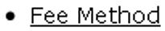**

The Fee Method Maintenance document allows you to specify different sets of fee calculations to be used by the system to assess fees against KEMIDs. Fields in this e-doc allow you to select many different options for calculating fees. All such fees are calculated and charged via an overnight batch process.

##### Document Layout

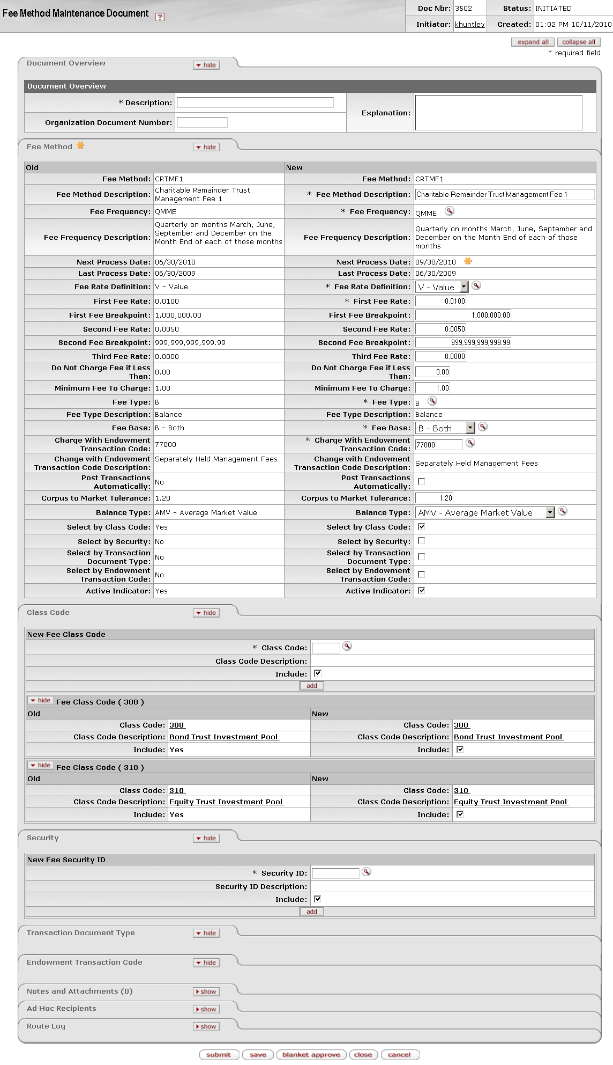

###### Fee Method Tab

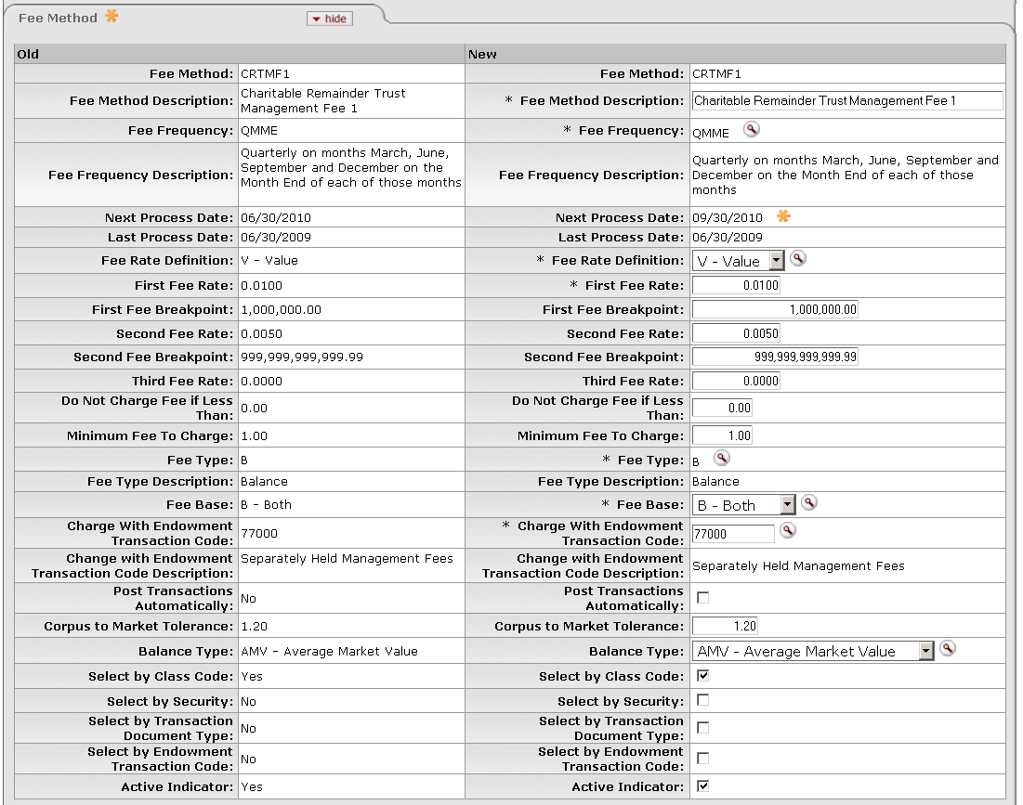

The Fee Method Maintenance document includes the **Fee Method** tab. The system automatically enters data into both the **Old** and **New** sections in this tab. Selected data fields are available for editing.

Fee Method tab definition

|  |  |
| --- | --- |
| Title | Description |
| Fee Method | Required when initiating a document; otherwise, display only. A code defined by your institution to identify a set of parameters used to calculate fees to be assessed against KEMIDs. |
| Fee Method Description | Required. Your institution's description of the fee method. |
| Fee Frequency | Required. The frequency with which this fee or set of fees is assessed. Use the lookup _searchicon to select the appropriate fee frequency code. |
| Fee Frequency Description | Your institution's description of the fee frequency. |
| Next Process Date | Display only, based on the value in the **Fee Frequency** field. The next date on which this fee is to be processed by the system. |
| Last Process Date | Display only. The last date that this fee was processed by the system. |
| Fee Rate Definition | Required. The rate used by the system for calculation of the fee. A fee may be calculated for a specific dollar amount per item (count) or a percentage of a total value (value). Choose the appropriate option from the list. |
| First Fee Rate | Required. The amount of the first-tier rate to be charged based on item count or value. |
| First Fee Breakpoint | The amount per item or value to be considered for the first-tier rate. The default entry is 999,999,999,999.99, but you may change it. |
| Second Fee Rate | The amount of the second-tier rate to be charged based on item count or value. |
| Second Fee Breakpoint | The amount per item or value to be considered for the second-tier rate. If the first fee breakpoint is less than the default value of,999,999,999,999.99, you must enter a value greater than zero in this field. The default entry is 999,999,999,999.99, but you may change it. |
| Third Fee Rate | The amount of the third-tier rate to be charged based on item count or value. If the second fee breakpoint is less than,999,999,999,999.99, you must enter a value greater than zero in this field. |
| Do Not Charge Fee If Less Than | The threshold at which to begin actually charging the fee. If the calculated fee is below the value specified here, the system is not to charge the fee. |
| Minimum Fee To Charge | The minimum fee to charge to the KEMID. If the calculated fee is less than this amount, the system is to charge this amount rather than the calculated amount. |
| Fee Type | Required. The code used to determine the sets of criteria that are valid for specifying the basis for fee calculations for this fee method. Values include 'B' (balance) and 'T' (transactions). Use the lookup _searchicon to select the appropriate type.  pencil-small A fee type of ''P' (payment)' will be available in future releases but is not available in KFS 4.0.  If you select 'B', the system opens the **Class Code** tab and the **Security** tab so you can specify one or more groups of securities and/or individual securities to be used to specify the basis for fee calculations.  If you select 'T', the system opens the **Transaction Document Type** tab and the **Endowment Transaction Code** tab so you can specify one or more e-doc types and/or Etran codes to be used to specify the basis for fee calculations. |
| Fee Type Description | Display only. The description ('balance' or 'transactions') of the fee type.  pencil-small A fee description of 'payment' will be available in future releases but is not available in KFS 4.0. |
| Fee Base | Required. Indicates whether the fee is to be calculated on the income and/or principal side of the KEMID activity and/or holdings. Valid values are 'Income (I),' 'Principal (P),' and 'Both (B).' Select the appropriate fee base from the list. |
| Charge With Endowment Transaction Code | Required. The Etran code to be used to post the transaction to charge the fee to the KEMID. Enter a valid code or use the lookup _searchicon to find it. |
| Charge with Endowment Transaction Code Description | Your institution's description of the endowment transaction code. |
| Post Transactions Automatically | Indicator specifying whether the system is to automatically set the e-doc status to FINAL for all fee transactions generated via this fee method and post them to the KEMIDs. If checked, this field directs the system will post the transactions automatically. If unchecked, the field directs the system to submit all fee transaction e-docs for approval before posting. |
| Corpus to Market Tolerance | A number specifying a level of performance that must be achieved before the fee may be charged. This number must be zero (the default) or greater.  If the KEMID is a true endowment and if the corpus-to-market-value ratio is less than the number specified in this field, the system is not to charge the fee. For example, if the value in this field is 1.25 and the market value is less than 125% of the corpus, no fee is to be charged. |
| Balance Type | pencil-small This field is applicable only for fee methods that have a **Fee Type** of 'B' (balance), which indicates that the calculation will be based on the holdings of the KEMID.  For fee methods that have a **Fee Type** value of 'B' (balance), the specific values to be used to calculate the fee.  If the rate definition is Value, the options available are 'Average Market Value (AMV),' 'Month End Market Value (MMV)' and 'Current Market Value (CMV).'  If the rate definition is Count, the options available are 'Average Units (AU),' 'Month End Units (MU),' and 'Current Units (CU).'  Select the appropriate value from the list. |
| Select by Class Code | If the **Fee Type** value is 'B' (balance), indicates whether class code is to be used to select securities on which fee calculations are to be based.  If checked, the **Class Code** tab must contain at least one class code for which the **Include** box is checked.  If unchecked, the system disregards information in the **Class Code** tab when determining the basis for fee calculations for this fee method. |
| Select by Security | If the **Fee Type** value is 'B' (balance), indicates whether security ID is to be used to identify securities on which fee calculations are to be based.  If checked, the **Security** tab must contain at least one security ID for which the **Include** box is checked.  If unchecked, the system disregards information in the **Security** tab when determining the basis for fee calculations for this fee method. |
| Select by Transaction Document Type | If the **Fee Type** value is 'T' (transactions), indicates whether e-doc type is to be used to determine the basis for fee calculations.  If checked, the **Transaction Document Type** tab must contain at least one type of e-doc for which the **Include** box is checked.  If unchecked, the system disregards information in the **Transaction Document Type** tab when determining the basis for fee calculations for this fee method. |
| Select by Endowment Transaction Code | If the **Fee Type** value is 'T' (transactions), indicates whether Etran code is to be used to determine the basis for fee calculations. If checked, the **Endowment** **Transaction Code** tab must contain at least one Etran code for which the **Include** box is checked.  If unchecked, the system disregards information in the **Endowment** **Transaction Code** tab when determining the basis for fee calculations for this fee method. |
| Active Indicator | Indicates whether this fee method is active or inactive. Remove the check mark to deactivate this Fee Method record. |

###### Class Code Tab

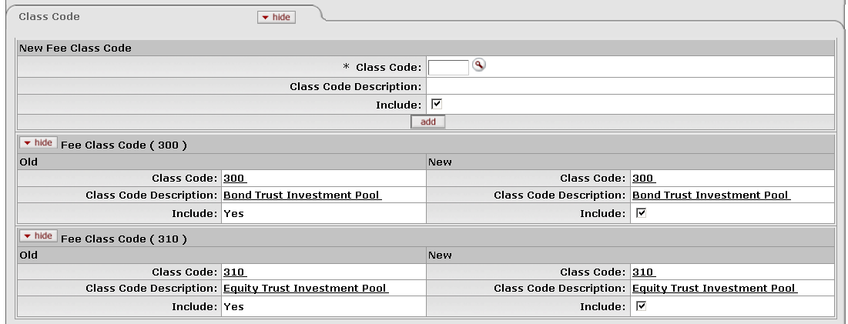

The **Class Code** tab identifies the various security classes (if any) to be used as selection criteria for calculating fees.

 This tab is available for your use only if the **Fee Type** value is 'B' (balance) in the **Fee Method** tab.

 If the **Select by Class Code** box is checked in the **Fee Method** tab, the **Class Code** tab must contain at least one class code for which the **Include** box is checked.

Class Code tab definition

|  |  |
| --- | --- |
| Title | Description |
| Class Code | Required if class code is to be used as a criterion when calculating fees; otherwise, not used. Specifies a class code to be used. Each class code denotes a different category of securities. |
| Class Code Description | Your institution's description of the class code. |
| Include | Indicates whether this class code is to be used as a basis for fee calculation. Uncheck the box to discontinue using this class code for the fee calculations for this fee method. |

After entering information for a class code, click .

###### Security Tab

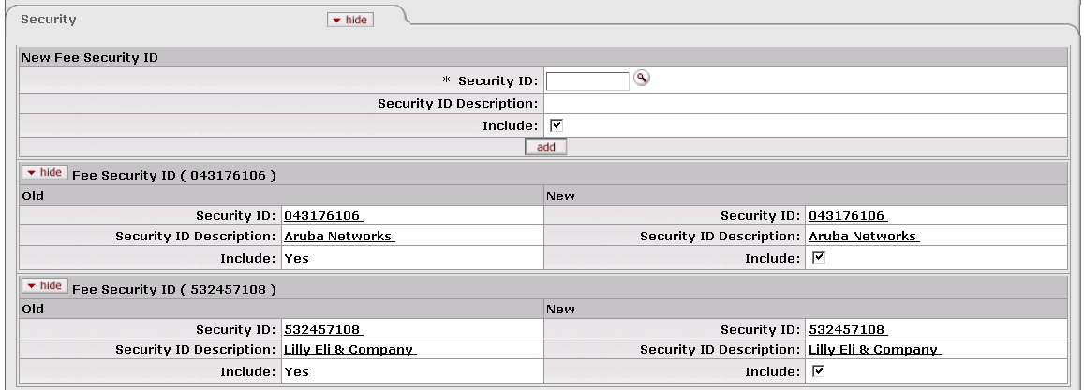

The Security tab identifies specific securities (if any) to be used as selection criteria when calculating fees.

 This tab is available for your use only if the **Fee Type** value is 'B' (balance) in the **Fee Method** tab.

 If the **Select by Security** box is checked in the **Fee Method** tab, the **Security** tab must contain at least one security for which the **Include** box is checked.

Security tab definition

|  |  |
| --- | --- |
| Title | Description |
| Security ID | Required if security ID is to be used as a criterion when calculating fees; otherwise, not used. Specifies a security ID to be used. Each security ID uniquely identifies an asset or liability. |
| Security ID Description | The description of, or name for, the security. |
| Include | Indicates whether this security ID is to be used as a basis for fee calculation. Uncheck the box to discontinue using this security ID for the fee calculations for this fee method. |

After entering information for a security, click .

###### Transaction Document Type Tab

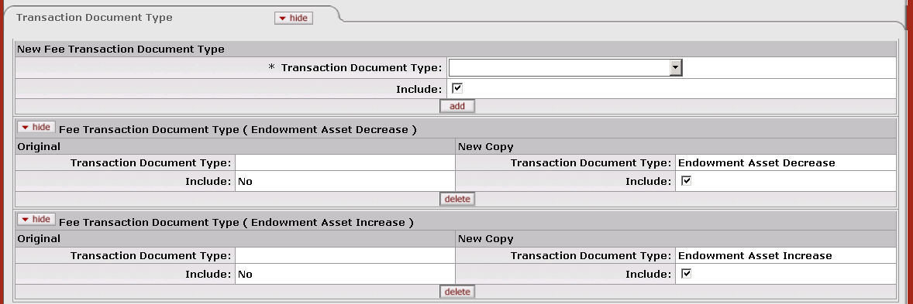

The **Transaction Document Type** tab identifies specific types of e-docs (if any) to be used as selection criteria when calculating fees.

 This tab is available for your use only if the **Fee Type** value is 'T' (transactions) in the **Fee Method** tab.

 If the **Select by Transaction Type** box is checked in the **Fee Method** tab, the **Transaction Document Type** tab must contain at least one e-doc type for which the **Include** box is checked.

Transaction Type tab definition

|  |  |
| --- | --- |
| Title | Description |
| Transaction Document Type | Required if e-doc type is to be used as a criterion when calculating fees; otherwise, not used. Specifies a type of e-doc to be used (Asset Increase, Asset Decrease, Liability Increase, etc.) |
| Include | Indicates whether this type of e-doc is to be used as a basis for fee calculation. Uncheck the box to discontinue using this type of e-doc for the fee calculations for this fee method. |

After entering information for a type of e-doc, click .

###### Endowment Transaction Code Tab

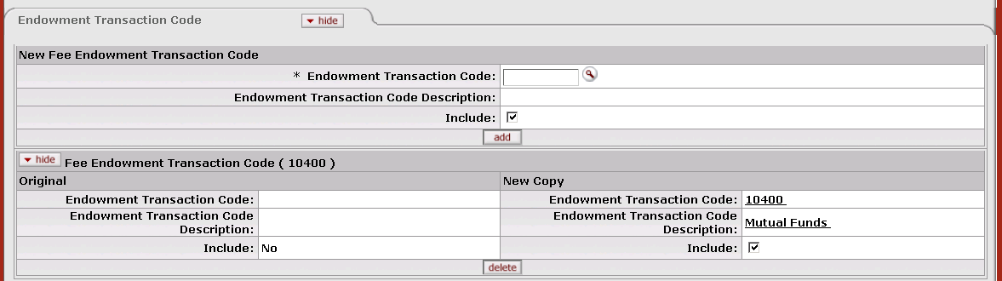

The Endowment Transaction Code tab identifies specific Etran codes (if any) to be used as selection criteria when calculating fees.

 This tab is available for your use only if the **Fee Type** value is 'T' (transactions) in the **Fee Method** tab.

 If the **Select by Endowment Transaction Code** box is checked in the **Fee Method** tab, the **Endowment Transaction Code** tab must contain at least one Etran code for which the **Include** box is checked.

Endowment Transaction Code tab definition

|  |  |
| --- | --- |
| Title | Description |
| Endowment Transaction Code | Required if Etran code is to be used as a criterion when calculating fees; otherwise, not used. Specifies an Etran code to be used. |
| Endowment Transaction Code Description | The description of, or name for, this endowment transaction code. |
| Include | Indicates whether this Etran code is to be used as a basis for fee calculation. Uncheck the box to discontinue using this Etran code for the fee calculations for this fee method. |

After entering information for an Etran code, click .

#### Purpose Code

 **> ** **>  > 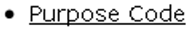**

The Purpose Code Maintenance document allows you to manage codes used to categorize KEMIDs according to their allowable use of funds. Each purpose code may indicate a very specific limitation or a broad range of uses, depending on the donor's wishes for a gift fund. So, for example, you might set up different purpose codes for scholarships, professorships, chairs, and/or general use.

##### Document Layout

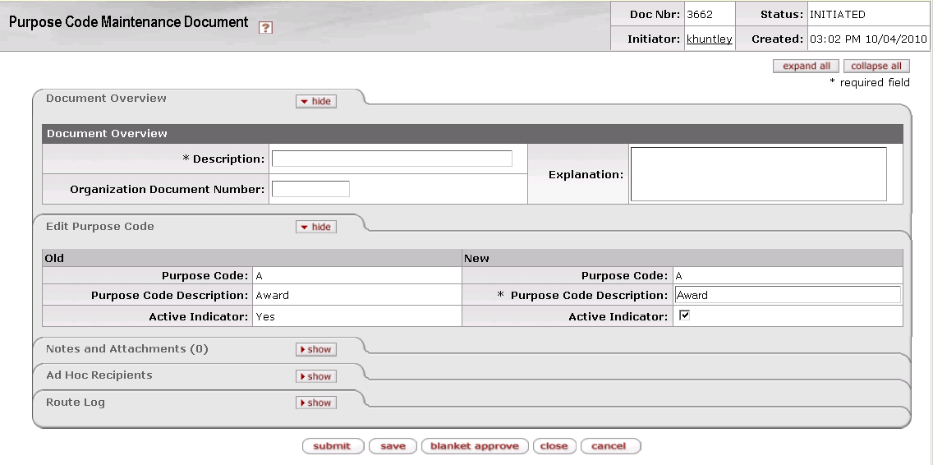

The Purpose Code Maintenance document includes the **Edit Purpose Code** tab. The system automatically enters data into both the **Old** and **New** sections in this tab. Selected data fields are available for editing.

Edit Purpose Code tab definition

|  |  |
| --- | --- |
| Title | Description |
| Purpose Code | Required when initiating a document; otherwise, display only. A code representing the allowable use of funds for a KEMID. |
| Purpose Code Description | Required. Your institution's description of this purpose code. |
| Active Indicator | Indicates whether this purpose code is active or inactive. Remove the check mark to deactivate this Purpose Code record. |

#### Responsible Administration Code

 **> ** **> ** **> 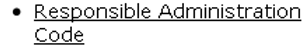**

The Responsible Administration Code Maintenance document allows you to manage codes that represent the department or group responsible for administering a KEMID.

 This code does not represent the department or organization that is the beneficiary of the funds. It represents the group that administers the endowment.

##### Document Layout

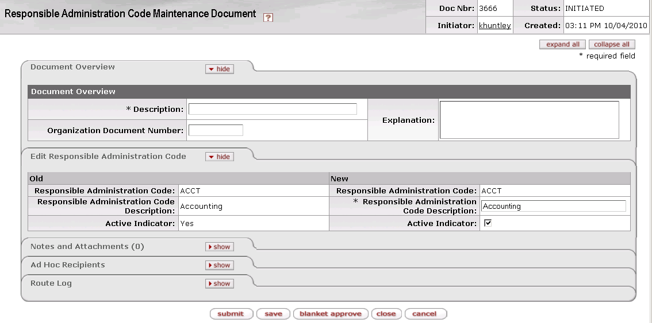

The Responsible Administration Code Maintenance document includes the **Edit Responsible Administration Code** tab. The system automatically enters data into both the **Old** and **New** sections in this tab. Selected data fields are available for editing.

Edit Responsible Administration Code tab definition

|  |  |
| --- | --- |
| Title | Description |
| Responsible Administration Code | Required when initiating a document; otherwise, display only. Indicates the department or group responsible for administration of the endowment. |
| Responsible Administration Code Description | Required. Your institution's description of this responsible administration code. |
| Active Indicator | Indicates whether this responsible administration code is active or inactive. Remove the check mark to deactivate this Responsible Administration Code record. |

#### Source of Funds Code

 **> ** **>  > 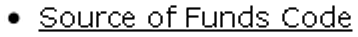**

The Fund Source Code Maintenance document allows you to manage your institution's codes that identify the standard sources of funding for KEMIDs. These codes are associated with a KEMID record and used for reporting purposes only.

##### Document Layout

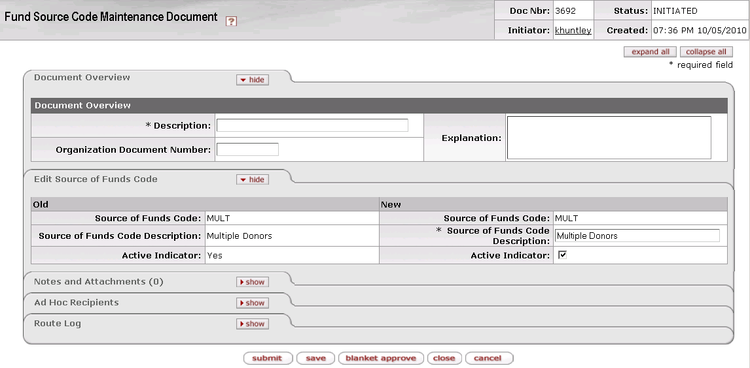

The Fund Source Code Maintenance document includes the **Edit Source of Funds Code** tab. The system automatically enters data into both the **Old** and **New** sections in this tab. Selected data fields are available for editing.

Edit Source of Funds tab definition

|  |  |
| --- | --- |
| Title | Description |
| Source of Funds Code | Required when initiating a document; otherwise, display only. Identifies a source of funding for a KEMID. |
| Source of Funds Code Description | Required. Your institution's description of this fund source. |
| Active Indicator | Indicates whether this source of funds code is active or inactive. Remove the check mark to deactivate this Fund Source Code record. |

#### Tickler Type Code

 **> ** **>  > 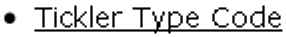**

The Tickler Type Code Maintenance document allows you to manage your institution's codes identifying the reasons a person or department may want to be notified of an upcoming event or action to be taken. Your institution's codes might represent reasons such as investment review, spending review, and income reinvestment. These codes are used on Tickler records.

##### Document Layout

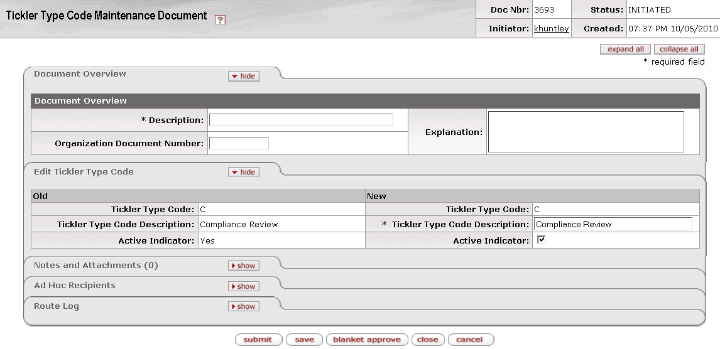

The Tickler Type Code Maintenance document includes the **Edit Tickler Type Code** tab. The system automatically enters data into both the **Old** and **New** sections in this tab. Selected data fields are available for editing.

Edit Tickler Type Code tab definition

|  |  |
| --- | --- |
| Title | Description |
| Tickler Type Code | Required when initiating a document; otherwise, display only. A reason a person or department may want to be notified of upcoming events or actions to be taken. |
| Tickler Type Code Description | Required. Your institution's description of this tickler type code; clarifies the general purpose of the tickler. |
| Active Indicator | Indicates whether this tickler type code is active or inactive. Remove the check mark to deactivate this Tickler Type Code record. |

#### Transaction Restriction Code

 **> ** **>  > 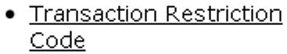**

The Transaction Restriction Code Maintenance document allows you to define and manage codes for your institution's rules that govern allowable transactions for a KEMID. Each code is associated with specific rules regarding allowable transactions.

Whenever an agreement status code is set up in the system, the initiator assigns a transaction restriction code to it. Subsequently, when this agreement status code is associated with a KEMID, its transaction restriction code is also assigned to the KEMID. If the agreement status code's transaction restriction code is changed, the system automatically updates the default restriction code on all associated KEMID records. Users may change this default transaction restriction code on the KEMID record as needed.

Transaction restriction codes may also be used to assign unique activity routing.

##### Document Layout

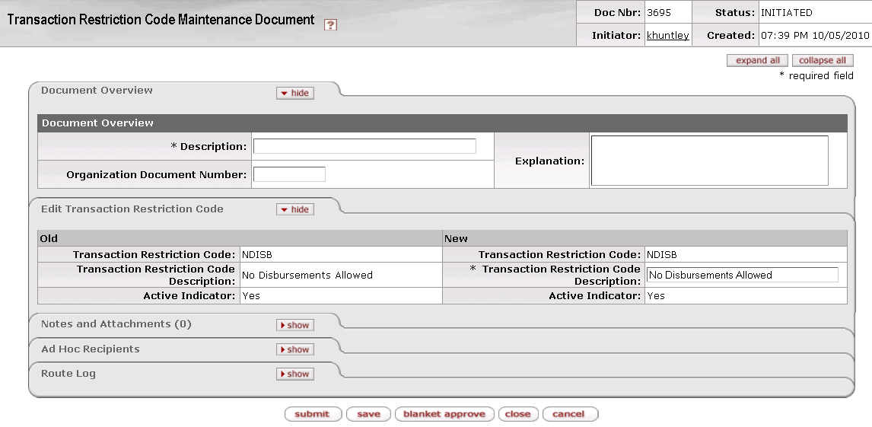

The Transaction Restriction Code Maintenance document includes the **Edit Transaction Restriction Code** tab. The system automatically enters data into both the **Old** and **New** sections in this tab. Selected data fields are available for editing.

Edit Transaction Restriction Code tab definition

|  |  |
| --- | --- |
| Title | Description |
| Transaction Restriction Code | Required when initiating a document; otherwise, display only. Determines allowable transactions for a KEMID. |
| Transaction Restriction Code Description | Required. Your institution's description of this transaction restriction code. |
| Active Indicator | Indicates whether this transaction restriction code is active or inactive. Remove the check mark to deactivate this Transaction Restriction Code record. |

#### Type Code

 **> ** **>  > **

The Type Code Maintenance document allows you to manage codes used to organize KEMIDS into groups for reporting purposes. For example, your institution's groups might include University General Endowed Funds, Discretionary Funds and Expendable Funds. Data stored in each Type Code record also provides default information for fields in the KEMID records to which the type code is assigned. Finally, through these records, users may reset fees to be automatically assessed against KEMIDs.

##### Document Layout

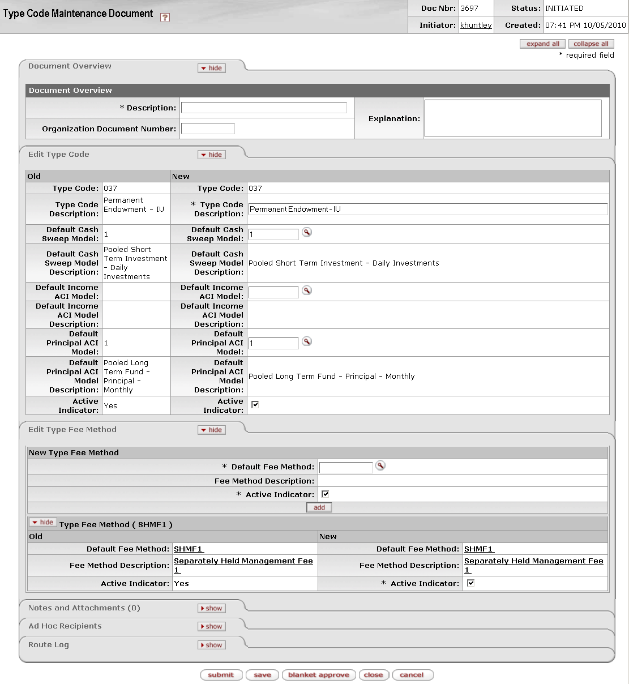

###### Edit Type Code Tab

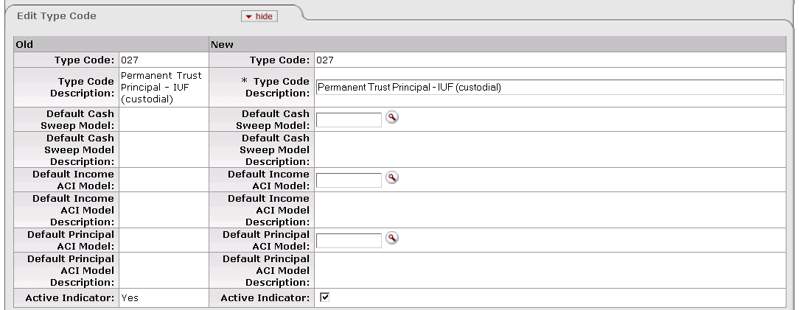

The Type Code Maintenance document includes the **Edit Type Code** tab. The system automatically enters data into both the **Old** and **New** sections in this tab. Selected data fields are available for editing.

Edit Type Code tab definition

|  |  |
| --- | --- |
| Title | Description |
| Type Code | Required when initiating a document; otherwise, display only. A code used by your institution to group KEMIDs for reporting purposes. |
| Type Code Description | Required. Your institution's description of this type code. |
| Default Cash Sweep Model | The default cash sweep model associated with this type code. This value is automatically displayed in the **Cash Sweep Model** field for each new KEMID that uses this type code. |
| Default Cash Sweep Model Description | Your institution's description of the default cash sweep model. |
| Default Income ACI Model | The default income ACI (automated cash investment) model associated with this type code. This value is automatically displayed in the **Income ACI Model** field of each new KEMID that uses this type code. |
| Default Income ACI Model Description | Your institution's description of the default income ACI model. |
| Default Principal ACI Model | The default principal ACI model associated with this type code. This value is automatically displayed in the **Principal** **ACI Model** field of each new KEMID that uses this type code. |
| Default Principal ACI Model Description | Your institution's description of the default principal ACI model. |
| Active Indicator | Indicates whether this type code is active or inactive. Remove the check mark to deactivate this type code record. |

###### Edit Type Fee Method Tab

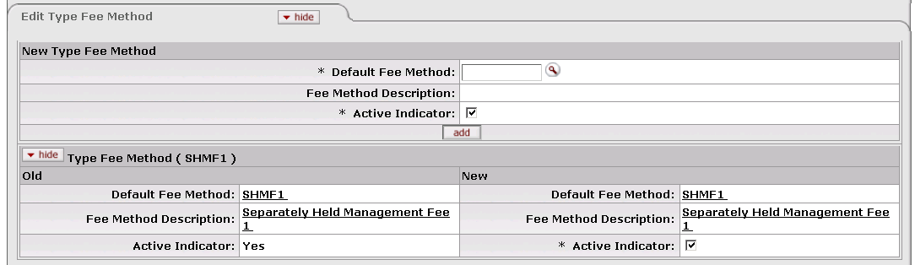

The Type Code Maintenance document includes the **Edit Type Fee Method** tab. The system automatically enters data into both the **Old** and **New** sections in this tab. Selected data fields are available for editing.

Edit Type Fee Method tab definition

|  |  |
| --- | --- |
| Title | Description |
| Default Fee Method | Required. The default fee method associated with this type code. This entry represents the default fee method(s) displayed in the **Fees** tab when a new KEMID is created that uses this type code. More than one default Fee Method record may be associated with each type code. |
| Fee Method Description | Required. Your institution's description of this default fee method. |
| Active Indicator | Indicates whether this default fee method is active or inactive. Remove the check mark to deactivate a Default Fee Method record. |

#### Type Restriction Code

 **> ** **> ** **> 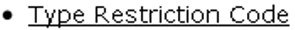**

Type restriction codes are related to endowment types. When an endowment type is assigned to a KEMID, the associated restriction code serves to define how the KEMID's funds are to be used according to the agreement establishing the KEMID. Additionally, specific rules affecting activity in the KEMID depend upon whether or not the associated type restriction code represents permanently endowed funds or not.

The Type Restriction Code maintenance e-doc allows you to set up and manage your institution's type restriction codes.

##### Document Layout

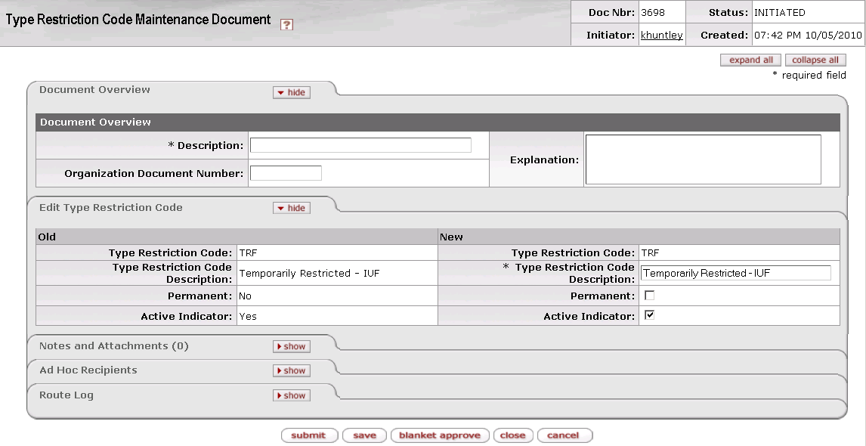

The Type Restriction Code Maintenance document includes the **Edit Type Restriction Code** tab. The system automatically enters data into both the **Old** and **New** sections in this tab. Selected data fields are available for editing.

Edit Type Restriction Code tab definition

|  |  |
| --- | --- |
| Title | Description |
| Type Restriction Code | Required when initiating a document; otherwise, display only. A code associated with the Income and/or Principal side(s) of a KEMID. This code affects transaction processing for true endowments. |
| Type Restriction Code Description | Required. Your institution's description of this type restriction code. |
| Permanent | Indicates whether this type restriction code applies to funds that are part of a true endowment. Check the box to indicate that this code applies to funds that are part of a true endowment. |
| Active Indicator | Indicates whether this type restriction code is active or inactive. Remove the check mark to deactivate a Type Restriction code record. |

#### Use Criteria Code

 **> ** **> ** **> **

The Use Criteria Code Maintenance document allows you to manage criteria that govern specific restrictions a donor has placed on spendable funds and/or earnings of a gift. This information is available in coded form to expedite verification of compliance with donor intent.

##### Document Layout

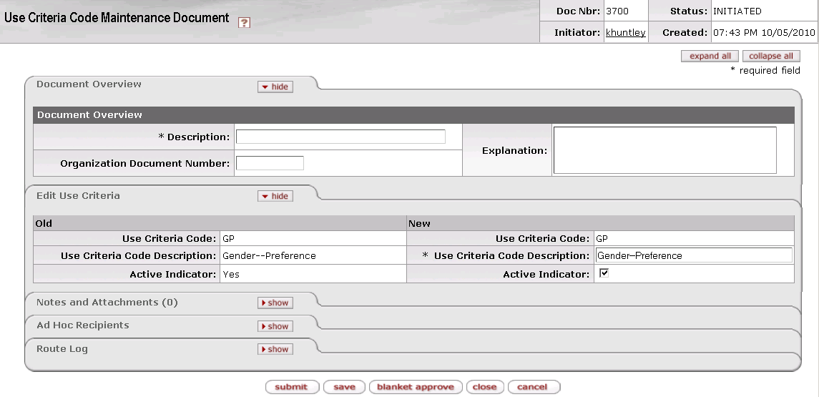

The Use Criteria Code Maintenance document includes the **Edit Use Criteria** tab. The system automatically enters data into both the **Old** and **New** sections in this tab. Selected data fields are available for editing.

Edit Use Criteria tab definition

|  |  |
| --- | --- |
| Title | Description |
| Use Criteria Code | Required when initiating a document; otherwise, display only. A code used by your institution to restrict the use of funds and/or earnings from gifts. |
| Use Criteria Code Description | Required. Your institution's description of this use criteria code. |
| Active Indicator | Indicates whether this use criteria code is active or inactive. Remove the check mark to deactivate this Use Criteria Code record. |